Name:

ID:

**M5 Challenge 02**

1. Consider the following:

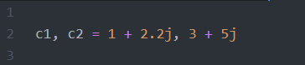

* What is **c1.real + c2.real**?
* What is **round(c1.imag)**?
* Let **p0** and **p1** be points on the xy plane. The real component is the x value and the imaginary component is the y value. What is the midpoint between p0 and p1?

*Hint: p = (p.real, p.imag) = (x,y)*

*midpoint = (x0+x1)/2, (y1+y0)/2*

* Bonus (Extra Credit): Let **p0** and **p1** be points on the xy plane. The real component is the x value and the imaginary component is the y value. What is the distance between p0 and p1?

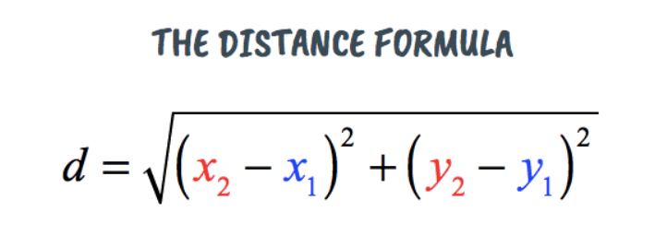

1. Consider the following:

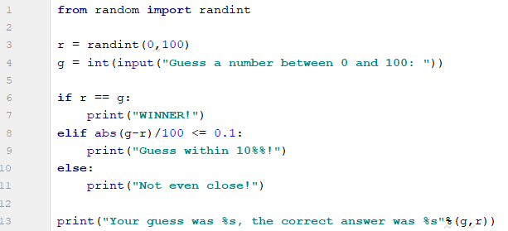

* What is the output of your program?
* Will the value of r be the same every time you run the program?
* What is **randint(60,71)**?
* What is **abs(-20)**?
* Change line 8 so that the user’s guess can be within **31%** rather than **10%**.
* What is **“hello %s %s” %(“Mr.”,”Nick”)**?

1. Consider the following:

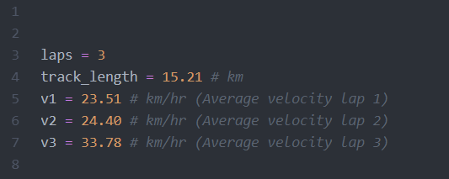

* What is the average velocity of the car after completing 4 laps around the track?

Hint: average velocity = (total distance)/ (total time)