Name:

ID:

**M5 Challenge 02 Advanced**

1. Consider the following Graph, G:

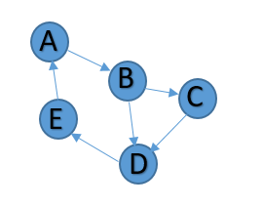

* Represent G as an adjacency matrix in python:
* Add the following weights to your adjacency matrix:

|  |  |
| --- | --- |
| Edge | Weight |
| A-B | 1.5 |
| B-C | 1.1 |
| B-D | 1.25 |
| C-D | 1.3 |
| D-E | 1.7 |
| E-A | 1 |

* Represent G as an adjacency matrix in python, given G is undirected: