Name:

ID:

**M5 Challenge 03**

Part 1:

1. Write a python program that computes the following sum:

*N = $17+18+19…+112$*

1. Write a python program that calculates the sum of the 17th, 31st, and 48th Fibonacci numbers:

*Fibonacci sequence:*

*S = 1, 1, 2, 3, 5, 8, ...*

*Si+2= Si+1+ Si*

Part 2: [Lists](https://runestone.academy/runestone/books/published/thinkcspy/Lists/intro-Lists.html)

1. Evaluate the following (10.3):

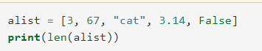

|  |  |
| --- | --- |
| 3 | 67 |
| 5 | 6 |

1. Evaluate the following (10.4):



|  |  |
| --- | --- |
| 1 | 6 |
| n | 5 |