Name:

ID:

**M5 Advanced Challenge 03**

1. Consider the following:

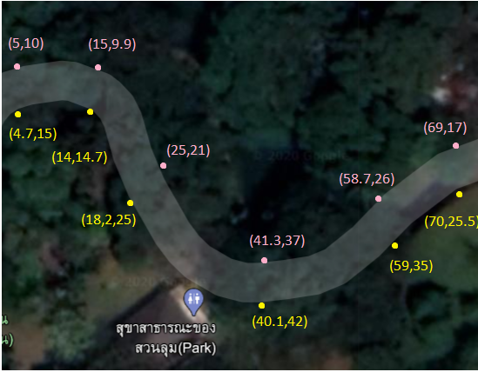

The pink points are a subset of the points that make up one side of the border of a path (**P**), let’s call this collection of points **B1**. The yellow points are a subset of the points that make up the other side of the border of **P,** called **B2**. Answer the following questions in regards to a robot attempting to traverse **P**.

* Group the points in **B1** and **B2** in pairs such that every point in **B1** is paired with exactly one point from **B2 ,** the difference in the x-values of a pair should be smaller than any other combination.

*Ex:*

*((5,10), (4.7,15)) is a pair because 5 - 4.7 is the smallest difference available for the point (5,10)*

* Compute the midpoint for each pair of points. What is the distance from the midpoint with the smallest x value to the midpoint with the largest x value?

|  |  |
| --- | --- |
| 63.21 | 60 |
| 66.11 | 65.24 |
| 70.13 | 64.45 |

* Use the [scipy.stats.linregress](https://docs.scipy.org/doc/scipy-0.14.0/reference/generated/scipy.stats.linregress.html) function to generate a best fitting line for the midpoints. Which of the following is the best fitting line?

|  |  |
| --- | --- |
| y = 0.23x + 15.24 | y = 0.25x + 32.26 |
| y = 0.17x + 32.26 | y = 0.17x + 15.24 |
| y = 0.55x + 21.25 | y = 0.25x + 21.25 |

* Use [matplotlib.pyplot](https://matplotlib.org/tutorials/introductory/pyplot.html#sphx-glr-tutorials-introductory-pyplot-py) to plot the best fitting line and the path formed by the midpoints, paste plot below:
* Generate a Lagrange interpolating polynomial from the midpoints that your robot can use to traverse **P**. Use this polynomial to predict f(x) given x:

[Lagrange interpolating polynomials](https://en.wikipedia.org/wiki/Lagrange_polynomial)

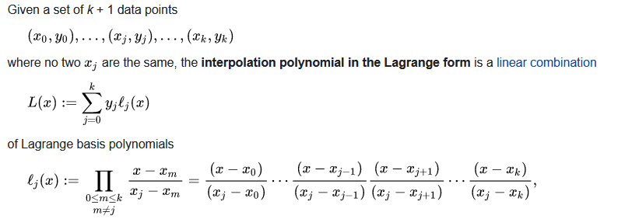

|  |  |
| --- | --- |
| x | f(x) |
| 21.1 |  |
| 44.3 |  |