Name:

ID:

Submit here: <https://docs.google.com/forms/d/e/1FAIpQLSfkdZNI5nBI1Uq8tAYiUKVEG5fHlqiLkCMc6qsT7s9jWKhuag/viewform>

**M5 Challenge 04**

1. The Goldbach conjecture is a famous unsolved problem in mathematics stating that any even integer can be decomposed into the sum of two prime numbers: *n = p + q*, where n is any integer and p and q are both primes. Use Python to find Goldbach decompositions for the following integers:

|  |  |  |
| --- | --- | --- |
| n | p | q |
| 4 | 2 | 2 |
| 18 |  |  |
| 98 |  |  |
| 110 |  |  |
| 556 |  |  |

1. Consider the following:

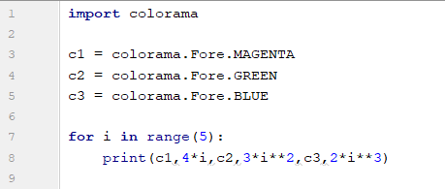

* Which color has the smallest value?

|  |  |
| --- | --- |
| magenta | green |
| blue | navy |
| black | white |

1. What is the sum of the position of “orange” and the position of “cherry”:

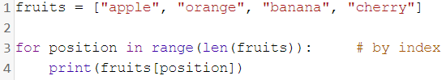

|  |  |
| --- | --- |
| 0 | 1 |
| 3 | 4 |
| 2 | 5 |
| 6 | 7 |