Name:

ID:

Submit here: <https://docs.google.com/forms/d/e/1FAIpQLSdvbqWd17Fs1kKSTPXG8vJo8pZodRt4h8oOj4Tx2vMgv-1Mvw/viewform>

**M5 Challenge 04**

1. Which element is at the 1 position in *blist*:

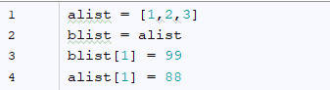

|  |  |
| --- | --- |
| 1 | 2 |
| 3 | 88 |
| 99 | 187 |
| -1 | 0 |

1. The following code generates the famous Collatz sequence. The sequence is started at any integer **n** and continued by dividing **n** by 2 if **n** is even, and multiply **n** by 3 and adding 1 if **n** is odd. A famous unsolved mystery in mathematics is whether or not there exists a value for n where the sequence will not reach 1.

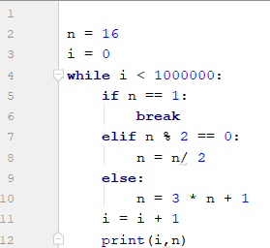

* What is the collatz sequence for n=20?

|  |  |
| --- | --- |
| 1,2,3,4,5,6,7 | 8,4,2,1 |
| 20,60,30,20,15,46,23,70,35,106,53,160,80,40,20,10,5,16,8,4,2,1 | 10,5,16,8,4,2,1 |
| 20,61,30,15,7,3,2,1 | 20,10,5,16,8,4,2,1 |
| 0,1,2,3,4,5,6,7 | 20,10,5,2,1 |

* How long is the collatz sequence for n = 33?

|  |  |
| --- | --- |
| 26 | 33 |
| 25 | 27 |
| 1 | 25 |
| 100 | 6 |

* Which of the following has the longest collatz sequence?

|  |  |
| --- | --- |
| 19 | 20 |
| 21 | 22 |
| 23 | 24 |
| 25 | 26 |
| 27 | 28 |
| 29 | 12 |

1. Evaluate the following:

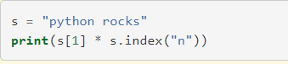

|  |  |
| --- | --- |
| python rocks | python rocks5 |
| p | y5 |
| p5 | yyyyyy |
| ppppp | tttt |
| yyyyy | pythonpythonpythonpythonpython |