Name:

ID:

Submit here: <https://docs.google.com/forms/d/e/1FAIpQLSdNYDOm8ZBoK3Kw88Jkbl16cWULsWYsFRJo42nact1Gj_QtbQ/viewform>

Python editor: <https://repl.it/repls/IrresponsibleWrathfulAddresses>

**M5 Challenge 05A**

1. Consider the following:

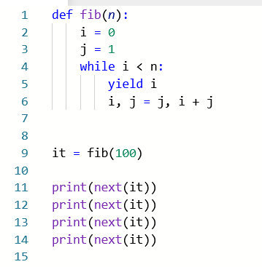

* How many times should I print **next(it)** to get the value 134?

|  |  |
| --- | --- |
| 4 | 12 |
| 16 | 20 |
| 15 | Not possible |

1. Consider the following:

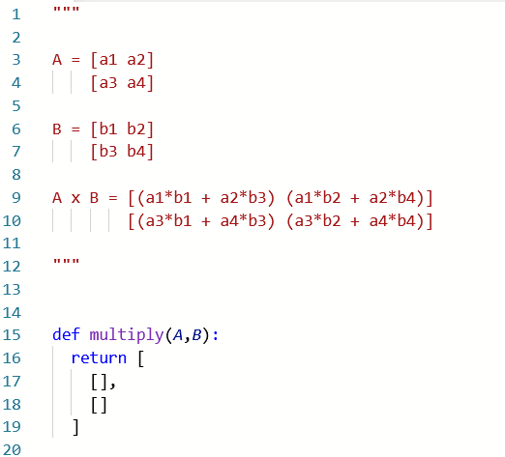

* Lines 1-12 describe how to multiply two 2x2 matrices. Complete the multiply function so that it correctly multiplies two matrices A and B. Matrices will be represented as list with two lists inside: [[],[]]. Paste a screenshot of your code below:
* Complete the following table:

|  |  |  |
| --- | --- | --- |
| A | B | A x B |
| [[1,0],[0,1]] | [[2,3],[4,7]] |  |
| [[45.22,-12.2],[2.71,-1.4]] | [[1.736,1.1229],[4.9,-1.23]] |  |
| [[13,1.2],[12,13 + 2j]] | [[3,0],[1,1]] |  |

The determinant of a 2x2 matrix is computed as follows:

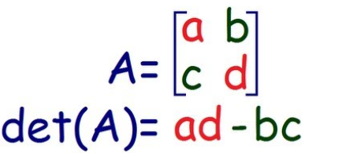

* Find the determinants of the following matrices:

|  |  |
| --- | --- |
| A | det(A) |
| [[45.22,-12.2],[2.71,-1.4]] |  |
| [[1.2233,-2.244555],[2.713456,-1.466]] |  |
| [[1.2233*12,13.65*13],[3.2121**2,-2.88]] |  |