Name:

ID:

Submit here: <https://docs.google.com/forms/d/e/1FAIpQLSdNYDOm8ZBoK3Kw88Jkbl16cWULsWYsFRJo42nact1Gj_QtbQ/viewform>

Python editor: <https://repl.it/repls/IrresponsibleWrathfulAddresses>

**M5 Challenge 05B**

1. Consider the following:

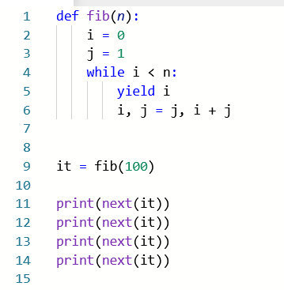

* How many times should I print **next(it)** to get the value 13?

|  |  |
| --- | --- |
| 4 | 7 |
| 6 | 8 |
| 9 | None of the above |

1. Consider the following:

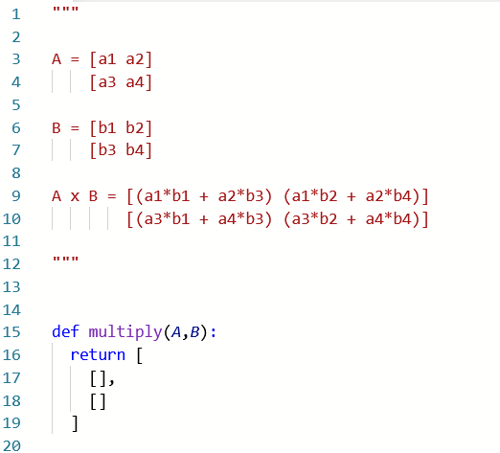

* Lines 1-12 describe how to multiply two 2x2 matrices. Complete the multiply function so that it correctly multiplies two matrices A and B. Matrices will be represented as list with two lists inside: [[],[]]. Paste a screenshot of your code below:
* Complete the following table:

|  |  |  |
| --- | --- | --- |
| A | B | A x B |
| [[1,0],[0,1]] | [[4,4],[4,1]] |  |
| [[5.22,-2.2],[2.1,-0.4]] | [[1.736,1.1229],[4.9,-1.23]] |  |
| [[0.3345,0.1113],[0.15,0.1 + 2j]] | [[0.22,0],[0.1,1]] |  |

The determinant of a 2x2 matrix is computed as follows:

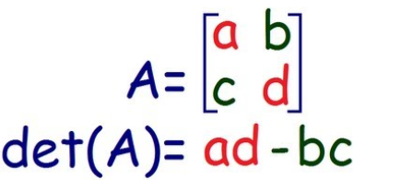

* Find the determinants of the following matrices:

|  |  |
| --- | --- |
| A | det(A) |
| [[16.22,-12.2],[12.71,-10.4]] |  |
| [[1.77,-0.244555],[3.1,-0.466]] |  |
| [[3.14+23,13.15*13],[0.1**2,-0.88]] |  |