Name:

ID:

Submit here: <https://docs.google.com/forms/d/e/1FAIpQLSdNYDOm8ZBoK3Kw88Jkbl16cWULsWYsFRJo42nact1Gj_QtbQ/viewform>

Python editor: <https://repl.it/repls/IrresponsibleWrathfulAddresses>

**M5 Challenge 05B**

1. Consider the following:

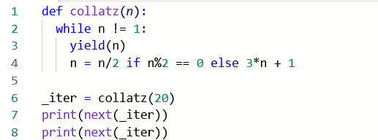

* How many times should I print **next(_iter)** to get the value 8?

|  |  |
| --- | --- |
| 4 | 7 |
| 6 | 11 |
| 9 | 5 |

* Let n = 47. How long is this collatz sequence? (Include n and 1 in the collatz sequence. For example, collatz(20) has a length of 8: 20, 10, 5, 16, 8, 4, 2, 1)

|  |  |
| --- | --- |
| 100 | 98 |
| 105 | 54 |
| 110 | 201 |
| 103 | 199 |

1. Consider the following:

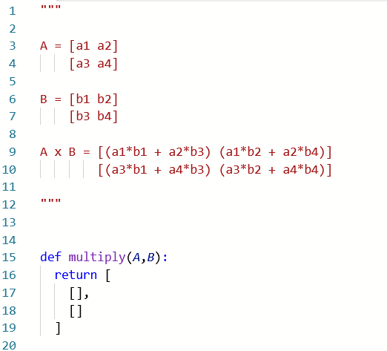

* Lines 1-12 describe how to multiply two 2x2 matrices. Complete the multiply function so that it correctly multiplies two matrices A and B. Matrices will be represented as list with two lists inside: [[],[]]. Paste a screenshot of your code below:
* Complete the following table:

|  |  |  |
| --- | --- | --- |
| A | B | A x B |
| [[1,0],[0,1]] | [[4,4],[4,1]] |  |
| [[5.22,-2.2],[2.1,-0.4]] | [[1.736,1.1229],[4.9,-1.23]] |  |
| [[0.3345,0.1113],[0.15,0.1 + 2j]] | [[0.22,0],[0.1,1]] |  |

1. Consider the following:

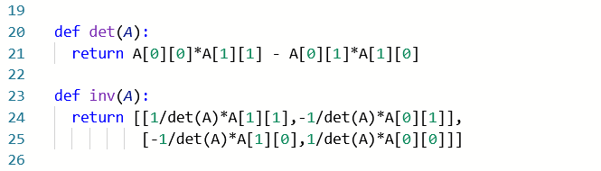

* Give A is a 2x2 matrix represented by a list of two lists. Complete the following table:

|  |  |  |  |
| --- | --- | --- | --- |
| A | det(A) | inv(A) | multiply(A,inv(A)) |
| [[1,2],[1,1]] |  |  |  |
| [[1,2],[0.1,0.5]] |  |  |  |
| [[-1,1],[0.5,2]] |  |  |  |