Name:

ID:

**M6 Assignment C1-06**

*Submit completed assignment here:* <https://docs.google.com/forms/d/e/1FAIpQLSezxUSjYgwQ5vf_xaUzfIJZabx8I1T5H-pKIp7X__dVg0dyIg/viewform>

1. Use HTML, JavaScript and CSS to create the following:



*Hint: create two divs and use the CSS attribute [transform](https://www.w3schools.com/cssref/css3_pr_transform.asp)

1. Use the following JavaScript code to change the background color of the body after 5 seconds:

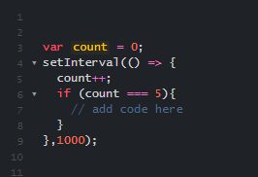

1. Use HTML, JavaScript and CSS to create a timer that counts down from 10 and then changes the font color of an h1 that says “Game Over” from white to red :