Name:

ID:

M63 Assignment 01A

Part 1: Intro to Data Science

<http://runestone.academy/runestone/books/published/httlads/index.html>

1. According to the book, what percentage of data has been created in the last 2 years?
2. How much data does the Library of Congress hold in gigabytes?
3. How many Megabytes are in an Exabyte?
4. According to Eric Haller, data scientists can develop ____ and write ____?
5. According to The Harvard Business Review, big data successfully requires what?
6. How many steps are in the data science pipeline?
7. Data science is a very _____ process?
8. What data set will a machine learning algorithm build a model from?
9. What data set is used during model testing?
10. What is the happiness score for Iceland?

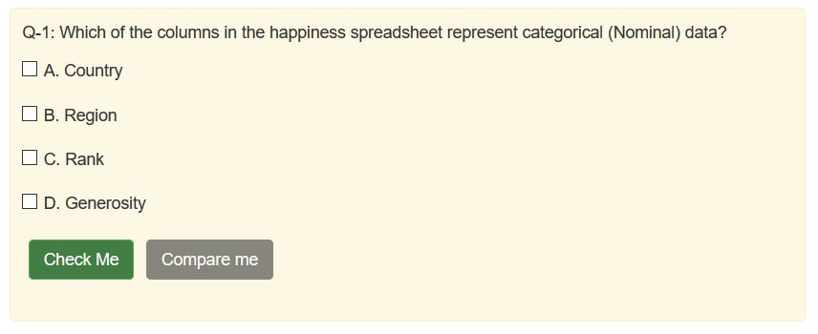

1. What is the median of the following set: {2,16,4,23,17}
2. What is the mode of the following set: {1,1,2,2,3}
3. What is the average happiness score?
4. What is the standard deviation of the happiness score?
5. What is the mean value for life expectance?

Part 2: [The Internet](https://runestone.academy/runestone/books/published/StudentCSP/CSPInternet/toctree.html)

1. Complete the following sentence:

One of the main goals of the Internet is to __________ collaboration

1. Give an example of an ISP from the book?
2. How does the book describe the difference between the internet and networks?
3. Complete the following:

One of the remarkable features of the internet is that the computers connected are _________?

1. Give an example of a protocol from the book?
2. Explain the meaning of autonomous in the following phrase, “Network of Autonomous Systems”:
3. Give an example of a top level domain (TLD) from the book?
4. Complete the following sentence:

Every computer on the internet uses your _______ to name your computer.

1. What is the agreed upon system for converting a domain name to an IP address?
2. Give an example of an IPV4 address and an IPV6 address:
3. What is a packet?
4. What term refers to the amount of time it takes for a message to be sent?
5. What term best refers to the units Mb/s or Gb/s

Part 3: [CS Principles](http://runestone.academy/runestone/static/StudentCSP/index.html)

1. Describe how the following Python code will affect the image (arch.jpg):

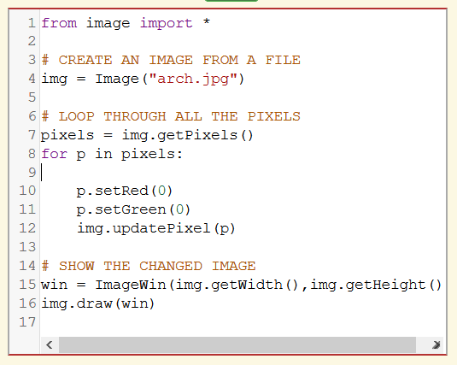

1. Fill in the gap in the following sentence:

A computer does not even have to be _______. Did you know there were ______ computers?

1. What device was defined by Alan Turing?
2. One of the most important things Turing proved was what?
3. What did Turing defend in his argument with Wittgenstein? (See Wikipedia page)
4. Turing was incredibly talented at which sport? (See Wikipedia page)
5. What is the Turing test? (See Wikipedia page)
6. How did Turing die? (See Wikipedia page)
7. Answer the following question:

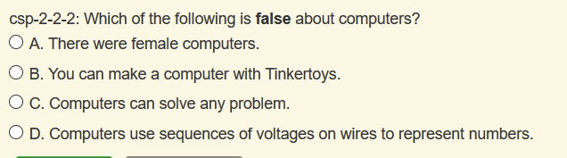

1. List the four fundamental abilities of a computer?