Name:

ID:

M63 Assignment 01B

**Part 1: Web Development**

1. What type of HTML tag is used for holding JavaScript code?

|  |  |
| --- | --- |
| Table | H1 |
| Code | Script |
| Link | a |
| div | style |

1. Consider the following HTML:

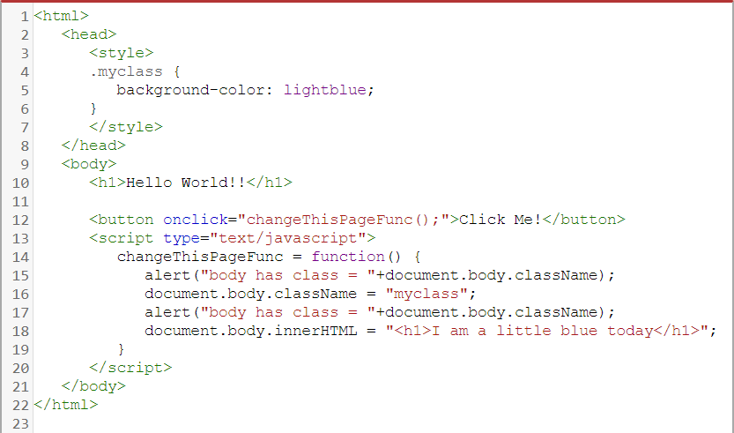

* What HTML element will turn light blue if the button is clicked?

|  |  |
| --- | --- |
| P | Button |
| Style | Head |
| H1 | H2 |
| Div | body |

1. Passwords, Check boxes, and Radios all use what HTML tag? What attribute needs to be specified to determine how it will look?

|  |  |
| --- | --- |
| H1, height | Div, quality |
| Table, border | Ol, padding |
| Form, size | Form, type |
| Input, type | Img, src |
| link, href | Iframe, href |

1. What does the alert box say?

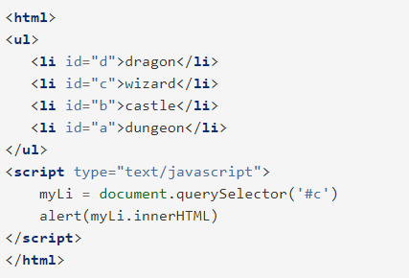

|  |  |
| --- | --- |
| #c | c |
| myLi.innerHTML | dragon |
| dragon wizard castle dungeon | d c b a |
| <li id=”c”>wizard</li> | wizard |

1. Match the following events:
2. Onkeyup
3. Onkeydown
4. Onkeypress

|  |  |
| --- | --- |
| Event | Definition |
|  | User releases a key |
|  | User presses shift + a |
|  | User presses space bar |

1. Consider the following JavaScript:

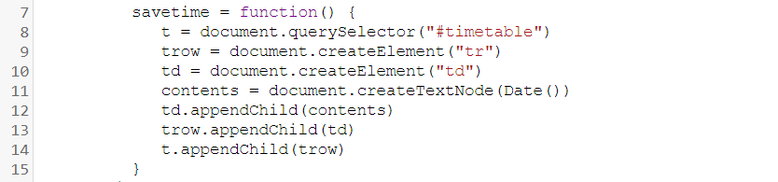

* On what lines are elements added to the DOM tree?

|  |  |
| --- | --- |
| 8,9,10 | 9,10 |
| 9,10,11 | 14 |

1. Consider the following:

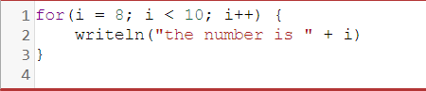

* What is the output?

|  |  |
| --- | --- |
| the number is i  the number is i | the number is 8  the number is 8 |
| the number is 8  the number is 9 | the number is 8  the number is 9  the number is 10 |

1. Consider the following:

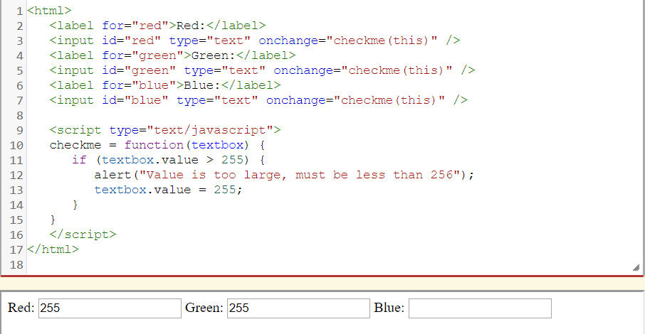

* What will happen if I enter the value 415 in the Blue text input?

|  |  |
| --- | --- |
| The background will turn blue | The background will turn black |
| The background will turn white | The blue input value will be 415 |
| The blue input value will be 255 | Nothing |

**Part 2: Design**

Use the following svg editor to complete the following: <https://www.drawsvg.org/drawsvg.html>

1. Create a logo for a Muay Thai boxing gym called “Bloody Elbow Muay Thai”, paste a screen shot below:
2. Create an Image for the homepage of a bank’s website, paste a screenshot below: