Name:

ID:

**M6 Assignment C1-07**

*Submit completed assignment here:* [*https://docs.google.com/forms/d/e/1FAIpQLScaT2_VoNpy5KxlwAKtQiJkKQRGyN-Ycn-4NC_D-5mvXSFXSA/viewform*](https://docs.google.com/forms/d/e/1FAIpQLScaT2_VoNpy5KxlwAKtQiJkKQRGyN-Ycn-4NC_D-5mvXSFXSA/viewform)

*Part 1:* [*CSS*](https://www.w3schools.com/cssref/default.asp)

1. The css selector **p,div.a** selects which of the following HTML elements?

|  |  |
| --- | --- |
| All **p, div, a** elements | An **p** element with **a** and **div** children |
| An **a** element with **p** and **div** parents | An **a** element with **p** and **div** parents |
| An **a** element with **p** and **div** siblings | All **p** elements and **div** elements with a class=”a” |

1. The css selector **button:hover** will do what?

|  |  |
| --- | --- |
| Style all elements with the class=”button:hover” | Style all button elements when they are hovered |
| Style all elements with the id=”button:hover” | Style all elements with the class button when they are hovered |
| Style all elements with the tag=”button:hover” | Style all elements with the id button when they are hovered |

*Part 2:*

1. The following code will change the background color of the body to whatever the user enters into the text input:

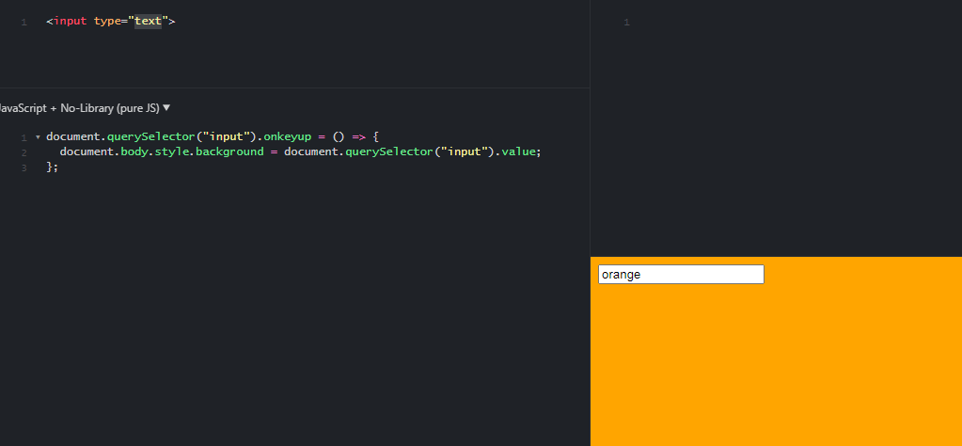

* Change the code so that the font color of an h1 element is changed instead