Name:

ID:

**M6 Assignment C1-08**

*Submit completed assignment here:* [*https://docs.google.com/forms/d/e/1FAIpQLScXf8dyaV413L5Z8SQV9FZY0N64tbMF_nzCIt-gT6WEdBSPMw/viewform*](https://docs.google.com/forms/d/e/1FAIpQLScXf8dyaV413L5Z8SQV9FZY0N64tbMF_nzCIt-gT6WEdBSPMw/viewform)

***Part 1:*** [***Thailand’s Computer Crime Act***](https://www.samuiforsale.com/law-texts/computer-crime-act.html#:~:text=is%20an%20act%20that%20is,to%20fifteen%20years%20and%20a)

1. **While flying to Phuket you and your friend think it will be funny to post online that there is a bomb on the plane. One of the other passengers sees the post online and tells everyone. Somebody jumps out of the plane and dies. Which of the following sections of the Computer Crime Act best describes your punishment?**

|  |  |
| --- | --- |
| **Section 10** | **Section 12** |
| **Section 11** | **Section 14** |
| **Section 8** | **Section 9** |

1. **You decide to get revenge on a guy that you hate at school by editing a picture of him and his mom. You edit the photo so that it looks like he is grabbing his mom inappropriately and post it online. Which of the following sections of the Computer Crime Act best describes your punishment?**

|  |  |
| --- | --- |
| **Section 10** | **Section 17** |
| **Section 11** | **Section 16** |
| **Section 5** | **Section 6** |

1. **You see the teacher’s mobile phone left out on a desk. You try a random pass code and the phone unlocks. You decide to look through the photos. Which of the following sections of the Computer Crime Act best describes your punishment?**

|  |  |
| --- | --- |
| **Section 10** | **Section 17** |
| **Section 11** | **Section 16** |
| **Section 5** | **Section 6** |

***Part 2: Identifying bad arguments online***

Use the following website to review common logical fallacies: <https://yourlogicalfallacyis.com/>

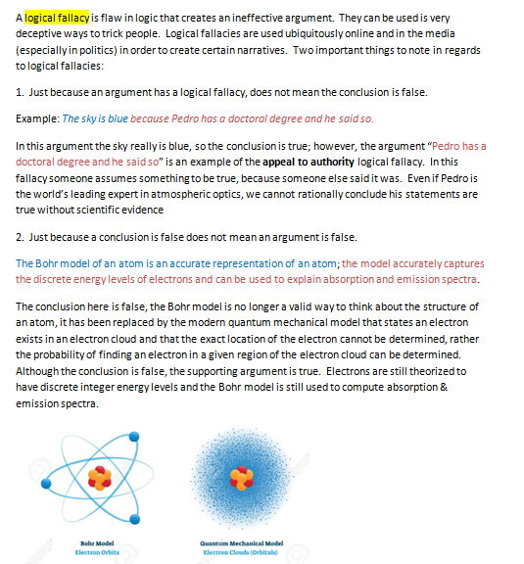

4. Identify the logical fallacy in the argument: “If we require special bathrooms for transgender, then special bathrooms for two-spirit and non-binary genders will be created, then bathrooms for squirrels and other animals will also need to be created!”

|  |  |
| --- | --- |
| Bandwagon | Slippery slope |
| Gambler’s fallacy | Appeal to emotion |
| False cause | Strawman |
| Ad hominen | Genetic |

5. Identify the logical fallacy in the argument: “Why would you take Hydroxychloroquine to cure COVID-19, Donald Trump is taking it, so it must be bad.”

|  |  |
| --- | --- |
| Bandwagon | Slippery slope |
| Gambler’s fallacy | Appeal to emotion |
| False cause | Strawman |
| Ad hominen | Genetic |

6. Identify the logical fallacy in the argument:

LeBron James claiming there is racial injustice in America spoke of reading about a black man who was trying to buy a bicycle for his son but had police called on him, “It's just heartbreaking. You guys don't understand," James said. "Unless you're a person of color, you guys don't understand. I understand you might feel for us. But you will never truly understand what it is to be black in America.”

|  |  |
| --- | --- |
| Bandwagon | Appeal to Nature |
| Gambler’s fallacy | Special Pleading |
| Texas Sharpshooter | Strawman |
| Ad hominen | Anecdotal |

7. Identify the logical fallacy in the argument: “I pay taxes in Thailand, so I am entitled to pay the same rate as Thai citizens at national parks.”

|  |  |
| --- | --- |
| False Equivalence | Tu Quoque |
| Gambler’s fallacy | Appeal to emotion |
| False cause | Strawman |
| Ad hominen | No True Scotsman |