Name:

ID:

M6 Warmup 01

Submit here: <https://docs.google.com/forms/d/e/1FAIpQLSewrkSNAqdeG7AOM3o-uWl8Y9pfIMkjTw-KhRMcEAvySih7jw/viewform>

JSFiddle: <https://jsfiddle.net/>

Book: [JavaScript](http://runestone.academy/runestone/books/published/webfundamentals/Javascript/toctree.html)

1. Consider the following HTML:

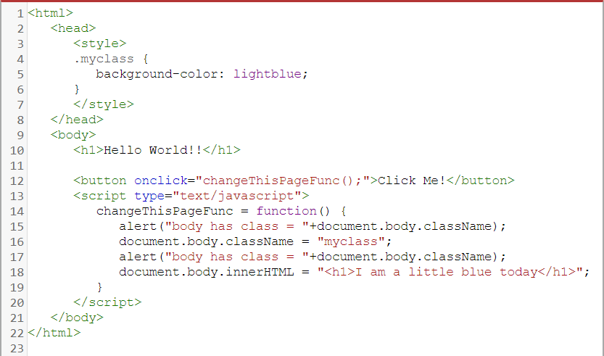

* What HTML element will turn light blue if the button is clicked?
* Make the background-color pink.

1. Consider the following HTML:

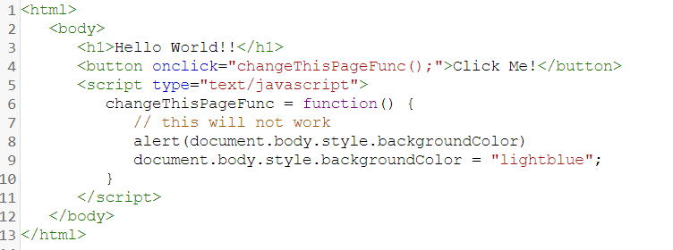

* On what line is the background color of the h1 changed?
* On what line is the background color of the h1 output in a popup window?
* What does the alert() function do in JavaScript?

1. Consider the following JavaScript:

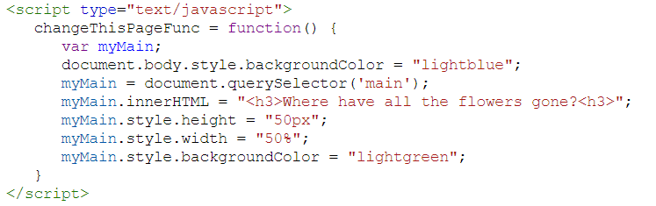

* What is the name of the variable?
* What does .innerHTML do?
* In the code, which lines change the size of the element “main”?

1. Consider the following:

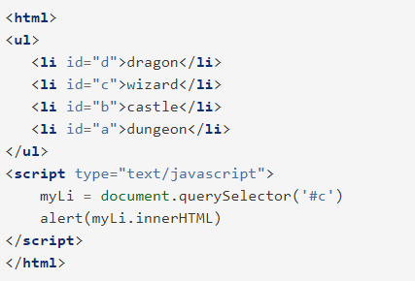

* What does the alert box say?
* How can you make the alert box say dungeon?