**Python**

*Heatmap*

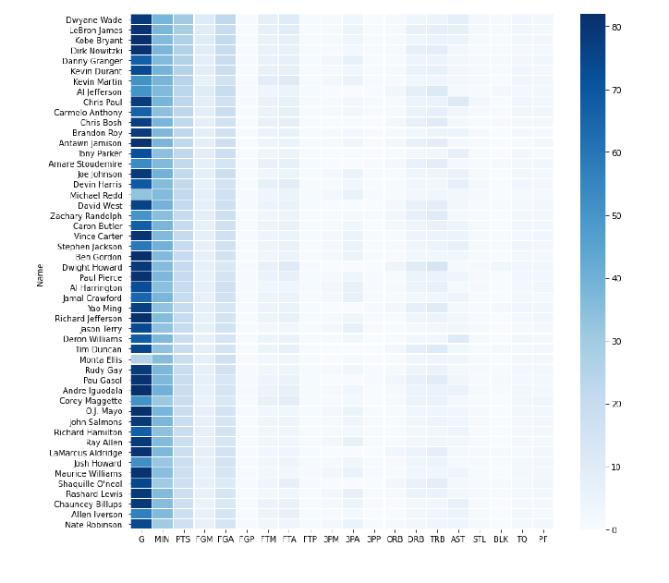

*Contour*

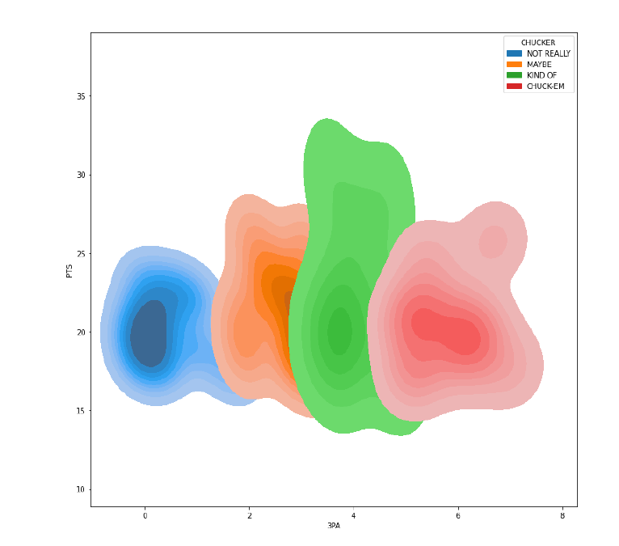

*Spatial*

For some reason, I could NOT get the points to show up on the map. I believe the code is correct, not sure what I am missing.

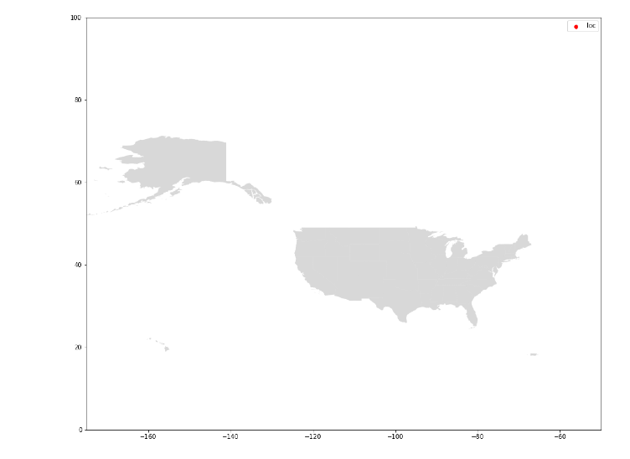

**R**

*Heatmap*

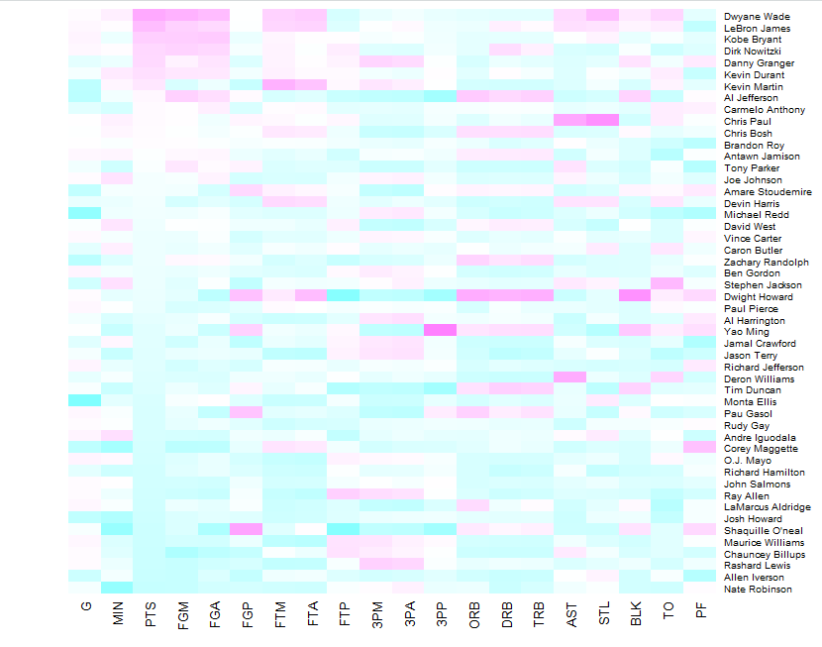

*Countour*

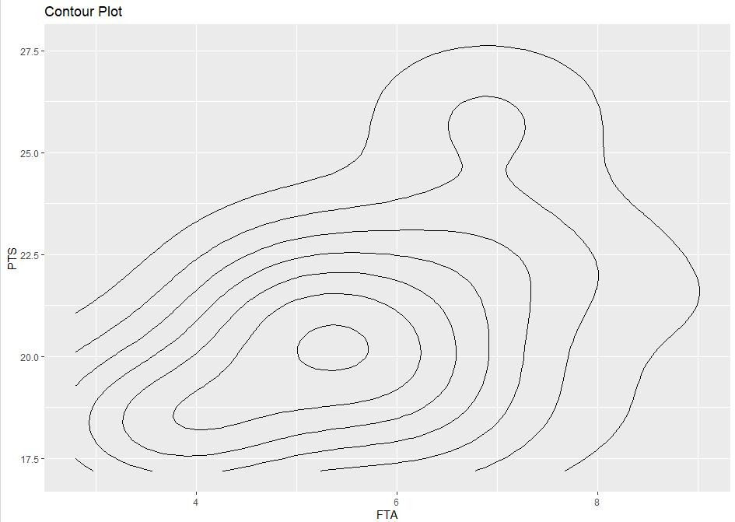

*Spatial*

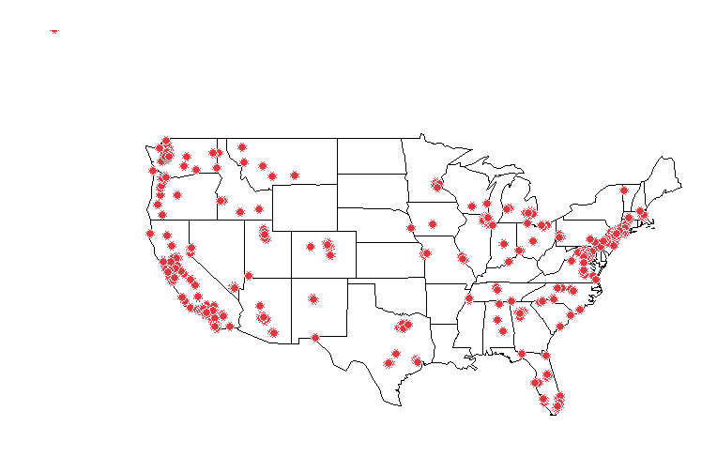

**Power BI (and Excel)**

*Heatmap*

**

*Spatial*

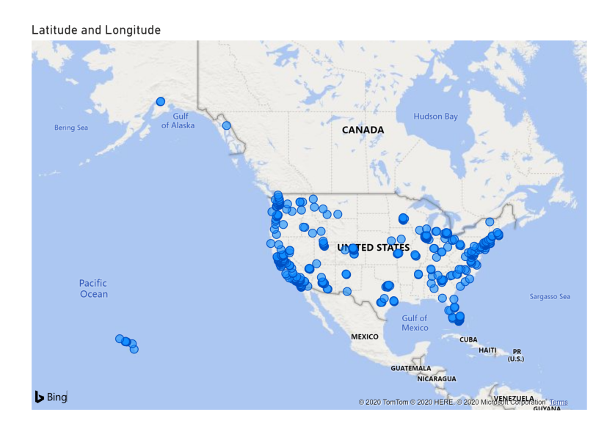

*Contour (from Excel)*