Overview

As most new AirBnb landlords will tell you, there’s a lot of stuff you can buy to try to spruce up your property and almost as many [YouTube personalities](https://www.youtube.com/watch?v=WwsMIChMDfE), [news articles](https://qz.com/810309/you-can-earn-10-more-per-night-on-airbnb-just-by-having-a-hair-dryer/) and [blogs](https://optimizemybnb.com/improve-airbnb-amenities/) telling you to do the same. Even AirBnb has released [analysis](https://www.airbnb.com/resources/hosting-homes/a/the-best-amenities-to-offer-right-now-203) (although no data) to try to help guide landlords trying to decide how or whether to improve their listings.

Motivated by my own frustration with trying to guess what amenities are worth getting, I’m going to try to walk you through some of the factors you might want to consider when preparing your listing for rental. There’ll be fancy data science predictions at the end, but I recommend reading the middle stuff since it’s pretty useful even if slightly more pedestrian.

# Caveats

*Dataset sourced from Mashvisor via RapidAPI.* *This project only contains data on listings for properties rented in their entirety in the Philadelphia marketplace. It does not contain listings for individual rooms or shared rooms.*

# EDA

The dataset began with 1497 observations of 283 features, many of which were irrelevant to the project or redundant.

## [1] "Column Names"

## [1] "X24.hour.check.in"   
## [2] "Accessible.height.bed"   
## [3] "Accessible.height.toilet"   
## [4] "Air.conditioning"   
## [5] "Amazon.Echo"   
## [6] "BBQ.grill"   
## [7] "Baby.bath"   
## [8] "Baby.monitor"   
## [9] "Babysitter.recommendations"   
## [10] "Baking.sheet"   
## [11] "Balcony"   
## [12] "Barbecue.utensils"   
## [13] "Bath.towel"   
## [14] "Bathroom.essentials"   
## [15] "Bathtub"   
## [16] "Beach.essentials"   
## [17] "Bed.linens"   
## [18] "Bedroom.comforts"   
## [19] "Body.soap"   
## [20] "Bread.maker"   
## [21] "Breakfast"   
## [22] "Breakfast.table"   
## [23] "Building.staff"   
## [24] "Buzzer.wireless.intercom"   
## [25] "Cable.TV"   
## [26] "Carbon.monoxide.alarm"   
## [27] "Carbon.monoxide.detector"   
## [28] "Cat.s."   
## [29] "Ceiling.fan"   
## [30] "Central.air.conditioning"   
## [31] "Changing.table"   
## [32] "Childrenâ..s.books.and.toys"   
## [33] "Childrenâ..s.dinnerware"   
## [34] "Cleaning.before.checkout"   
## [35] "Coffee.maker"   
## [36] "Conditioner"   
## [37] "Convection.oven"   
## [38] "Cooking.basics"   
## [39] "Crib"   
## [40] "DVD.player"   
## [41] "Day.bed"   
## [42] "Disabled.parking.spot"   
## [43] "Dishes.and.silverware"   
## [44] "Dishwasher"   
## [45] "Dog.s."   
## [46] "Dryer"   
## [47] "EV.charger"   
## [48] "Elevator"   
## [49] "En.suite.bathroom"   
## [50] "Espresso.machine"   
## [51] "Essentials"   
## [52] "Ethernet.connection"   
## [53] "Extra.pillows.and.blankets"   
## [54] "Extra.space.around.bed"   
## [55] "Family.kid.friendly"   
## [56] "Fire.extinguisher"   
## [57] "Fire.pit"   
## [58] "Fireplace.guards"   
## [59] "Firm.mattress"   
## [60] "First.aid.kit"   
## [61] "Fixed.grab.bars.for.shower"   
## [62] "Flat.path.to.guest.entrance"   
## [63] "Formal.dining.area"   
## [64] "Free.parking.on.premises"   
## [65] "Free.street.parking"   
## [66] "Freezer"   
## [67] "Full.kitchen"   
## [68] "Game.console"   
## [69] "Garden.or.backyard"   
## [70] "Gas.oven"   
## [71] "Gym"   
## [72] "HBO.GO"   
## [73] "Hair.dryer"   
## [74] "Hand.Sanitiser"   
## [75] "Handheld.shower.head"   
## [76] "Hangers"   
## [77] "Heat.lamps"   
## [78] "Heated.floors"   
## [79] "Heating"   
## [80] "High.chair"   
## [81] "Host.greets.you"   
## [82] "Hot.tub"   
## [83] "Hot.water"   
## [84] "Hot.water.kettle"   
## [85] "Indoor.fireplace"   
## [86] "Internet"   
## [87] "Iron"   
## [88] "Jetted.tub"   
## [89] "Keurig.coffee.machine"   
## [90] "Keypad"   
## [91] "Kitchen"   
## [92] "Kitchenette"   
## [93] "Laptop.friendly.workspace"   
## [94] "Laundromat.nearby"   
## [95] "Lock.on.bedroom.door"   
## [96] "Lockbox"   
## [97] "Long.term.stays.allowed"   
## [98] "Luggage.dropoff.allowed"   
## [99] "Memory.foam.mattress"   
## [100] "Microwave"   
## [101] "Mini.fridge"   
## [102] "Mudroom"   
## [103] "Murphy.bed"   
## [104] "Nespresso.machine"   
## [105] "Netflix"   
## [106] "No.stairs.or.steps.to.enter"   
## [107] "Other"   
## [108] "Other.pet.s."   
## [109] "Outdoor.parking"   
## [110] "Outdoor.seating"   
## [111] "Outlet.covers"   
## [112] "Oven"   
## [113] "Pack.â..n.Play.travel.crib"   
## [114] "Paid.parking.off.premises"   
## [115] "Paid.parking.on.premises"   
## [116] "Patio.or.balcony"   
## [117] "Pets.allowed"   
## [118] "Pets.live.on.this.property"   
## [119] "Piano"   
## [120] "Pillow.top.mattress"   
## [121] "Playground"   
## [122] "Pocket.wifi"   
## [123] "Pool"   
## [124] "Portable.fans"   
## [125] "Pour.Over.Coffee"   
## [126] "Printer"   
## [127] "Private.entrance"   
## [128] "Private.living.room"   
## [129] "Rain.shower"   
## [130] "Record.player"   
## [131] "Refrigerator"   
## [132] "Rice.Maker"   
## [133] "Roll.in.shower"   
## [134] "Room.darkening.shades"   
## [135] "Safety.card"   
## [136] "Self.check.in"   
## [137] "Shampoo"   
## [138] "Shower.gel"   
## [139] "Single.level.home"   
## [140] "Smart.TV"   
## [141] "Smart.lock"   
## [142] "Smoke.alarm"   
## [143] "Smoke.detector"   
## [144] "Smoking.allowed"   
## [145] "Soaking.tub"   
## [146] "Sound.system"   
## [147] "Stair.gates"   
## [148] "Stove"   
## [149] "Suitable.for.events"   
## [150] "TV"   
## [151] "Table.corner.guards"   
## [152] "Terrace"   
## [153] "Toilet.paper"   
## [154] "Trash.can"   
## [155] "Trash.compacter"   
## [156] "Walk.in.shower"   
## [157] "Washer"   
## [158] "Waterfront"   
## [159] "Well.lit.path.to.entrance"   
## [160] "Wheelchair.accessible"   
## [161] "Wide.clearance.to.shower"   
## [162] "Wide.doorway.to.guest.bathroom"   
## [163] "Wide.entrance"   
## [164] "Wide.entrance.for.guests"   
## [165] "Wide.entryway"   
## [166] "Wide.hallways"   
## [167] "Wifi"   
## [168] "Window.guards"   
## [169] "toilet"   
## [170] "translation.missing..en.hosting_amenity_49"  
## [171] "translation.missing..en.hosting_amenity_50"

Price, rental income, and occupancy all appear to be normally distributed, with obvious outliers. AirBnb is a roomsharing platform for landowners so it may be reasonable to attribute the frequency of occupancy rates between 0 and 25% to owners who don’t rent out their properties full-time. Median rental income for a Philadelphia Airbnb over this period was $1610, occupancy was 52%, and price was $104. By comparison, rentcafe.com suggests that mean rent for a single bedroom apartment in Philadelphia is $1660/month. 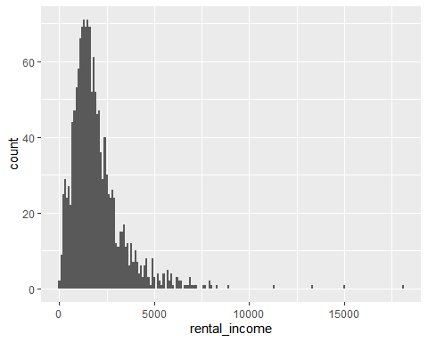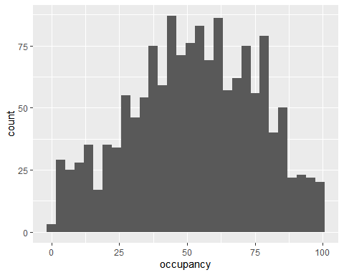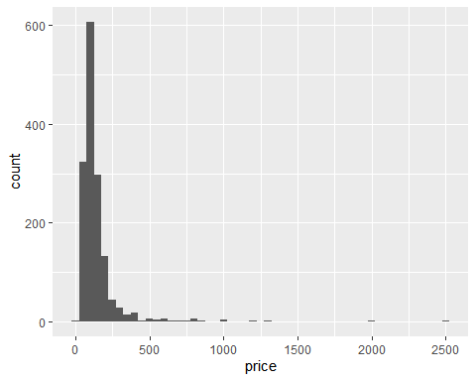

The number of properties managed by a host appeared to significantly vary with rental income, although the effect isn’t strictly linear. Property count doesn’t correlate substantially with any other numerical variable in the dataset and it’s introduction appears to dramatically reduce overfit in linear modeling.

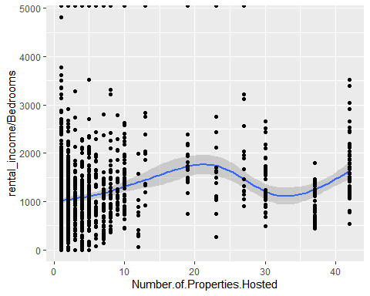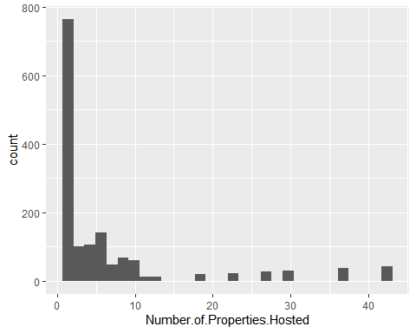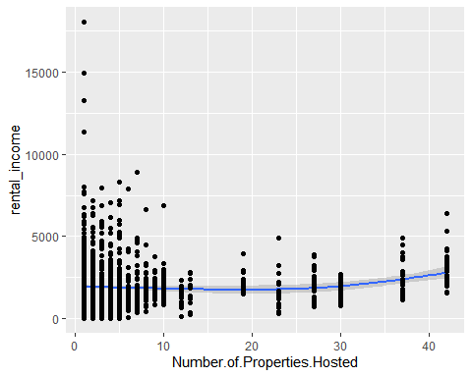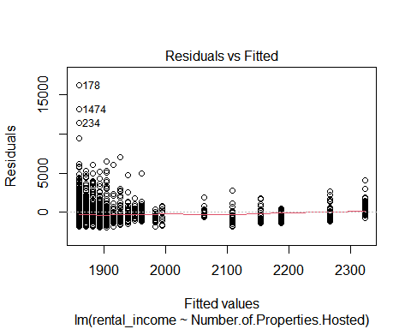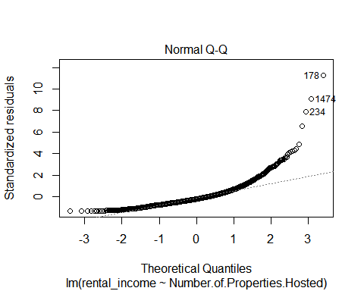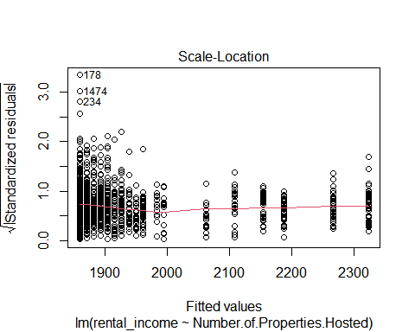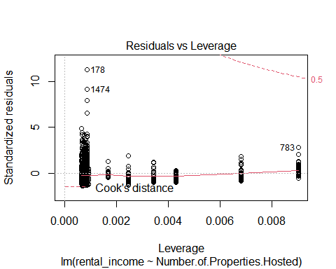

## Number.of.Properties.Hosted  
## Nightly.Price -0.048643153  
## Bedrooms -0.046185102  
## Beds -0.030563491  
## Bathrooms 0.038280305  
## Minimum.Nights -0.074077580  
## Maximum.Guest.Capacity 0.012680994  
## Review.Count -0.085495951  
## Picture.Count 0.065708884  
## Check.In.Time 0.283666779  
## Check.Out.Time -0.139435293  
## Guests.Included -0.102179007  
## Security.Deposit 0.002193177  
## Star.Rating -0.180870692  
## Price.per.Extra.Guest -0.132173845  
## Cleaning.Fee 0.019116066  
## Weekend.Nightly.Price 0.045531065  
## Monthly.Price.Factor 0.040262290  
## Weekly.Price.Factor 0.017504317  
## occupancy 0.081395127  
## rental_income 0.078251604  
## X24.hour.check.in 0.085291998  
## Accessible.height.bed -0.003094418  
## Accessible.height.toilet -0.002363208  
## Air.conditioning 0.050164239  
## BBQ.grill -0.092870147  
## Baby.bath -0.053007951  
## Baby.monitor -0.016430584  
## Babysitter.recommendations -0.071937868  
## Baking.sheet -0.121827709  
## Barbecue.utensils -0.072900417  
## Bath.towel -0.033466235  
## Bathroom.essentials -0.029452975  
## Bathtub 0.126235832  
## Beach.essentials 0.002126168  
## Bed.linens 0.189771699  
## Bedroom.comforts -0.029452975  
## Body.soap -0.070033387  
## Bread.maker -0.035707959  
## Breakfast -0.127922336  
## Breakfast.table -0.025702909  
## Building.staff -0.010453725  
## Buzzer.wireless.intercom -0.056546493  
## Cable.TV -0.102105109  
## Carbon.monoxide.alarm 0.082661396  
## Carbon.monoxide.detector -0.045920766  
## Cat.s. -0.061573420  
## Ceiling.fan -0.070399281  
## Central.air.conditioning -0.024835590  
## Changing.table -0.063199318  
## Childrenâ..s.books.and.toys -0.084653750  
## Childrenâ..s.dinnerware -0.049320489  
## Cleaning.before.checkout -0.098661279  
## Coffee.maker 0.097485367  
## Conditioner -0.062860748  
## Convection.oven -0.012957269  
## Cooking.basics 0.084468912  
## Crib -0.050182205  
## DVD.player -0.011067844  
## Disabled.parking.spot 0.289650063  
## Dishes.and.silverware 0.060904527  
## Dishwasher 0.181986982  
## Dog.s. -0.069846704  
## Dryer 0.169230896  
## EV.charger 0.101672815  
## Elevator 0.373255376  
## En.suite.bathroom -0.022978960  
## Essentials 0.046558593  
## Ethernet.connection -0.113949326  
## Extra.pillows.and.blankets -0.154911518  
## Extra.space.around.bed 0.003990097  
## Family.kid.friendly -0.142989524  
## Fire.extinguisher 0.030990573  
## Fireplace.guards -0.045440357  
## First.aid.kit -0.019440988  
## Flat.path.to.guest.entrance -0.015567326  
## Formal.dining.area -0.019907906  
## Free.parking.on.premises -0.153570716  
## Free.street.parking -0.344509286  
## Freezer -0.075569927  
## Full.kitchen -0.040840319  
## Game.console -0.033454720  
## Garden.or.backyard -0.182233798  
## Gas.oven -0.031956515  
## Gym 0.323187065  
## HBO.GO -0.024534984  
## Hair.dryer 0.139739114  
## Hangers 0.055738445  
## Heating 0.031956515  
## High.chair -0.058279114  
## Host.greets.you -0.067536414  
## Hot.tub -0.052107926  
## Hot.water 0.003548478  
## Hot.water.kettle -0.035932386  
## Indoor.fireplace -0.081774907  
## Internet 0.077933324  
## Iron 0.131516657  
## Keurig.coffee.machine -0.035867438  
## Keypad 0.030210782  
## Kitchen 0.024509422  
## Kitchenette -0.022978960  
## Laptop.friendly.workspace 0.002101110  
## Laundromat.nearby -0.069953658  
## Lock.on.bedroom.door -0.256927715  
## Lockbox -0.149959205  
## Long.term.stays.allowed 0.158520001  
## Luggage.dropoff.allowed -0.224675216  
## Memory.foam.mattress -0.018422030  
## Microwave 0.038848694  
## Mini.fridge -0.032578900  
## Netflix -0.031302678  
## No.stairs.or.steps.to.enter -0.040378460  
## Outdoor.seating -0.020254476  
## Outlet.covers -0.050674319  
## Oven 0.075938302  
## Pack.â..n.Play.travel.crib -0.033087808  
## Paid.parking.off.premises 0.106942086  
## Paid.parking.on.premises -0.008108075  
## Patio.or.balcony -0.153874275  
## Pets.allowed -0.008990106  
## Pets.live.on.this.property -0.083305269  
## Pocket.wifi -0.049901007  
## Pool 0.039529978  
## Portable.fans -0.052029117  
## Pour.Over.Coffee -0.038578931  
## Private.entrance -0.256526995  
## Private.living.room 0.090187519  
## Rain.shower -0.011067844  
## Refrigerator 0.073440686  
## Rice.Maker -0.022713782  
## Room.darkening.shades 0.108946937  
## Safety.card -0.027508749  
## Self.check.in 0.049113803  
## Shampoo 0.123946343  
## Shower.gel 0.039395298  
## Single.level.home 0.098369742  
## Smart.TV -0.026133053  
## Smart.lock 0.232784729  
## Smoke.alarm 0.068942876  
## Smoke.detector -0.048884724  
## Smoking.allowed -0.049943540  
## Soaking.tub -0.012957269  
## Sound.system -0.035707959  
## Stair.gates -0.040493121  
## Stove 0.112416726  
## Suitable.for.events -0.080290256  
## TV 0.115498581  
## Table.corner.guards -0.028365916  
## Toilet.paper -0.033466235  
## Trash.can 0.040056751  
## Walk.in.shower -0.011449896  
## Washer 0.164498492  
## Waterfront 0.009066195  
## Well.lit.path.to.entrance 0.145801836  
## Wheelchair.accessible -0.040688452  
## Wide.clearance.to.shower -0.021916904  
## Wide.entrance -0.016430584  
## Wide.entrance.for.guests -0.044957924  
## Wide.hallways -0.047739153  
## Wifi 0.003388764  
## Window.guards 0.211405612  
## toilet -0.021916904  
## Number.of.Properties.Hosted 1.000000000

Unsurprisingly, larger properties appear to earn more, although it’s important to remember that more income != more profit.

# Rooms and Rental Income

## # A tibble: 10 x 3  
## bedrooms Median_income Standard_Dev  
## <dbl> <dbl> <dbl>  
## 1 0 NA NA   
## 2 1 NA NA   
## 3 2 NA NA   
## 4 3 NA NA   
## 5 4 3462. 1814.  
## 6 5 4412. 3923.  
## 7 6 4924 4071.  
## 8 8 7145 NA   
## 9 9 4602 NA   
## 10 NA 1173 NA

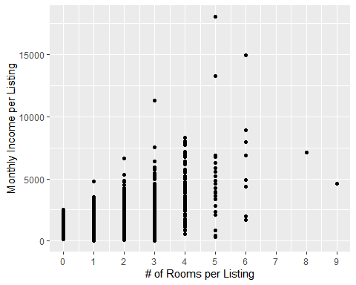

# Neighborhood and Rental Income

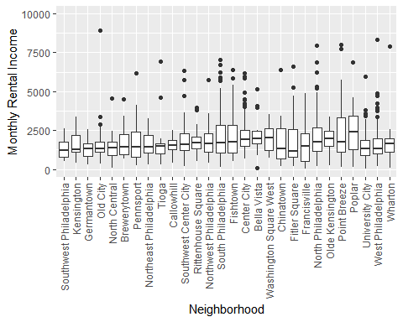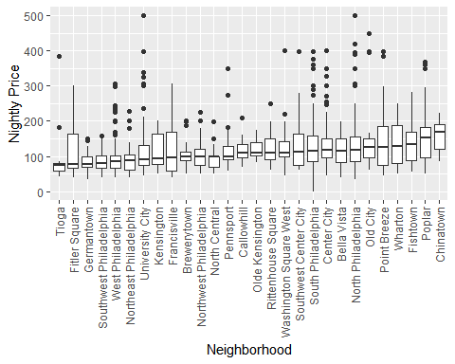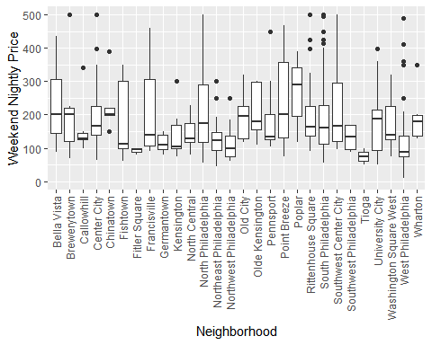

Interestingly, even though the dataset included rentals from before and after the initiation of the COVID19 quarantine in Philadelphia, listing created shortly before the quarantine didn’t seem to perform much worse than listings created after the quarantine 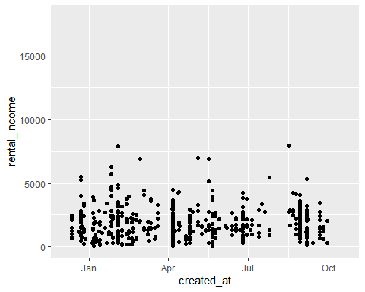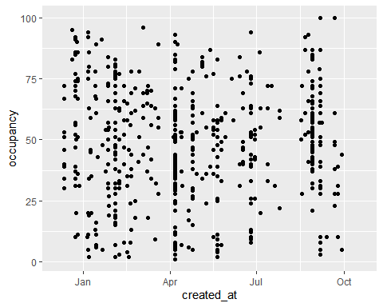

Some amenities are a lot more common than others. As you can see below, while a few amenities were present in almost every property, most amenities were listed in less than 25% of listings and no small number were available in less than 5% of listings. 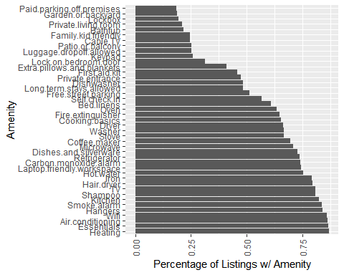

This is a major consideration and something you should consider independent of income predictions - if an amenity is particularly rare or exceedingly common then chances are the my modeling isn’t as accurate as I’d like and you’d be skip the fancy data voodoo and simply ask yourself how much more you’d pay to stay in a listing with the item you’re thinking about getting. If you wouldn’t pay an extra $20 a night to stay in a listing with a hot tub, then maybe shelling out $5k for one isn’t a great investment. Conversely, if you’ve met a lot of pruny-feet enthusiasts who decry the paucity of suitable listings in Philly, you might be on to something. 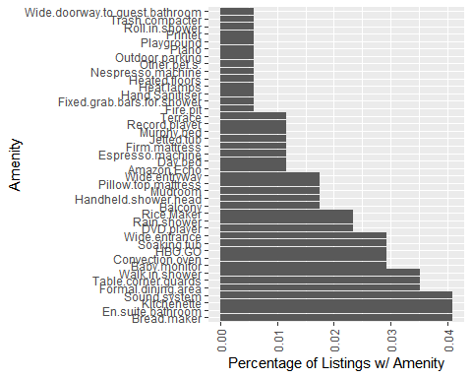

After variance drops I evaluated the number of amenities offered per listing, below.

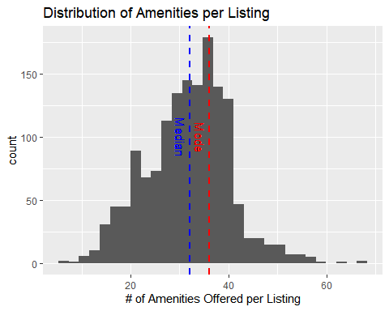

There seems to be a positive relationship between the number of amenities a listing offers and number of rooms (bathrooms plus bedrooms) per listing or the price of the listing, respectively.

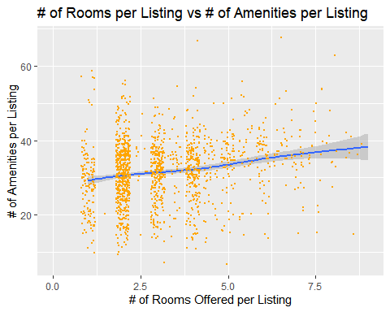

And, in general, properties that have more amenities appear to charge slightly more.

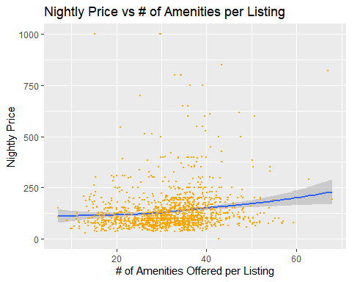 However, when related to rental income or occupancy, the number of amenities seems to be positively related only within specific tolerances. This may suggest that above a certain threshold, more amenities only overwhelm potential travelers, or, below a certain threshold, communicate disinterest on the part of the host, although limited data at particularly high or low counts creates substantial uncertainty. Of note, adding amenity count to penalized linear modeling appeared to greatly increase overfitting.

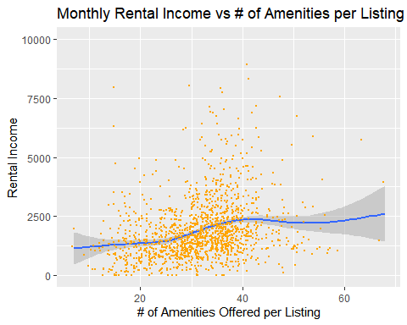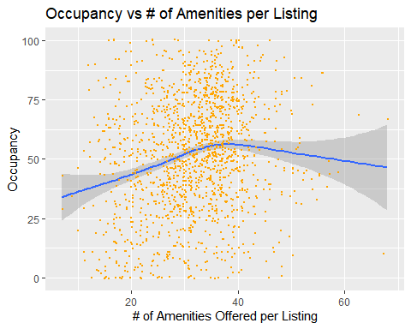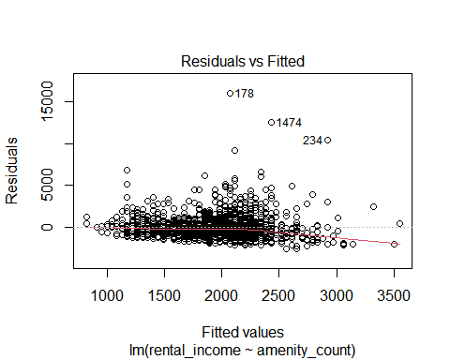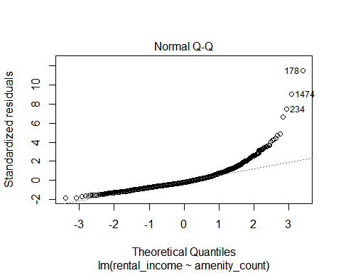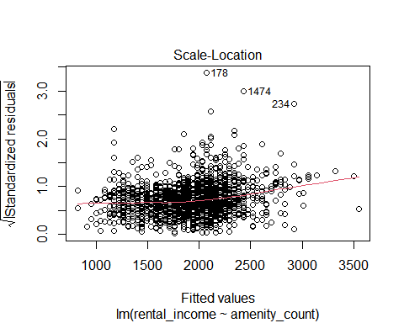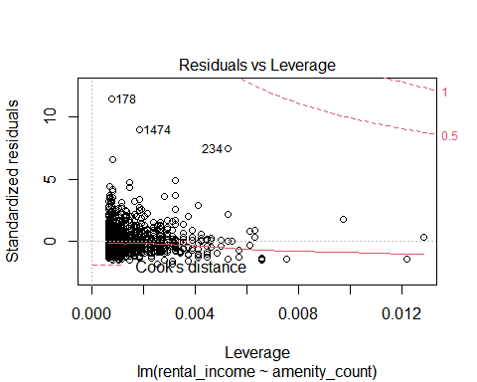

# Multicolinearity

One issue I dealt with working with this data set was the sheer number of variables, which you can get a sense of from the corrplot below. 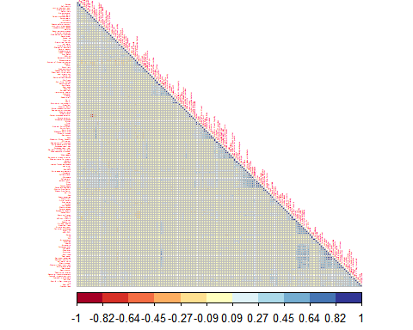

Even when we examine amenities only and drop variables with a near-zero variance, we still have a lot of variables to work with. However, we can begin to get the sense of some clusters of related variables within the dataset. 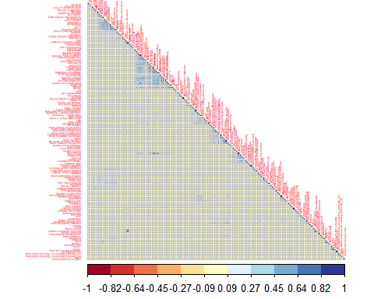

We see a fairly high correlation between certain categories of children’s amenities (Baby baths with changing tables, for example), but not necessarily others (see changing tables and bathtubs), suggesting that owners may view some mixes of amenities as redundant.

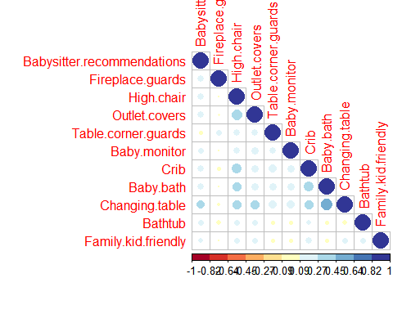

We also see correlations between access-related amenities that correspond to different locations within the listing, suggesting some possible redundancy in listings or that landlords are willing to make their properties more accessible when possible, but possibly unwilling or unable to ensure complete accessibility in many instances. 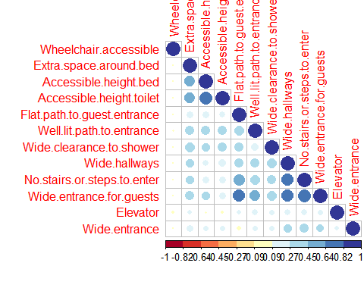

Not a lot of relationships here. Everything presumed incidental.

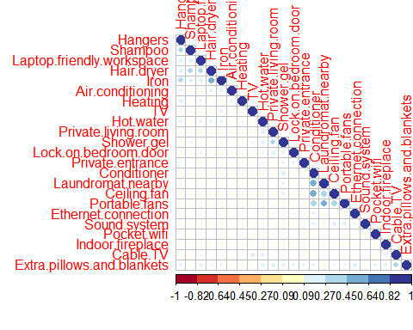

Lots of obvious relationships in the kitchen - listings with ovens tend to have stoves, cooking basics, microwaves, and refrigerators and there’s a strong relationship between microwave and coffee machines. Interestingly, there isn’t much of a relationship between listings that offer a Keurig or pour-over coffee and more complete kitchen amenities, suggesting that these may be more frequently offered in listings that offer a small coffee/snack station but not a full-service kitchen, or, alternatively, that owners aren’t very specific about the kinds of coffee in their listings.

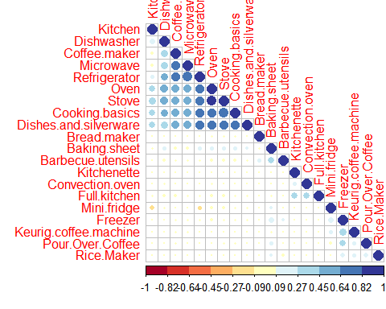

Amenities “Full Kitchen” and “Kitchenette” only apear on listings that also have “Kitchen”, suggesting that they are probably modifiers on the “Kitchen” feature.

df_l1%>%filter(Kitchen == 1)%>%  
 summarise(Kitchens=n())

## Kitchens  
## 1 1409

df_l1%>%filter(Full.kitchen == 1)%>%  
 summarise(Full.Kitchens=n())

## Full.Kitchens  
## 1 32

df_l1%>%filter(Kitchen == 1)%>%  
 filter(Full.kitchen==1)%>%  
 summarise(KitchenNFullKitchen=n())

## KitchenNFullKitchen  
## 1 32

df_l1%>%filter(Kitchenette == 1)%>%  
 summarise(Kitchenette=n())

## Kitchenette  
## 1 7

df_l1%>%filter(Kitchen == 1)%>%  
 filter(Kitchenette==1)%>%  
 summarise(KitchenNKitchenette=n())

## KitchenNKitchenette  
## 1 7

df_l1%>%filter(Full.kitchen == 1)%>%  
 filter(Kitchenette==1)%>%  
 summarise(FullKitchenNKitchenette=n())

## FullKitchenNKitchenette  
## 1 5

df_kitchen%>%filter(Kitchenette==1)

## Baking.sheet Barbecue.utensils Bread.maker Coffee.maker Convection.oven  
## 1 0 0 0 1 0  
## 2 0 0 0 1 0  
## 3 0 0 0 1 0  
## 4 0 0 0 1 0  
## 5 0 0 0 1 0  
## 6 0 0 0 1 0  
## 7 0 0 0 1 1  
## Cooking.basics Dishes.and.silverware Dishwasher Freezer Full.kitchen  
## 1 1 1 1 0 1  
## 2 0 1 0 0 0  
## 3 0 1 0 0 0  
## 4 1 1 1 0 1  
## 5 1 1 1 0 1  
## 6 1 1 1 0 1  
## 7 1 1 1 0 1  
## Keurig.coffee.machine Kitchen Kitchenette Microwave Mini.fridge Oven  
## 1 0 1 1 1 0 1  
## 2 0 1 1 1 0 0  
## 3 0 1 1 1 0 0  
## 4 0 1 1 1 0 1  
## 5 0 1 1 1 0 1  
## 6 0 1 1 1 0 1  
## 7 0 1 1 1 0 1  
## Pour.Over.Coffee Refrigerator Rice.Maker Stove  
## 1 0 1 0 1  
## 2 0 1 0 0  
## 3 0 1 0 0  
## 4 0 1 0 1  
## 5 0 1 0 1  
## 6 0 1 0 1  
## 7 0 1 0 1

The same thing appears to be true for ovens and convection ovens.

df_l1%>%filter(Oven == 1)%>%  
 summarise(Oven=n())

## Oven  
## 1 1087

df_l1%>%filter(Convection.oven == 1)%>%  
 summarise(Convection.oven=n())

## Convection.oven  
## 1 5

df_l1%>%filter(Oven == 1)%>%  
 filter(Convection.oven==1)%>%  
 summarise(Ovens=n())

## Ovens  
## 1 5

Some obvious correlations in facilities - listings with pools were more likely to have gyms and hottubs. Listings with gyms were less likely to offer free street parking, suggesting that they typically come in larger buildings in the city center where street parking isn’t available.

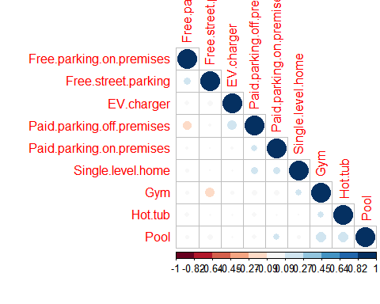

Unsurprisingly, listings with an exterior space are more likely to own a grill.

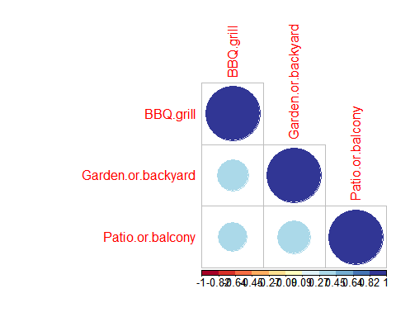

## Nightly.Price Beds Maximum.Guest.Capacity  
## Nightly.Price 1.000000e+00 0.388731397 0.4101435710  
## Beds 3.887314e-01 1.000000000 0.8382498003  
## Maximum.Guest.Capacity 4.101436e-01 0.838249800 1.0000000000  
## Weekend.Nightly.Price 8.322740e-01 0.486019749 0.5195521974  
## Monthly.Price.Factor -2.061496e-02 -0.055180847 -0.0071610355  
## Weekly.Price.Factor -5.034267e-02 -0.076885550 -0.0408070975  
## Accessible.height.bed -2.533614e-02 -0.016186292 -0.0194560619  
## Accessible.height.toilet -2.338703e-02 -0.008238349 -0.0156098535  
## Bath.towel 4.776582e-02 -0.005147486 0.0459987548  
## Bathroom.essentials 4.587515e-02 -0.009217416 0.0447017627  
## Bedroom.comforts 4.587515e-02 -0.009217416 0.0447017627  
## Breakfast.table 8.962500e-02 0.036363081 0.0651018240  
## Carbon.monoxide.detector 6.301574e-02 -0.013176338 -0.0100120830  
## Cat.s. 1.689128e-02 -0.023420262 -0.0063464694  
## Central.air.conditioning 7.498372e-02 -0.022502519 -0.0114614223  
## Conditioner -2.920033e-02 -0.025848804 -0.0234270944  
## Cooking.basics 2.204268e-02 0.146888065 0.1643198261  
## DVD.player 7.999503e-02 0.029212770 0.0673402461  
## Dishes.and.silverware -2.064860e-02 0.070559847 0.0935614651  
## Dog.s. -7.390400e-03 -0.011110051 -0.0050788104  
## Dryer 1.099920e-01 0.131548064 0.1360364536  
## En.suite.bathroom 4.057622e-02 0.018775203 0.0405774069  
## Formal.dining.area 8.027677e-02 0.041944119 0.0808643136  
## Freezer -2.187116e-02 -0.031010037 -0.0358090037  
## Full.kitchen 5.571261e-02 -0.005127127 0.0496578261  
## Memory.foam.mattress 7.263617e-02 0.020078293 0.0549421176  
## Microwave -3.804962e-02 0.036241326 0.0431865699  
## Netflix 5.557146e-02 0.032655147 0.0681874587  
## No.stairs.or.steps.to.enter -2.695469e-02 -0.031957831 -0.0347532648  
## Outdoor.seating 8.403856e-02 0.025400894 0.0578292281  
## Oven 3.254127e-02 0.157294949 0.1840355665  
## Pets.live.on.this.property 1.105927e-02 -0.018879235 -0.0047257152  
## Rain.shower 8.871000e-02 0.036729948 0.0795727546  
## Refrigerator -3.240602e-02 0.035852260 0.0551910192  
## Smoke.alarm -4.273822e-02 0.029559497 -0.0035251470  
## Smoke.detector 5.487203e-02 -0.031376662 -0.0237066721  
## Stove 7.009326e-05 0.118119890 0.1498621903  
## Toilet.paper 4.776582e-02 -0.005147486 0.0459987548  
## Washer 1.070223e-01 0.131632585 0.1337633685  
## Wide.clearance.to.shower 1.543375e-02 -0.008238349 -0.0008220925  
## Wide.entrance.for.guests -1.717204e-02 -0.002740050 -0.0141615373  
## Wide.hallways 1.118112e-03 -0.018979840 -0.0264918852  
## toilet 1.543375e-02 -0.008238349 -0.0008220925  
## Weekend.Nightly.Price Monthly.Price.Factor  
## Nightly.Price 0.832274043 -0.020614963  
## Beds 0.486019749 -0.055180847  
## Maximum.Guest.Capacity 0.519552197 -0.007161035  
## Weekend.Nightly.Price 1.000000000 -0.061073527  
## Monthly.Price.Factor -0.061073527 1.000000000  
## Weekly.Price.Factor -0.111485980 0.733963517  
## Accessible.height.bed -0.019790844 0.041380241  
## Accessible.height.toilet -0.015848786 0.042347062  
## Bath.towel 0.038086484 0.006800869  
## Bathroom.essentials 0.045613979 0.005388198  
## Bedroom.comforts 0.045613979 0.005388198  
## Breakfast.table 0.078066713 0.001598426  
## Carbon.monoxide.detector 0.058373923 0.048936259  
## Cat.s. -0.004625260 -0.009999838  
## Central.air.conditioning 0.031031202 0.018244075  
## Conditioner -0.033342698 0.020522208  
## Cooking.basics 0.035214160 -0.069867842  
## DVD.player 0.059408680 0.004846016  
## Dishes.and.silverware -0.004390037 -0.053650327  
## Dog.s. -0.022305107 -0.001377596  
## Dryer 0.170081684 -0.023893631  
## En.suite.bathroom 0.051796340 0.027166293  
## Formal.dining.area 0.070371627 -0.022645423  
## Freezer -0.024296560 -0.014539474  
## Full.kitchen 0.039745530 -0.015524285  
## Memory.foam.mattress 0.056256112 0.001506503  
## Microwave -0.032783926 -0.029255200  
## Netflix 0.053866367 -0.014806098  
## No.stairs.or.steps.to.enter -0.037152220 0.038474076  
## Outdoor.seating 0.064580332 0.015566064  
## Oven 0.061398249 -0.044715395  
## Pets.live.on.this.property -0.010932446 -0.003015988  
## Rain.shower 0.062614971 -0.008391648  
## Refrigerator -0.018011781 -0.027631269  
## Smoke.alarm -0.030779485 -0.055849789  
## Smoke.detector 0.046577841 0.049174003  
## Stove 0.034800561 -0.066966603  
## Toilet.paper 0.038086484 0.006800869  
## Washer 0.166210519 -0.016329100  
## Wide.clearance.to.shower 0.010045413 0.032631024  
## Wide.entrance.for.guests -0.026162943 0.034582591  
## Wide.hallways -0.015837923 0.016871966  
## toilet 0.010045413 0.032631024  
## Weekly.Price.Factor Accessible.height.bed  
## Nightly.Price -0.050342668 -0.025336141  
## Beds -0.076885550 -0.016186292  
## Maximum.Guest.Capacity -0.040807097 -0.019456062  
## Weekend.Nightly.Price -0.111485980 -0.019790844  
## Monthly.Price.Factor 0.733963517 0.041380241  
## Weekly.Price.Factor 1.000000000 0.047070666  
## Accessible.height.bed 0.047070666 1.000000000  
## Accessible.height.toilet 0.047429281 0.750641716  
## Bath.towel 0.015353367 0.093332377  
## Bathroom.essentials 0.010292566 0.087471654  
## Bedroom.comforts 0.010292566 0.087471654  
## Breakfast.table 0.004340921 -0.007298693  
## Carbon.monoxide.detector -0.016787869 -0.013870455  
## Cat.s. -0.030637260 -0.011194290  
## Central.air.conditioning 0.029323910 -0.006878957  
## Conditioner 0.029188430 -0.015349383  
## Cooking.basics -0.043450464 0.054472762  
## DVD.player -0.006301346 0.134612101  
## Dishes.and.silverware -0.019573763 0.042434787  
## Dog.s. -0.020521178 -0.012477065  
## Dryer -0.025225931 0.053216283  
## En.suite.bathroom 0.032210742 -0.006432509  
## Formal.dining.area -0.026341984 0.107999762  
## Freezer 0.016519727 -0.015945266  
## Full.kitchen -0.010160331 0.035909807  
## Memory.foam.mattress -0.006532984 -0.006878957  
## Microwave 0.021246325 0.045325369  
## Netflix -0.010729332 0.076227344  
## No.stairs.or.steps.to.enter 0.068767620 0.235030855  
## Outdoor.seating 0.009005004 -0.006878957  
## Oven -0.018336934 0.057665826  
## Pets.live.on.this.property -0.026537058 -0.014940358  
## Rain.shower -0.021493690 -0.004857619  
## Refrigerator 0.012995852 0.040813838  
## Smoke.alarm -0.007359522 0.019671754  
## Smoke.detector -0.022046834 -0.014940358  
## Stove -0.042960184 0.035637638  
## Toilet.paper 0.015353367 0.093332377  
## Washer -0.018457320 0.052249313  
## Wide.clearance.to.shower 0.024982097 0.329132734  
## Wide.entrance.for.guests 0.044132909 0.296980302  
## Wide.hallways 0.041354020 0.192089890  
## toilet 0.024982097 0.329132734  
## Accessible.height.toilet Bath.towel  
## Nightly.Price -0.023387026 0.047765825  
## Beds -0.008238349 -0.005147486  
## Maximum.Guest.Capacity -0.015609854 0.045998755  
## Weekend.Nightly.Price -0.015848786 0.038086484  
## Monthly.Price.Factor 0.042347062 0.006800869  
## Weekly.Price.Factor 0.047429281 0.015353367  
## Accessible.height.bed 0.750641716 0.093332377  
## Accessible.height.toilet 1.000000000 0.045824747  
## Bath.towel 0.045824747 1.000000000  
## Bathroom.essentials 0.042381615 0.949408341  
## Bedroom.comforts 0.042381615 0.949408341  
## Breakfast.table -0.006709290 0.563305642  
## Carbon.monoxide.detector -0.012750350 -0.020460210  
## Cat.s. -0.010290299 -0.016512618  
## Central.air.conditioning -0.006323449 0.530910804  
## Conditioner -0.014109848 -0.022641766  
## Cooking.basics 0.050073831 0.046258190  
## DVD.player 0.147051885 0.374906045  
## Dishes.and.silverware 0.039007979 0.062595254  
## Dog.s. -0.011469483 -0.018404830  
## Dryer 0.048918819 -0.013493935  
## En.suite.bathroom -0.005913054 0.496454455  
## Formal.dining.area -0.005472583 0.459472938  
## Freezer -0.014657611 -0.023520749  
## Full.kitchen 0.041329971 0.729580029  
## Memory.foam.mattress -0.006323449 0.530910804  
## Microwave 0.041665133 0.054261873  
## Netflix 0.084161453 0.623177891  
## No.stairs.or.steps.to.enter 0.203570936 0.047725266  
## Outdoor.seating -0.006323449 0.530910804  
## Oven 0.053009040 0.062937324  
## Pets.live.on.this.property -0.013733854 -0.022038416  
## Rain.shower -0.004465344 0.374906045  
## Refrigerator 0.037517929 0.046716077  
## Smoke.alarm 0.018083167 0.029017665  
## Smoke.detector -0.013733854 -0.022038416  
## Stove 0.048296669 0.054349671  
## Toilet.paper 0.045824747 1.000000000  
## Washer 0.048029936 -0.015800193  
## Wide.clearance.to.shower 0.358913017 0.045824747  
## Wide.entrance.for.guests 0.228224929 0.038216509  
## Wide.hallways 0.266741594 0.015389785  
## toilet 0.358913017 0.045824747  
## Bathroom.essentials Bedroom.comforts  
## Nightly.Price 0.045875155 0.045875155  
## Beds -0.009217416 -0.009217416  
## Maximum.Guest.Capacity 0.044701763 0.044701763  
## Weekend.Nightly.Price 0.045613979 0.045613979  
## Monthly.Price.Factor 0.005388198 0.005388198  
## Weekly.Price.Factor 0.010292566 0.010292566  
## Accessible.height.bed 0.087471654 0.087471654  
## Accessible.height.toilet 0.042381615 0.042381615  
## Bath.towel 0.949408341 0.949408341  
## Bathroom.essentials 1.000000000 1.000000000  
## Bedroom.comforts 1.000000000 1.000000000  
## Breakfast.table 0.534807075 0.534807075  
## Carbon.monoxide.detector -0.021550485 -0.021550485  
## Cat.s. -0.017392536 -0.017392536  
## Central.air.conditioning 0.504051146 0.504051146  
## Conditioner -0.023848291 -0.023848291  
## Cooking.basics 0.041386522 0.041386522  
## DVD.player 0.355938926 0.355938926  
## Dishes.and.silverware 0.053429573 0.053429573  
## Dog.s. -0.019385579 -0.019385579  
## Dryer -0.004836061 -0.004836061  
## En.suite.bathroom 0.471338000 0.471338000  
## Formal.dining.area 0.436227440 0.436227440  
## Freezer -0.024774112 -0.024774112  
## Full.kitchen 0.692005180 0.692005180  
## Memory.foam.mattress 0.504051146 0.504051146  
## Microwave 0.034468438 0.034468438  
## Netflix 0.591650288 0.591650288  
## No.stairs.or.steps.to.enter 0.043318212 0.043318212  
## Outdoor.seating 0.504051146 0.504051146  
## Oven 0.058021895 0.058021895  
## Pets.live.on.this.property -0.023212790 -0.023212790  
## Rain.shower 0.355938926 0.355938926  
## Refrigerator 0.037748305 0.037748305  
## Smoke.alarm 0.030563945 0.030563945  
## Smoke.detector -0.023212790 -0.023212790  
## Stove 0.048593232 0.048593232  
## Toilet.paper 0.949408341 0.949408341  
## Washer -0.007175525 -0.007175525  
## Wide.clearance.to.shower 0.042381615 0.042381615  
## Wide.entrance.for.guests 0.034019420 0.034019420  
## Wide.hallways 0.012623247 0.012623247  
## toilet 0.042381615 0.042381615  
## Breakfast.table Carbon.monoxide.detector  
## Nightly.Price 0.089625001 0.063015736  
## Beds 0.036363081 -0.013176338  
## Maximum.Guest.Capacity 0.065101824 -0.010012083  
## Weekend.Nightly.Price 0.078066713 0.058373923  
## Monthly.Price.Factor 0.001598426 0.048936259  
## Weekly.Price.Factor 0.004340921 -0.016787869  
## Accessible.height.bed -0.007298693 -0.013870455  
## Accessible.height.toilet -0.006709290 -0.012750350  
## Bath.towel 0.563305642 -0.020460210  
## Bathroom.essentials 0.534807075 -0.021550485  
## Bedroom.comforts 0.534807075 -0.021550485  
## Breakfast.table 1.000000000 -0.011525352  
## Carbon.monoxide.detector -0.011525352 1.000000000  
## Cat.s. -0.009301651 -0.017676880  
## Central.air.conditioning 0.705439678 -0.010862546  
## Conditioner -0.012754235 -0.024238179  
## Cooking.basics 0.025346186 -0.031080214  
## DVD.player 0.498150721 -0.007670656  
## Dishes.and.silverware 0.035260260 -0.043768344  
## Dog.s. -0.010367545 -0.019702507  
## Dryer 0.003914372 0.040949125  
## En.suite.bathroom 0.754656509 -0.010157562  
## Formal.dining.area 0.678902642 -0.009400913  
## Freezer -0.013249370 -0.025179136  
## Full.kitchen 0.466456594 -0.021902806  
## Memory.foam.mattress 0.586913745 -0.010862546  
## Microwave 0.037662126 -0.070024130  
## Netflix 0.701561283 -0.012750350  
## No.stairs.or.steps.to.enter -0.011525352 0.073900582  
## Outdoor.seating 0.705439678 -0.010862546  
## Oven 0.028528944 -0.043649105  
## Pets.live.on.this.property -0.012414364 -0.023592288  
## Rain.shower 0.665546406 -0.007670656  
## Refrigerator 0.033913368 -0.049259178  
## Smoke.alarm 0.016345814 -0.705094984  
## Smoke.detector -0.012414364 0.928388403  
## Stove 0.023370444 -0.047147117  
## Toilet.paper 0.563305642 -0.020460210  
## Washer 0.002725388 0.039010092  
## Wide.clearance.to.shower -0.006709290 -0.012750350  
## Wide.entrance.for.guests -0.012921160 0.004086173  
## Wide.hallways -0.011151743 0.077684859  
## toilet -0.006709290 -0.012750350  
## Cat.s. Central.air.conditioning Conditioner  
## Nightly.Price 0.0168912760 0.074983723 -0.029200326  
## Beds -0.0234202616 -0.022502519 -0.025848804  
## Maximum.Guest.Capacity -0.0063464694 -0.011461422 -0.023427094  
## Weekend.Nightly.Price -0.0046252603 0.031031202 -0.033342698  
## Monthly.Price.Factor -0.0099998384 0.018244075 0.020522208  
## Weekly.Price.Factor -0.0306372600 0.029323910 0.029188430  
## Accessible.height.bed -0.0111942902 -0.006878957 -0.015349383  
## Accessible.height.toilet -0.0102902987 -0.006323449 -0.014109848  
## Bath.towel -0.0165126184 0.530910804 -0.022641766  
## Bathroom.essentials -0.0173925357 0.504051146 -0.023848291  
## Bedroom.comforts -0.0173925357 0.504051146 -0.023848291  
## Breakfast.table -0.0093016511 0.705439678 -0.012754235  
## Carbon.monoxide.detector -0.0176768804 -0.010862546 -0.024238179  
## Cat.s. 1.0000000000 -0.008766728 0.016098367  
## Central.air.conditioning -0.0087667275 1.000000000 -0.012020758  
## Conditioner 0.0160983675 -0.012020758 1.000000000  
## Cooking.basics 0.0170550612 0.021542143 0.046859894  
## DVD.player -0.0061906805 0.351176080 -0.008488535  
## Dishes.and.silverware -0.0064685154 0.033232497 0.051801111  
## Dog.s. 0.5493453864 -0.009771323 0.042402423  
## Dryer -0.0249046933 -0.001059073 0.014752180  
## En.suite.bathroom -0.0081977630 0.532183641 -0.011240606  
## Formal.dining.area -0.0075871013 0.285372725 -0.010403279  
## Freezer 0.0140772981 -0.012487420 0.708656839  
## Full.kitchen -0.0176768804 0.432592427 0.004758296  
## Memory.foam.mattress -0.0087667275 0.497306397 -0.012020758  
## Microwave -0.0147933045 0.035496236 0.047062068  
## Netflix -0.0102902987 0.530091840 -0.014109848  
## No.stairs.or.steps.to.enter -0.0176768804 0.052488164 -0.024238179  
## Outdoor.seating -0.0087667275 0.497306397 -0.012020758  
## Oven 0.0097731773 0.024604253 0.034906853  
## Pets.live.on.this.property 0.7492652100 -0.011700433 0.027917072  
## Rain.shower -0.0061906805 0.351176080 -0.008488535  
## Refrigerator 0.0054012399 0.031963062 0.036905215  
## Smoke.alarm -0.0315130475 0.015405792 0.013487276  
## Smoke.detector -0.0190403934 -0.011700433 -0.026107800  
## Stove 0.0002858006 0.019636513 0.062275640  
## Toilet.paper -0.0165126184 0.530910804 -0.022641766  
## Washer -0.0270239149 -0.002225097 0.022187814  
## Wide.clearance.to.shower -0.0102902987 -0.006323449 -0.014109848  
## Wide.entrance.for.guests 0.0506294678 0.044640288 -0.027173607  
## Wide.hallways 0.0639630174 0.054873171 -0.023452469  
## toilet -0.0102902987 -0.006323449 -0.014109848  
## Cooking.basics DVD.player Dishes.and.silverware  
## Nightly.Price 0.022042682 0.079995034 -0.020648600  
## Beds 0.146888065 0.029212770 0.070559847  
## Maximum.Guest.Capacity 0.164319826 0.067340246 0.093561465  
## Weekend.Nightly.Price 0.035214160 0.059408680 -0.004390037  
## Monthly.Price.Factor -0.069867842 0.004846016 -0.053650327  
## Weekly.Price.Factor -0.043450464 -0.006301346 -0.019573763  
## Accessible.height.bed 0.054472762 0.134612101 0.042434787  
## Accessible.height.toilet 0.050073831 0.147051885 0.039007979  
## Bath.towel 0.046258190 0.374906045 0.062595254  
## Bathroom.essentials 0.041386522 0.355938926 0.053429573  
## Bedroom.comforts 0.041386522 0.355938926 0.053429573  
## Breakfast.table 0.025346186 0.498150721 0.035260260  
## Carbon.monoxide.detector -0.031080214 -0.007670656 -0.043768344  
## Cat.s. 0.017055061 -0.006190680 -0.006468515  
## Central.air.conditioning 0.021542143 0.351176080 0.033232497  
## Conditioner 0.046859894 -0.008488535 0.051801111  
## Cooking.basics 1.000000000 0.030124596 0.729772932  
## DVD.player 0.030124596 1.000000000 0.023467339  
## Dishes.and.silverware 0.729772932 0.023467339 1.000000000  
## Dog.s. 0.018448209 -0.006900082 0.033022832  
## Dryer 0.104433394 -0.000747871 0.037669769  
## En.suite.bathroom 0.017323013 0.186123776 0.031075693  
## Formal.dining.area 0.036919747 0.611137952 0.028760825  
## Freezer 0.033617333 -0.008818071 0.055470674  
## Full.kitchen 0.064727273 0.350213405 0.067008684  
## Memory.foam.mattress 0.021542143 0.528666224 0.033232497  
## Microwave 0.541000383 0.025065893 0.599673219  
## Netflix 0.032046286 0.450086343 0.039007979  
## No.stairs.or.steps.to.enter 0.064727273 0.081800359 0.054700125  
## Outdoor.seating 0.042659950 0.351176080 0.033232497  
## Oven 0.702832245 0.031890428 0.648007479  
## Pets.live.on.this.property 0.003400836 -0.008262335 0.003379237  
## Rain.shower 0.030124596 0.749328408 0.023467339  
## Refrigerator 0.677655089 0.022570920 0.718319357  
## Smoke.alarm 0.100396097 0.010878898 0.100035565  
## Smoke.detector -0.056100503 -0.008262335 -0.065418951  
## Stove 0.769332680 0.029055449 0.719912943  
## Toilet.paper 0.046258190 0.374906045 0.062595254  
## Washer 0.103710878 -0.001571267 0.040969281  
## Wide.clearance.to.shower 0.050073831 0.147051885 0.039007979  
## Wide.entrance.for.guests 0.077340039 0.071645679 0.075123946  
## Wide.hallways 0.061255700 -0.007422003 0.052132983  
## toilet 0.050073831 0.147051885 0.039007979  
## Dog.s. Dryer En.suite.bathroom  
## Nightly.Price -0.0073903995 0.109991952 0.040576222  
## Beds -0.0111100507 0.131548064 0.018775203  
## Maximum.Guest.Capacity -0.0050788104 0.136036454 0.040577407  
## Weekend.Nightly.Price -0.0223051072 0.170081684 0.051796340  
## Monthly.Price.Factor -0.0013775956 -0.023893631 0.027166293  
## Weekly.Price.Factor -0.0205211781 -0.025225931 0.032210742  
## Accessible.height.bed -0.0124770649 0.053216283 -0.006432509  
## Accessible.height.toilet -0.0114694834 0.048918819 -0.005913054  
## Bath.towel -0.0184048304 -0.013493935 0.496454455  
## Bathroom.essentials -0.0193855790 -0.004836061 0.471338000  
## Bedroom.comforts -0.0193855790 -0.004836061 0.471338000  
## Breakfast.table -0.0103675448 0.003914372 0.754656509  
## Carbon.monoxide.detector -0.0197025074 0.040949125 -0.010157562  
## Cat.s. 0.5493453864 -0.024904693 -0.008197763  
## Central.air.conditioning -0.0097713233 -0.001059073 0.532183641  
## Conditioner 0.0424024229 0.014752180 -0.011240606  
## Cooking.basics 0.0184482090 0.104433394 0.017323013  
## DVD.player -0.0069000822 -0.000747871 0.186123776  
## Dishes.and.silverware 0.0330228324 0.037669769 0.031075693  
## Dog.s. 1.0000000000 0.015966635 -0.009137160  
## Dryer 0.0159666351 1.000000000 0.016136018  
## En.suite.bathroom -0.0091371601 0.016136018 1.000000000  
## Formal.dining.area -0.0084565215 0.011411672 0.305596426  
## Freezer 0.0083173368 0.002262179 -0.011676980  
## Full.kitchen 0.0156530738 0.019406826 0.396054239  
## Memory.foam.mattress -0.0097713233 -0.001059073 0.397878337  
## Microwave -0.0009362593 0.035832765 0.033192514  
## Netflix -0.0114694834 0.012437402 0.567346027  
## No.stairs.or.steps.to.enter -0.0197025074 0.062491424 -0.010157562  
## Outdoor.seating -0.0097713233 -0.001059073 0.666488944  
## Oven 0.0130783112 0.150428506 0.020261396  
## Pets.live.on.this.property 0.8351249188 0.010242495 -0.010941070  
## Rain.shower -0.0069000822 -0.000747871 0.375804867  
## Refrigerator 0.0160114252 0.025459909 0.029888645  
## Smoke.alarm 0.0279430542 -0.010550185 0.014405949  
## Smoke.detector -0.0212222679 0.040344945 -0.010941070  
## Stove -0.0093991700 0.127859478 0.015488747  
## Toilet.paper -0.0184048304 -0.013493935 0.496454455  
## Washer 0.0140227877 0.981829435 0.015209478  
## Wide.clearance.to.shower -0.0114694834 0.048918819 -0.005913054  
## Wide.entrance.for.guests 0.0413312274 0.065229365 -0.011387721  
## Wide.hallways 0.0539164124 0.059076090 -0.009828293  
## toilet -0.0114694834 0.048918819 -0.005913054  
## Formal.dining.area Freezer Full.kitchen  
## Nightly.Price 0.080276770 -0.021871158 0.055712612  
## Beds 0.041944119 -0.031010037 -0.005127127  
## Maximum.Guest.Capacity 0.080864314 -0.035809004 0.049657826  
## Weekend.Nightly.Price 0.070371627 -0.024296560 0.039745530  
## Monthly.Price.Factor -0.022645423 -0.014539474 -0.015524285  
## Weekly.Price.Factor -0.026341984 0.016519727 -0.010160331  
## Accessible.height.bed 0.107999762 -0.015945266 0.035909807  
## Accessible.height.toilet -0.005472583 -0.014657611 0.041329971  
## Bath.towel 0.459472938 -0.023520749 0.729580029  
## Bathroom.essentials 0.436227440 -0.024774112 0.692005180  
## Bedroom.comforts 0.436227440 -0.024774112 0.692005180  
## Breakfast.table 0.678902642 -0.013249370 0.466456594  
## Carbon.monoxide.detector -0.009400913 -0.025179136 -0.021902806  
## Cat.s. -0.007587101 0.014077298 -0.017676880  
## Central.air.conditioning 0.285372725 -0.012487420 0.432592427  
## Conditioner -0.010403279 0.708656839 0.004758296  
## Cooking.basics 0.036919747 0.033617333 0.064727273  
## DVD.player 0.611137952 -0.008818071 0.350213405  
## Dishes.and.silverware 0.028760825 0.055470674 0.067008684  
## Dog.s. -0.008456522 0.008317337 0.015653074  
## Dryer 0.011411672 0.002262179 0.019406826  
## En.suite.bathroom 0.305596426 -0.011676980 0.396054239  
## Formal.dining.area 1.000000000 -0.010807148 0.356108534  
## Freezer -0.010807148 1.000000000 -0.025179136  
## Full.kitchen 0.356108534 -0.025179136 1.000000000  
## Memory.foam.mattress 0.575407767 -0.012487420 0.432592427  
## Microwave 0.030719962 0.061609226 0.059773419  
## Netflix 0.489713288 -0.014657611 0.473972545  
## No.stairs.or.steps.to.enter -0.009400913 -0.025179136 0.041966119  
## Outdoor.seating 0.430390246 -0.012487420 0.495943138  
## Oven 0.039083895 0.068377119 0.080697749  
## Pets.live.on.this.property -0.010126056 -0.001064609 0.006157109  
## Rain.shower 0.815948044 -0.008818071 0.350213405  
## Refrigerator 0.027662203 0.051957629 0.051814799  
## Smoke.alarm 0.013332832 0.035710275 0.031063625  
## Smoke.detector -0.010126056 -0.027121338 -0.023592288  
## Stove 0.035609435 0.066884834 0.072122307  
## Toilet.paper 0.459472938 -0.023520749 0.729580029  
## Washer 0.010520461 0.009128886 0.017261747  
## Wide.clearance.to.shower -0.005472583 -0.014657611 0.041329971  
## Wide.entrance.for.guests -0.010539435 -0.028228521 0.032727748  
## Wide.hallways -0.009096171 0.004505207 0.011766419  
## toilet -0.005472583 -0.014657611 0.041329971  
## Memory.foam.mattress Microwave Netflix  
## Nightly.Price 0.072636173 -0.0380496182 0.05557146  
## Beds 0.020078293 0.0362413256 0.03265515  
## Maximum.Guest.Capacity 0.054942118 0.0431865699 0.06818746  
## Weekend.Nightly.Price 0.056256112 -0.0327839264 0.05386637  
## Monthly.Price.Factor 0.001506503 -0.0292551998 -0.01480610  
## Weekly.Price.Factor -0.006532984 0.0212463253 -0.01072933  
## Accessible.height.bed -0.006878957 0.0453253693 0.07622734  
## Accessible.height.toilet -0.006323449 0.0416651331 0.08416145  
## Bath.towel 0.530910804 0.0542618728 0.62317789  
## Bathroom.essentials 0.504051146 0.0344684381 0.59165029  
## Bedroom.comforts 0.504051146 0.0344684381 0.59165029  
## Breakfast.table 0.586913745 0.0376621264 0.70156128  
## Carbon.monoxide.detector -0.010862546 -0.0700241300 -0.01275035  
## Cat.s. -0.008766728 -0.0147933045 -0.01029030  
## Central.air.conditioning 0.497306397 0.0354962357 0.53009184  
## Conditioner -0.012020758 0.0470620675 -0.01410985  
## Cooking.basics 0.021542143 0.5410003825 0.03204629  
## DVD.player 0.528666224 0.0250658929 0.45008634  
## Dishes.and.silverware 0.033232497 0.5996732192 0.03900798  
## Dog.s. -0.009771323 -0.0009362593 -0.01146948  
## Dryer -0.001059073 0.0358327653 0.01243740  
## En.suite.bathroom 0.397878337 0.0331925141 0.56734603  
## Formal.dining.area 0.575407767 0.0307199620 0.48971329  
## Freezer -0.012487420 0.0616092259 -0.01465761  
## Full.kitchen 0.432592427 0.0597734193 0.47397254  
## Memory.foam.mattress 1.000000000 0.0354962357 0.53009184  
## Microwave 0.035496236 1.0000000000 0.04166513  
## Netflix 0.530091840 0.0416651331 1.00000000  
## No.stairs.or.steps.to.enter 0.052488164 0.0361738649 0.04132997  
## Outdoor.seating 0.371632997 0.0354962357 0.53009184  
## Oven 0.024604253 0.5677563723 0.03546081  
## Pets.live.on.this.property -0.011700433 -0.0108451433 -0.01373385  
## Rain.shower 0.706156368 0.0250658929 0.45008634  
## Refrigerator 0.031963062 0.7604128869 0.03751793  
## Smoke.alarm 0.015405792 0.1535012089 0.01808317  
## Smoke.detector -0.011700433 -0.0877919135 -0.01373385  
## Stove 0.019636513 0.5942651136 0.02993483  
## Toilet.paper 0.530910804 0.0542618728 0.62317789  
## Washer -0.002225097 0.0317376599 0.01119958  
## Wide.clearance.to.shower -0.006323449 0.0416651331 0.08416145  
## Wide.entrance.for.guests 0.044640288 0.0590751442 0.03420937  
## Wide.hallways 0.054873171 0.0327177906 -0.01233703  
## toilet -0.006323449 0.0416651331 0.08416145  
## No.stairs.or.steps.to.enter Outdoor.seating  
## Nightly.Price -0.026954693 0.084038559  
## Beds -0.031957831 0.025400894  
## Maximum.Guest.Capacity -0.034753265 0.057829228  
## Weekend.Nightly.Price -0.037152220 0.064580332  
## Monthly.Price.Factor 0.038474076 0.015566064  
## Weekly.Price.Factor 0.068767620 0.009005004  
## Accessible.height.bed 0.235030855 -0.006878957  
## Accessible.height.toilet 0.203570936 -0.006323449  
## Bath.towel 0.047725266 0.530910804  
## Bathroom.essentials 0.043318212 0.504051146  
## Bedroom.comforts 0.043318212 0.504051146  
## Breakfast.table -0.011525352 0.705439678  
## Carbon.monoxide.detector 0.073900582 -0.010862546  
## Cat.s. -0.017676880 -0.008766728  
## Central.air.conditioning 0.052488164 0.497306397  
## Conditioner -0.024238179 -0.012020758  
## Cooking.basics 0.064727273 0.042659950  
## DVD.player 0.081800359 0.351176080  
## Dishes.and.silverware 0.054700125 0.033232497  
## Dog.s. -0.019702507 -0.009771323  
## Dryer 0.062491424 -0.001059073  
## En.suite.bathroom -0.010157562 0.666488944  
## Formal.dining.area -0.009400913 0.430390246  
## Freezer -0.025179136 -0.012487420  
## Full.kitchen 0.041966119 0.495943138  
## Memory.foam.mattress 0.052488164 0.371632997  
## Microwave 0.036173865 0.035496236  
## Netflix 0.041329971 0.530091840  
## No.stairs.or.steps.to.enter 1.000000000 -0.010862546  
## Outdoor.seating -0.010862546 1.000000000  
## Oven 0.039248798 0.045160575  
## Pets.live.on.this.property -0.023592288 -0.011700433  
## Rain.shower -0.007670656 0.528666224  
## Refrigerator 0.051814799 0.031963062  
## Smoke.alarm -0.037951244 0.015405792  
## Smoke.detector 0.065655902 -0.011700433  
## Stove 0.050436957 0.041145914  
## Toilet.paper 0.047725266 0.530910804  
## Washer 0.060758437 -0.002225097  
## Wide.clearance.to.shower 0.419892223 -0.006323449  
## Wide.entrance.for.guests 0.720125567 -0.012178084  
## Wide.hallways 0.637991592 -0.010510424  
## toilet 0.419892223 -0.006323449  
## Oven Pets.live.on.this.property  
## Nightly.Price 0.032541272 0.011059269  
## Beds 0.157294949 -0.018879235  
## Maximum.Guest.Capacity 0.184035567 -0.004725715  
## Weekend.Nightly.Price 0.061398249 -0.010932446  
## Monthly.Price.Factor -0.044715395 -0.003015988  
## Weekly.Price.Factor -0.018336934 -0.026537058  
## Accessible.height.bed 0.057665826 -0.014940358  
## Accessible.height.toilet 0.053009040 -0.013733854  
## Bath.towel 0.062937324 -0.022038416  
## Bathroom.essentials 0.058021895 -0.023212790  
## Bedroom.comforts 0.058021895 -0.023212790  
## Breakfast.table 0.028528944 -0.012414364  
## Carbon.monoxide.detector -0.043649105 -0.023592288  
## Cat.s. 0.009773177 0.749265210  
## Central.air.conditioning 0.024604253 -0.011700433  
## Conditioner 0.034906853 0.027917072  
## Cooking.basics 0.702832245 0.003400836  
## DVD.player 0.031890428 -0.008262335  
## Dishes.and.silverware 0.648007479 0.003379237  
## Dog.s. 0.013078311 0.835124919  
## Dryer 0.150428506 0.010242495  
## En.suite.bathroom 0.020261396 -0.010941070  
## Formal.dining.area 0.039083895 -0.010126056  
## Freezer 0.068377119 -0.001064609  
## Full.kitchen 0.080697749 0.006157109  
## Memory.foam.mattress 0.024604253 -0.011700433  
## Microwave 0.567756372 -0.010845143  
## Netflix 0.035460815 -0.013733854  
## No.stairs.or.steps.to.enter 0.039248798 -0.023592288  
## Outdoor.seating 0.045160575 -0.011700433  
## Oven 1.000000000 0.001551756  
## Pets.live.on.this.property 0.001551756 1.000000000  
## Rain.shower 0.031890428 -0.008262335  
## Refrigerator 0.687266642 0.010571507  
## Smoke.alarm 0.117191100 -0.009402026  
## Smoke.detector -0.056367550 -0.025412088  
## Stove 0.823145513 -0.021744081  
## Toilet.paper 0.062937324 -0.022038416  
## Washer 0.150971600 0.007829982  
## Wide.clearance.to.shower 0.053009040 -0.013733854  
## Wide.entrance.for.guests 0.046325563 0.026914147  
## Wide.hallways 0.034634389 0.038580557  
## toilet 0.053009040 -0.013733854  
## Rain.shower Refrigerator Smoke.alarm  
## Nightly.Price 0.088709996 -0.03240602 -0.042738220  
## Beds 0.036729948 0.03585226 0.029559497  
## Maximum.Guest.Capacity 0.079572755 0.05519102 -0.003525147  
## Weekend.Nightly.Price 0.062614971 -0.01801178 -0.030779485  
## Monthly.Price.Factor -0.008391648 -0.02763127 -0.055849789  
## Weekly.Price.Factor -0.021493690 0.01299585 -0.007359522  
## Accessible.height.bed -0.004857619 0.04081384 0.019671754  
## Accessible.height.toilet -0.004465344 0.03751793 0.018083167  
## Bath.towel 0.374906045 0.04671608 0.029017665  
## Bathroom.essentials 0.355938926 0.03774831 0.030563945  
## Bedroom.comforts 0.355938926 0.03774831 0.030563945  
## Breakfast.table 0.665546406 0.03391337 0.016345814  
## Carbon.monoxide.detector -0.007670656 -0.04925918 -0.705094984  
## Cat.s. -0.006190680 0.00540124 -0.031513047  
## Central.air.conditioning 0.351176080 0.03196306 0.015405792  
## Conditioner -0.008488535 0.03690521 0.013487276  
## Cooking.basics 0.030124596 0.67765509 0.100396097  
## DVD.player 0.749328408 0.02257092 0.010878898  
## Dishes.and.silverware 0.023467339 0.71831936 0.100035565  
## Dog.s. -0.006900082 0.01601143 0.027943054  
## Dryer -0.000747871 0.02545991 -0.010550185  
## En.suite.bathroom 0.375804867 0.02988865 0.014405949  
## Formal.dining.area 0.815948044 0.02766220 0.013332832  
## Freezer -0.008818071 0.05195763 0.035710275  
## Full.kitchen 0.350213405 0.05181480 0.031063625  
## Memory.foam.mattress 0.706156368 0.03196306 0.015405792  
## Microwave 0.025065893 0.76041289 0.153501209  
## Netflix 0.450086343 0.03751793 0.018083167  
## No.stairs.or.steps.to.enter -0.007670656 0.05181480 -0.037951244  
## Outdoor.seating 0.528666224 0.03196306 0.015405792  
## Oven 0.031890428 0.68726664 0.117191100  
## Pets.live.on.this.property -0.008262335 0.01057151 -0.009402026  
## Rain.shower 1.000000000 0.02257092 0.010878898  
## Refrigerator 0.022570920 1.00000000 0.127030322  
## Smoke.alarm 0.010878898 0.12703032 1.000000000  
## Smoke.detector -0.008262335 -0.06004710 -0.759482758  
## Stove 0.029055449 0.73821505 0.124471345  
## Toilet.paper 0.374906045 0.04671608 0.029017665  
## Washer -0.001571267 0.02395721 -0.015179122  
## Wide.clearance.to.shower -0.004465344 0.03751793 0.018083167  
## Wide.entrance.for.guests -0.008599631 0.07225432 0.014192841  
## Wide.hallways -0.007422003 0.04932018 -0.041172853  
## toilet -0.004465344 0.03751793 0.018083167  
## Smoke.detector Stove Toilet.paper  
## Nightly.Price 0.0548720270 7.009326e-05 0.047765825  
## Beds -0.0313766623 1.181199e-01 -0.005147486  
## Maximum.Guest.Capacity -0.0237066721 1.498622e-01 0.045998755  
## Weekend.Nightly.Price 0.0465778412 3.480056e-02 0.038086484  
## Monthly.Price.Factor 0.0491740034 -6.696660e-02 0.006800869  
## Weekly.Price.Factor -0.0220468337 -4.296018e-02 0.015353367  
## Accessible.height.bed -0.0149403576 3.563764e-02 0.093332377  
## Accessible.height.toilet -0.0137338537 4.829667e-02 0.045824747  
## Bath.towel -0.0220384161 5.434967e-02 1.000000000  
## Bathroom.essentials -0.0232127896 4.859323e-02 0.949408341  
## Bedroom.comforts -0.0232127896 4.859323e-02 0.949408341  
## Breakfast.table -0.0124143641 2.337044e-02 0.563305642  
## Carbon.monoxide.detector 0.9283884027 -4.714712e-02 -0.020460210  
## Cat.s. -0.0190403934 2.858006e-04 -0.016512618  
## Central.air.conditioning -0.0117004332 1.963651e-02 0.530910804  
## Conditioner -0.0261077999 6.227564e-02 -0.022641766  
## Cooking.basics -0.0561005030 7.693327e-01 0.046258190  
## DVD.player -0.0082623354 2.905545e-02 0.374906045  
## Dishes.and.silverware -0.0654189508 7.199129e-01 0.062595254  
## Dog.s. -0.0212222679 -9.399170e-03 -0.018404830  
## Dryer 0.0403449453 1.278595e-01 -0.013493935  
## En.suite.bathroom -0.0109410698 1.548875e-02 0.496454455  
## Formal.dining.area -0.0101260558 3.560944e-02 0.459472938  
## Freezer -0.0271213381 6.688483e-02 -0.023520749  
## Full.kitchen -0.0235922877 7.212231e-02 0.729580029  
## Memory.foam.mattress -0.0117004332 1.963651e-02 0.530910804  
## Microwave -0.0877919135 5.942651e-01 0.054261873  
## Netflix -0.0137338537 2.993483e-02 0.623177891  
## No.stairs.or.steps.to.enter 0.0656559020 5.043696e-02 0.047725266  
## Outdoor.seating -0.0117004332 4.114591e-02 0.530910804  
## Oven -0.0563675500 8.231455e-01 0.062937324  
## Pets.live.on.this.property -0.0254120879 -2.174408e-02 -0.022038416  
## Rain.shower -0.0082623354 2.905545e-02 0.374906045  
## Refrigerator -0.0600471037 7.382150e-01 0.046716077  
## Smoke.alarm -0.7594827575 1.244713e-01 0.029017665  
## Smoke.detector 1.0000000000 -7.224799e-02 -0.022038416  
## Stove -0.0722479890 1.000000e+00 0.054349671  
## Toilet.paper -0.0220384161 5.434967e-02 1.000000000  
## Washer 0.0382203543 1.231424e-01 -0.015800193  
## Wide.clearance.to.shower -0.0137338537 2.993483e-02 0.045824747  
## Wide.entrance.for.guests 0.0002323266 5.411410e-02 0.038216509  
## Wide.hallways 0.0692845931 5.789435e-02 0.015389785  
## toilet -0.0137338537 2.993483e-02 0.045824747  
## Washer Wide.clearance.to.shower  
## Nightly.Price 0.107022252 0.0154337544  
## Beds 0.131632585 -0.0082383487  
## Maximum.Guest.Capacity 0.133763368 -0.0008220925  
## Weekend.Nightly.Price 0.166210519 0.0100454133  
## Monthly.Price.Factor -0.016329100 0.0326310243  
## Weekly.Price.Factor -0.018457320 0.0249820974  
## Accessible.height.bed 0.052249313 0.3291327338  
## Accessible.height.toilet 0.048029936 0.3589130168  
## Bath.towel -0.015800193 0.0458247472  
## Bathroom.essentials -0.007175525 0.0423816149  
## Bedroom.comforts -0.007175525 0.0423816149  
## Breakfast.table 0.002725388 -0.0067092897  
## Carbon.monoxide.detector 0.039010092 -0.0127503505  
## Cat.s. -0.027023915 -0.0102902987  
## Central.air.conditioning -0.002225097 -0.0063234488  
## Conditioner 0.022187814 -0.0141098482  
## Cooking.basics 0.103710878 0.0500738309  
## DVD.player -0.001571267 0.1470518852  
## Dishes.and.silverware 0.040969281 0.0390079786  
## Dog.s. 0.014022788 -0.0114694834  
## Dryer 0.981829435 0.0489188188  
## En.suite.bathroom 0.015209478 -0.0059130541  
## Formal.dining.area 0.010520461 -0.0054725833  
## Freezer 0.009128886 -0.0146576106  
## Full.kitchen 0.017261747 0.0413299712  
## Memory.foam.mattress -0.002225097 -0.0063234488  
## Microwave 0.031737660 0.0416651331  
## Netflix 0.011199585 0.0841614526  
## No.stairs.or.steps.to.enter 0.060758437 0.4198922230  
## Outdoor.seating -0.002225097 -0.0063234488  
## Oven 0.150971600 0.0530090402  
## Pets.live.on.this.property 0.007829982 -0.0137338537  
## Rain.shower -0.001571267 -0.0044653437  
## Refrigerator 0.023957207 0.0375179289  
## Smoke.alarm -0.015179122 0.0180831672  
## Smoke.detector 0.038220354 -0.0137338537  
## Stove 0.123142422 0.0299348341  
## Toilet.paper -0.015800193 0.0458247472  
## Washer 1.000000000 0.0480299362  
## Wide.clearance.to.shower 0.048029936 1.0000000000  
## Wide.entrance.for.guests 0.063240300 0.4222404850  
## Wide.hallways 0.057385989 0.4341887703  
## toilet 0.048029936 1.0000000000  
## Wide.entrance.for.guests Wide.hallways  
## Nightly.Price -0.0171720393 0.001118112  
## Beds -0.0027400499 -0.018979840  
## Maximum.Guest.Capacity -0.0141615373 -0.026491885  
## Weekend.Nightly.Price -0.0261629431 -0.015837923  
## Monthly.Price.Factor 0.0345825914 0.016871966  
## Weekly.Price.Factor 0.0441329086 0.041354020  
## Accessible.height.bed 0.2969803025 0.192089890  
## Accessible.height.toilet 0.2282249294 0.266741594  
## Bath.towel 0.0382165086 0.015389785  
## Bathroom.essentials 0.0340194199 0.012623247  
## Bedroom.comforts 0.0340194199 0.012623247  
## Breakfast.table -0.0129211597 -0.011151743  
## Carbon.monoxide.detector 0.0040861726 0.077684859  
## Cat.s. 0.0506294678 0.063963017  
## Central.air.conditioning 0.0446402881 0.054873171  
## Conditioner -0.0271736069 -0.023452469  
## Cooking.basics 0.0773400394 0.061255700  
## DVD.player 0.0716456789 -0.007422003  
## Dishes.and.silverware 0.0751239463 0.052132983  
## Dog.s. 0.0413312274 0.053916412  
## Dryer 0.0652293648 0.059076090  
## En.suite.bathroom -0.0113877206 -0.009828293  
## Formal.dining.area -0.0105394350 -0.009096171  
## Freezer -0.0282285212 0.004505207  
## Full.kitchen 0.0327277483 0.011766419  
## Memory.foam.mattress 0.0446402881 0.054873171  
## Microwave 0.0590751442 0.032717791  
## Netflix 0.0342093738 -0.012337032  
## No.stairs.or.steps.to.enter 0.7201255668 0.637991592  
## Outdoor.seating -0.0121780837 -0.010510424  
## Oven 0.0463255630 0.034634389  
## Pets.live.on.this.property 0.0269141470 0.038580557  
## Rain.shower -0.0085996314 -0.007422003  
## Refrigerator 0.0722543177 0.049320180  
## Smoke.alarm 0.0141928413 -0.041172853  
## Smoke.detector 0.0002323266 0.069284593  
## Stove 0.0541140964 0.057894352  
## Toilet.paper 0.0382165086 0.015389785  
## Washer 0.0632403004 0.057385989  
## Wide.clearance.to.shower 0.4222404850 0.434188770  
## Wide.entrance.for.guests 1.0000000000 0.715257240  
## Wide.hallways 0.7152572400 1.000000000  
## toilet 0.4222404850 0.434188770  
## toilet  
## Nightly.Price 0.0154337544  
## Beds -0.0082383487  
## Maximum.Guest.Capacity -0.0008220925  
## Weekend.Nightly.Price 0.0100454133  
## Monthly.Price.Factor 0.0326310243  
## Weekly.Price.Factor 0.0249820974  
## Accessible.height.bed 0.3291327338  
## Accessible.height.toilet 0.3589130168  
## Bath.towel 0.0458247472  
## Bathroom.essentials 0.0423816149  
## Bedroom.comforts 0.0423816149  
## Breakfast.table -0.0067092897  
## Carbon.monoxide.detector -0.0127503505  
## Cat.s. -0.0102902987  
## Central.air.conditioning -0.0063234488  
## Conditioner -0.0141098482  
## Cooking.basics 0.0500738309  
## DVD.player 0.1470518852  
## Dishes.and.silverware 0.0390079786  
## Dog.s. -0.0114694834  
## Dryer 0.0489188188  
## En.suite.bathroom -0.0059130541  
## Formal.dining.area -0.0054725833  
## Freezer -0.0146576106  
## Full.kitchen 0.0413299712  
## Memory.foam.mattress -0.0063234488  
## Microwave 0.0416651331  
## Netflix 0.0841614526  
## No.stairs.or.steps.to.enter 0.4198922230  
## Outdoor.seating -0.0063234488  
## Oven 0.0530090402  
## Pets.live.on.this.property -0.0137338537  
## Rain.shower -0.0044653437  
## Refrigerator 0.0375179289  
## Smoke.alarm 0.0180831672  
## Smoke.detector -0.0137338537  
## Stove 0.0299348341  
## Toilet.paper 0.0458247472  
## Washer 0.0480299362  
## Wide.clearance.to.shower 1.0000000000  
## Wide.entrance.for.guests 0.4222404850  
## Wide.hallways 0.4341887703  
## toilet 1.0000000000

# Imputation Graphs

After cleaning less than 1% of the dataset was null/NA. Missing values were imputed using KNN with euclidean distance used as a metric and 3-6 nearby features selected by correlation for each variable, or by imputing the median. Pre- and post-imputation distributions are available below.

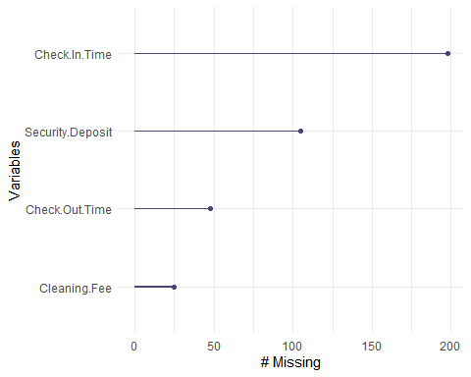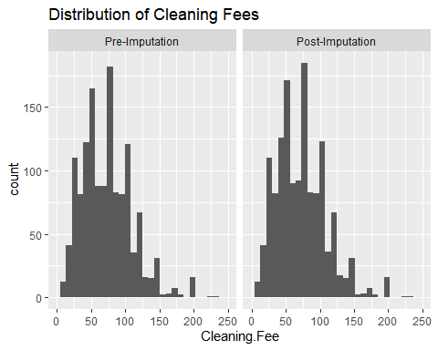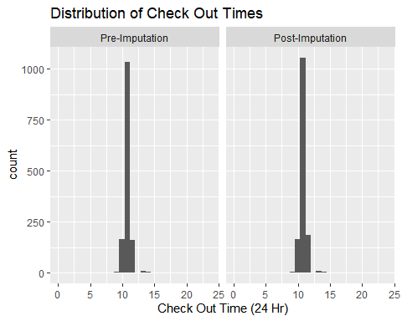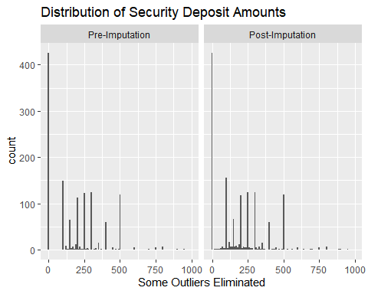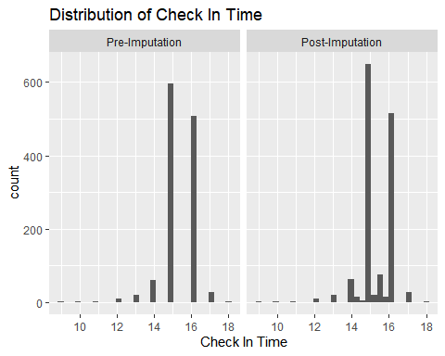

#ANOVA Drops ANOVA testing was used to eliminate zipcode and city on the basis of inadquate variance. “is_location_exact”, “description_locale”, “require_guest_phone_verification”, “instant_bookable” and “require_guest_phone_verification” were dropped for similar reasons.

summary(aov(rental_income ~ zipcode , data = df_l0))

## Df Sum Sq Mean Sq F value Pr(>F)  
## zipcode 1 7.099e+05 709879 0.344 0.558  
## Residuals 1472 3.036e+09 2062656   
## 23 observations deleted due to missingness

summary(aov(price ~ zipcode , data = df_l0))

## Df Sum Sq Mean Sq F value Pr(>F)  
## zipcode 1 17048 17048 0.912 0.34  
## Residuals 1495 27936925 18687

summary(aov(listing_weekend_price_native ~ zipcode , data = df_l0))

## Df Sum Sq Mean Sq F value Pr(>F)  
## zipcode 1 33414 33414 1.735 0.188  
## Residuals 689 13269497 19259   
## 806 observations deleted due to missingness

summary(aov(rental_income ~ city , data = df_l0))

## Df Sum Sq Mean Sq F value Pr(>F)  
## city 7 9.796e+06 1399453 0.678 0.691  
## Residuals 1466 3.027e+09 2064900   
## 23 observations deleted due to missingness

summary(aov(price ~ city , data = df_l0))

## Df Sum Sq Mean Sq F value Pr(>F)  
## city 7 23892 3413 0.182 0.989  
## Residuals 1489 27930081 18758

summary(aov(listing_weekend_price_native ~ city , data = df_l0))

## Df Sum Sq Mean Sq F value Pr(>F)  
## city 5 47998 9600 0.496 0.779  
## Residuals 685 13254913 19350   
## 806 observations deleted due to missingness

summary(aov(rental_income ~ city , data = df_l0))

## Df Sum Sq Mean Sq F value Pr(>F)  
## city 7 9.796e+06 1399453 0.678 0.691  
## Residuals 1466 3.027e+09 2064900   
## 23 observations deleted due to missingness

summary(aov(price ~ city , data = df_l0))

## Df Sum Sq Mean Sq F value Pr(>F)  
## city 7 23892 3413 0.182 0.989  
## Residuals 1489 27930081 18758

summary(aov(listing_weekend_price_native ~ city , data = df_l0))

## Df Sum Sq Mean Sq F value Pr(>F)  
## city 5 47998 9600 0.496 0.779  
## Residuals 685 13254913 19350   
## 806 observations deleted due to missingness

summary(aov(rental_income ~ bed_type_category , data = df_l0))

## Df Sum Sq Mean Sq F value Pr(>F)  
## bed_type_category 3 5.061e+06 1686902 0.818 0.484  
## Residuals 1470 3.032e+09 2062503   
## 23 observations deleted due to missingness

summary(aov(price ~ bed_type_category , data = df_l0))

## Df Sum Sq Mean Sq F value Pr(>F)  
## bed_type_category 3 23589 7863 0.42 0.738  
## Residuals 1493 27930384 18708

summary(aov(listing_weekend_price_native ~ bed_type_category , data = df_l0))

## Df Sum Sq Mean Sq F value Pr(>F)  
## bed_type_category 2 47668 23834 1.237 0.291  
## Residuals 688 13255243 19266   
## 806 observations deleted due to missingness

summary(aov(occupancy ~ bed_type_category , data = df_l0))

## Df Sum Sq Mean Sq F value Pr(>F)  
## bed_type_category 3 1856 618.6 1.134 0.334  
## Residuals 1469 801543 545.6   
## 24 observations deleted due to missingness

summary(aov(rental_income ~ require_guest_phone_verification , data = df_l0))

## Df Sum Sq Mean Sq F value Pr(>F)  
## require_guest_phone_verification 1 1.046e+05 104621 0.051 0.822  
## Residuals 1472 3.037e+09 2063067   
## 23 observations deleted due to missingness

summary(aov(price ~ require_guest_phone_verification , data = df_l0))

## Df Sum Sq Mean Sq F value Pr(>F)  
## require_guest_phone_verification 1 1158 1158 0.062 0.804  
## Residuals 1495 27952815 18698

summary(aov(listing_weekend_price_native ~ require_guest_phone_verification , data = df_l0))

## Df Sum Sq Mean Sq F value Pr(>F)  
## require_guest_phone_verification 1 73 73 0.004 0.951  
## Residuals 689 13302839 19307   
## 806 observations deleted due to missingness

summary(aov(occupancy ~ require_guest_phone_verification , data = df_l0))

## Df Sum Sq Mean Sq F value Pr(>F)  
## require_guest_phone_verification 1 98 97.5 0.179 0.673  
## Residuals 1471 803302 546.1   
## 24 observations deleted due to missingness

summary(aov(rental_income ~ is_location_exact , data = df_l0))

## Df Sum Sq Mean Sq F value Pr(>F)  
## is_location_exact 1 1.162e+05 116193 0.056 0.812  
## Residuals 1472 3.037e+09 2063059   
## 23 observations deleted due to missingness

summary(aov(price ~ is_location_exact , data = df_l0))

## Df Sum Sq Mean Sq F value Pr(>F)  
## is_location_exact 1 43086 43086 2.308 0.129  
## Residuals 1495 27910887 18669

summary(aov(listing_weekend_price_native ~ is_location_exact , data = df_l0))

## Df Sum Sq Mean Sq F value Pr(>F)   
## is_location_exact 1 63490 63490 3.304 0.0695 .  
## Residuals 689 13239422 19215   
## ---  
## Signif. codes: 0 '***' 0.001 '**' 0.01 '*' 0.05 '.' 0.1 ' ' 1  
## 806 observations deleted due to missingness

summary(aov(occupancy ~ is_location_exact , data = df_l0))

## Df Sum Sq Mean Sq F value Pr(>F)  
## is_location_exact 1 1154 1153.9 2.116 0.146  
## Residuals 1471 802245 545.4   
## 24 observations deleted due to missingness

summary(aov(rental_income ~ instant_bookable , data = df_l0))

## Df Sum Sq Mean Sq F value Pr(>F)  
## instant_bookable 1 8.784e+05 878350 0.426 0.514  
## Residuals 1472 3.036e+09 2062542   
## 23 observations deleted due to missingness

summary(aov(price ~ instant_bookable , data = df_l0))

## Df Sum Sq Mean Sq F value Pr(>F)  
## instant_bookable 1 24200 24200 1.295 0.255  
## Residuals 1495 27929773 18682

summary(aov(listing_weekend_price_native ~ instant_bookable , data = df_l0))

## Df Sum Sq Mean Sq F value Pr(>F)   
## instant_bookable 1 222901 222901 11.74 0.000648 ***  
## Residuals 689 13080010 18984   
## ---  
## Signif. codes: 0 '***' 0.001 '**' 0.01 '*' 0.05 '.' 0.1 ' ' 1  
## 806 observations deleted due to missingness

summary(aov(occupancy ~ instant_bookable , data = df_l0))

## Df Sum Sq Mean Sq F value Pr(>F)  
## instant_bookable 1 103 103.0 0.189 0.664  
## Residuals 1471 803296 546.1   
## 24 observations deleted due to missingness

summary(aov(rental_income ~ require_guest_profile_picture , data = df_l0))

## Df Sum Sq Mean Sq F value Pr(>F)  
## require_guest_profile_picture 1 2.020e+05 201993 0.098 0.754  
## Residuals 1472 3.037e+09 2063001   
## 23 observations deleted due to missingness

summary(aov(price ~ require_guest_profile_picture , data = df_l0))

## Df Sum Sq Mean Sq F value Pr(>F)  
## require_guest_profile_picture 1 59 59 0.003 0.955  
## Residuals 1495 27953913 18698

summary(aov(listing_weekend_price_native ~ require_guest_profile_picture , data = df_l0))

## Df Sum Sq Mean Sq F value Pr(>F)  
## require_guest_profile_picture 1 341 341 0.018 0.894  
## Residuals 689 13302570 19307   
## 806 observations deleted due to missingness

summary(aov(occupancy ~ require_guest_profile_picture , data = df_l0))

## Df Sum Sq Mean Sq F value Pr(>F)  
## require_guest_profile_picture 1 435 435.1 0.797 0.372  
## Residuals 1471 802964 545.9   
## 24 observations deleted due to missingness

summary(aov(rental_income ~ description_locale , data = df_l0))

## Df Sum Sq Mean Sq F value Pr(>F)  
## description_locale 4 9.158e+06 2289568 1.111 0.35  
## Residuals 1469 3.028e+09 2061117   
## 23 observations deleted due to missingness

summary(aov(price ~ description_locale , data = df_l0))

## Df Sum Sq Mean Sq F value Pr(>F)  
## description_locale 4 25500 6375 0.341 0.851  
## Residuals 1492 27928472 18719

summary(aov(listing_weekend_price_native ~ description_locale , data = df_l0))

## Df Sum Sq Mean Sq F value Pr(>F)  
## description_locale 3 11095 3698 0.191 0.902  
## Residuals 687 13291817 19348   
## 806 observations deleted due to missingness

summary(aov(occupancy ~ description_locale , data = df_l0))

## Df Sum Sq Mean Sq F value Pr(>F)  
## description_locale 4 4049 1012.2 1.859 0.115  
## Residuals 1468 799350 544.5   
## 24 observations deleted due to missingness

summary(aov(rental_income ~ locale , data = df_l0))

## Df Sum Sq Mean Sq F value Pr(>F)   
## locale 7 8.196e+07 11707967 5.808 1.17e-06 ***  
## Residuals 1466 2.955e+09 2015678   
## ---  
## Signif. codes: 0 '***' 0.001 '**' 0.01 '*' 0.05 '.' 0.1 ' ' 1  
## 23 observations deleted due to missingness

summary(aov(price ~ locale , data = df_l0))

## Df Sum Sq Mean Sq F value Pr(>F)  
## locale 7 122317 17474 0.935 0.478  
## Residuals 1489 27831656 18692

summary(aov(listing_weekend_price_native ~ locale , data = df_l0))

## Df Sum Sq Mean Sq F value Pr(>F)   
## locale 5 260917 52183 2.741 0.0184 *  
## Residuals 685 13041994 19039   
## ---  
## Signif. codes: 0 '***' 0.001 '**' 0.01 '*' 0.05 '.' 0.1 ' ' 1  
## 806 observations deleted due to missingness

summary(aov(occupancy ~ locale , data = df_l0))

## Df Sum Sq Mean Sq F value Pr(>F)  
## locale 7 3443 491.8 0.901 0.505  
## Residuals 1465 799957 546.0   
## 24 observations deleted due to missingness

summary(aov(rental_income ~ max_nights , data = df_l0))

## Df Sum Sq Mean Sq F value Pr(>F)  
## max_nights 1 2.035e+05 203533 0.099 0.753  
## Residuals 1472 3.037e+09 2063000   
## 23 observations deleted due to missingness

summary(aov(price ~ max_nights , data = df_l0))

## Df Sum Sq Mean Sq F value Pr(>F)   
## max_nights 1 53006 53006 2.84 0.0921 .  
## Residuals 1495 27900967 18663   
## ---  
## Signif. codes: 0 '***' 0.001 '**' 0.01 '*' 0.05 '.' 0.1 ' ' 1

summary(aov(listing_weekend_price_native ~ max_nights , data = df_l0))

## Df Sum Sq Mean Sq F value Pr(>F)  
## max_nights 1 25205 25205 1.308 0.253  
## Residuals 689 13277706 19271   
## 806 observations deleted due to missingness

summary(aov(occupancy ~ max_nights , data = df_l0))

## Df Sum Sq Mean Sq F value Pr(>F)   
## max_nights 1 1500 1500.4 2.752 0.0973 .  
## Residuals 1471 801899 545.1   
## ---  
## Signif. codes: 0 '***' 0.001 '**' 0.01 '*' 0.05 '.' 0.1 ' ' 1  
## 24 observations deleted due to missingness

In order to improve modeling on non-tree models I dropped amenities with near-zero variance, listed below.

## [1] "Amazon.Echo" "Balcony"   
## [3] "Day.bed" "Espresso.machine"   
## [5] "Fire.pit" "Firm.mattress"   
## [7] "Fixed.grab.bars.for.shower" "Hand.Sanitiser"   
## [9] "Handheld.shower.head" "Heat.lamps"   
## [11] "Heated.floors" "Jetted.tub"   
## [13] "Mudroom" "Murphy.bed"   
## [15] "Nespresso.machine" "Other.pet.s."   
## [17] "Outdoor.parking" "Piano"   
## [19] "Pillow.top.mattress" "Playground"   
## [21] "Printer" "Record.player"   
## [23] "Roll.in.shower" "Terrace"   
## [25] "Trash.compacter" "Wide.doorway.to.guest.bathroom"  
## [27] "Wide.entryway"