# Invoice

# Invoice Information

Invoice No: 12345

Date: 2022-09-05

Due Date: 2022-10-05

# Billing Information

Name: ODA

Address: 4 New St., Toronto

# Items

|  |  |  |  |
| --- | --- | --- | --- |
| **Description** | **Hours** | **Rate** | **Amount** |
| Fix CDA list 2022-2023 | 3.0 | 75.0 | 225.0 |
| Venngo member list | 4.0 | 75.0 | 300.0 |
| New member's list | 4.0 | 75.0 | 300.0 |

|  |  |
| --- | --- |
| Subtotal | 825.0 |
| Sales Tax | 107.25 |
| **Total** | **932.25** |
| **Amount Paid** | **0.0** |
| **Amount Due** | **932.25** |

**Signature**

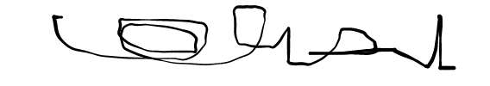

**Nitin Prakash Panicker**

**for: Sopanam Technologies Inc.**