CryptoVehicles: Blockchain based Secure Communication in VANETs

A PROJECT REPORT

Submitted in partial fulfillment of the requirements for the award of the degree of

Bachelor of Technology

in

COMPUTER SCIENCE AND ENGINEERING

BY
Katta Monika Nalla Phani Srujana
(21331A0583) (21331A05C5)
Mulaga Narendra Kumarapu Sai Vardhan
(21331A05B9) (21331A05A1) Gemmela Rambha
(22335A0507)

Under the Supervision of

Dr. C. Kalyana Chakravarthy
Professor, Department of CSE



DEPARTMENT OF COMPUTER SCIENCE AND ENGINEERING

MAHARAJ VIJAYARAM GAJAPATHI RAJ COLLEGE OF ENGINEERING (Autonomous)

(Approved by AICTE, New Delhi, and permanently affiliated to JNTUGV, Vizianagaram), Listed u/s 2(f) & 12(B) of UGC Act 1956.

Vijayaram Nagar Campus, Chintalavalasa,Vizianagaram-535005, Andhra Pradesh

APRIL, 2025

CERTIFICATE



This is to certify that the project report entitled “CRYPTOVEHICLES : BLOCKCHAIN BASED SECURE COMMUNICATION IN VANETS” being submitted by K.Monika(21331A0583), N.Phani Srujana(21331A05C5), M.Narendra(21331A05B9), K.Sai Vardhan(21331A05A1), G.Rambha(22335A0507)in partial fulfillment for the award of the degree of “Bachelor of Technology” in Computer Science and Engineering is a record of Bonafide work done by them under my supervision during the academic year 2024-2025.

Dr. C. Kalyana Chakravarthy Dr. T. Pavan Kumar
Professor, Professor,
Supervisor, Head of the Department,
Department of CSE, Department of CSE,
MVGR College of Engineering(A), MVGR College of Engineering(A),
Vizianagaram. Vizianagaram.

External Examiner

DECLARATION

We hereby declare that the work done on the dissertation entitled “CRYPTOVEHICLES : BLOCKCHAIN BASED SECURE COMMUNICATION IN VANETS” has been carried out by us and submitted in partial fulfilment for the award of credits in Bachelor of Technology in Computer Science and Engineering of MVGR College of Engineering (Autonomous) and affiliated to JNTUGV, Vizianagaram. The various contents incorporated in the dissertation have not been submitted for the award of any degree of any other institution or university.

ACKNOWLEDGEMENTS

We express our sincere gratitude to Dr. C. Kalyana Chakravarthy for his invaluable guidance and support as our mentor throughout the project. His unwavering commitment to excellence and constructive feedback motivated us to achieve our project goals. We are greatly indebted to him for his exceptional guidance.

Additionally, we extend our thanks to Prof. P.S. Sitharama Raju (Director), Prof. Ramakrishnan Ramesh (Principal), and Dr. T. Pavan Kumar (Head of the Department) for their unwavering support and assistance, which were instrumental in the successful completion of the project. We also acknowledge the dedicated assistance provided by all the staff members in the Department of Computer Science & Engineering. Finally, we appreciate the contributions of all those who directly or indirectly contributed to the successful execution of this endeavour.

Katta Monika (21331A0583)
Nalla Phani Srujana (21331A05C5)
Mulaga Narendra (21331A05B9)
Kumarapu Sai Vardhan (21331A05A1)
Gemmela Rambha (22335A0507)

LAST MILE EXPERIENCE (LME)
PROJECT TITLE
CRYPTOVEHICLES:
BLOCKCHAIN BASED SECURE COMMUNICATION IN VANETS
Project Objectives
- PO1: Develop a blockchain-based authentication scheme to ensure secure and anonymous communication between vehicles and RSUs.
- PO2: Implement a trust model to evaluate vehicle credibility and detect malicious nodes.
- PO3: Integrate the authentication and trust model with Ethereum smart contracts for enhanced security and auditability.


Name:
Dr. C. Kalyana Chakravarthy
Designation: Professor
Email: kalyan@mvgrce.edu.in
Contact Number:
9848129319
Project Supervisor


Name: Katta Monika
Email: kattamonika25@gmail.com
Contact Number:
8688579394

Name: Nalla Phani Srujana
Email: npsrujana27@gmail.com
Contact Number:
8978615692

Name: Mulaga Narendra
Email: narendramulaga98@gmail.com
Contact Number:
7013293427

Name: Kumarapu Sai Vardhan
Email:saivardhankumarapu@gmail.com
Contact Number: 7993197282

Name: Gemmela Rambha
Email: rambhagemmela5@gmail.com
Contact Number: 9959788773

End Users of Your Solution
Government and Transport Authorities,
Vehicle users
List the Program Outcomes (POs) that are being met by doing the project work
PO4: Individual and teamwork | Function effectively as an individual, and as a member or leader in diverse teams and in multi-disciplinary settings.
PO5: Communication | Communicate effectively on complex engineering activities with the engineering community and society at large, such as being able to comprehend and write effective reports and design documentation, make effective presentations, and give and receive clear instructions.
PO6: Project management and finance | Demonstrate knowledge and understanding of engineering management principles and economic decision-making and apply these to one’s own work as a member and leader in a team, to manage projects and in multi-disciplinary environments.
PO7: Life-long learning | Recognize the need for, and have the preparation and ability to engage in, independent and life-long learning in the broadest context of technological change.

How your solution helping the domains?
The solution strengthens cybersecurity, blockchain security, and IoT-enabled smart transportation by preventing data tampering, detecting malicious vehicles, and enabling real-time, trust-based decision-making. It ensures secure, scalable, and efficient vehicular communication for intelligent road networks.
BATCH NUMBER – 1B
BATCH SIZE – 5
DEPARTMENT OF COMPUTER SCIENCE AND ENGINEERING

Project Outcomes
- Overall Project Outcome:

The project enhances the security and reliability of vehicular communication, enabling trustworthy data exchange in VANETs. It provides a scalable, efficient, and tamper-proof solution for future intelligent transportation systems, making roads safer and smarter.

Domain of Specialisation
Blockchain Technology,
Vehicular Ad-Hoc Networks (VANETs)
ABSTRACT

The project “CryptoVehicles: Blockchain-Based Secure Communication in VANETs” presents a comprehensive framework that leverages the decentralized, immutable, and transparent nature of blockchain technology to enhance the security of Vehicular Ad Hoc Network (VANET) communications. By integrating Ethereum smart contracts and deploying them through Web3, the project ensures automated, secure, and tamper-proof transactions in real-time. This approach addresses the inherent limitations of centralized systems, such as susceptibility to tampering and inefficiency, while facilitating efficient and robust communication. Additionally, CryptoVehicles incorporates a trust model that evaluates the reliability of vehicle-generated messages using a trust computation mechanism based on historical behaviour. This model enables Roadside Units (RSUs) to assess the credibility of received reports and filter out malicious or misleading information or nodes, ensuring that only trustworthy messages are propagated within the network. By combining blockchain-based authentication with trust evaluation, CryptoVehicles enhances the resilience of VANETs against security threats and contributes to the advancement of safer and more intelligent transportation systems.

CONTENTS

Page No
List of Abbreviations 1
List of Figures 2
List of Tables 3
1. Introduction 4
1.1 Identification of seriousness of the problem 5
1.2 Problem definition 5
1.3 Objective 5
1.4 Existing models 6
2. Literature Survey 7
3. Theoretical Background 11
3.1 VANETs 11
3.1.1 What are VANETs 11
3.1.2 Why VANETs 12
3.2. Blockchain 12
3.2.1 What is Blockchain 12
3.2.2 Why Blockchain 13
3.3 Cryptographic Methods used 13
3.3.1 ECDSA 13
3.3.2 Keccak hash function 14
3.3.3 Ecrecover 15
3.4 Confusion matrix and its metrics 15
3.4.1 Confusion matrix 15
3.4.2 Metrics- Accuracy, Precision, Recall, F1 Score, FPR, FNR 16
4.Proposed Work 17
4.1. Flowchart of Proposed System 17
4.2 Components of Network Model 18
4.2.1 Trusted Authority (TA) 18
4.2.2 Roadside Units (RSUs) 19
4.2.3 Vehicles 19
4.3 Data Structure of the Proposed Blockchain 19
4.3.1 Data Structure of the Authentication Blockchain 19
4.4 Trust Computation Model 20
4.4.1 Dynamic Trust 20
4.4.2 Attacker Model 21
5.System Design 22
5.1 High-Level Architecture 22
5.2 Low-Level Architecture 23
5.2.1 Vehicle Registration 23
5.2.2 Vehicle Authentication 24
5.2.3 Secure Message Transmission 24
5.2.4 Trust Evaluation and blockchain update 25
5.2.5 Malicious Vehicle Detection 25
6.Implementation 27
6.1 Blockchain-Based Authentication System 27
6.1.1 Smart Contract Deployment 27
6.1.2 Vehicle Registration 27
6.1.3 Vehicle Authentication 27
6.1.4 Message Authentication 28
6.1.5 Blockchain Data Storage 28
6.2 Trust Computation Model Implementation 29
6.2.1 Packet Forwarding Ratio 29
6.2.2 Packet Forwarding Delay 29
6.3 System Integration and Testing 30
7.Testing 31
7.1 Testing Authentication model 31
7.2 Testing Trust Model 36
8. Results 40
9.Conclusion 42
References 43
Appendix A: Packages, Tools Used & Working Process 45
Solidity Programming Language 45
Python Programming Language 45
Libraries and Packages 46
Web3 46
NumPy 46
Pandas 46 Matplotlib 47
Sklearn 47
Tools used 48
Remix IDE 48
Google Colab 48
Sepolia 48
Ethereum 49
Appendix B: Source Code 50
List of Abbreviations
VANET - Vehicular Ad Hoc NETwork
MANET - Mobile Ad Hoc NETwork
ITS - Intelligent Transportation System
V2V - Vehicle-to-Vehicle
V2I - Vehicle-to-Infrastructure
RSU - Road Side Unit
TA - Trusted Authority
OBU - On Board Unit
PKI - Public Key Infrastructure
CPPA - Conditional Privacy Preserving Authentication
PKG - Private Key Generator
DSRC - Dedicated Short Range Communication
RID - Real Identity
PID - Pseudo Identity
MVM - Motor Vehicle’s Manufacturer
CMT - Chronological Merkle Tree
ECDSA - Elliptical Curve Digital Signature Algorithm
ECC - Elliptic Curve Cryptography
PFR - Packet Forwarding Ratio
PFD - Packet Forwarding Delay
IDE - Integrated Development Environment
CSV - Comma Separated Values
TP - True positive
TN - True Negative
FP - False Positive
FN - False Negative
TPR - True Positive Rate
FPR - False Positive Rate
FNR - False Negative Rate
PoW - Proof of Work
PoS - Proof of Stake

List of Figures

Figure 3.1.1 : VANET Architecture
Figure 3.4.1 : Confusion matrix with 4 parameters
Figure 4.1 : Flowchart of proposed Solution
Figure 4.2 : Network Model
Figure 4.3 : Data Structure of the Authentication Blockchain
Figure 5.1 : Flow of modules in the system
Figure 5.2 : Sequence diagram of message exchange b/w Vehicle, RSU and TA
Figure 5.2.1 : Vehicle Registration of proposed system
Figure 5.2.2 : Vehicle authentication of proposed system
Figure 5.2.3 : Message authentication of proposed system
Figure 5.2.4 : Trust calculation of proposed system
Figure 7.1.1 : Deployment of authentication blockchain successful
Figure 7.1.2 : Contracts deployed
Figure 7.1.3 : Metamask Sepolia account
Figure 7.1.4 : Address of Trusted Authority
Figure 7.1.5 : Registration of a vehicle successful
Figure 7.1.6 : Pseudonym Generation
Figure 7.1.7 : Checking Registration status
Figure 7.1.8 : Successful authentication of a vehicle
Figure 7.1.9 : Updating root value of CMT
Figure 7.1.10 : Authentication of a message successful
Figure 7.1.11 : Trying to register a registered vehicle
Figure7.1.12 : Some of the transactions in a blockchain
Figure 7.1.13 : Gas Usage per Transaction
Figure 7.1.14 : Execution Time for Recorded blocks
Figure 7.2.1 : Calculated values of Trust, PFR, PFD
Figure 7.2.2 : Trust Scores of vehicles
Figure 7.2.3 : Packet loss ratio of vehicles
Figure 7.2.4 : Packet Forwarding ratio of vehicles
Figure 7.2.5 : Packet Forwarding Delay of vehicles
Figure 7.2.6 : Evaluation metrics of trust model
List of Tables
Table 8.1 : Results of Performance metrics of trust model

CHAPTER 1
INTRODUCTION

In intelligent transportation systems (ITS), Vehicular Ad Hoc Networks (VANETs) play a crucial role in facilitating real-time vehicle-to-vehicle (V2V) and vehicle-to-infrastructure (V2I) communication. With the assistance of smooth data exchange, VANETs enhance road safety, optimize traffic, and facilitate new applications such as autonomous driving and smart mobility services. However, owing to the highly dynamic and open nature of VANETs, they are vulnerable to severe security and privacy attacks such as message tampering, identity spoofing, Sybil attacks, and unauthorized vehicle tracking. These attacks undermine trust among network entities and hinder the large-scale deployment of VANET-based solutions.

Conventional security models, based on centralized authentication authorities, are severely limited by scalability, single points of failure, and vulnerability to cyberattacks. CryptoVehicles overcomes such limitations with a blockchain-based model that provides secure, decentralized, and privacy-preserving communication for VANETs. Utilization of Ethereum smart contracts and cryptographic protocols, CryptoVehicles provides a tamper-proof trust management system, secure message exchange, and automated vehicular transactions. Decentralized blockchain technology eliminates the need for centralized authorities, and the network becomes more resilient with user anonymity being maintained.

This project explains the use of blockchain technology in VANETs to provide efficient security, real-time establishment of trust, and efficient transaction processing. Based on the use of smart contracts, CryptoVehicles provides self-executing contracts for secure data exchange, payment automation (for example tolls, parking, and charging), and reputation management. This proposed approach aims to enhance vehicular network security, efficiency, and privacy and further drive next-generation intelligent transportation systems.

  - Identification of seriousness of the problem
Vehicular Ad Hoc Networks (VANETs) play a crucial role in modern intelligent transportation systems, enabling seamless vehicular communication. However, their open and dynamic nature exposes them to critical security and privacy vulnerabilities, which can lead to attacks such as identity spoofing, message tampering, Sybil attacks. These breaches compromise the integrity of vehicular communication and pose threats to road safety, potentially leading to accidents, traffic disruptions, and loss of life.

Traditional centralized authentication models struggle to mitigate these risks, leading to widespread network failures and potential security breaches. The reliance on third-party entities for identity verification increases the risk of privacy violations, as sensitive location and behavioral data can be exploited for surveillance or unauthorized tracking. Given the increasing reliance on vehicular communication, these security flaws demand urgent and robust solutions. The adoption of blockchain-based security mechanisms is essential to safeguard the integrity, efficiency, and privacy of vehicular communications, contributing to safer and more reliable intelligent transportation systems.

  - Problem definition
Ensuring secure and trustworthy communication in Vehicular Ad Hoc Networks (VANETs) is a significant challenge due to their dynamic nature, reliance on wireless communication, and susceptibility to various security threats like message tampering and spoofing. Current security mechanisms are prone to being unable to provide robust protection and scalability for these networks. The problem lies in the lack of a decentralized and efficient security framework capable of guaranteeing message integrity, authenticity, and controlled access (restricting participation to authorized vehicles and infrastructure) while flexible to provide the high mobility and transaction volume demands of VANETs. This project aims to address this situation by exploring the application of blockchain technology to establish a more secure and reliable communication environment for VANETs.

  - Objective
The main goal of this project is to use blockchain technology to build and experiment with a secure message system for VANETs, to ensure real-time communication between infrastructure and vehicles, etc. One of the main goals is to enhance the whole safety of vehicular networking communications through the usage of decentralized trust management system using Blockchain. Also uses smart contracts to automate some messaging processes and operations in the VANET. The system will be able to show resilience against a set of attacks on VANET messaging systems as well as providing an immutable communication audit record that enhances accountability and transparency.

This research aims to design and implement a blockchain-based authentication and trust framework for VANETs, with the following key objectives:
- Develop an authentication scheme that ensures secure and anonymous vehicle communication using a Chronological Merkle Tree (CMT).
- Implement a trust model to evaluate the trustworthiness of vehicle nodes and prevent the propagation of false messages.
- Integrate the authentication and trust model with Ethereum smart contracts for enhanced security and auditability.
- Incorporate packet forwarding ratio and delay as key parameters in trust evaluation to accurately measure vehicle reliability.
- Evaluate the performance of the proposed solution based on event detection accuracy, time consumption etc.

  - Existing models
Several authentication and trust models have been proposed for VANET security. Traditional models rely on Public Key Infrastructure (PKI) for authentication, where vehicles obtain digital certificates from a central authority. However, PKI-based approaches suffer from certificate revocation challenges and single points of failure. Trust-based models evaluate vehicle behavior using historical data and reputation scores, but they often struggle with false positives and long convergence times. Recent advancements leverage blockchain for decentralized security, providing immutability and transparency. However, existing blockchain-based models often face high latency and storage overhead. This research proposes an optimized approach that combines blockchain with efficient data structures to address these limitations.

CHAPTER 2
LITERATURE SURVEY
There have been numerous security schemes proposed by various researchers to address the security and privacy issues in VANETs. This section highlights some of the existing approaches that focused on similar problems in VANET using similar techniques to the proposed solution.

[1]Ahmed et al. (2022) presented a privacy-preserving blockchain-based authentication and trust management in VANETs. Their paper illustrates how blockchain provides data integrity, unauthorized access prevention, and anonymity to users. Blockchain's decentralized property eliminates the central authority, thus minimizing single points of failure and maximizing security. This paper introduces blockchain as an advantageous technology which highlights the decentralization that helps score security. Therefore, according to this paper, all the past communication ledgers (audit trails) are stored as records along with the vehicle information helping in preventing unauthorized changes in the messages sent. This paper also shows a pseudonym-based authentication where each value is assigned to a unique cryptographic identity instead of showing real identity and hence ensuring privacy preservation. The trust evaluation is implemented too, so as to check the behavior of each vehicle involved. Vehicles that are with low trust scores are not approved of further communication. This system also integrates Ethereum smart contracts which verifies vehicle identities, and authenticates communication without the need of a central system, making it decentralized. Also Proof-of-Authority is the algorithm used for Consensus to detect fake identities, data manipulation.

[2]Khan et al. (2019) presented a trust-based blockchain architecture to avoid attacks in VANETs. The research points out the ways in which blockchain's transparency and cryptographic operations help prevent malicious practices like Sybil attacks and message tampering. The architecture makes use of smart contracts for automatic trust assessment and access control policy enforcement. And the main purpose of this paper is to address limitations, for example the message tampering, and they proposed that using Blockchain technology, a decentralized trust-based architecture is introduced such that this mechanism also integrates a trust evaluation, with an immutable ledger so as to secure the communication data to be stored on the network. This approach helps in preventing malicious nodes from spreading false data and to increase reliability of the VANETs. Therefore, for this approach, the main advantages are decentralization, immutability to prevent message tampering, and to enhance security to protect the data against sybil attacks, and to handle large-scale data in the VANET environment thus enhancing the scalability.

[3]Huszti et al. (2023) discussed blockchain-based messaging applications for VANETs. They utilized the decentralized nature of blockchain to guarantee secure and tamper-proof messaging. This solution not only promotes data integrity but also optimizes the efficiency of communication between vehicles and infrastructure. The main advantages of this approach are security from message tampering, false data injection, etc. Therefore considering this as the main challenge, along with unauthorized modification of messages, this approach formed a solution by using Blockchain to ensure security with decentralized message storing, therefore making the data tamper-proof and immutable. The vehicle authentication here uses Blockchain as every vehicle is assigned to a unique cryptographic identity, and whenever a vehicle sends a message, it is digitally signed and verified by the blockchain network. For message validation, smart contracts are used to automatically validate the authenticity of a message and verify it by checking if the message is from a trusted vehicle. In case of a false message the system detects and blocks the vehicle from sending further messages. This is identified by the trust score, for each vehicle. This approach is mainly advantageous for real time attack detection, as it detects Sybil attacks and false data injection.

[4]Ravi et al. (2021) proposed a thorough framework for securing VANETs through blockchain. The research indicates the benefits of blockchain in data privacy, vehicular identity authentication, and secure data sharing. The framework also tackles scalability and latency issues with efficient consensus mechanisms. This paper identifies the main challenges in VANETs are Sybil attacks, message tampering and data modifications, and no decentralized system for data storage. This paper shows that the solution to all these challenges is to maintain a Blockchain based Secure communication system for VANETs where the vehicle communication data is stored in an immutable decentralized blockchain ledger to prevent unauthorized access and data manipulation. This paper shows the blockchain is used for data security, making the data tamper-proof. Each vehicle is assigned to a unique cryptographic identity, which is verified by the blockchain network, to prevent Sybil attacks. Here, Ethereum based smart contracts are used to automate vehicle authentication, verify the message source(the vehicle) and then detect malicious nodes. If the malicious node is identified, it will be blocked for further communication. Consensus mechanism is used here for attack detection. So Proof-of-Work is the algorithm used to implement the consensus, and therefore detecting false data injection and to therefore prevent unauthorized message modification. This shows that the use of smart contracts and the decentralized trust management enhances real-time authentication of vehicles and improves overall security of VANETs communication.

[5]Rasheed et al. (2017) performed a survey on VANETs, defining the major challenges and uses. Their paper highlights secure communication, trust management, and privacy preservation, which are the strengths of blockchain. With blockchain technology, VANETs can outlast data tampering, attacks from malicious nodes, and untrustworthy message transmission. Blockchain also promotes effective data sharing and enhances traffic management by authenticating the messages and secure identity management. According to this paper, the challenges in VANETs such as high mobility leading to network disconnections, security threats such as message tampering, scalability issues to handle huge number of vehicles, real time communication especially for emergency messages, and no proper mechanism for trust management are the major challenges that are needed to be addressed. This also states that the traditional methods are failing in addressing such challenges because of having centralized servers which are often prone to be hacked and the data to be manipulated, and that there is no proper trust management system to detect fake messages, and the lack of real-time communication that leads to delayed traffic alerts in case of emergencies. Therefore this paper explains about VANETs, and the problems that they face in real time.

[6]Lu et al. (2018) proposed a Privacy-preserving trust model for VANETs (Vehicular Ad-Hoc Networks) using Blockchain technology to enhance security, privacy and trust management. This paper highlights the major issues in VANETs communication, as how to verify trustworthiness of a vehicle whilst the details being private, how to prevent data tampering, and how to secure communication in VANETs and their proposed solution is to introduce blockchain for trust management by maintaining trust scores for each of the vehicle and an immutable decentralized ledger, to prevent data tampering or false message injection. This model ensures privacy by using pseudonyms which are temporary IDs to make sure the actual identity of the driver is hidden, and to evaluate trust score for each of the vehicles, based on the past communication of the vehicles. Vehicles, therefore with a low trust score are blocked from the network and trusted vehicles are allowed to share the traffic data. This approach uses this unique idea of Zero-Knowledge Proof(ZKP) for Privacy Preservation, which is to prove their trustiness without revealing their sensitive information, such as location or identity. In conclusion, this approach has major advantages as preventing Sybil attacks and data tampering, ensuring secure communication without revealing the vehicle’s sensitive information, and improves the trust management through decentralized blockchain storage, therefore clearing up some of the major challenges in the environment of VANETs.

[7]Raya et al. introduced the concept of conditional privacy-preserving authentication (CPPA) in order to solve the security and privacy issues in VANETs. They demonstrated how to use a modified PKI to implement a practical CPPA protocol based on anonymous certificates. In this scheme, a large number of certificates and public/private key pairs are installed into vehicle onboard units (OBUs) to hide the vehicle's real identity and achieve anonymous authentication. The CPPA protocols proposed by Zhang et al. [8] require substantial storage costs for certificates. In fact, key/certificate management complexity is a common weakness in existing CPPA protocols. As a result, CPPA protocols that use ID-based signatures have been developed. Each of these protocols aims at either enhancing existing solutions to meet security criteria or increasing CPPAs performance to support VANET applications.

Integrating blockchain technology into VANETs provides solutions to traditional security and privacy issues. An innovative solution is the utilization of a decentralized blockchain-based trust management framework (BC-TMF). The proposed framework supports vehicles in evaluating the validity of incoming messages in real-time, calculating local trust values for message senders, and publishing these values to network miners. By capitalizing on blockchain's decentralized ledger, BC-TMF provides secure, transparent, and tamper-evident trust assessments, increasing vehicular communications reliability. Another innovation is the Blockchain-based Anonymous Reputation System (BARS) aimed at solving privacy and trust in VANETs.

CHAPTER 3
THEORETICAL BACKGROUND

3.1 VANETs
3.1.1 What are VANETs?
VANETs (Vehicular Ad-Hoc Networks) are ad hoc wireless communication and data sharing networks that may be embedded in vehicles, offering comparable services to office or domestic networks. VANETs are a branch of MANET, with a changing topology and no central node. Vehicular ad-hoc networks are responsible for the communication between moving vehicles in a certain environment.
The two main communication models in VANETs are classified as Vehicle-to-Vehicle (V2V) communication and Vehicle to Infrastructure (V2I). V2V communication is the ability of exchanged transmission between different vehicles while V2I is the communication between the vehicles and the road-side framework. The main communication module consists of Road-Side Unit (RSU), on-board unit (OBU), and trusted authority (TA) as shown in Figure 3.1.1. The RSU unit is fixed and made up of a transceiver that sends and receives information from the OBU and TA.
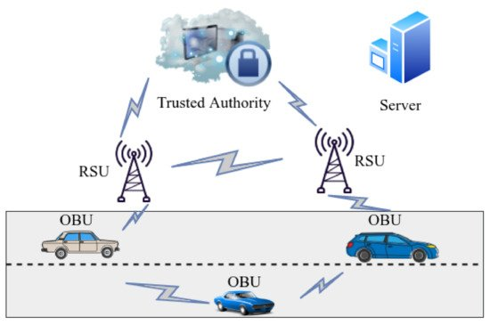
Figure 3.1.1 VANET Architecture

Therefore, it acts as a communication frontier between OBU and TA. RSUs can be placed at key indicators after a particular interlude to provide reliable network coverage and systematic operation. Therefore, the distance between nearby roadside units is kept within the range of each sequential RSU. OBU is fixed in the automobile and works as a central point for receiving, processing, and managing all data developed in the vehicle. It also serves as a source for exchanging data with the OBU of close-by vehicles as well as the RSU. TA is basically the foundation of the whole ITS and is usually connected to the RSU via fiber optic cable or wireless media. It manages the trust and safety of VANETs. TA verifies the entire network components via RSU and identifies the OBU that sends malicious packets and cancels the target node.

3.1.2 Why VANETs?
VANETs (Vehicular Ad-hoc Networks) facilitate road safety as it helps vehicles communicate with other vehicles (V2V), or vehicles communicating with roadside infrastructure (V2I) for communication. A Dedicated Short-Range Communication is a protocol that facilitates such message communication between vehicles and road-side units. The usual messages that are communicated by the vehicles are generally of the traffic conditions of that particular area and other traffic accidents/emergencies. The information transferred between the vehicles must be trustworthy and reliable. Therefore to make sure the messages are actually true about the traffic conditions, the messages are to be communicated among only trusted vehicles, based off on their trust score. In case any malicious vehicle sends a false message, there shouldn’t be any unnecessary traffic regarding their condition. Therefore to overcome this problem and to maintain privacy, this project deals to find a solution.

3.2 BLOCKCHAIN
3.2.1 What is Blockchain?
Blockchain technology is a shared, decentralized, distributed and a digital ledger system that is used to record transactions that are securely linked together through cryptographic hashes. Each block in a blockchain contains a cryptographic hash of the previous block, a timestamp, and transactional data (generally represented by a Merkle tree, where data nodes are represented as leaf nodes). Since each block has the information of the previous block, they form a chain (as in the linked list data structure), with each additional block linking to the ones before it. Therefore, blockchain transactions are resistant to change, because once recorded, the data in the block cannot be changed.
The blockchain is a distributed database that stores records of all transactions or digital events that have occurred and are shared among participants.
The majority of system participants confirm each transaction. It contains every single transaction record. Bitcoin is the most well-known cryptocurrency and a blockchain example. Some examples of blockchains are:
- Public Blockchain: It is a permissionless public ledger on which anyone may join and transact and it is a non-restrictive version of the ledger, with a copy for each peer. This also implies that anyone who has internet access can connect to the public Blockchain.
- Private Blockchain: A blockchain network works in a private setting, such as a confined network, or is managed by a single identity and they are frequently run on a local network within a company or organization rather than being available to anybody who wishes to donate computing power.
- Hybrid Blockchain: Companies who want the best of both worlds employ a hybrid blockchain, which incorporates the benefits of both private and public blockchains and it allows businesses to build a private, authorization system alongside a public, permissionless system, letting them choose who has access to specific data and what data is made public.
- Consortium Blockchain: A consortium blockchain’s consensus procedures are controlled by predetermined nodes. A validator node is in charge of initiating, collecting, and validating transactions. Member nodes can initiate or receive transactions.

3.2.2 Why Blockchain?
Blockchain technology is a powerful tool for VANETs. It provides immutability of the data stored on it and also distributed data storage. The blockchain uses cryptographic primitives and protocols to build the chain. These primitives make the system robust, prevent attacks. The blockchain infrastructure also helps recover from security damages. It reduces the importance of centralized, trusted authorities but cannot replace them completely.

3.3 Cryptographic methods Used
3.3.1 ECDSA
The Elliptic Curve Digital Signature Algorithm (ECDSA) is a Digital Signature Algorithm (DSA) which uses keys derived from elliptic curve cryptography (ECC). It is a particularly efficient equation based on public key cryptography (PKC). ECDSA is used across many security systems, and is popular for use in messaging apps, and is the basis of Bitcoin security. It offers a more efficient and secure alternative to algorithms like RSA and DSA, particularly in a resource-constrained environments. The process how the ECDSA works is:
Key Generation: Here, a private key is randomly generated and a public key is derived from the private key by using a point on the elliptic curve.
Signature scheme: Here the message sent is hashed using a cryptographic hash function, and a random number is generated. The point on the elliptic curve is calculated based on this random number and the generator point(G). So, the signature(r, s) is calculated using the message hash, private key, random number(k), and the co-ordinates of the point R.
Verification: The receiver hashes the message and calculates the public key point based on the signature (r, s) and the generator point G. Therefore, the receiver verifies the signature by checking if the calculated point matches the public key point that is derived from the private key.

3.3.2 Keccak Hash Function
The Keccak-256 hash function, is a cryptographic hash function that takes an input of an arbitrary length and produces a fixed-length output of 256 bits. It is the function used to compute the hashes of Ethereum addresses, transaction IDs, and other important values in the Ethereum ecosystem. Keccak256 is designed to be secure against a wide range of attacks, including preimage attacks, collision attacks, and length extension attacks. It is also efficient, with a relatively low computational cost and a simple implementation. Keccak256 can be used in many different ways in Solidity, depending on your needs. Used to generate unique pseudo-identities PIDs and compute the hashes for CMT nodes. Keccak-256 is a cryptographic hash function, known for its security and efficiency. It generates a 256-bit fixed hash output.
Some other common use cases include:
- Generating random numbers: You can use Keccak256 to generate random numbers by hashing a seed value with a block timestamp or block hash.
- Verifying digital signatures: You can use Keccak256 to verify digital signatures by hashing the signed message and comparing it to the expected hash value.
- Creating unique identifiers: You can use Keccak256 to create unique identifiers for entities in your smart contract, such as tokens or accounts.
Keccak256 is a powerful tool for securing and manipulating data in Solidity smart contracts. Its efficient implementation and strong security guarantees have become a popular choice for developers in the Ethereum ecosystem.

3.3.3 Ecrecover
Ecrecover is an Ethereum-specific function that allows a user to recover the address associated with a signed message. This function is primarily used for authentication, such as when logging into an account or approving a transaction. The ecrecover function works by taking in three parameters: the hash of the original message, its signature, and its signer’s public key. It then uses elliptic curve cryptography to validate that these three pieces of data are valid and match up correctly before returning the signer’s address associated with it. The primary benefit of using ecrecover over other authentication methods is its security; since it relies on cryptographic algorithms rather than passwords or tokens that can be easily guessed or stolen.
Here are the steps to use ecrecover in Solidity:
- Concatenate the uint8 values of the message hash with the v, r, and s values of the signature.
- Hash the concatenated value using keccak256.
- Pass the hashed value, along with the v, r, and s values, to the ecrecover function.
The recovered address will be returned by the function as an Ethereum address

3.4 Confusion matrix and its metrics
3.4.1 Confusion matrix
A confusion matrix is a table that is often used to describe the performance of a classification model on a set of test data for which the true values are known. All the measures can be calculated by using left most four parameters. So, let’s talk about those four parameters first.
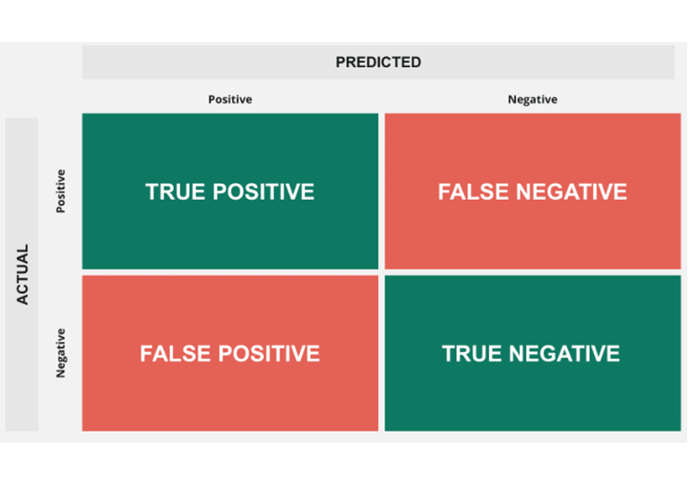
Figure 3.4.1 Confusion matrix with 4 parameters
True positive and true negatives are the observations that are correctly predicted. We want to minimize false positives and false negatives. These terms are a bit confusing. So, let’s take each term one by one and understand it fully.
True Positives (TP) - These are the correctly predicted positive values which means that the value of actual class is yes and the value of predicted class is also yes.
True Negatives (TN) - These are the correctly predicted negative values which means that the value of actual class is no and value of predicted class is also no.
False positives and false negatives, these values occur when your actual class contradicts with the predicted class.
False Positives (FP) – When actual class is no and predicted class is yes.
False Negatives (FN) – When actual class is yes but predicted class in no.

3.4.2 Metrics
Accuracy
Accuracy is the most intuitive performance measure and it is simply a ratio of correctly predicted observation to the total observations.
Accuracy = TP+TN/TP+FP+FN+TN
Precision
Precision is the ratio of correctly predicted positive observations to the total predicted positive observations.
Precision = TP/TP+FP
Re-call/ Sensitivity/ True Positive Rate (TPR)
Recall is the ratio of correctly predicted positive observations to the all observations in actual class - yes.
Recall = TP/TP+FN
F1 Score
F1 Score is the weighted average of Precision and Recall. Therefore, this score takes both false positives and false negatives into account. Intuitively it is not as easy to understand as accuracy, but F1 is usually more useful than accuracy, especially if you have an uneven class distribution.
F1 Score = 2*(Recall * Precision) / (Recall + Precision)
False Positive Rate (FPR)
FPR tells us what proportion of the negative class got incorrectly classified by the classifier.
FPR=FP/TN+FP
False Negative Rate (FNR)
FNR tells us what proportion of actual positive instances that are incorrectly classified as negative, ranging from 0 to 1.
FNR=FN/FN+TP
CHAPTER 4
PROPOSED SYSTEM

To address the gaps in security, privacy, and trust in VANETs, our proposed solution consists of two key components: an authentication scheme and a trust model. The authentication scheme ensures secure and anonymous vehicle communication, while the trust model enables Roadside Units (RSUs) to assess the trustworthiness of vehicle nodes and messages exchanged in the VANET.
When an event occurs in the network, nearby vehicles send event reports to the closest RSU. The RSU evaluates the credibility of the received reports. If the event is verified as authentic, the RSU broadcasts notifications within its communication range and records the trust values of participating vehicles in a block. Through a consensus mechanism, RSUs validate the correctness of each block, and verified blocks are stored on the blockchain. This decentralized approach eliminates reliance on a central authority, ensuring secure and tamper-proof transactions.

4.1 Flowchart of Proposed System
The proposed solution consists of seven phases: system initialization, vehicle registration, vehicle authentication, message authentication, trust calculation, miner election and block generation, and distributed consensus, as illustrated in Figure 4.1.
- System Initialization: The first phase of the proposed solution begins with a system initialization i.e., setting up the required environment, cryptographic parameters, and blockchain infrastructure.
- Vehicle Registration: The subsequent phase vehicle registration is responsible for registering the vehicles through the Trusted Authority(TA) before joining the network.
- Vehicle Authentication: The phase vehicle authentication, acts as a security layer to authenticate vehicles before they can communicate with each other in the network.
- Message Authentication: Message authentication is concerned with verification of authenticity and integrity of the messages sent by the communicating nodes to ensure their trustworthiness.
- Trust Calculation: RSUs evaluate vehicle trustworthiness based on parameters such as packet forwarding ratio and delay of the vehicles in the network.
- Miner Election & Block Generation: The system selects nodes to validate and generate new blocks in the blockchain.
- Distributed Consensus: The network reaches an agreement on block validity, ensuring a consistent and tamper-proof ledger.
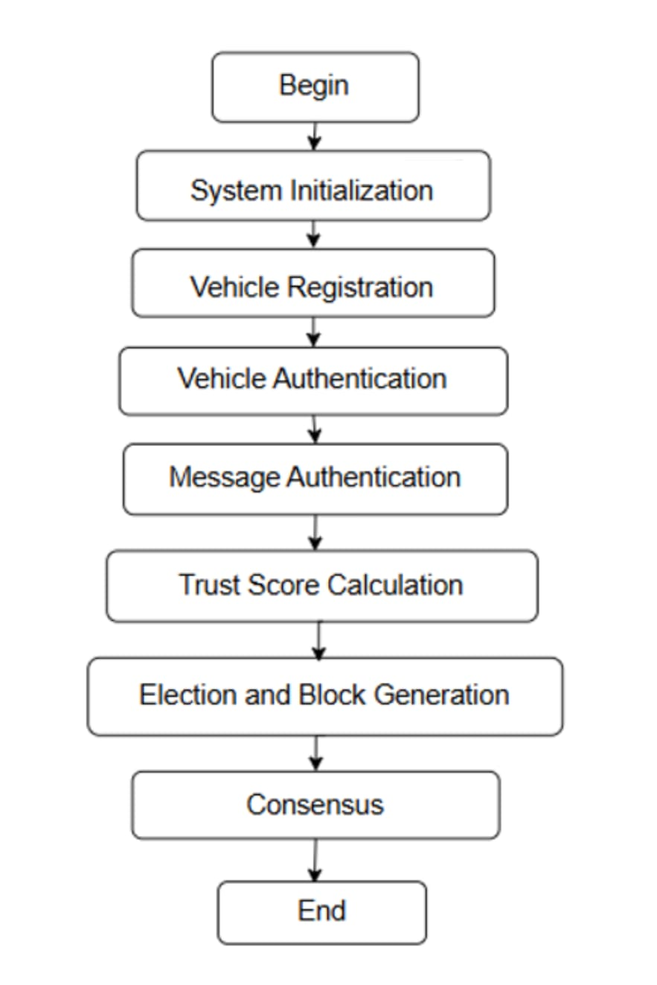
Figure 4.1 Flowchart of proposed Solution

Each phase contributes to the overall security and efficiency of the system by ensuring reliable authentication, secure messaging, and accurate trust evaluation.

4.2 Components of the Network Model
4.2.1 Trusted Authority (TA)
The TA is responsible for vehicle registration and first-time authentication. It generates authentication transactions stored in the authentication blockchain, which is a private blockchain. Other RSUs can read and verify authentication records from the blockchain, eliminating the need for vehicles to contact the TA repeatedly. This reduces dependency on a centralized authority and enhances scalability.

4.2.2 Roadside Units (RSUs)
RSUs serve as semi-trusted entities with processing, storage, and communication capabilities. Their responsibilities include:
- Collecting messages from nearby vehicles.
- Evaluating the trustworthiness of vehicles based on message integrity and trust metrics (packet forwarding ratio and delay).
- Updating vehicle trust values and maintaining a decentralized ledger.
- Broadcasting verified event notifications to surrounding vehicles.
- Participating in block validation through a consensus mechanism, ensuring a decentralized trust evaluation system.
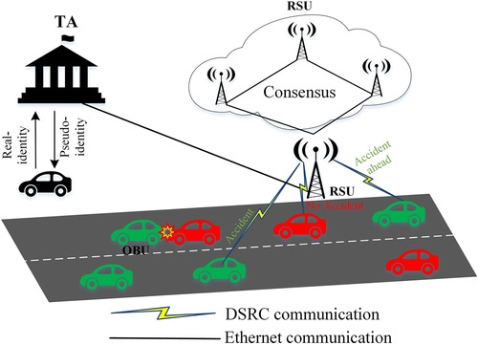
Figure 4.2 Network Model

4.2.3 Vehicles
Each vehicle is equipped with an On-Board Unit (OBU), enabling V2V and V2I communication. Vehicles report detected events to the nearest RSU, which assesses their credibility based on historical trust scores. Since vehicles have limited storage and computational resources compared to RSUs, the blockchain is maintained primarily by RSUs.

4.3 Data Structure of the Proposed Blockchain
To achieve secure and privacy-preserving authentication, the authentication blockchain employs the Chronological Merkle Tree (CMT).

4.3.1 Data Structure of the Authentication Blockchain
As illustrated in Figure X, the authentication blockchain utilizes a CMT-based structure:
- Transactions are hashed and stored in chronological order, ensuring integrity and resistance to tampering.
- Only the root hash is stored in the blockchain, reducing storage overhead while maintaining verification capabilities.
- Privacy-preserving mechanism: Transactions do not include personally identifiable vehicle information, ensuring anonymity.
- Immutability: Transactions issued by the TA are stored permanently and cannot be altered.

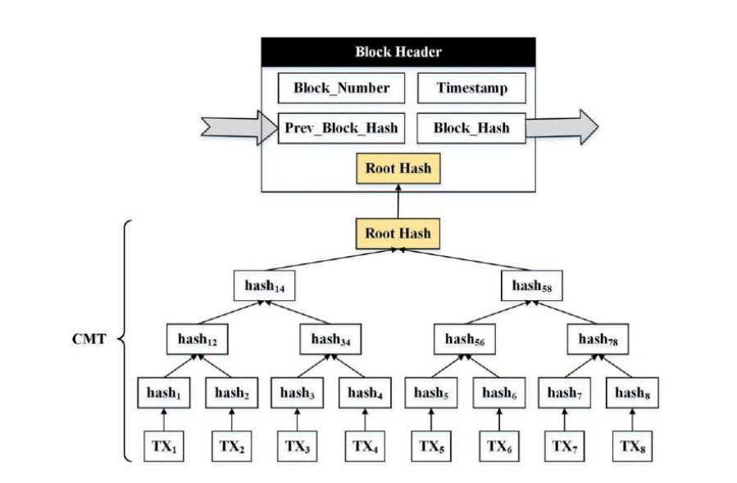
Figure 4.3 Data Structure of the Authentication Blockchain
This architecture guarantees secure and efficient authentication while maintaining user privacy in the VANET.

4.4 Trust Computation Model
4.4.1 Dynamic Trust
We consider the concept of dynamic trust, which refers to the dynamic alteration of a vehicle’s trust level as the operational and environmental conditions of the VANET change due to the mobility and behavior of the nodes. The trust level of each node changes dynamically based on current behaviours and past trust history. To model the trust level of individual nodes, we considered two key metrics derived from the VANET communication environment:
Packet Forwarding Ratio (PFR): This metric determines how many packets a node has forwarded to its neighbouring vehicles compared to the number of packets it received. It helps identify a node’s maliciousness if it intentionally drops packets to create black hole attacks. For instance, if a vehicle receives 10 packets and forwards 5 packets, the packet forwarding ratio (PFR) is 0.5. It is defined as follows:
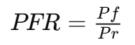
Where, Pf represents the number of packets forwarded by a vehicle.
Pr represents the number of packets received by a vehicle.
Packet Forwarding Delay (PFD): This metric measures how long it takes a vehicular node to forward all the packets it receives during a sensing window. It helps detect vehicles attempting to launch packet delay attacks. In such attacks, a malicious node adds a delay to the forwarding of packets in the network. If a vehicle forwards packets during a sensing window, the packet forwarding delay (PFD) is computed as:
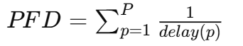
Where, delay(p) represents the forwarding delay of packet p.

4.4.2 Attacker Model
In VANETs, malicious nodes attempt to disrupt normal operations by injecting falsified information or altering existing information. To model the behavior of such attackers, we designed the communication patterns so that they drop most of the packets to mimic black hole attacks while forwarding the remaining packets with some delay. Specifically, a malicious node drops 90% of the packets it receives and forwards the rest with a delay ranging between 100 and 500 milliseconds.

CHAPTER 5
SYSTEM DESIGN

5.1 High-Level Architecture
The system is structured into two key components: the Authentication Scheme and the Trust Model. These modules ensure secure vehicle communication and trust-based message validation within the VANET environment.
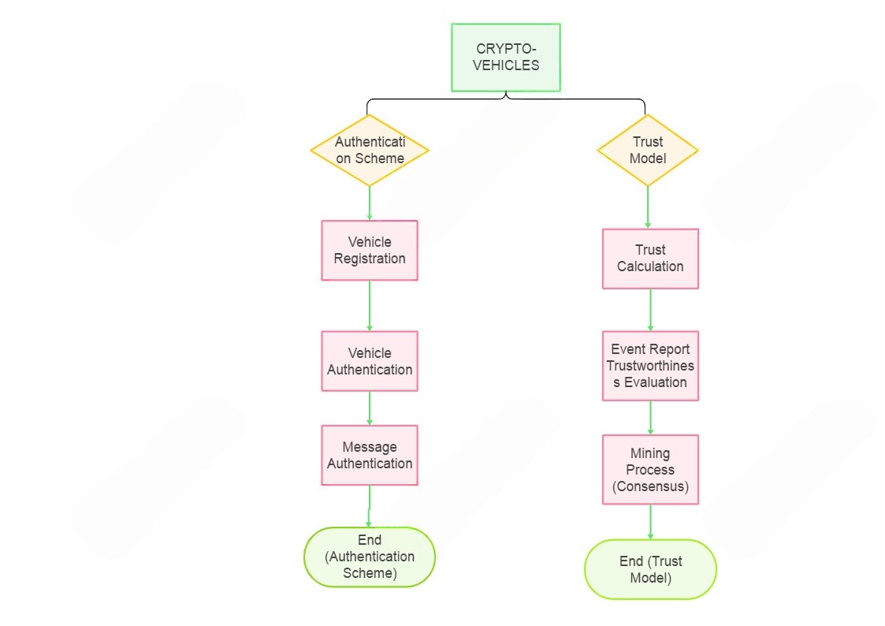
Figure 5.1 Flow of modules in the system

Authentication Scheme:
Vehicle Registration: Each vehicle registers with the system through a trusted certification authority (CA).
Vehicle Authentication: The system verifies vehicle identities using a Chronological Merkle Tree (CMT)-based authentication mechanism.
Message Authentication: Once authenticated, vehicles can securely exchange messages, ensuring tamper-proof and trusted communication.
Trust Model:
Trust Calculation & Event Report Trustworthiness Evaluation: The system evaluates vehicle behavior based on packet forwarding ratio, delay to detect malicious activities.
Mining Process (Consensus): Valid reports undergo a blockchain-based consensus mechanism, ensuring that only verified events are broadcasted.
5.2 Low level Architecture
The interaction between the components follows the steps below:
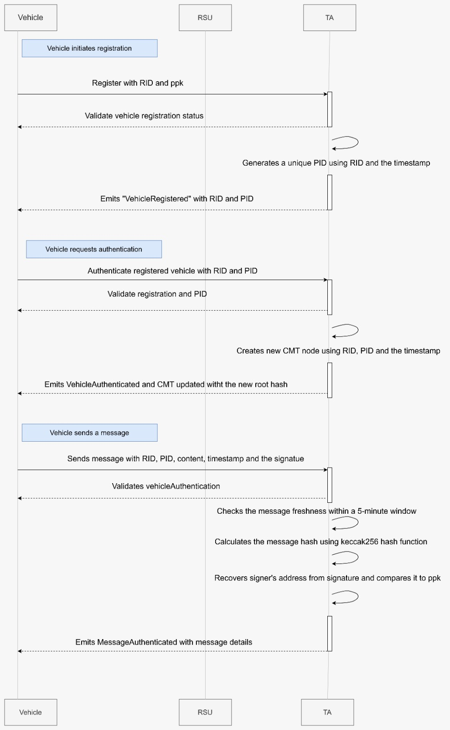
Figure 5.2 Sequence diagram of message exchange between Vehicle, RSU and TA

5.2.1 Vehicle Registration
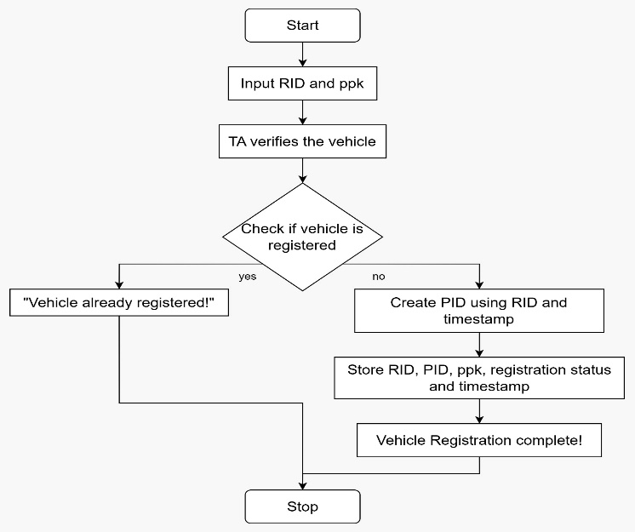
Figure 5.2.1 Vehicle Registration of proposed system
- A vehicle registers with the Trusted Authority (TA) using its Real Identity (RID) and public key.
- The TA assigns a unique Pseudonym (PID) to the vehicle and stores the information in the Vehicle Registry on the blockchain

5.2.2 Vehicle Authentication
- When a vehicle wants to communicate, it sends an authentication request with its RID and PID.
- The TA verifies the identity and records an authentication event on the Chronological Merkle Tree (CMT) in the blockchain.
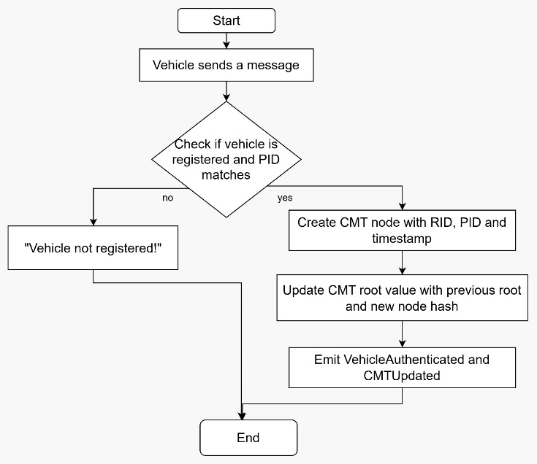
Figure 5.2.2 Vehicle authentication of proposed system

5.2.3 Secure Message Transmission
- Vehicles generate messages containing traffic or safety information and sign them using their private key.
- The signed message is sent to the nearest Roadside Unit (RSU) for validation.
- The RSU checks:
  - The sender’s authentication using the blockchain records.
  - The freshness of the message (validity period check).
  - The digital signature using the vehicle’s public key.
- If valid, the RSU forwards the message to nearby vehicles and updates its local trust model.

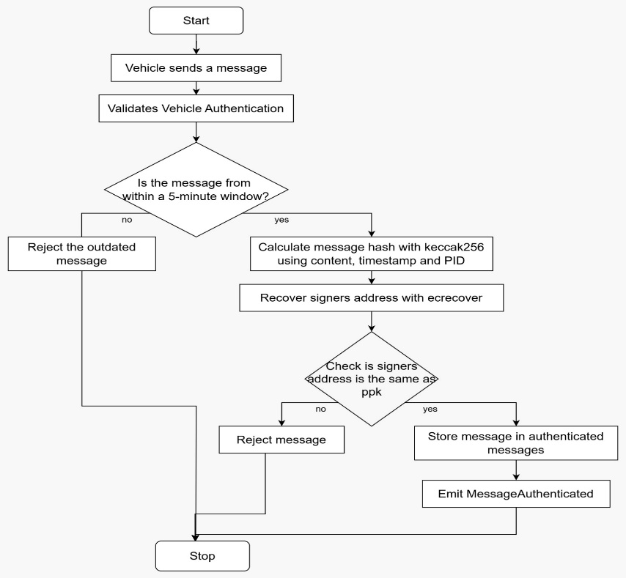
Figure 5.2.3 Message authentication of proposed system

5.2.4 Trust Evaluation and Blockchain Update
- The RSU monitors packet forwarding behavior and records:
- Packet Forwarding Ratio (PFR): Measures how reliably a vehicle forwards received packets.
- Packet Forwarding Delay (PFD): Tracks the delay in forwarding messages.
- Based on these parameters, the trust score of each vehicle is computed dynamically.
- The trust score is periodically updated in the blockchain ledger to ensure tamper-proof storage.
- If a vehicle is detected as malicious (low PFR, high PFD), its trust score is reduced, and RSUs alert other vehicles.

5.2.5 Malicious Vehicle Detection
- Vehicles with a trust score, pfr and pfd below a certain threshold are flagged as potentially malicious.
- The RSU may broadcast a warning about malicious nodes to prevent network attacks.
- In severe cases, the TA may revoke a malicious vehicle’s authentication credentials.

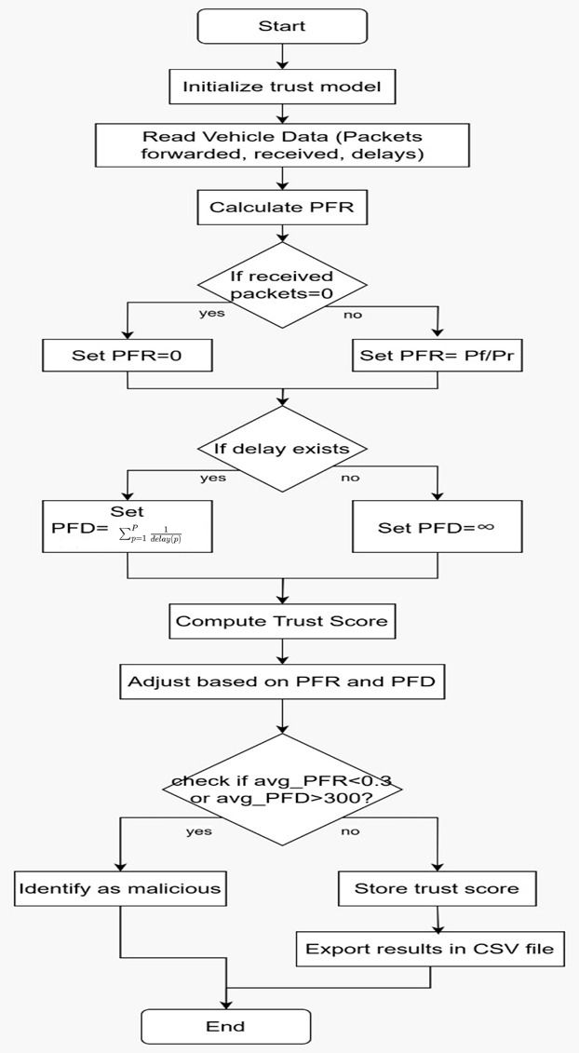
Figure 5.2.4 Trust calculation of proposed system
CHAPTER 6
IMPLEMENTATION

6.1 Blockchain-Based Authentication System
The authentication system is implemented using Solidity-based smart contracts deployed on the Ethereum blockchain through Remix IDE. The key components include:

6.1.1 Smart Contract Deployment
- Smart contracts are written in Solidity and tested using Remix IDE.
- Contracts handle vehicle registration, authentication requests, and verification logic.
- The Web3.py library is used for blockchain interactions in Python.

6.1.2 Vehicle Registration
Each vehicle is registered with its unique Real Identity (RID) and public key by the Trusted Authority which inturn generates a unique pseudo-identity(PID) to each vehicle for privacy protection. This creates a decentralized registry of trusted vehicles.
Inputs:
RID: The real identity of the vehicle.
ppk: The public key of the vehicle (Ethereum address).
Process:
Vehicle registers with its unique RID and public key then the Trusted Authority verifies if the vehicle is already registered. Generates a unique pseudonym (PID) using the vehicle's RID and the current timestamp. It then Stores the RID, PID, public key, and registration status in the vehicleRegistry mapping to prevent identity spoofing.
Event Triggered: Emits VehicleRegistered with RID and PID.

6.1.3 Vehicle Authentication
Authenticate a registered vehicle using its RID and PID. Update the Chronological Merkle Tree (CMT) with a new authentication event.
Inputs:
RID: The real identity of the vehicle.
PID: The pseudonym of the vehicle.
Process:
When a vehicle sends messages , TA validates that the vehicle is registered and the PID matches. It then creates a new CMT node using the hash of RID, PID, and the current timestamp. Appends the node to the CMT array. For each addition of records to the CMT , the current CMT root value is updated using the previous root and the new node's hash.
Event Triggered: Emits VehicleAuthenticated and CMTUpdated with the new root hash.

6.1.4 Message Authentication
Verifies the message's authenticity using ECDSA signature validation. Checks the message's freshness and ensures its sender is a registered vehicle.
Inputs:
RID: Real identity of the vehicle.
PID: Pseudonym of the vehicle.
content: The content of the message.
timestamp: The message timestamp.
signature: The ECDSA signature of the message.
Process:
When a message is sent by a vehicle , it validates the vehicle’s authentication. It then checks whether the message is within a 5-minute window, ensuring that outdated messages are rejected. This prevents replay attacks where an old message could be reused maliciously. Then calculate the message hash using keccak256 that combines the content, timestamp, and the vehicle’s pseudonym (PID). This ensures that the hash is unique and tied to the specific message sent at that time. It uses ecrecover to recover the signer's address from the signature and then compares it to the vehicle’s public key (ppk). If the addresses match, it ensures the authenticity of the message. If the message passes the signature verification, you store the message in the authenticatedMessages mapping. This way, all authenticated messages are logged, allowing future verification if needed.
Event Triggered: Emits MessageAuthenticated with message details.

6.1.5 Blockchain Data Storage
Each vehicle’s authentication status and message verification details are stored on the Ethereum blockchain. The immutable ledger ensures that authentication records cannot be altered by malicious actors.

6.2 Trust Computation Model Implementation
After authentication, the trustworthiness of vehicles within the VANET network is dynamically evaluated by analysing their behaviour in packet forwarding and message transmission delays. To achieve this, two primary metrics are used:

6.2.1 Packet Forwarding Ratio (PFR): The PFR is calculated by determining the ratio of packets successfully forwarded to the packets received by a vehicle. If a vehicle receives packets but fails to forward them, it results in a low PFR, indicating possible malicious behavior. If no packets are received, the PFR is set to zero to prevent undefined calculations.

6.2.2 Packet Forwarding Delay (PFD): On the other hand, PFD measures the time delay a vehicle introduces while forwarding packets. Instead of using a simple average, a harmonic mean approach is employed, where the sum of reciprocals of delay values is used to mitigate the influence of extreme values. If a vehicle exhibits high delays, its PFD increases, signifying a slow or unreliable node. If no delay values are recorded or if all values are zero, the PFD is set to infinity to mark the vehicle as untrustworthy.
Once the PFR and PFD values are computed for each vehicle, a trust score is dynamically assigned. The trust score, which ranges from 0 to 100, is determined by rewarding high PFR values and penalizing excessive PFD values. The formula used ensures that vehicles with a strong history of forwarding packets efficiently receive a higher trust score, while those with poor forwarding behavior or significant delays are penalized accordingly. If a vehicle’s trust score exceeds 100, it is capped at this value to maintain consistency.
Additionally, the system implements a threshold-based approach to detect malicious vehicles. Any vehicle with a PFR lower than 0.3 or a PFD greater than 300 milliseconds is classified as malicious, indicating that it either drops packets or introduces excessive forwarding delays. When a vehicle is detected as malicious, its trust score is significantly reduced to a value of 20 or lower, limiting its ability to participate in critical communication.
To ensure the transparency and integrity of trust computations, the trust scores are recorded and stored securely. The computed values, including PFR, PFD, and the final trust scores, are structured in a Pandas DataFrame and exported as a CSV file for further analysis. This allows for easy tracking of vehicle behavior over time and enables authorities to identify trends in malicious activity. Furthermore, the detection system continuously scans for vehicles that meet the malicious criteria and lists them separately for network administrators to take appropriate action. Through this rigorous process, the trust model enhances the security of VANET communication by ensuring that only reliable and trustworthy vehicles participate in message exchange, thereby mitigating potential threats posed by malicious nodes.

6.3 System Integration & Testing
a) Web3 Integration for Blockchain Communication
- Web3.py is used to connect Python-based trust computation with Ethereum blockchain.
- Smart contracts are called via Python scripts to update trust scores.
b) Simulation & Testing
- Google Colab is used to simulate vehicle interactions and trust calculations.
- Multiple test cases are executed for:
  - Blockchain authentication: Ensuring only registered vehicles can communicate.
  - Trust calculation accuracy: Checking if malicious nodes are detected correctly.
  - Performance under high network load: Evaluating system scalability.
c) Performance Visualisation
- Trust Score Distribution
- Packet Forwarding Behaviour
- Malicious Vehicle Trends

CHAPTER 7
TESTING

7.1Testing Authentication system
7.1.1 Deployment:

Fig 7.1.1 Deployment of authentication blockchain successful

7.1.2 Working with the deployed contracts:
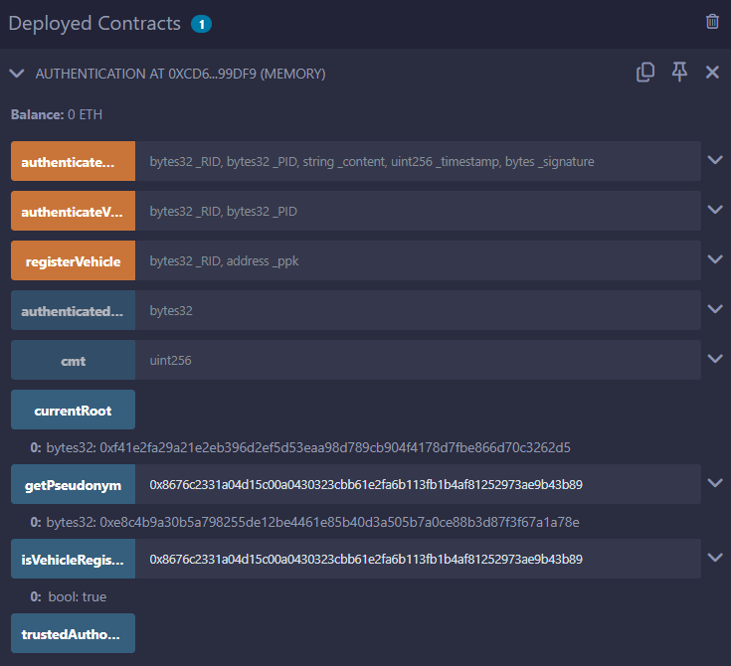
Fig 7.1.2 Contracts deployed

7.1.3 Metamask testnet Sepolia account to interact with blockchain
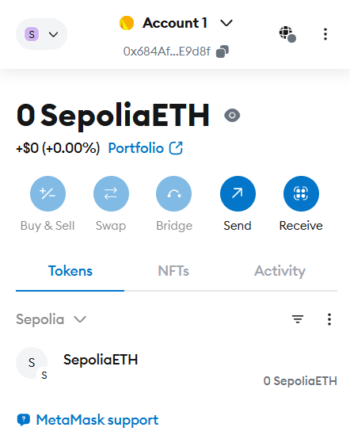
Fig 7.1.3 Metamask Sepolia account

7.1.4 Trusted Authority Address:
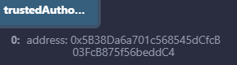
Fig 7.1.4 Address of Trusted Authority

7.1.5 Registering a Vehicle:
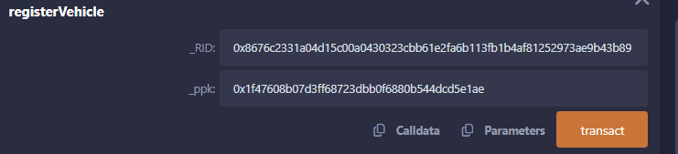
Fig 7.1.5 Registration of a vehicle successful

7.1.6 Generate Pseudonym:
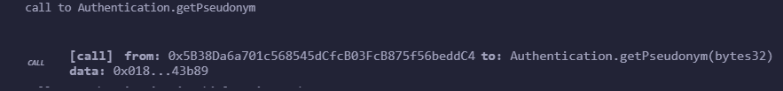
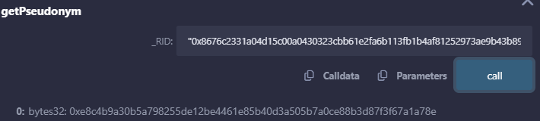
Fig 7.1.6 Pseudonym Generation

7.1.7 Registration Status:
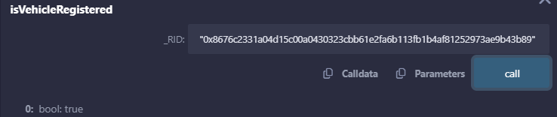
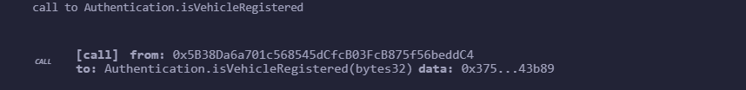
Fig 7.1.7 Checking Registration status

7.1.8 Vehicle Authentication:
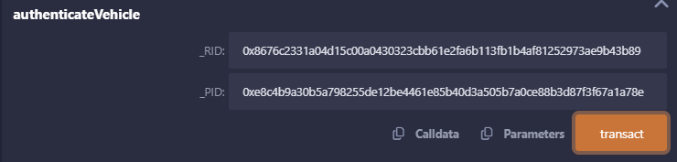
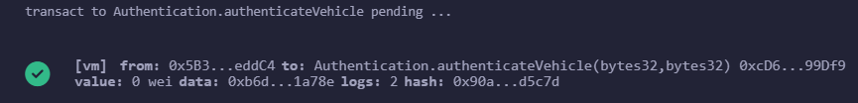
Fig 7.1.8 Successful authentication of a vehicle

7.1.9 Retrieving current root value of CMT :
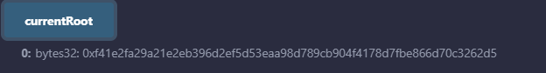
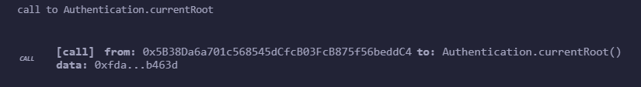
Fig 7.1.9 Updating root value of CMT

7.1.10 Message Authentication :
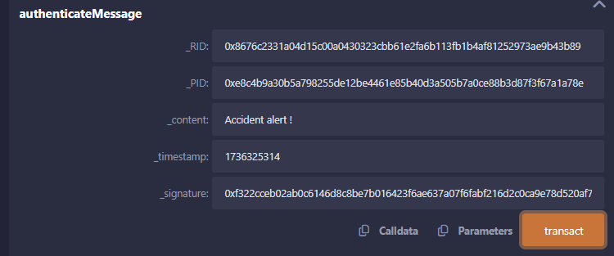
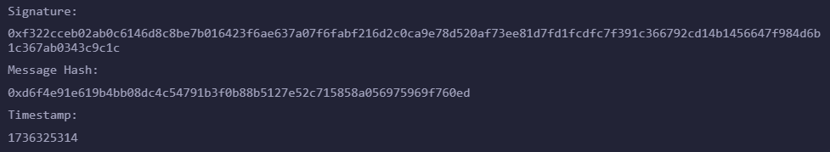
Fig 7.1.10 Authentication of a message successful

7.1.11 While trying to register a registered vehicle :
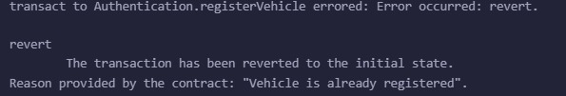
Fig 7.1.11 Trying to register a registered vehicle

7.1.12 Few Transactions in the blockchain:
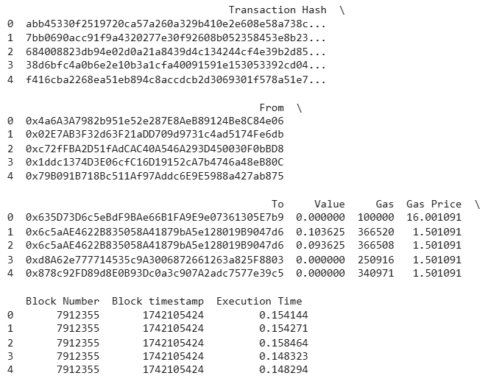
Fig 7.1.12 Some of the transactions in a blockchain

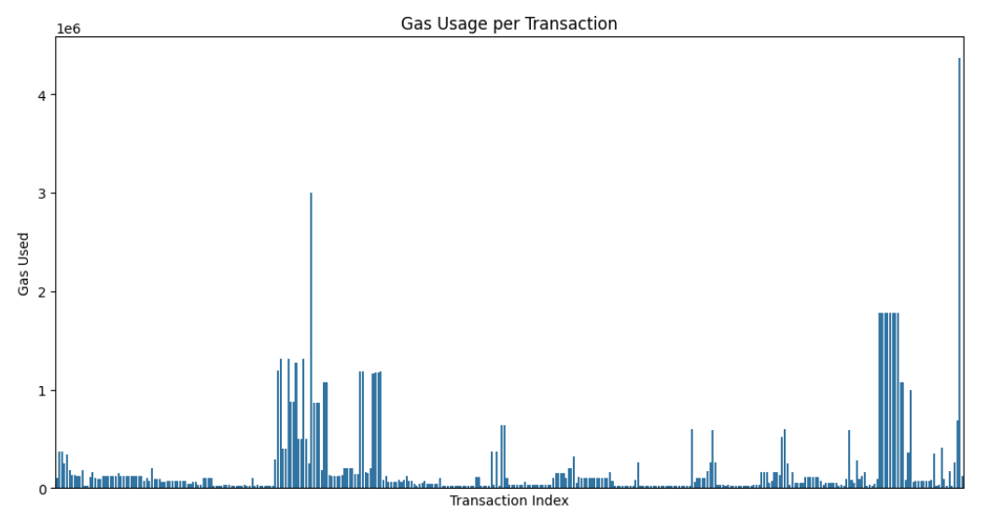
Fig 7.1.13 Gas Usage per Transaction

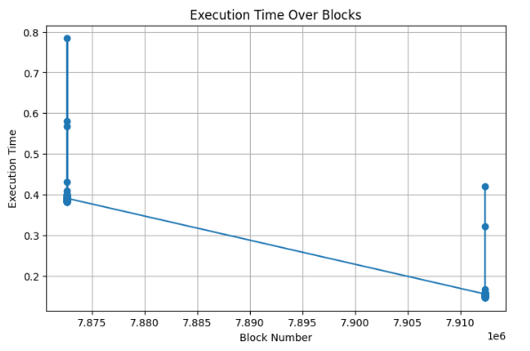
Fig 7.1.14 Execution Time for Recorded blocks

7.2 Testing Trust Model
7.2.1 Calculated trust, packet forwarding ratio and packet forwarded delay and detected malicious vehicles
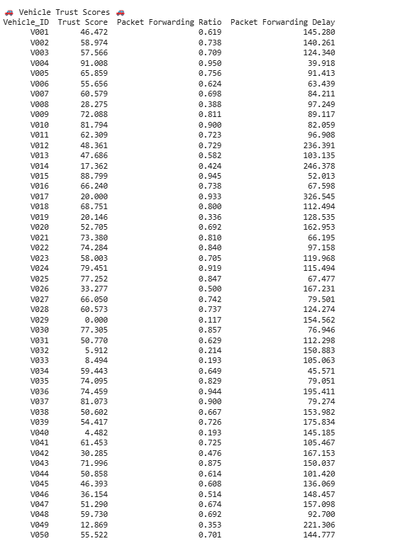
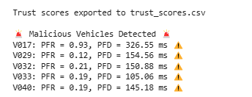
Fig 7.2.1 Calculated values of Trust, Packet Forwarding Ratio, Packet Forwarding Delay
7.2.2 Vehicle Trust Scores
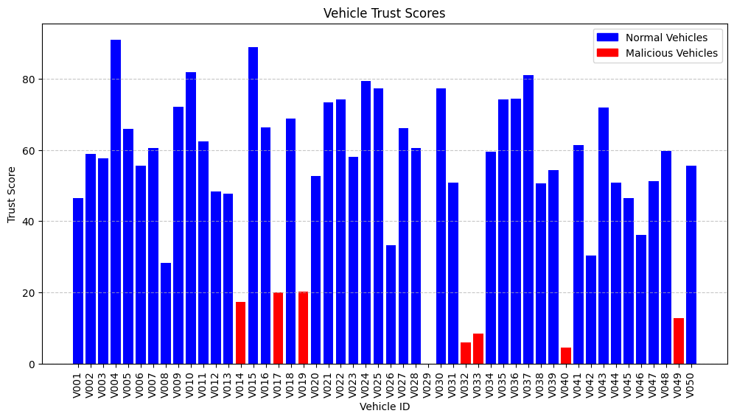
Fig 7.2.2 Trust Scores of vehicles
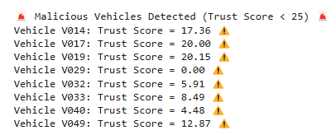

7.2.3 Packet Loss Ratio:
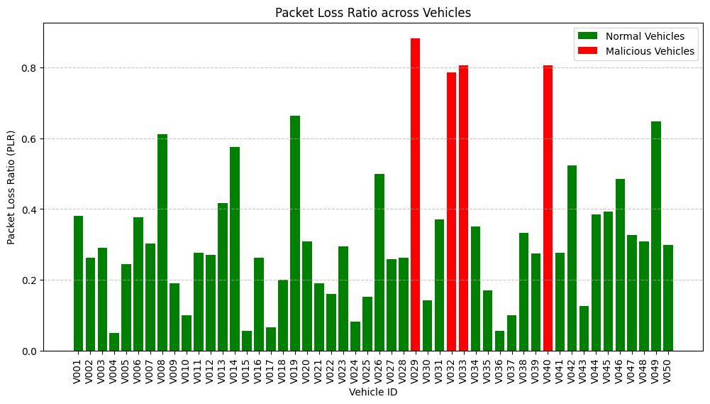
Fig 7.2.3 Packet loss ratio of vehicles
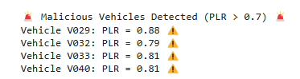

7.2.4 Packet Forwarding Ratio:

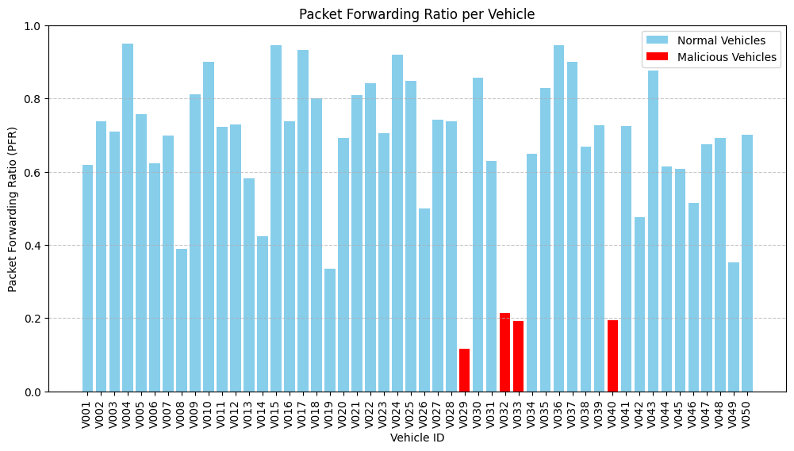
Fig 7.2.4 Packet Forwarding ratio of vehicles

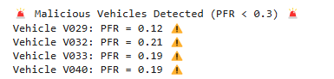

7.2.5 Packet Forwarding Delay:

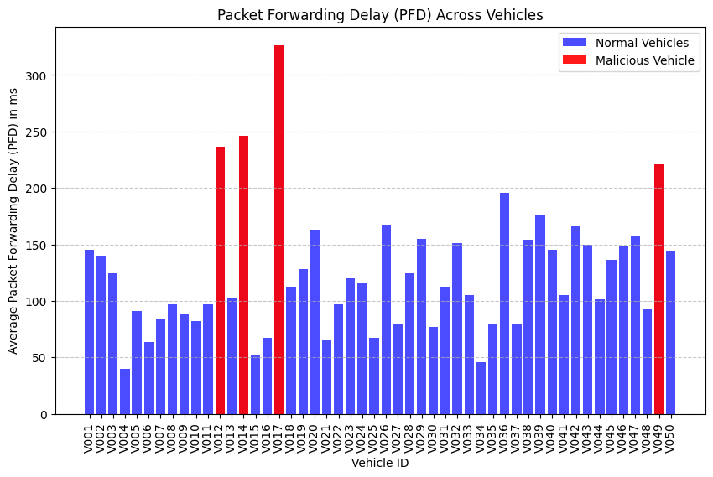
Fig 7.2.5 Packet Forwarding Delay of vehicles

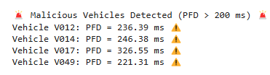

7.2.6 Performance Evaluation Metrics for trust model:

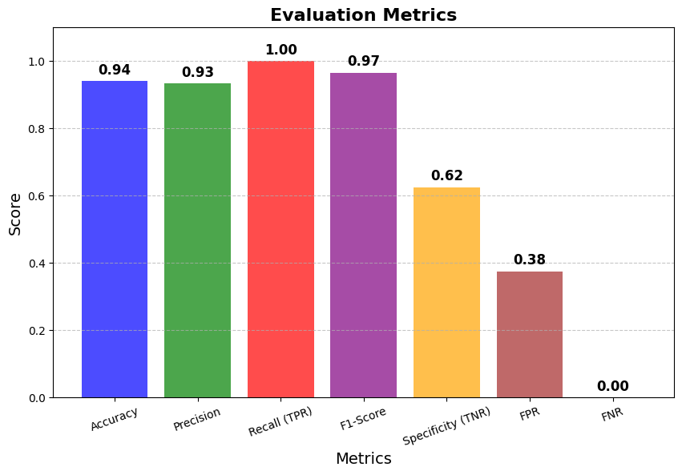
Fig 7.2.6 Evaluation metrics of trust model
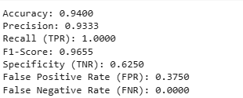

CHAPTER 8
RESULTS
8.1. Results
The trust model's performance evaluation demonstrates its effectiveness in accurately distinguishing between trusted and malicious vehicles within the VANET environment.
The accuracy, precision, re-call, f1 scores, specificity, false positive rate and false negative rate of trust model in our project are shown in the below table:
 | Precision
Accuracy | 0.94
Precision | 0.933
Recall | 1.0
F1 score | 0.965
Specificity | 0.625
False Positive Rate | 0.375
False Negative Rate | 0.0
Table 8.1: Results of Performance metrics of trust model

The model achieves a high accuracy of 94%, indicating that the majority of classifications are correct.
Precision of 93.3% ensuring that when a vehicle is classified as trustworthy, it is highly likely to be genuinely reliable.
Recall score of 1.0 reflects the model's ability to correctly identify all malicious vehicles, ensuring that no threats go undetected. This high recall suggests that the model is highly sensitive to detecting malicious activity and does not miss any potentially harmful vehicles.
F1 score of 0.965 balances precision and recall, confirming the robustness of the model in maintaining a trade-off between false positives and false negatives.
specificity of 0.625 indicates that while the model is good at identifying malicious vehicles, there is room for improvement in distinguishing genuine vehicles from falsely flagged ones. False Positive Rate (FPR) of 0.375 implies that 37.5% of non-malicious vehicles are mistakenly classified as threats, which could lead to some trustworthy vehicles being unnecessarily restricted.
False Negative Rate (FNR) of 0.0 ensures that no actual malicious vehicles evade detection, reinforcing the system’s reliability in preventing security breaches.
Overall, the results confirm that the trust model is highly effective in ensuring secure and efficient communication in VANETs, accurately detecting malicious entities while maintaining a strong level of trustworthiness among participating vehicles. Further optimizations can focus on reducing false positives to enhance specificity while maintaining the high recall and precision rates.

CHAPTER 9
CONCLUSION

The CryptoVehicles project successfully implements a blockchain-based authentication and trust model to enhance vehicular security and trustworthiness in VANETs. By integrating Chronological Merkle Tree (CMT)-based authentication and a trust evaluation model, the system ensures tamper-proof vehicle communication, prevents malicious attacks, and enhances decision-making in smart transportation networks. The proposed approach effectively reduces data tampering, spoofing, and false event propagation, making vehicle-to-vehicle (V2V) and vehicle-to-infrastructure (V2I) communication more secure, efficient, and scalable.

For future work, we aim to enhance the system by implementing a lightweight consensus protocol, such as Proof of Stake (PoS), to achieve agreement on event authenticity in a more efficient and scalable manner. Additionally, enhancing real-time data exchange and reducing latency by leveraging 5G networks and edge computing for faster processing and decision-making and implementing dynamic trust evaluation that adapts to changing network conditions and behaviours of vehicles using reinforcement learning for possible future enhancements.

REFERENCES

[1] Ahmed, Waheeb & Di, Wu & Mukathe, Daniel. (2022). Privacy‐preserving blockchain‐based authentication and trust management in VANETs. IET Networks. 11. 10.1049/ntw2.12036.

[2] Khan, Shahid & Balan, Kuhanraj & Javed, Yasir & Tarmizi, Seleviawati. (2019). Secure Trust-Based Blockchain Architecture to Prevent Attacks in VANET. Sensors. 19. 4954. 10.3390/s19224954.

[3] Huszti, Andrea & Girászi, Tamás & Olah, Norbert. (2023). Blockchain-Based Messaging for VANETs. 2443-2450. 10.1109/CSCE60160.2023.00394.

[4] Ravi, Nikhil & Verma, Prof & ., Kavita & Jhanjhi, Noor & Talib, Maria. (2021). Securing VANET Using Blockchain Technology. Journal of Physics: Conference Series. 1979. 012035. 10.1088/1742-6596/1979/1/012035.

[5] Rasheed, Chaudhary Muhammad Asim & Gilani, Saira & Ajmal, Sana & Qayyum, Amir. (2017). Vehicular Ad Hoc Network (VANET): A Survey, Challenges, and Applications. 10.1007/978-981-10-3503-6_4.

[6] Z. Lu, W. Liu, Q. Wang, G. Qu and Z. Liu, "A Privacy-Preserving Trust Model Based on Blockchain for VANETs," in IEEE Access, vol. 6, pp. 45655-45664, 2018, doi: 10.1109/ACCESS.2018.2864189.

[7] Raya M, Hubaux J-P. Securing vehicular ad hoc networks. Journal of Computer Security. 2007;15(1):39-68. doi:10.3233/JCS-2007-15103

[8] Zhang, C,Lin, X.; Lu, R.; Ho, “RAISE: An efficient RSU-aided message authentication scheme in vehicular communication networks”, in Proceedings of the IEEE International Conference on Communications (ICC’08), Beijing, China, 19– pp. 1451–1457, 23 May 2008.

[9] Shaikh, R.A., Alzahrani, A.S.: Intrusion-aware trust model for vehicular ad hoc networks. Secur. Commun. Network. 7(11), 1652–1669 (2014). https://doi.org/10.1002/sec.862

[10] Sáez de Ocáriz Borde, Haitz. (2022). An Overview of Trees in Blockchain Technology: Merkle Trees and Merkle Patricia Tries.
[11] Tiwari, Varun & Singh, Santosh & Vadi, Vikas. (2023). Smart Contract Using Solidity (Remix -Ethereum IDE). 12. 243-249. 10.17148/IJARCCE.2023.12253.

[12] Al-Zubaidie, M., Zhang, Z., & Zhang, J. (2019). Efficient and Secure ECDSA Algorithm and its Applications: A Survey. arXiv (Cornell University). https://doi.org/10.48550/arxiv.1902.10313

[13] Existence of trust-field in vehicular ad hoc networks: empirical evidence. (n.d.). https://arxiv.org/html/2407.13923v1#bib.bib36

[14] Bertoni, G., Daemen, J., Peeters, M., Van Assche, G. (2013). Keccak. In: Johansson, T., Nguyen, P.Q. (eds) Advances in Cryptology – EUROCRYPT 2013. EUROCRYPT 2013. Lecture Notes in Computer Science, vol 7881. Springer, Berlin, Heidelberg. https://doi.org/10.1007/978-3-642-38348-9_19

[15] Guo, H., & Yu, X. (2022). A survey on blockchain technology and its security. Blockchain Research and Applications, 3(2), 100067. https://doi.org/10.1016/j.bcra.2022.100067

Appendix: A- Packages, Tools used & Working Process

Solidity Programming language
Solidity is an object-oriented, high-level back-end language, for implementing smart contracts. Smart contracts are programs that govern the behaviour of accounts within the Ethereum state. Solidity targets the Ethereum Virtual Machine (EVM). Solidity plays an important role in the development of blockchain technology, and this programming language is known for its influence in powering smart contracts, developing robust decentralized applications. Solidity supports complex user-defined programming, libraries and inheritance. Solidity can be used to create contracts like voting, crowdfunding, etc. Solidity can be used to create smart contracts that enhance transparency and traceability.
The main features of Solidity programming are that solidity is a syntactic object- oriented and contract- oriented language. The main importance is that it is designed in a way that is essential for decentralized applications, and it plays a vital role in creating complex and secure applications in Blockchain.

Python Programming language
Python is a high-level Interpreter based programming language used especially for general-purpose programming. Python features a dynamic type of system and supports automatic memory management.
It supports multiple programming paradigms, including object-oriented, functional and Procedural and also has its a large and comprehensive standard library. Python is of two versions. They are Python 2 and Python 3.
This project uses the latest version of Python, i.e., Python 3. This python language uses different types of memory management techniques such as reference counting and a cycle-detecting garbage collector for memory management. One of its features is late binding (dynamic name resolution), which binds method and variable names during program execution.
Python's offers a design that supports some of things that are used for functional programming in the Lisp tradition. It has vast usage of functions for faster results such as filter, map, split, list comprehensions, dictionaries, sets and expressions. The standard library of python language has two modules like itertools and functools that implement functional tools taken from Standard machine learning.

Libraries and Packages
Web3
Web3.js is a collection of libraries that allows interaction with a local or a remote Ethereum node using HTTP or WebSocket. Web3 envisions a decentralized, open and user-centric internet leveraging technologies like blockchain and smart contracts to empower users with greater control over their data and digital identities. Web3 aims to be a more distributed and a community-driven model. One great example where Web3 is used is in Bitcoin where the Web3 in blockchain enabled secure and transparent data storage and management. Web3 emphasizes user ownership and control over data. Some key features of Web3 include decentralized applications, data ownership and privacy, and to enable new business models.

NumPy
Numpy is the basic package for scientific calculations and computations used along with Python. NumPy was created in 2005 by Travis Oliphant. It is open source so can be used freely. NumPy stands for Numerical Python. And it is used for working with arrays and mathematical computations. Using NumPy in Python gives you much more functional behavior comparable to MATLAB because they both are interpreted, and they both allows the users to quickly write fast programs as far as most of the operations work on arrays, matrices instead of scalars. Numpy is a library consisting of array objects and a collection of those routines for processing those arrays. It has also functions that mostly works upon linear algebra, Fourier transform, arrays and matrices. In general scenario the working of NumPy in the code involves searching, join, split, reshaping etc. operations using NumPy.
The syntax for importing the NumPy package is → import NumPy as np indicates NumPy is imported alias np.

Pandas
Pandas is used whenever working with matrix data, time series data and mostly on tabular data. Pandas is also open-source library which provides high-performance, easy-to-use data structures and data analysis tools for the Python programming language.
This helps extremely in handling large amounts of data with help of data structures like Series, Data Frames etc. It has inbuilt methods for manipulating data in different formats like csv, html etc.,
Simply we can define pandas is used for data analysis and data manipulation and extremely works with data frames objects in our project, where data frame is dedicated structure for two-dimensional data, and it consists of rows and columns similar to database tables and excel spreadsheets.
In our code we firstly import pandas package alias pd and use pd in order to read the csv file and assign to data frame and in the further steps. We work on the data frames by manipulating them. So, finally the whole code depends on the data frames which are to be acquired by coordinating with pandas. So, this package plays a key role in our project.

Matplotlib
Matplotlib is a library used for plotting in the Python programming language and it is a numerical mathematical extension of NumPy. Matplotlib is most commonly used for visualization and data exploration in a way that statistics can be known clearly using different visual structures by creating the basic graphs like bar plots, scatter plots, histograms etc.
Matplotlib is a foundation for every visualizing library and the library also offers a great flexibility with regards to formatting and styling plots. We can choose freely certain assumptions like ways to display labels, grids, legends etc.
In our code firstly we import the matplotlib.pyplot alias plt, This plt comes into picture in the exploratory data analysis part to analyze and summarize datasets into visual methods, we use plt to add some characteristics to figures such as title, legends, labels on x and y axis as said earlier ,to understand more clearly we can also use different plots.

Sklearn
Scikit-learn (Sklearn) is the most useful and robust library for machine learning in Python. Scikit learn is an efficient, and beginner, user friendly tool for predictive data analysis and it provides a selection of tools for machine learning and statistical modeling including classification, regression, clustering and dimensionality reduction via a consistent interface in Python. This library is built upon different libraries such as NumPy, SciPy and Matplotlib.
Scikit learn is used when identifying to which category an object likely belongs, predicting continuous values and grouping of similar objects into clusters.
When coming to our code, sklearn plays an important with respect to classification algorithm, the final result and performance. Accuracy of the algorithm can be determined using sklearn.. On taking the syntax as example from sklearn. metrics, import * describes to import all the metrics required for doing some kind of mathematical, or evidential calculations. Similarly when coming to metrics we use confusion matrix in order to calculate the performance of classification model by using certain measures like precision,recall,f1 sore and threshold value.

Tools Used
Remix IDE
Remix is an open-source web-based Integrated Development Environment (IDE) for developing smart contracts using the Solidity programming language. It provides a user-friendly interface for writing, testing, debugging, and deploying smart contracts on various blockchain networks such as Ethereum, Binance Smart Chain, and more. Remix has a built-in compiler and debugger, making it straightforward for developers to write efficient and secure smart contracts. It also supports a wide range of plugins and extensions, allowing users to customize their development environment according to their needs. Remix is widely used by blockchain developers worldwide and has become an essential tool in the Ethereum development ecosystem. Remix IDE offers several benefits, including a user-friendly interface, built-in Solidity compiler and debugger, support for various plugins and extensions, and the ability to switch between different blockchain networks. It simplifies developing, testing, and deploying Solidity smart contracts, making it an essential tool for blockchain developers.

Google Colab
Google Colab, short for Colaboratory, is a free cloud- based service that allows one to write, run and share the Python code through a browser. It’s like a Jupyter notebook environment that requires no setup and runs entirely in the cloud. Some key features are that it’s a cloud based free environment, and it has access to computing resources including Graphics Processing Unit (GPUs) and Tensor Processing Unit (TPUs), which are essential for computationally intensive tasks like machine learning and deep learning. It also supports data visualization libraries, enabling to create graphs, and other visualizations to explore data. Google Colab supports interactive visualizations, providing an excellent platform for data exploration and result presentation. Google Colab comes with multiple popular libraries pre-installed such as TensorFlow, Keras, PyTorch, OpenCV, etc that helps in machine learning and data analysis.

Sepolia
The Sepolia testnet is an Ethereum test network used for deploying and testing smart contracts without spending real ETH. Key Features of Sepolia Testnet include Faster block times than mainnet making testing quicker , Lower gas fees since it's a test environment, Proof-of-Stake (PoS) consensus like Ethereum mainnet, Faucet available to get free test ETH for deployments.
Sepolia is Ideal for testing smart contracts before deploying to Ethereum mainnet , Simulates real-world Ethereum conditions but with free transactions and Works well with Remix, Hardhat, Foundry, and Web3.js.

Ethereum
Ethereum is a decentralized, open-source blockchain platform that facilitates the creation pf smart contracts and decentralized applications, using its native cryptocurrency, Ether to power transactions and network operations. The Ethereum virtual machine (EVM) is a run-time environment that provides a platform for executing smart contracts in Ethereum. It is a decentralized virtual machine that can execute scripts using a globally distributed network of public nodes. The EVM allows the execution of scripts on the Ethereum network and enables the development of blockchain applications with enhanced scalability, interoperability, and feature-fullness. Main advantages are that it is an open source system, available in public and private modes.
Ethereum offers an extremely flexible platform on which to build decentralized applications using the native Solidity scripting language and Ethereum Virtual Machine. Decentralized application developers who deploy smart contracts on Ethereum benefit from the rich ecosystem of developer tooling and established best practices that have come with the maturity of the protocol.

Appendix: B
Sample Source Code with Execution
Blockchain based authentication
// SPDX-License-Identifier: MIT
pragma solidity ^0.8.0;

contract Authentication {
address public trustedAuthority;

struct Vehicle {
bytes32 RID;
bytes32 PID;
address ppk;
bool isRegistered;
}

struct CMTNode {
bytes32 hash;
uint256 timestamp;
}

struct Message {
bytes32 PID;
string content;
uint256 timestamp;
}

mapping(bytes32 => Vehicle) private vehicleRegistry;
mapping(bytes32 => Message) public authenticatedMessages;
CMTNode[] public cmt;
bytes32 public currentRoot;

event VehicleRegistered(bytes32 RID, bytes32 PID);
event VehicleAuthenticated(bytes32 RID, bytes32 PID);
event CMTUpdated(bytes32 rootHash);
event MessageAuthenticated(bytes32 RID, bytes32 PID, string content, uint256 timestamp);
event Debug(bytes32 messageHash, address recoveredSigner);

modifier onlyTrustedAuthority() {
require(msg.sender == trustedAuthority, "Caller is not the Trusted Authority");
_; }

modifier onlyRegistered(bytes32 _RID) {
require(vehicleRegistry[_RID].isRegistered, "Vehicle is not registered");
_; }

constructor(address _trustedAuthority) {
require(_trustedAuthority != address(0), "Invalid Trusted Authority address");
trustedAuthority = _trustedAuthority;
currentRoot = bytes32(0);
}

function registerVehicle(bytes32 _RID, address _ppk) public onlyTrustedAuthority {
require(!vehicleRegistry[_RID].isRegistered, "Vehicle is already registered");
require(_RID != bytes32(0), "Invalid RID");

bytes32 _PID = keccak256(abi.encodePacked(_RID, block.timestamp));
vehicleRegistry[_RID] = Vehicle({
RID: _RID,
PID: _PID,
ppk: _ppk,
isRegistered: true
});
emit VehicleRegistered(_RID, _PID);
}

function authenticateVehicle(bytes32 _RID, bytes32 _PID) public onlyRegistered(_RID) {
require(vehicleRegistry[_RID].PID == _PID, "Invalid PID for the vehicle");

bytes32 nodeHash = keccak256(abi.encodePacked(_RID, _PID, block.timestamp));
cmt.push(CMTNode({hash: nodeHash, timestamp: block.timestamp}));
currentRoot = keccak256(abi.encodePacked(currentRoot, nodeHash));

emit VehicleAuthenticated(_RID, _PID);
emit CMTUpdated(currentRoot);
}

function authenticateMessage(
bytes32 _RID,
bytes32 _PID,
string memory _content,
uint256 _timestamp,
bytes memory _signature
) public onlyRegistered(_RID) returns (bool) {
Vehicle storage vehicle = vehicleRegistry[_RID];
require(block.timestamp - _timestamp < 300, "Message is too old");

bytes32 messageHash = keccak256(abi.encodePacked(_content, _timestamp, vehicle.PID));
address recoveredSigner = recoverSigner(messageHash, _signature);

emit Debug(messageHash, recoveredSigner);
require(recoveredSigner == vehicle.ppk, "Invalid signature");
authenticatedMessages[messageHash] = Message({
PID: _PID,
content: _content,
timestamp: _timestamp
});
emit MessageAuthenticated(_RID, _PID, _content, _timestamp);
return true;
}

function recoverSigner(bytes32 _messageHash, bytes memory _signature) internal pure returns (address) {
(bytes32 r, bytes32 s, uint8 v) = splitSignature(_signature);
return ecrecover(_messageHash, v, r, s);
}

function splitSignature(bytes memory _signature) internal pure returns (bytes32 r, bytes32 s, uint8 v) {
require(_signature.length == 65, "Invalid signature length");
assembly {
r := mload(add(_signature, 32))
s := mload(add(_signature, 64))
v := byte(0, mload(add(_signature, 96)))
}
}

function getPseudonym(bytes32 _RID) public view onlyRegistered(_RID) returns (bytes32) {
return vehicleRegistry[_RID].PID;
}

function isVehicleRegistered(bytes32 _RID) public view returns (bool) {
return vehicleRegistry[_RID].isRegistered;
}
}

TRUST CALCULATION
import pandas as pd
import numpy as np

class VehicleTrust:
def __init__(self):
self.vehicles = {}
self.trust_scores = {}

def record_packet_forwarding(self, vehicle_id, received, forwarded):
PFR = forwarded / received if received > 0 else 0
if vehicle_id not in self.vehicles:
self.vehicles[vehicle_id] = {"PFR": [], "PFD": []}
self.vehicles[vehicle_id]["PFR"].append(PFR)
return PFR

def record_packet_delay(self, vehicle_id, delays):
"""Corrected PFD Calculation Using Sum of Reciprocals (in milliseconds)"""
if not delays or all(d == 0 for d in delays):
PFD = float('inf') # Avoid division by zero
else:
PFD = len(delays) / sum(1 / (d + 1e-6) for d in delays if d > 0) # Small epsilon to avoid zero division

self.vehicles[vehicle_id]["PFD"].append(PFD)
return PFD

def update_trust_score(self, vehicle_id):
if vehicle_id not in self.vehicles:
return 0

avg_PFR = np.mean(self.vehicles[vehicle_id]["PFR"])
avg_PFD = np.mean(self.vehicles[vehicle_id]["PFD"])

trust = 0
trust += min(100, int(avg_PFR * 100))
trust_penalty = min(40, avg_PFD / 10)
trust -= trust_penalty
trust = max(0, min(100, trust))

is_malicious = avg_PFR < 0.3 or avg_PFD > 300
if is_malicious:
trust = min(trust, 20)

self.trust_scores[vehicle_id] = trust
return trust

def detect_malicious_vehicles(self):
"""Detect vehicles with low PFR or high PFD"""
malicious_vehicles = []
for vehicle_id in self.vehicles:
avg_PFR = np.mean(self.vehicles[vehicle_id]["PFR"])
avg_PFD = np.mean(self.vehicles[vehicle_id]["PFD"])

if avg_PFR < 0.3 or avg_PFD > 300:
malicious_vehicles.append((vehicle_id, avg_PFR, avg_PFD))

return malicious_vehicles

def print_trust_scores(self, export_csv=True, filename="trust_scores.csv"):
print("\n🚗 Vehicle Trust Scores 🚗")
trust_data = []

for vehicle_id, trust in self.trust_scores.items():
avg_PFR = round(np.mean(self.vehicles[vehicle_id]["PFR"]), 3)
avg_PFD = round(np.mean(self.vehicles[vehicle_id]["PFD"]), 3)
trust = round(trust, 3)
trust_data.append([vehicle_id, trust, avg_PFR, avg_PFD])

df = pd.DataFrame(trust_data, columns=["Vehicle_ID", "Trust Score", "Packet Forwarding Ratio", "Packet Forwarding Delay"])
print(df.to_string(index=False))

# Export to CSV if enabled
if export_csv:
df.to_csv(filename, index=False)
print(f"\nTrust scores exported to {filename}")

# Example Usage:
# self.print_trust_scores()

# Load dataset
file_path = "/content/vehicle_dataset (1).csv"
df = pd.read_csv(file_path)

# Initialize trust system
trust_system = VehicleTrust()

# Process dataset
for index, row in df.iterrows():
vehicle_id = row["vehicle_id"]
forwarded = row["forwarded"]
received = row["received"]

# Convert delay string to list of integers
delays = list(map(int, row["packet_delays"].strip("[]").split(", "))) if isinstance(row["packet_delays"], str) else []

trust_system.record_packet_forwarding(vehicle_id, received, forwarded)
trust_system.record_packet_delay(vehicle_id, delays)
trust_system.update_trust_score(vehicle_id)

# Print Trust Scores
trust_system.print_trust_scores()

# Detect Malicious Vehicles
malicious_vehicles = trust_system.detect_malicious_vehicles()
print("\n🚨 Malicious Vehicles Detected 🚨")
for vehicle, pfr, pfd in malicious_vehicles:
print(f"{vehicle}: PFR = {pfr:.2f}, PFD = {pfd:.2f} ms ⚠️")

