Use Case:

Concept Diagrams:

Sequence Diagrams:

1. Find closest shops

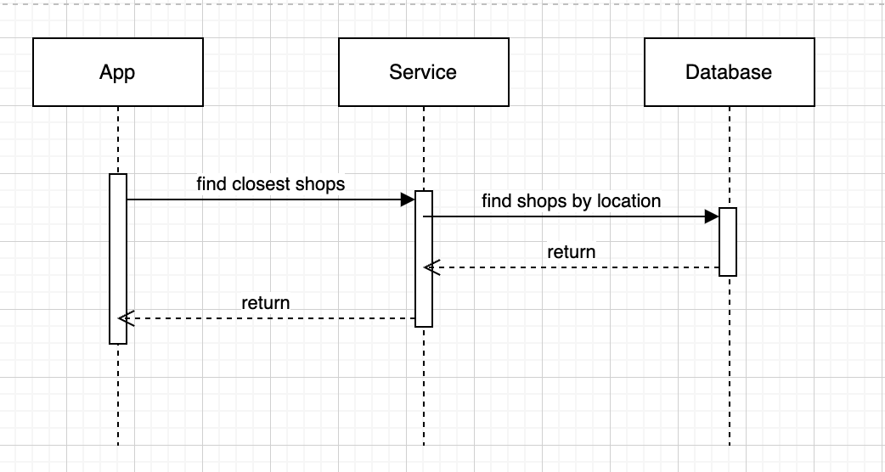

1. View Items in menu of selected shop

1. Select items
2. View selected items
3. Order

1. View status of order

API:

1. Get closest shops

URL: {{base-url}}/v1/location/targeted

Method: GET

Request Params:

locationId

Request Body:

Response:

Error:

1. Get closest shops

URL: {{base-url}}/v1/shops/closest

Method: GET

Request Params:

locationId

Request Body:

Response:

Error:

1. Get menu by selected shop

URL: {{base-url}}/v1/shop/menu

Method: GET

Request Params:

shopId

Request Body:

Response:

Error:

1. Order

URL: {{base-url}}/v1/order

Method: POST

Request Body:

Response:

Error:

1. View Order History

URL: {{base-url}}/v1/order/history

Method: GET

Request Body:

Response:

Error: