**LAB 2**

**Name: Nguyen Phi Thong**

**ID: 1814205**

1. My browser running HTTP version 1.1.
2. Language: en-us.
3. IP address of my computer: 192.168.43.233. IP of gaia.cs.mass.edu: 128.119.245.12
4. Status code: 200
5. The HTML file that you are retrieving last modified at the server: Mon, 12 Oct 2020 05:59:02 GMT
6. 128 bytes of content are being returned to my browser
7. No, I don’t see any headers within the data that are not displayed in the packet-listing window.
8. No, I don’t see an “IF-MODIFIED-SINCE” line in the HTTP GET
9. 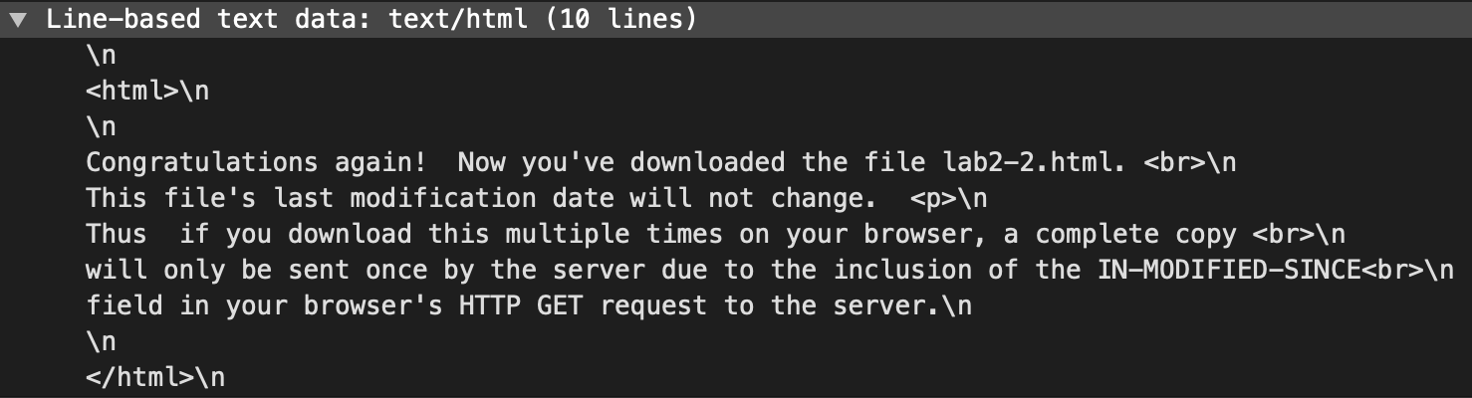Yes.
10. 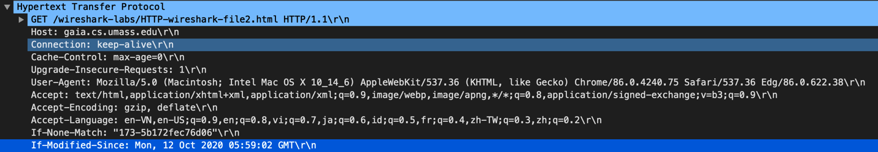Yes, I see
11. 

Server doesn’t explicitly return the contents of the file.

1. 

My browser sent only one HTTP GET request message. Packet number 80 contained the GET message for the Bill of Rights.

1. Packet 101 contained the response to the HTTP GET request.
2. 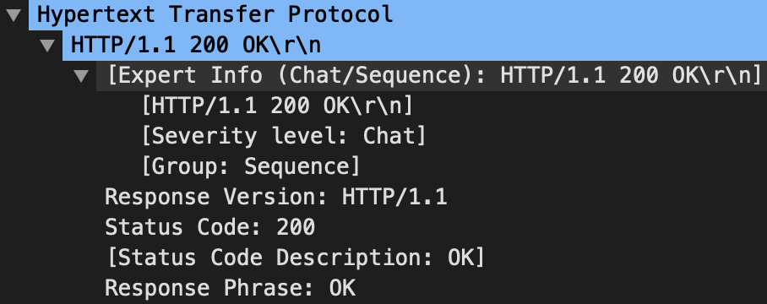
3. 

3 data-containing TCP segments were needed to carry the single HTTP response and the text of the Bill of Rights