**LAB 3B**

**Name: Nguyen Phi Thong**

**ID: 1814205**

1. What is the IP address and TCP port number used by the client computer (source) that is transferring the file to gaia.cs.umass.edu?

Client computer (source): IP 192.168.1.102, source port: 1161

1. What is the IP address of gaia.cs.umass.edu? On what port number is it sending and receiving TCP segments for this connection?

gaia.cs.umass.edu: IP 128.119.245.12, port 80



1. What is the IP address and TCP port number used by your client computer (source) to transfer the file to gaia.cs.umass.edu?

Client computer (source): IP 192.168.43.233, source port: 56112

1. What is the sequence number of the TCP SYN segment that is used to initiate the TCP connection between the client computer and gaia.cs.umass.edu? What is it in the segment that identifies the segment as a SYN segment?

Sequence number: 0.

We can see Flags: 0x02 to identifies segment as a SYN segment.

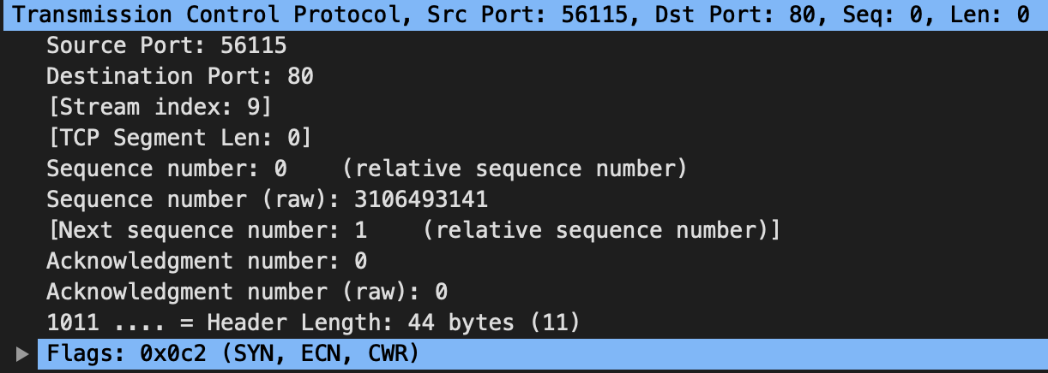

1. What is the sequence number of the SYNACK segment sent by gaia.cs.umass.edu to the client computer in reply to the SYN? What is the value of the Acknowledgement field in the SYNACK segment? How did gaia.cs.umass.edu determine that value? What is it in the segment that identifies the segment as a SYNACK segment?

Sequence number: 0

Value of the Acknowledgement field in the SYNACK segment: 1

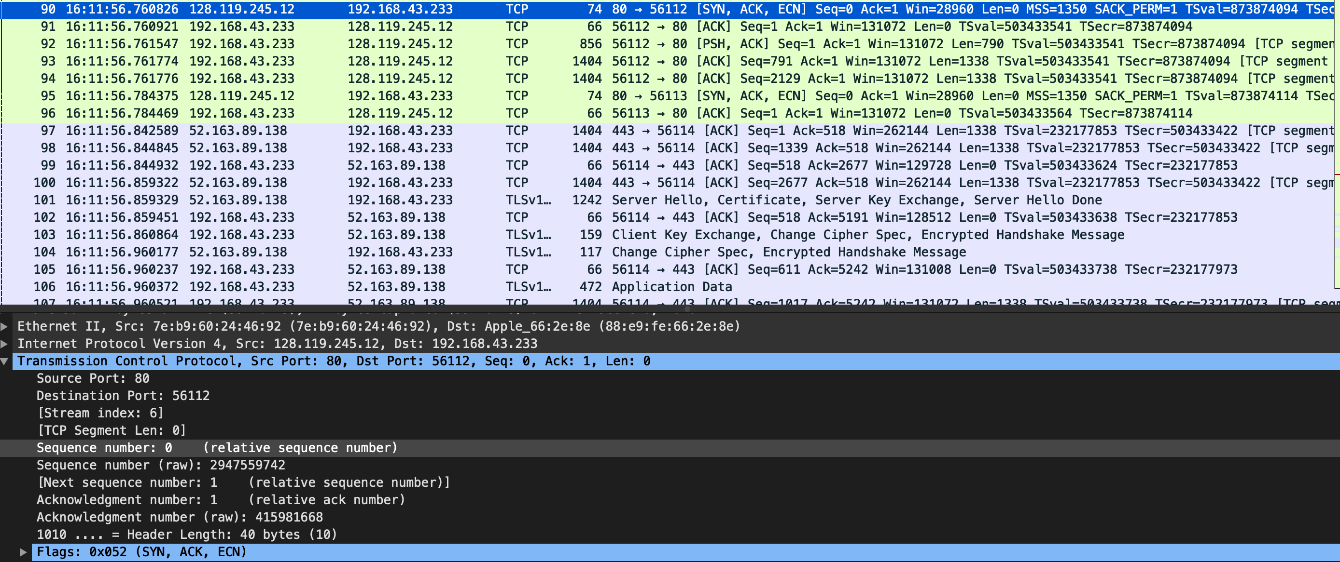We can see Flags: 0x052 to identifies segment as a SYNACK segment

1. What is the sequence number of the TCP segment containing the HTTP POST command?

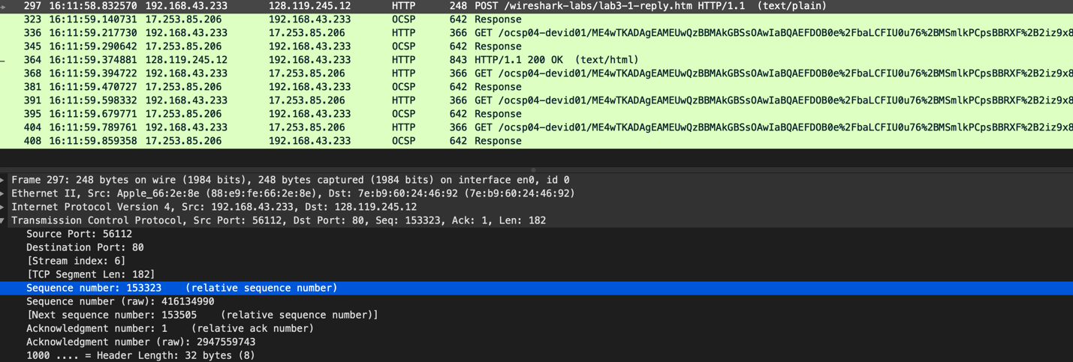Sequence number: 153323

1. Consider the TCP segment containing the HTTP POST as the first segment in the TCP connection. What are the sequence numbers of the first six segments in the TCP connection (including the segment containing the HTTP POST)? At what time was each segment sent? When was the ACK for each segment received? Given the difference between when each TCP segment was sent, and when its acknowledgement was received, what is the RTT value for each of the six segments? What is the EstimatedRTT value (see Section 3.5.3, page 242 in text) after the receipt of each ACK? Assume that the value of the EstimatedRTT is equal to the measured RTT for the first segment, and then is computed using the EstimatedRTT equation on page 242 for all subsequent segments.

Segments 1-6 are No. 221, 226, 227, 228, 229, 230.

Segments 1-6 have sequence number: 152159, 1, 1, 1, 1, 1.

*Thưa thầy, sau khi em chạy thì sau HTTP POST thì toàn là TCP của server gửi về nên em không biết làm sao để lấy thời gian để trừ. (Hình đính kèm)*

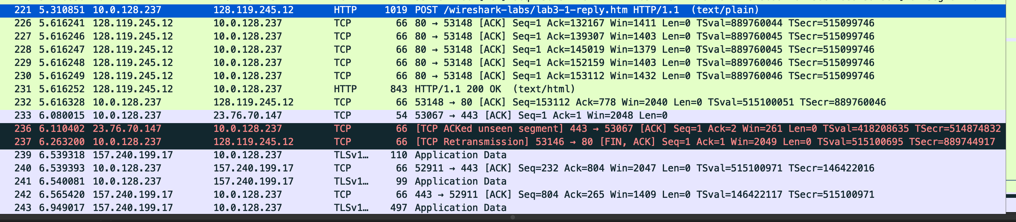

1. What is the length of each of the first six TCP segments?

* Segment 1: 953 bytes
* Segment 2-5: 1428 bytes

1. What is the minimum amount of available buffer space advertised at the received for the entire trace? Does the lack of receiver buffer space ever throttle the sender?

The minimum amount of buffer space (receiver window) advertised at gaia.cs.umass.edu for the entire trace is 28960 bytes. This receiver window grows steadily until a maximum receiver buffer size of 131328 bytes. The sender is never throttled due to lacking of receiver buffer space by inspecting this trace

1. 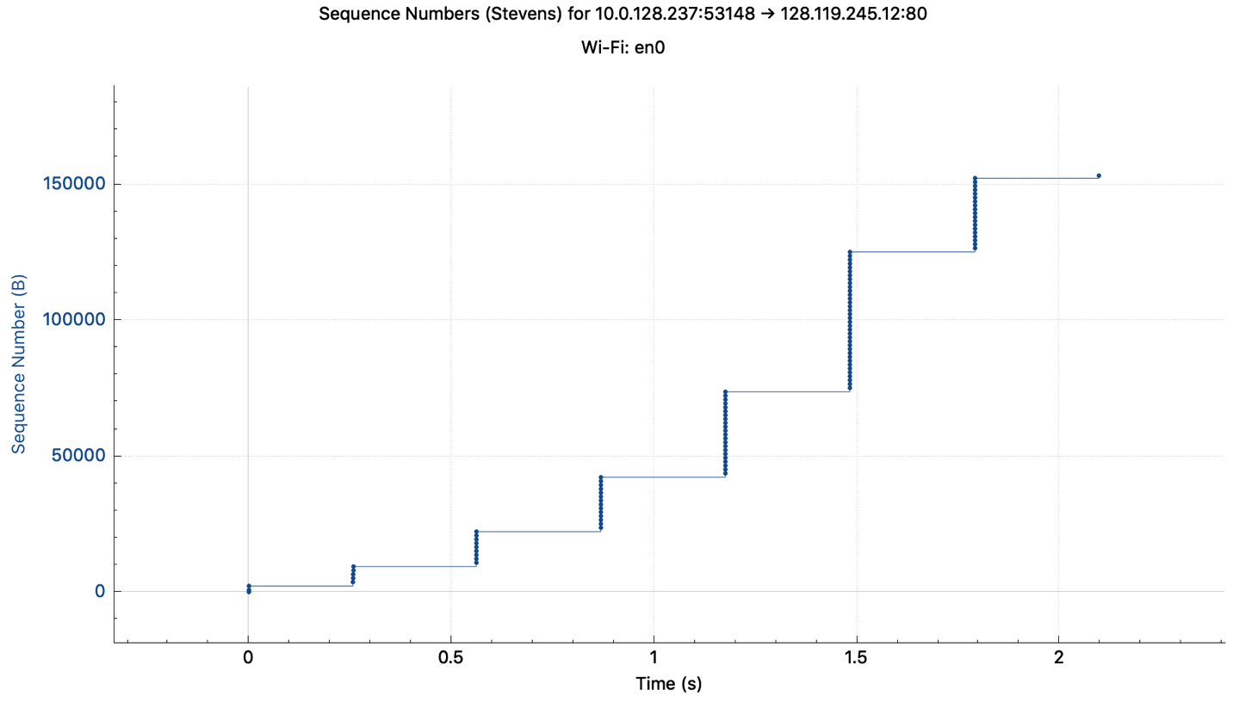Are there any retransmitted segments in the trace file? What did you check for (in the trace) in order to answer this question?

There is no retransmitted segments in the trace file since in the time sequence graph (stevens), all sequence numbers are monotonically increasing

1. *Sorry thầy, em chưa biết làm*
2. What is the throughput (bytes transferred per unit time) for the TCP connection? Explain how you calculated this value.

Throughput=(amount of data transmitted)/(time incurred)

amount of data transmitted = 152159 bytes

time incurred = 5.310851 – 3.519122 = 1.791729 seconds

throughput = 152157.2083 (bytes/second)

* Amount of data



* Time first sent
* Time last sent

1. 