**LAB 4A**

Name: Nguyen Phi Thong

ID: 1814205

1. **What is the IP address of your computer?**

192.168.1.102

1. **Within the IP packet header, what is the value in the upper layer protocol field?**

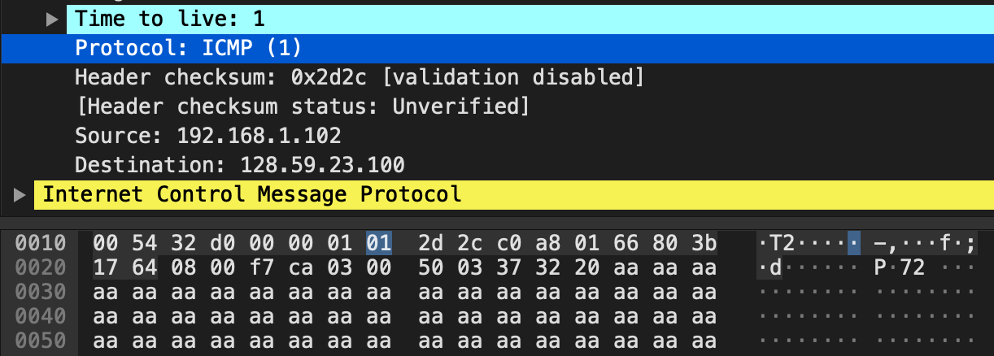The value in the upper layer protocol field is ICMP (0x01)

1. **How many bytes are in the IP header? How many bytes are in the payload of the IP datagram? Explain how you determined the number of payload bytes**.

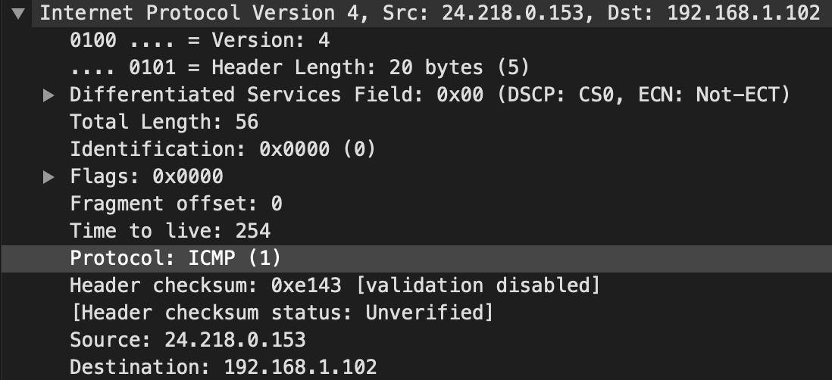There are 20 bytes in the IP header. Total length: 56 bytes 🡪 there are 36 bytes in the payload of the IP datagram.

1. **Has this IP datagram been fragmented? Explain how you determined whether or not the datagram has been fragmented.**

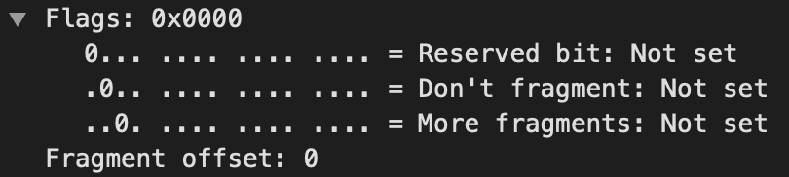More fragments flag set = 0 🡪 the datagram is not fragmented.

1. **Which fields in the IP datagram always change from one datagram to the next within this series of ICMP messages sent by your computer?**

Identification, header checksum, time to live

1. **Which fields stay constant? Which of the fields must stay constant? Which fields must change? Why?**

* Fields stay constant
  + IP version (use IPv4 for all packets)
  + Header length (these are ICMP packets)
  + Source IP (sent from the same source)
  + Destination IP (send to the same destination)
  + Upper Layer Protocol (these are ICMP packets)
  + Differentiated service (all packets are ICMP they use the same Type of Service class)
* Fields must stay constant
  + IP version
  + Header length
  + Total length
  + Source IP
  + Destination IP
  + Upper Layer Protocol
  + Differentiated service
* Fields must change
  + Identification (IP packets must have different ids)
  + Header checksum (because header changes, so must checksum)
  + Time to live (traceroute increments each subsequent packet)

1. **Describe the pattern you see in the values in the Identification field of the IP datagram**

Values in the Identification field of the IP datagramm increment (+1) with each ICMP Echo (ping) request

1. **What is the value in the Identification field and the TTL field?**

Identification: 40316.

TTL: 255

1. **Do these values remain unchanged for all of the ICMP TTL-exceeded replies sent to your computer by the nearest (first hop) router? Why?**

Value of TTL filed doesn’t change for all of the ICMP TTL-exceeded because TTL to the first hop router is always the same. The identification filed changes from all of the replies because this field has to have a unique value.

1. **Find the first ICMP Echo Request message that was sent by your computer after you changed the Packet Size in pingplotter to be 2000. Has that message been fragmented across more than one IP datagram?**

Yes, this packet has been fragmented across more than one IP datagram

1. **Print out the first fragment of the fragmented IP datagram. What information in the IP header indicates that the datagram been fragmented? What information in the IP header indicates whether this is the first fragment versus a latter fragment? How long is this IP datagram?**

Flag bit for more fragments set 1 indicates that the datagram been fragmented.  
Fragment offset is 0 indicates this is the first fragment versus a latter fragment.

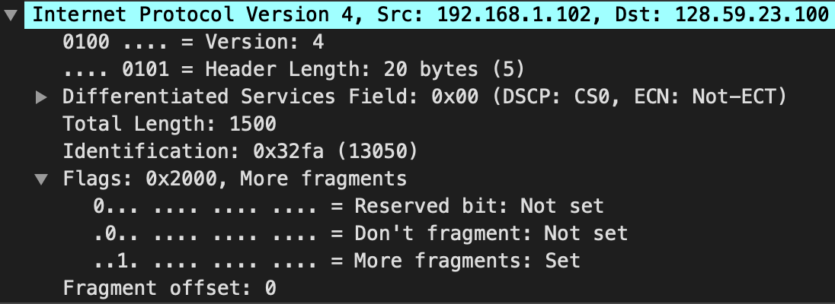 The first IP datagram length: 1500 bytes.

1. **Print out the second fragment of the fragmented IP datagram. What information in the IP header indicates that this is not the first datagram fragment? Are the more fragments? How can you tell?**

Fragment offset: 1480 indicates that this is not the first datagram fragment.

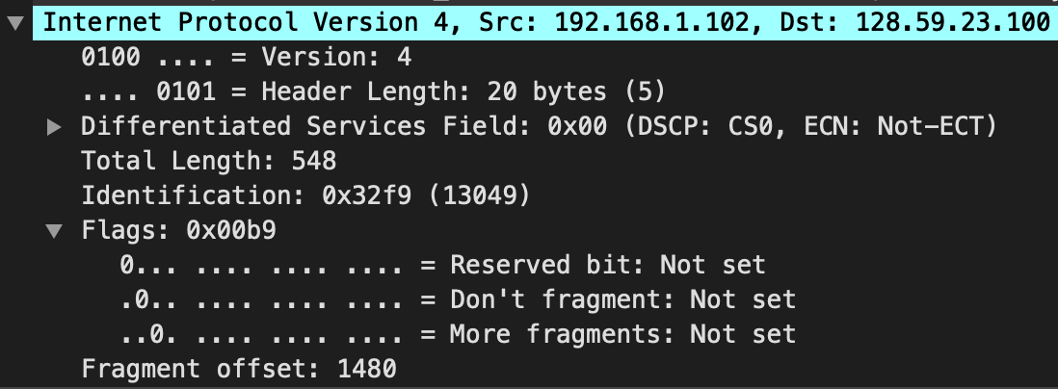It is the last fragment because the more fragments flag set 0.

1. **What fields change in the IP header between the first and second fragment?**

Total length, flags, fragment offset, header checksum.

1. **How many fragments were created from the original datagram?**

There are 3 fragments were created from the original datagram

1. **What fields change in the IP header among the fragments?**

Fragment offset (0,1480,2960), checksum.

The first 2 packet also have length 1500 and more fragment flag set. The last packet has length 568 and more fragment flag doesn’t set.