**LAB 6**

**Name: Nguyen Phi Thong**

**ID: 1814205**

1. **What is the 48-bit Ethernet address of your computer?**

88:e9:fe:66:2e:8e

1. **What is the 48-bit destination address in the Ethernet frame? Is this the Ethernet address of gaia.cs.umass.edu? (Hint: the answer is no). What device has this as its Ethernet address?**

Ethernet address: 6c:3b:6b:bf:e2:1a. This is not Ethernet address of gaia.cs.umass.edu.

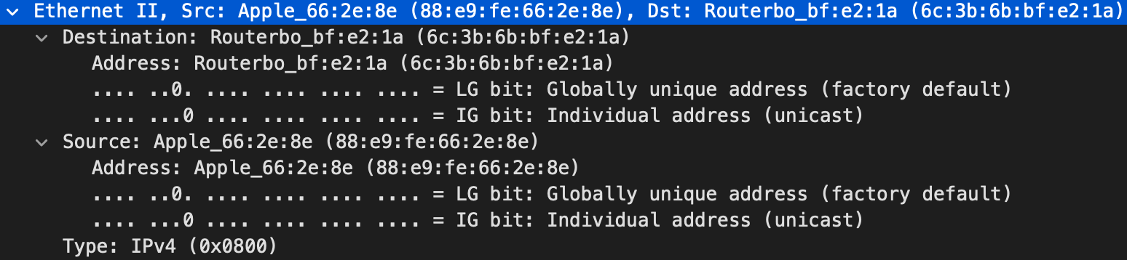This is address of Routerbo_bf router.

1. **Give the hexadecimal value for the two-byte Frame type field. What upper layer protocol does this correspond to?**

Type: IPv4 (0x0800)

1. **How many bytes from the very start of the Ethernet frame does the ASCII “G” in “GET” appear in the Ethernet frame?**

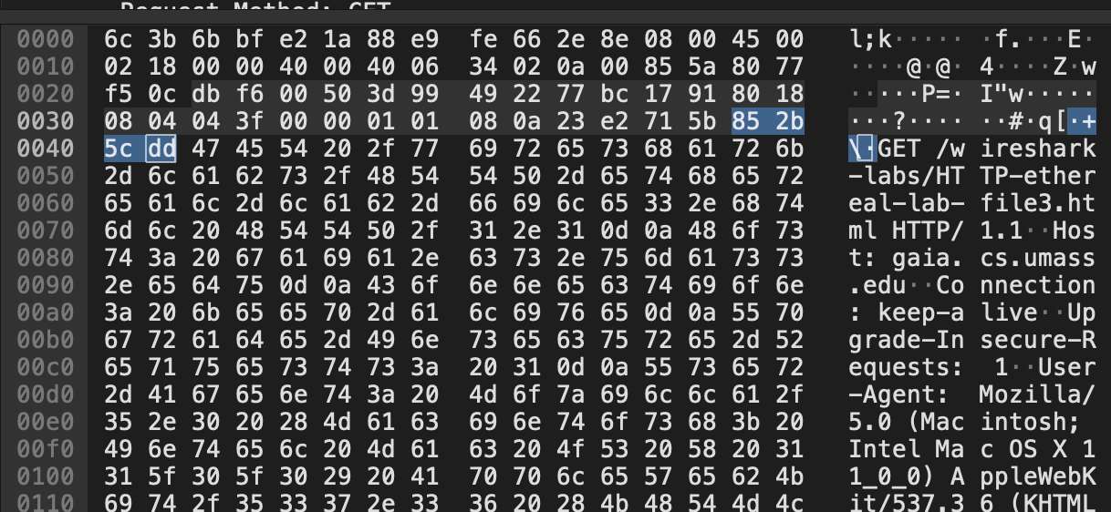66 bytes.

1. **What is the value of the Ethernet source address? Is this the address of your computer, or of gaia.cs.umass.edu (Hint: the answer is no). What device has this as its Ethernet address?**

Ethernet source address: 6c:3b:6b:bf:e2:1a. This is not address of my computer, or of gaia.cs.umass.edu. This is address of Routerbo_bf router.

1. **What is the destination address in the Ethernet frame? Is this the Ethernet address of your computer?**

Destination address in the Ethernet frame: 88:e9:fe:66:2e:8e, this is ethernet address of my computer.

1. **Give the hexadecimal value for the two-byte Frame type field. What upper layer protocol does this correspond to?**

Type: IPv4 (0x0800)

1. **How many bytes from the very start of the Ethernet frame does the ASCII “O” in “OK” (i.e., the HTTP response code) appear in the Ethernet frame?**

66 bytes ( = 14 byte ethernet + 20 bytes header IP + 32 bytes TCP)

1. **Write down the contents of your computer’s ARP cache. What is the meaning of each column value?**

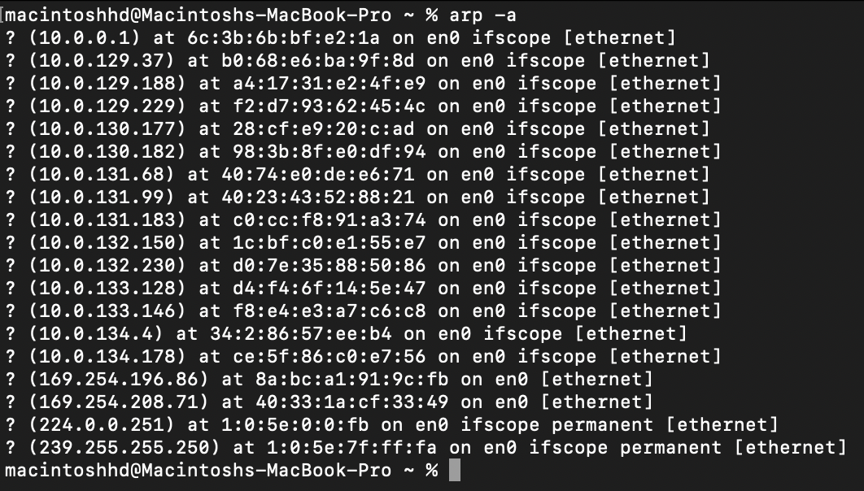 Physical address



1. **What are the hexadecimal values for the source and destination addresses in the Ethernet frame containing the ARP request message?**

Source address: dc:85:de:07:c1:5a.

Destination address: ff:ff:ff:ff:ff:ff.

1. **Give the hexadecimal value for the two-byte Ethernet Frame type field. What upper layer protocol does this correspond to?**

Type: ARP (0x0806).

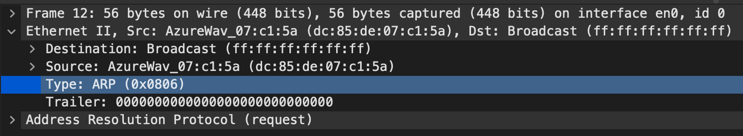

* 1. **How many bytes from the very beginning of the Ethernet frame does the ARP opcode field begin?**
     1. 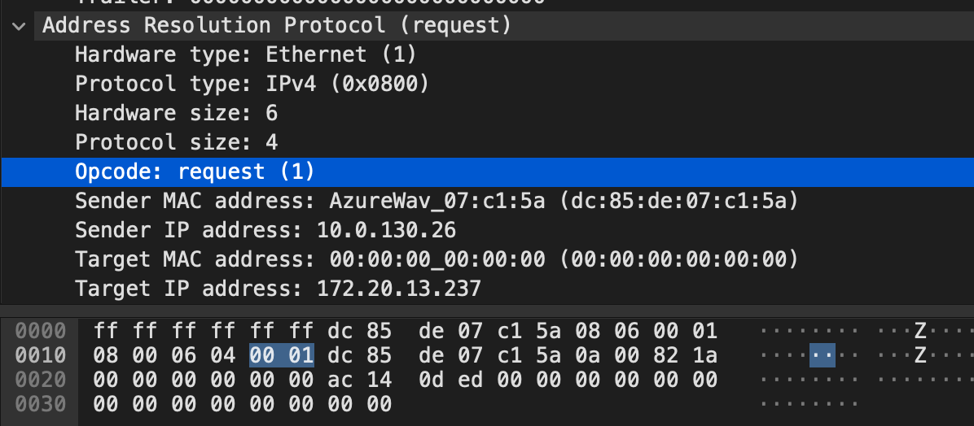bytes
  2. **What is the value of the opcode field within the ARP-payload part of the Ethernet frame in which an ARP request is made?**

Hexa value of opcode field: 0x0001.

* 1. **Does the ARP message contain the IP address of the sender?**

Yes

* 1. **Where in the ARP request does the “question” appear – the Ethernet address of the machine whose corresponding IP address is being queried?**

The field “Target MAC address” is set to 00:00:00:00:00:00 to question the machine whose corresponding IP address (172.20.13.237) is being queried.

**13,14. I don’t see ARP replay**.

**15. Open the ethernet-ethereal-trace-1 trace file in http://gaia.cs.umass.edu/wireshark-labs/wireshark-traces.zip. The first and second ARP packets in this trace correspond to an ARP request sent by the computer running Wireshark, and the ARP reply sent to the computer running Wireshark by the computer with the ARP-requested Ethernet address. But there is yet another computer on this network, as indicated by packet 6 – another ARP request. Why is there no ARP reply (sent in response to the ARP request in packet 6) in the packet trace?**

There is no reply in this trace, because we are not at the machine that sent the request. The ARP request is broadcast, but the ARP reply is sent back directly to the sender’s Ethernet address