DropCeiling: Empowering Ubiquitous Objects with Adaptive Intelligence
Keywords: Responsive Systems, Learning Algorithms, Augmented Reality
DropCeiling is an open-source hardware and software system that enables standard LED office light panels to act as an intelligent agent that interprets real-time data, short term trends, and long-term arcs to drive the behaviour of an Augmented Reality character (Darbar et al. 2019). The position, brightness, and falloff properties of this character were controlled by a three tiered system that adapted a set of meta-parmeters. The system was first deployed for XXXXXXXXX in XXXXXXXX in the storefront of XXXXXXXX. This installation served as an active experiment into how millions of interactions can be distilled into twelve brightness values.
The site at the corner of XXXXXXX and XXXXXX in XXXXXXXX is a busy pedestrian corridor. The primary input to the response system is the position and movement of pedestrians on the sidewalk directly in front of the installation. Two standard security cameras mounted inside looking out tracked the position. This 3d space of the sidewalk was calibrated using ARuco markers (Ribeiro Neto et al. 2026) which allowed the two camera feeds to be combined into a single frame and map the position of each person to their location on the sidewalk. Though all position data was fed into the behavior system, the response was split based on whether the person was in the active or passive zone. These zones were determined by the existing architecture which created an alcove directly in front of the installation. The interaction was entirely implicit: there was no screen, no application, and no instruction, only the presence and movement of a person reading as input, so that a passerby could engage the work without ever knowing they were doing so.
The behavior of the character was driven by three nested control loops operating at very different timescales. The fastest, running at thirty frames per second, reacted to the people present in that moment, moving the light through one of five modes (idle, flow, aware, engaged, and crowd) and layering small gestures that deepened the longer a person stayed. A slower loop read the recent history of the sidewalk across nested one, five, thirty, and sixty minute windows, together with a thirty second measure of the dominant direction of traffic, and used these trends to anticipate where to position the light when no one was directly engaging. The slowest loop, running across hours and days, adjusted the twelve meta-parameters that gave the character its personality, traits such as responsiveness, energy, sociability, and exploration, so that the same situation would produce a measurably different response weeks later. At every frame this entire apparatus resolved to the position and intensity of a single virtual point light, from which each of the twelve physical panels brightened according to its distance.
DropCeiling was developed using AI coding agents rather than conventionally hand-written code. Because the problem was fundamentally spatial, the central challenge was giving a language model an accurate understanding of the physical site. This was addressed by building a lightweight three-dimensional model of the installation, comprising the panel units, the camera positions, and the tracking zones, that served as a shared reference for both the author and the agents. The control software itself was written as a simple three-dimensional game, in which the physical space, the virtual light, and the control logic share a single coordinate frame, so that the behavior of the character could be observed within the same model the agents reasoned about. The model was exported both as structured context that the agents read directly and as a set of standard JSON files that the running system consumed.
The installation ran continuously, twenty-four hours a day, for fifty-four days, taking in roughly one million inputs from the active and passive movement of pedestrians on the sidewalk and generating some fifteen million individual position readings in the process. At this scale the design problem inverts: the interactions cannot be anticipated, so the work cannot script its responses and must instead learn them from the structures and feedback loops. (Nguyen et al. 2023). Across the run the system performed more than a hundred and sixty deep analyses of its own accumulated history, and the character measurably changed, becoming more confident at attracting engagement, calmer during the rush-hour crowds that would not stop, and less repetitive in its gestures. Each of these changes was recorded, making the evolution an auditable result rather than an impression. Throughout the run a public web view rendered the state of the system in real time, showing the position of the light, the tracked pedestrians, and the brightness of each panel, so that the work continuously explained its own behaviour to anyone who looked.
Sustaining that adaptation across fifty-four days required a mechanism to keep the system from either overreacting to momentary noise or settling into a comfortable and unchanging routine. This was the role of the interaction budget. Every change the system proposed to its personality drew down a finite budget that replenished only slowly over time, so that a burst of activity could move the parameters by a few small steps before further change was throttled until the budget recovered. Two further forces worked against complacency: a gentle pull returned each parameter toward a learned resting value whenever it drifted too far, while a periodic curiosity introduced small random nudges that kept the system exploring rather than hardening around a single solution. The effect was an algorithm that remained responsive, continuously adjusting without becoming lazy and simply turning all the sliders to maximum.

View of DropCeiling Installation
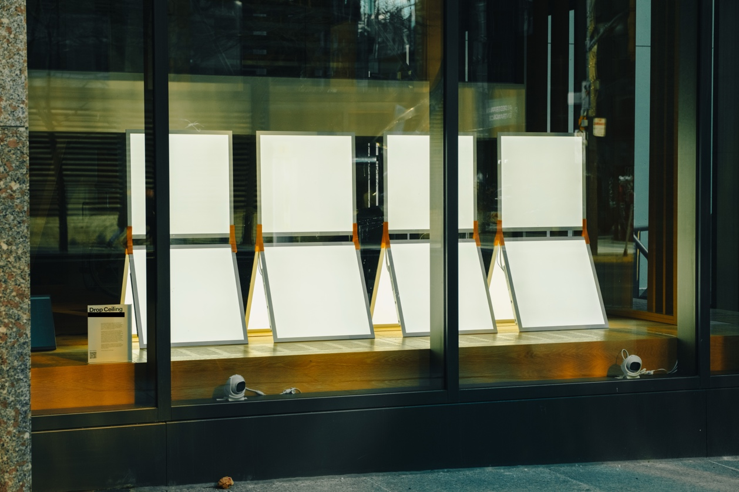
DropCeiling is composed of 12 LED light panels attached by custom 3d-printed connectors
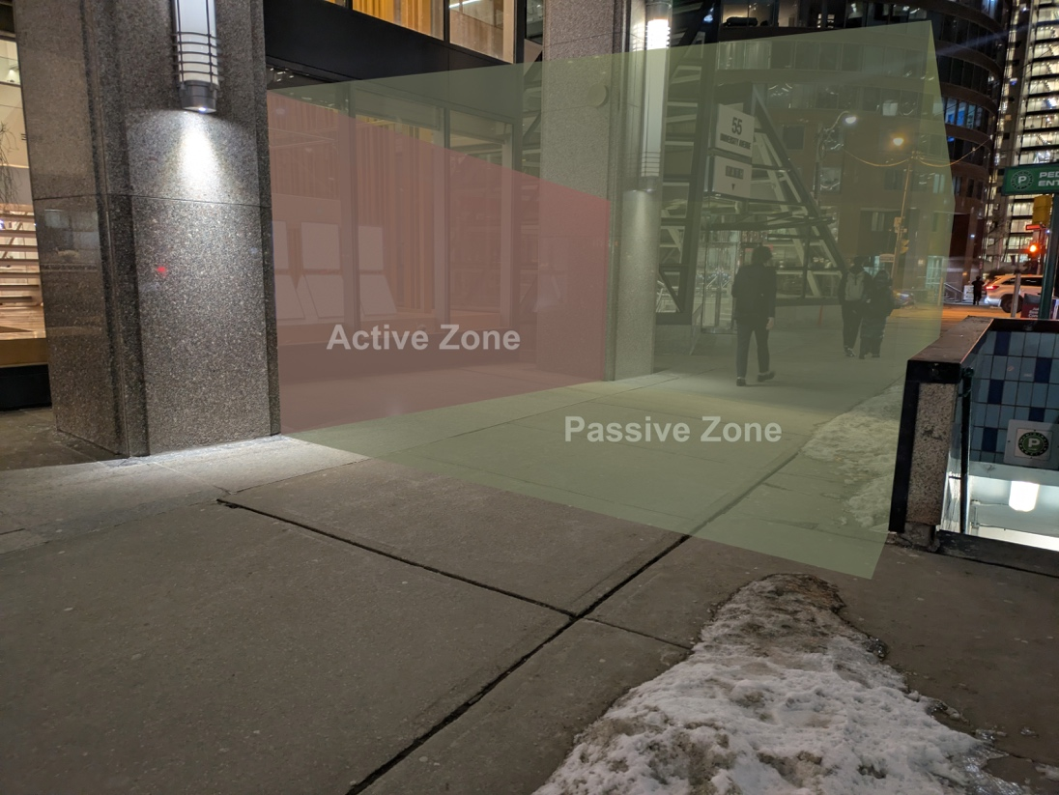
Active and Passive Tracking Zones on the sidewalk
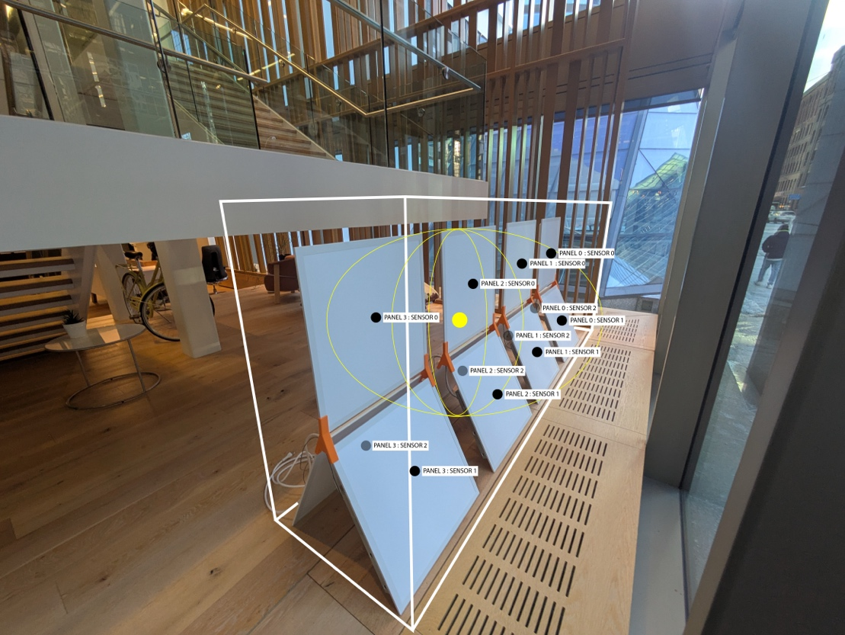
Panel brightness is calculated by AR sensors that calibrate the light from the point light character.
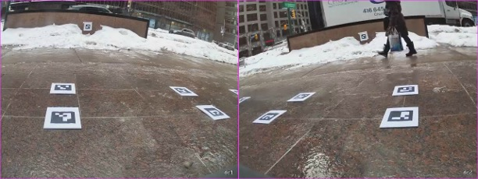
AR markers as scene by both cameras during calibration

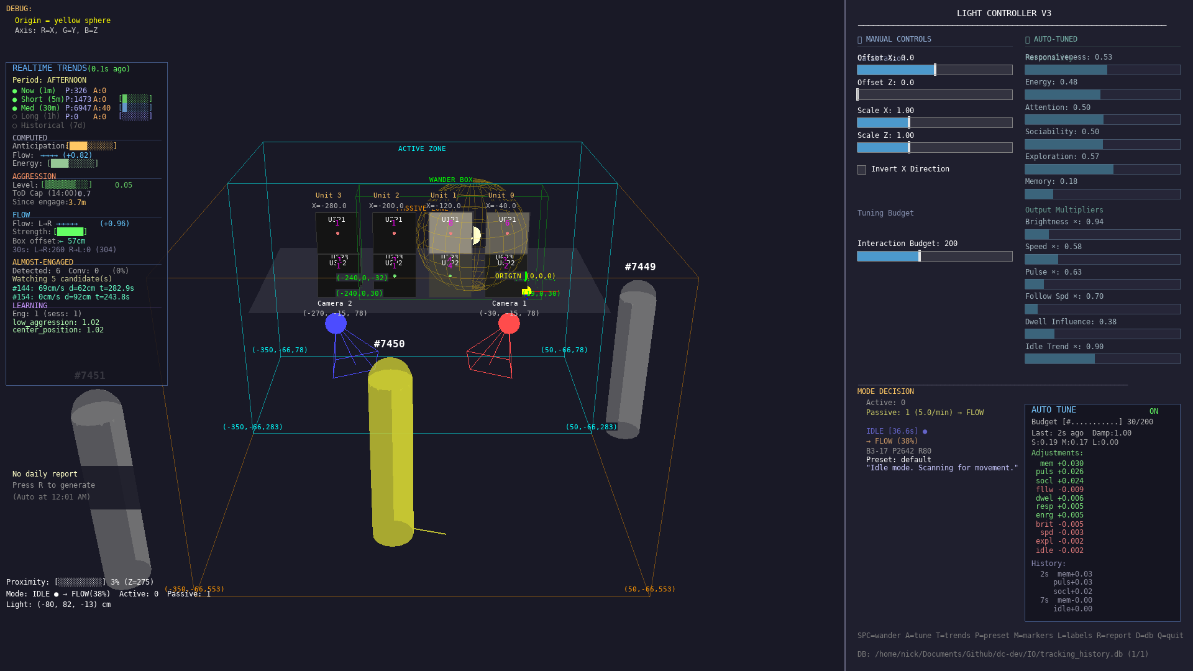
DropCeiling control software interface created in PyGame

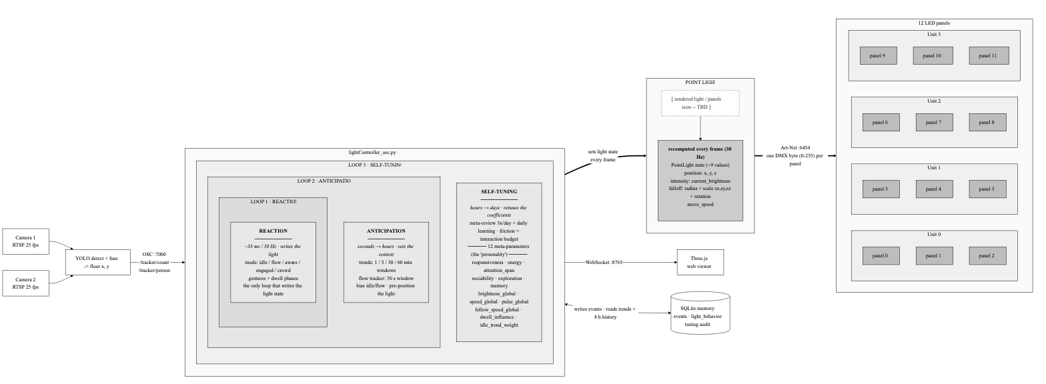

DropCeiling Data Pipeline
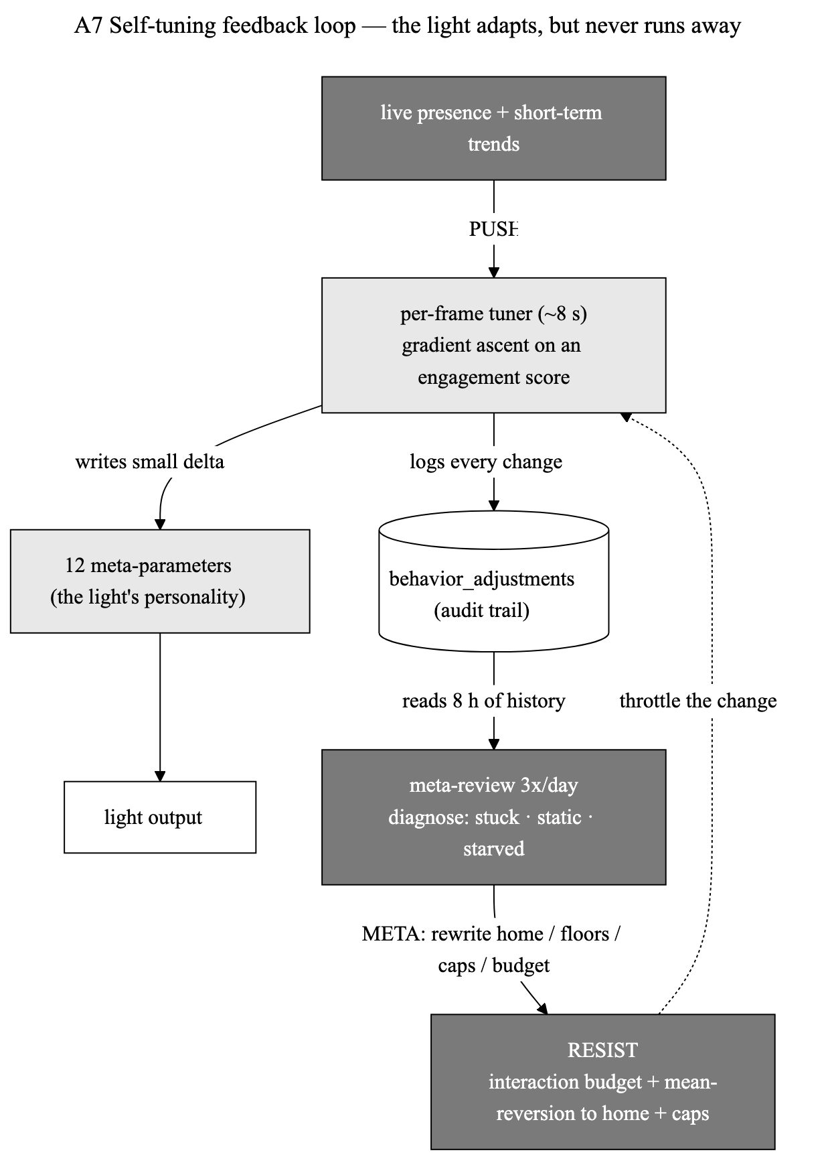
Feedback loop used for self-tuning the light behavior

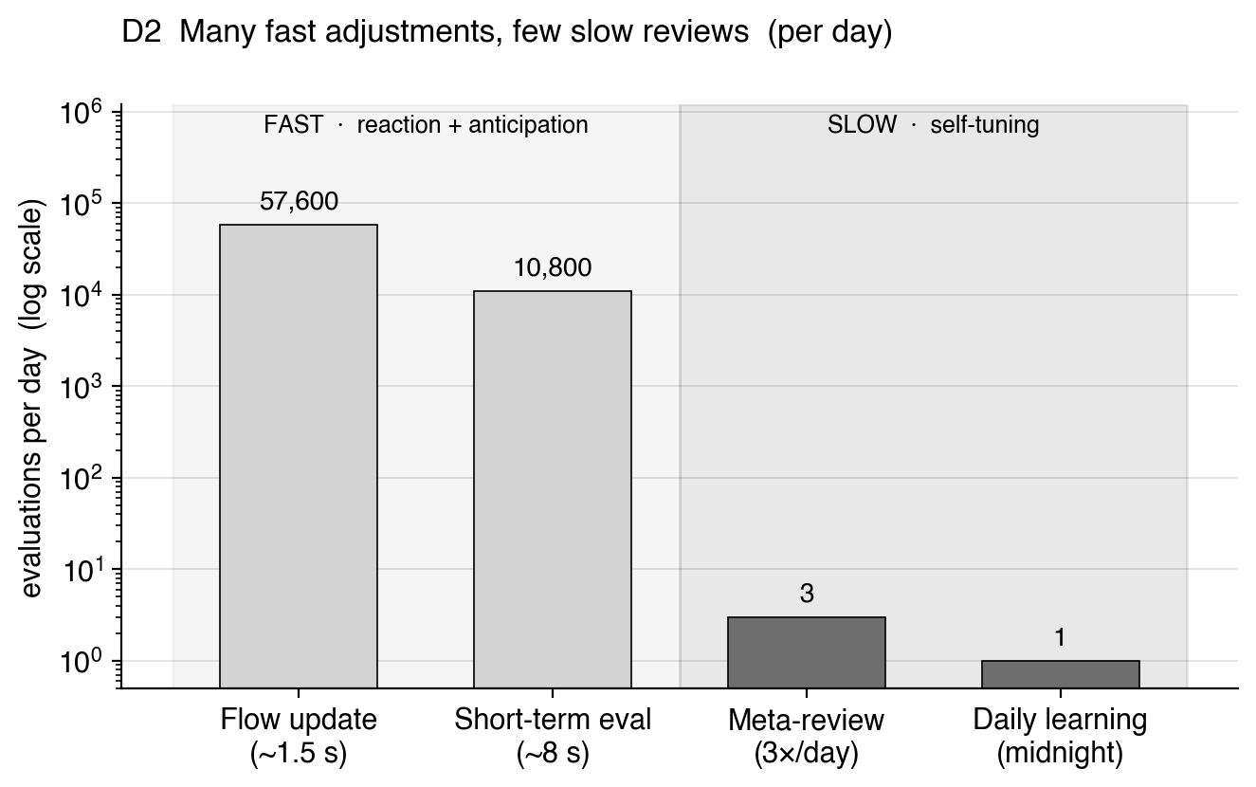
Evaluation Cadence of reflection loops

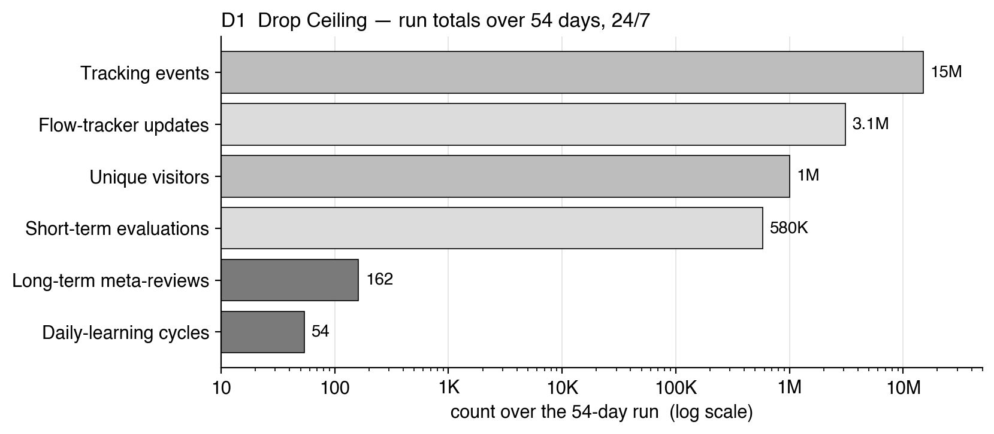

Total Tracking events and evaluations during the run
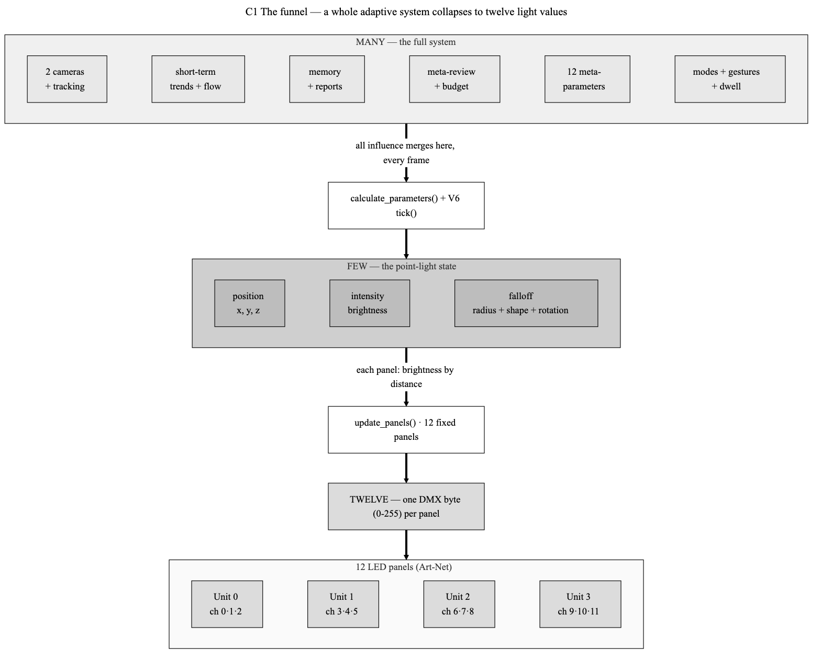
The system distills down to twelve 0-255 byte values

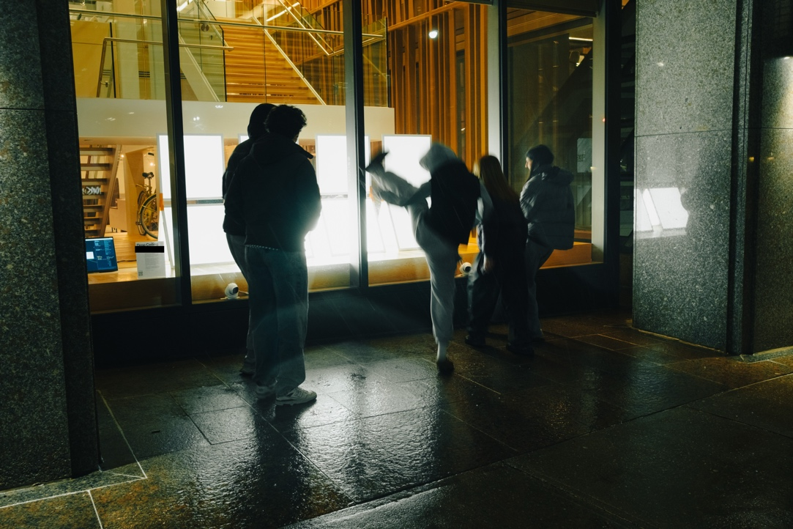
Visitors in the ‘Active’ zone


References
Bouneffouf, Djallel, and Raphaël Féraud. 2024. “A Tutorial on Multi-Armed Bandit Applications for Large Language Models.” In Proceedings of the 30th ACM SIGKDD Conference on Knowledge Discovery and Data Mining, 6412–6413. New York: ACM. https://doi.org/10.1145/3637528.3671440.
Darbar, Rajkumar, Joan Sol Roo, Thibault Lainé, and Martin Hachet. 2019. “DroneSAR: Extending Physical Spaces in Spatial Augmented Reality Using Projection on a Drone.” In Proceedings of the 18th International Conference on Mobile and Ubiquitous Multimedia, 1–7. New York: ACM. https://doi.org/10.1145/3365610.3365631.
Nguyen, Binh Vinh Duc, Jihae Han, Maarten Houben, Yssmin Bayoumi, and Andrew Vande Moere. 2023. “Engaging Passers-by with Rhythm: Applying Feedforward Learning to a Xylophonic Media Architecture Facade.” In Proceedings of the 2023 CHI Conference on Human Factors in Computing Systems, 1–21. New York: ACM. https://doi.org/10.1145/3544548.3580761.
Ribeiro Neto, Benedito, Bianchi Meiguins, Tiago Araújo, and Carlos dos Santos. 2026. “Artificial Markers: A Comprehensive Systematic Review and Design Framework.” ACM Computing Surveys 58 (9): 1–35. https://doi.org/10.1145/3793661.

