Table of Contents

Drop Ceiling — System Logic for Diagrams & Drawings
Companion to ACADIA_2026_SOFTWARE_REPORT.md. This document pairs short prose with structured “diagram-ready” blocks. Each block marked ◧ DRAW is a suggestion for a figure you can lift directly. Production software = V6.5c (March 2026), dc-dev/IO/.
Rendered figures now exist in diagrams/ (SVG + PNG, editable Mermaid/Graphviz sources in diagrams/src/; see diagrams/README.md). The ◧ DRAW blocks below are the design intent; the diagrams/ IDs (A1–A11, B1–B3, A7.1–A7.7 + A7.3b, C1–C5) are the built versions. Three figure families: A/B = how the system decides; A7.x = the self-tuning loop exploded node by node; C = how all of that collapses to 12 light values (§3d–§3f). A handful of captured project images (photos/renders/screens, IDs P1–P6) live in diagrams/assets/ and are embedded where relevant.
◧ Diagram P3 — the project’s own system diagram (an earlier, project-made overview; the A-series figures in this guide are the cleaned, verified reconstruction of it):
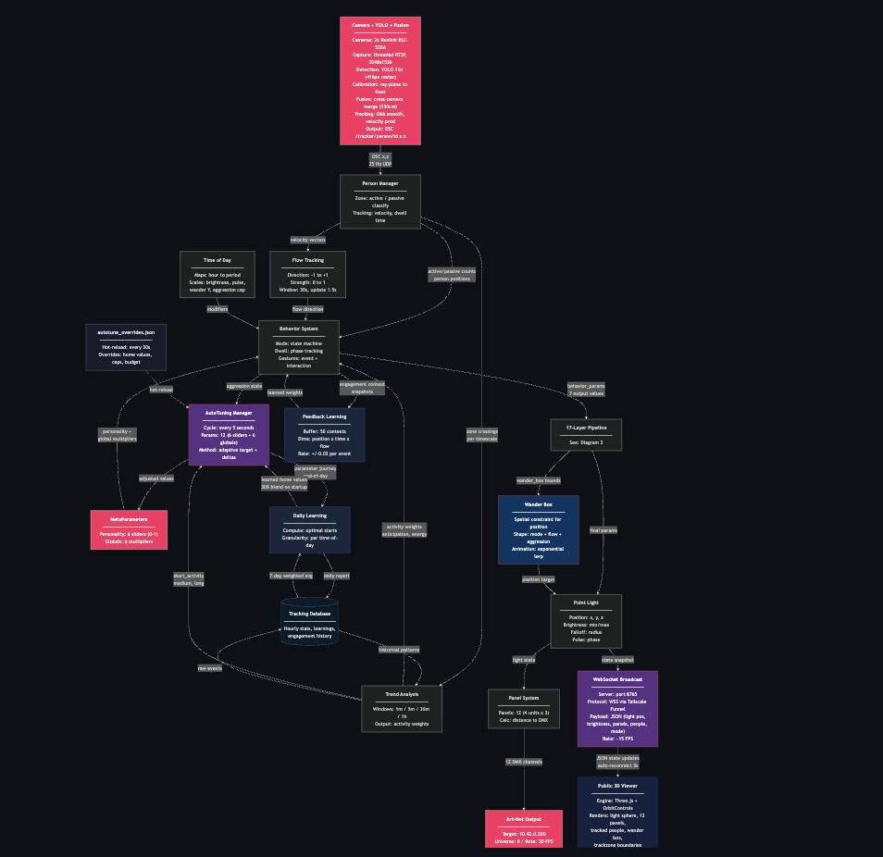
P3 — The original Drop Ceiling system diagram: camera+YOLO → person manager → behavior system → autotuning/feedback/daily-learning → wander box → point light → panel system → Art-Net, with the web viewer branch

1. The whole system in one picture
Drop Ceiling turns a sidewalk into an instrument. Two cameras watch pedestrians; a single simulated point light, hovering in a 3D field of LED panels, responds to them. What makes it more than a motion sensor is that it runs three nested control loops at three timescales — it reacts to the instant, anticipates the next hour, and reshapes its own personality over days — with an interaction budget providing the friction that keeps that self-adaptation deliberate rather than twitchy.
◧ Photo P1 — the installation in situ (Haworth Canada showroom window, 55 University Ave, Toronto; twelve panels in four sandwich-board units, seen from the sidewalk at night):
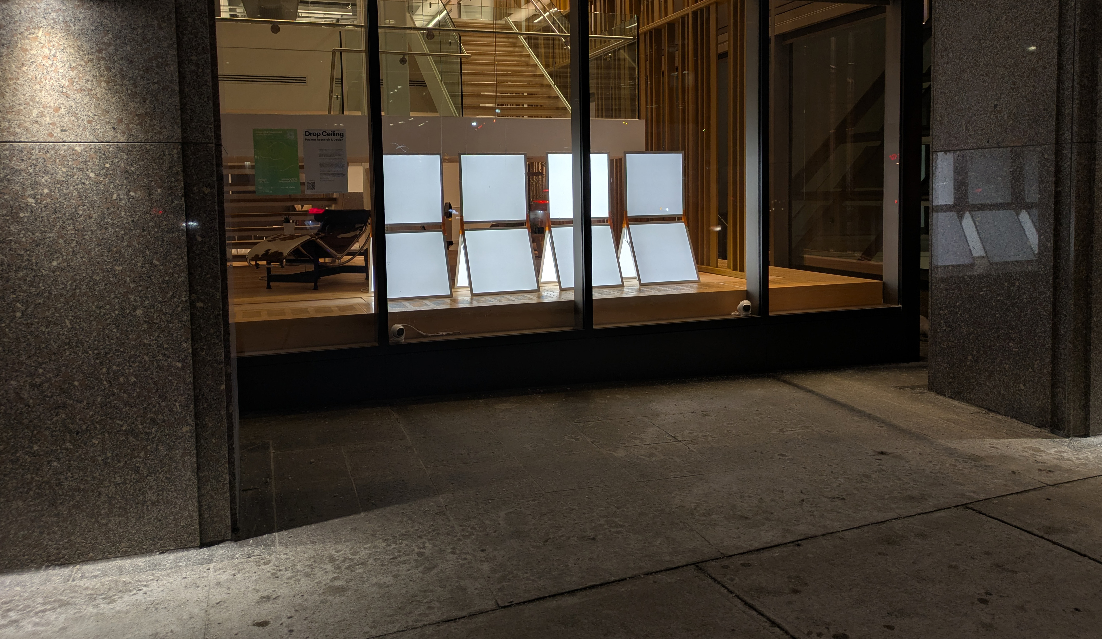
P1 — Drop Ceiling installed in the Haworth showroom window at night: four illuminated free-standing units of three panels each, viewed from the sidewalk between the building’s columns
◧ Render P2 — the four units / panel geometry (each unit = 3 panels, numbered 1/2/3; the layout the whole spatial model is built on, §15d):
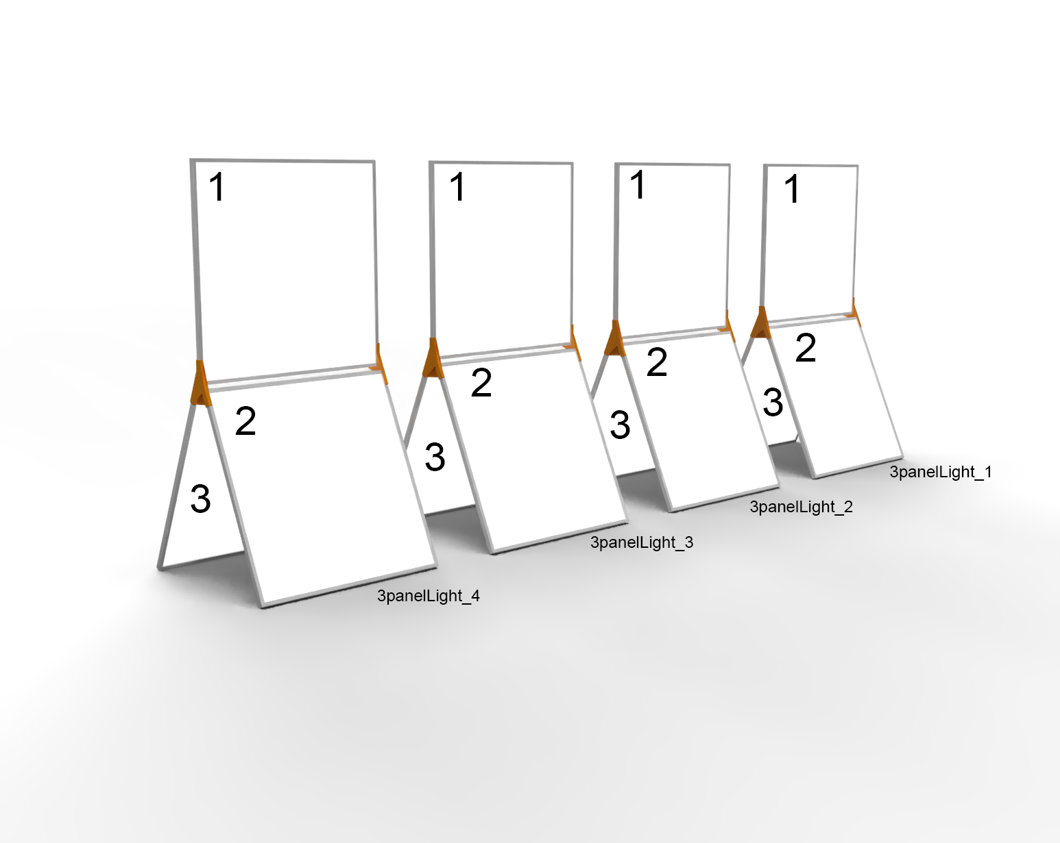
P2 — 3D render of the four Drop Ceiling units, each a sandwich-board of three numbered panels (1 upper, 2 and 3 angled), matching world_coordinates.json
◧ Figure A1 — Top-level pipeline (left-to-right signal flow):
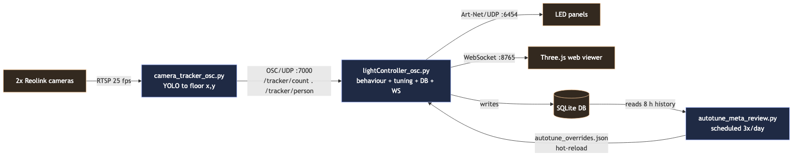
A1 — Top-level pipeline: tracker → controller → panels, with WebSocket viewer, SQLite DB, and the 3×/day meta-tuner loop
Three OS processes (each a systemd service): tracker, controller, meta-tuner. Everything they share passes through two channels — OSC (live positions) and the SQLite database (memory).

2. The three nested loops (the conceptual core)
This is the single most important diagram for the submission — it shows the project is about time and adaptation, not just reactivity.
◧ Figure A2 — Three concentric loops, fastest innermost:
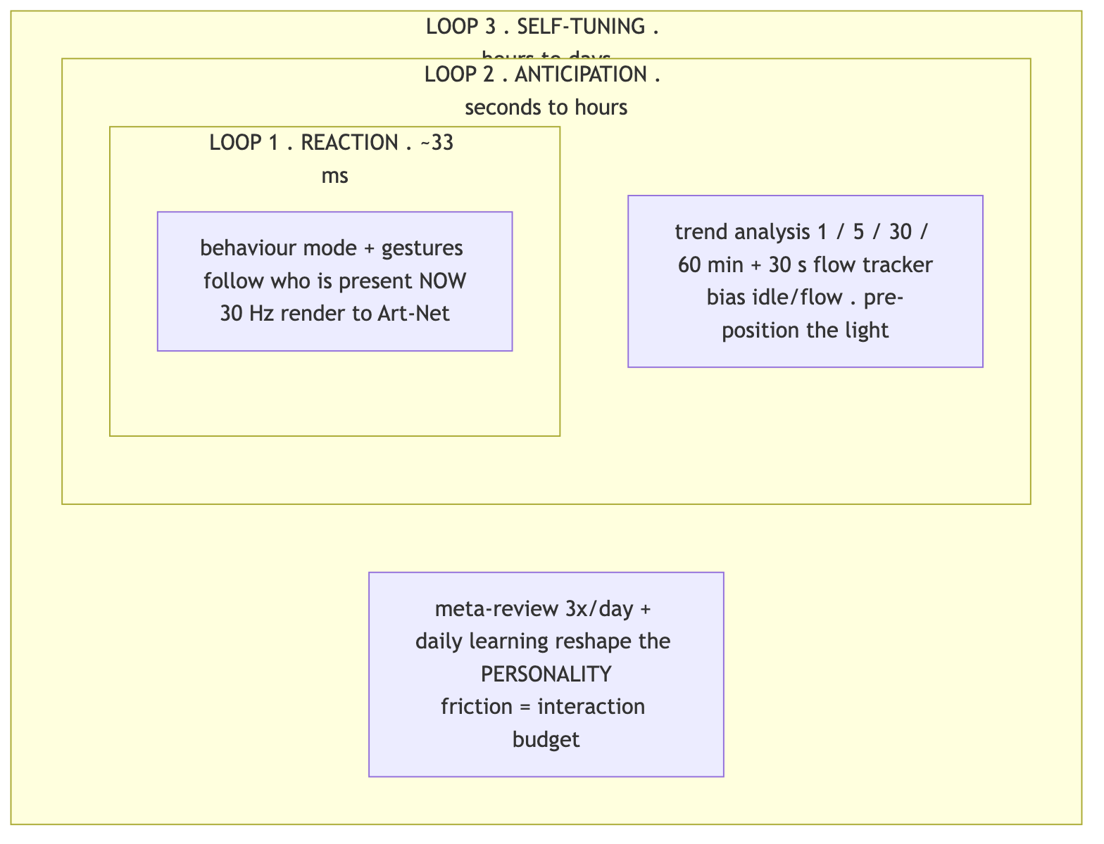
A2 — Three nested control loops: reaction (~33 ms) inside anticipation (sec–hours) inside self-tuning (hours–days)
Loop | Cadence | Reads | Writes / Affects
1 — Reaction | ~30 Hz | live OSC people + zones | light position, brightness, pulse, gesture
2 — Anticipation | 1.5 s (flow), background thread (trends) | DB trend queries (1/5/30/60 min) | wander box bias, idle energy, mode selection
3 — Self-tuning | 3×/day (+ midnight daily learning) | 8 h of DB history | rewrites meta-parameters via autotune_overrides.json
The outer loops never move the light — only the reaction loop does. Instead, each loop sets the terms for the one inside it. Loop 2 changes the situation the light is responding to: it pre-positions the wander box and raises or lowers the idle energy so the light is already leaning toward arriving traffic. Loop 3 changes the disposition with which it responds to any situation at all: it slowly rewrites the personality coefficients that turn “a person is here” into a particular brightness, speed, and pulse. The first is transient and contextual; the second is persistent and characterological.
Put differently, the indirection deepens at each level: Loop 1 sets the light’s values, Loop 2 sets its context, Loop 3 sets the coefficients of its reaction (and even rewrites the constants that govern its own adjustments). Three consequences follow, and they are the reason the architecture is built this way:
- It is the mechanism of “character.” A purely reactive light feels identical on day 1 and day 100. Because Loop 3 slowly drifts the coefficients of reaction, the same stimulus produces a measurably different response months later — which is, concretely, what “grows a personality” means here.
- Timescale separation buys stability. Slow self-modification physically cannot cause fast flicker: only the fast, smoothed reaction loop ever reaches the fixtures, and the slow loops are budget-limited and gentle. That separation is what makes a self-rewriting system safe to run 24/7.
- It stays authorable. Because the three concerns are kept distinct, a designer tunes a temperament, an anticipation behaviour, and a reaction as three legible things rather than one tangled controller.

3. Meta-parameters — the light’s personality
Prose: the behaviour mode decides the shape of a response (e.g. “follow the nearest person, brighten, tighten the beam”). The meta-parameters decide its flavour (eager vs reserved, brisk vs contemplative, bright vs dim). They are the only variables the self-tuning loop is allowed to move — which is exactly why the light can “grow a character” over weeks. Defined in MetaParameters (light_behavior.py:429), persisted in slider_settings.json.

3a. Six personality axes (0.0 – 1.0)
◧ DRAW — a 6-spoke radar/wheel; show “neutral 0.5” ring vs “as-deployed” values.
Parameter | 0.0 ⟶ 1.0 | Light outputs it bends | As-deployed*
responsiveness | contemplative ⟶ reactive | follow-smoothing, move speed, transition time | 0.83
energy | calm ⟶ lively | pulse rate, max brightness, gesture frequency | 0.77
attention_span | distractible ⟶ loyal | follow-smoothing, dwell rewards, mode stickiness | 0.51
sociability | reserved ⟶ eager | gesture chance, entrance flash, engaged brightness | 0.44
exploration | stays put ⟶ wanders | wander-box size, wander interval, position variety | 0.71
memory | forgets ⟶ avoids repeats | anti-repetition strength, trend-influence weight | 0.49
* from slider_settings.json — the tuner had evolved a bright, brisk, exploratory character, far from the 0.5 neutral start. (Good caption for a “before/after personality” figure.)

3b. Six output multipliers (scaling knobs)
◧ DRAW — a small “mixing console” of faders.
Multiplier | Default | Effect | As-deployed
brightness_global | 1.0 | master brightness gain | 2.43
speed_global | 1.0 | all movement speeds | 1.46
pulse_global | 1.0 | breathing/pulse rate | 0.66
follow_speed_global | 1.0 | chase speed onto a person | 0.60
dwell_influence | 1.0 | how strongly dwell-time bonuses apply | 0.49
idle_trend_weight | 1.0 | how strongly passive-zone trends bend idle | 0.51

3c. How a meta-parameter becomes light (the modulation chain)
◧ Figure A4 — a horizontal “signal chain” / pipeline of multiply stages:
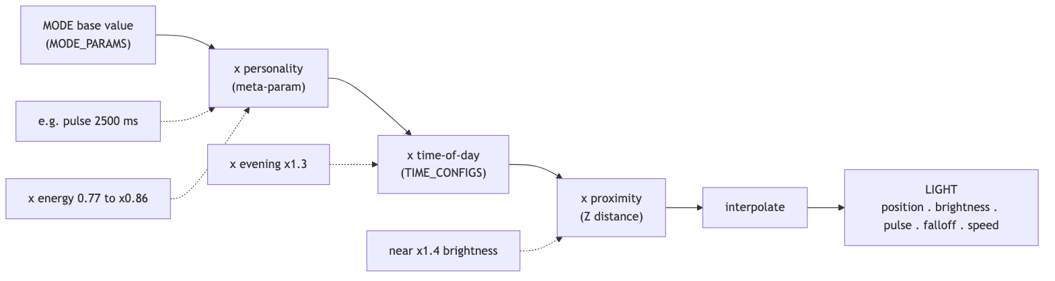
A4 — Modulation chain: mode base value × personality × time-of-day × proximity → interpolate → light
MODE base value × META-PARAM × TIME-OF-DAY × PROXIMITY → interp → LIGHT
e.g. pulse 2500 ms × energy 0.77→0.86 × evening ×1.3 × near → ~2800 ms
e.g. brightness 8–30 × brightness_global × ×0.6 late-night × near ×1.4 → final DMX
(Worked numeric examples, kept as text since A4 shows the structure.)
Key idea for the figure: the light fixture only understands a handful of physical quantities — position, brightness min/max, pulse speed, falloff radius/shape, move speed. The whole meta-parameter system exists to colour those few numbers. The next three sub-sections (§3d–§3f) follow that thread all the way to the wire — the part the first round of diagrams under-told.

3d. The output funnel — from a whole system to 12 light values (the C-series)
Prose: this is the point the project most needs to make legible. Everything above — two cameras, four trend windows, a tiered database, a 3×/day self-review, twelve personality meta-parameters, five modes and sixteen gestures — exists only to set the state of one virtual point light. And that light, in turn, is read by the panels as just 12 numbers: one brightness byte per panel, recomputed from scratch ~30 times a second. The drama of the piece is this collapse from enormous contextual complexity to a near-trivial output, happening continuously and live.
Be precise about the two layers (they’re easy to conflate):
- The “light state” (the pinch point) ≈ 9 scalars held on the PointLight object: position (x, y, z), current_brightness (intensity), falloff_radius, and the beam shape — falloff_scale (sx, sy, sz) + falloff_rotation. (PointLight, lightController_osc.py:2217.)
- The “output” = 12 DMX bytes, one 0–255 brightness per panel (4 units × 3 panels), sent over Art-Net universe 0. (StupidArtnet(TARGET_IP, UNIVERSE, 12, FPS), :4604.)
So the honest headline is many → ~9-value light state → 12 panel bytes, not “12 inputs.” The light is monochrome per panel — the system computes one intensity per panel, not RGB. That restraint is part of the story: extraordinary behavioural complexity expressed through a deliberately minimal palette.
◧ Figure C1 — the hero funnel: a wide top band of all subsystems narrowing through a single waist labelled PointLight (≈9 values) and fanning back out to a row of 12 panel cells → Art-Net.
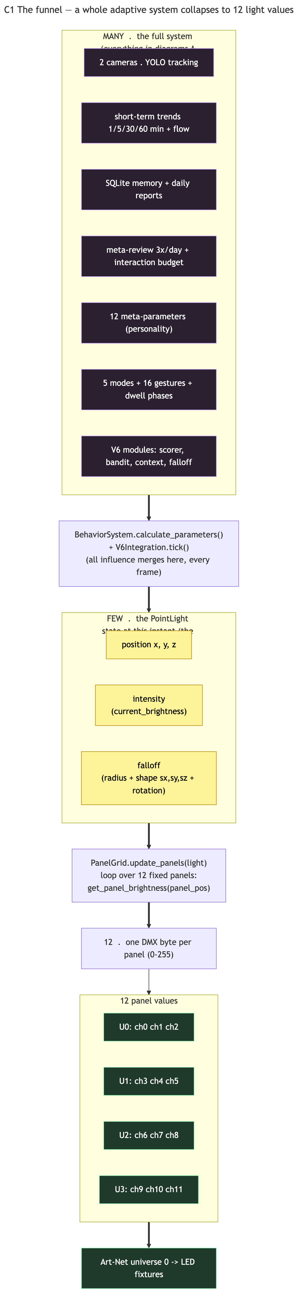
C1 — The funnel: the whole adaptive system collapses to the PointLight state, then fans back out to 12 DMX panel values

3e. The pinch point — who writes each light value (C2)
Prose: the nine scalars look trivial, but each is the sum of the whole system pressing on one number. This is the figure that connects §3c’s modulation chain to a concrete field. (PointLight fields set in the main loop, lightController_osc.py:4956.)
◧ DRAW — C2, a two-column table: “upstream system writes…” → “the few values”. (Rendered: diagrams/C2_light_state_pinch.)
Light value (read at render) | What collapses into it
position (x, y, z) | mode + wander + follow + gestures (the movement layer)
current_brightness | mode base × brightness_global × time-of-day × proximity × dwell × breathing × bloom × entry-pulse, hard-capped at 600 (V6.5c)
pulse_speed (→ brightness over time) | mode base × pulse_global × time-of-day
falloff_radius | mode base × breathing
falloff_scale (sx,sy,sz) + falloff_rotation | SWEEP/FOCUS gestures × ambient oscillation × V6 falloff manager
move_speed | mode base × speed_global × proximity × pedestrian speed-match
current_brightness is itself dynamic between tuning events: it pulses as brightness_min + (brightness_max − brightness_min) × (sin(pulse_phase)+1)/2 — the visible “breathing.” (PointLight.get_brightness, :2248.)

3f. Per-panel math + the 12-channel map (C3, C4, C5)
Prose: each panel computes its own brightness from the same light state, by distance. This is where “falloff” stops being a word and becomes the actual geometry — and where the anisotropic shape (scale + rotation) lets a gesture stretch or steer the beam across the panel field. (PanelSystem.calculate_brightness, lightController_osc.py:2299.)
◧ Figure C3 — the per-panel pipeline (runs ×12 every frame):
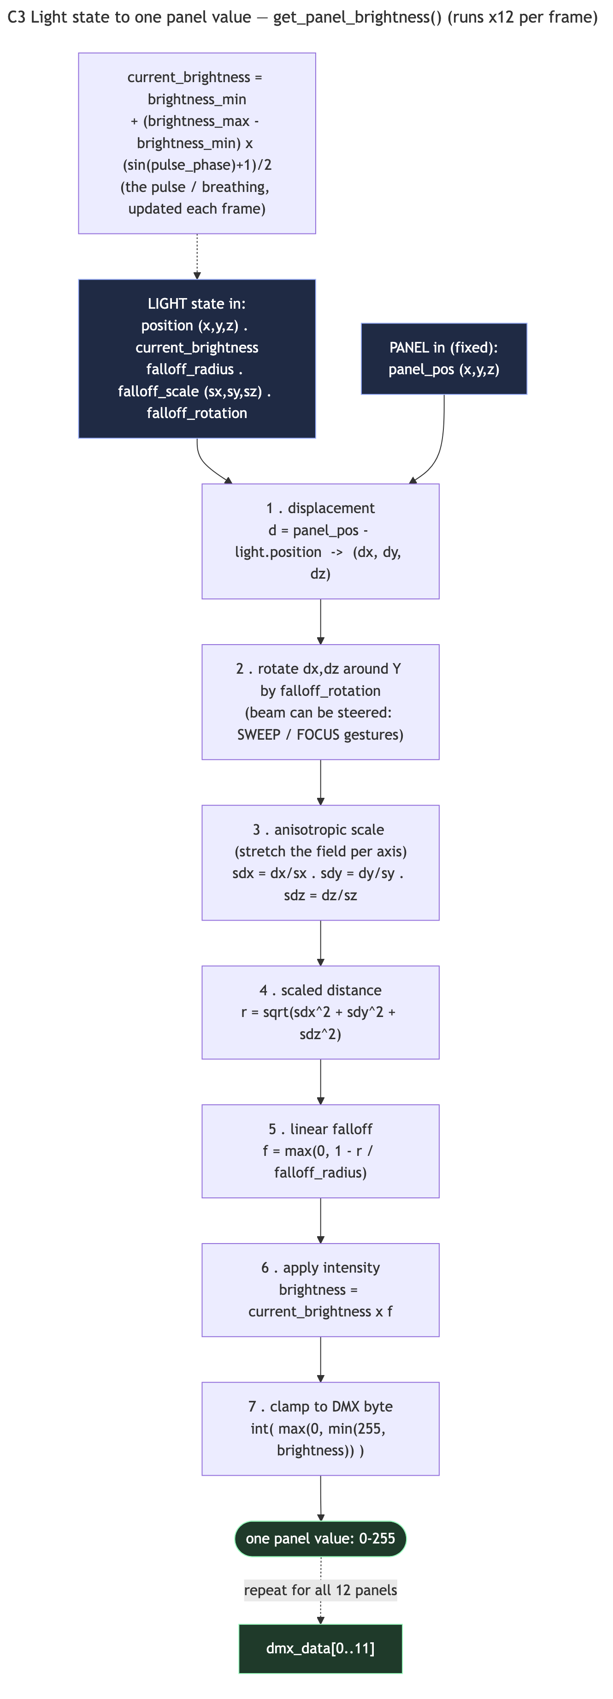
C3 — Per-panel math: displacement → rotate → anisotropic scale → distance → linear falloff → × intensity → clamp to one DMX byte
◧ DRAW — C4, the wiring map: 4 units × 3 panels → DMX channels 0–11 → 512-byte frame (only 12 bytes used) → set_single_value → Art-Net :6454 universe 0, target 10.42.0.200 @ 30 fps. (Rendered: diagrams/C4_panel_dmx_map.)
◧ DRAW — C5, one frame as a sequence: OSC → BehaviorSystem → V6Integration → set PointLight fields → PointLight.update(dt) advances pulse + moves → PanelSystem ×12 → Art-Net + DB record + WebSocket. The point of the figure is that the entire funnel re-runs every frame (~30 Hz) — the collapse is continuous, not a one-time build. (Rendered: diagrams/C5_per_frame_sequence.)
Caption-ready takeaway: A camera array, a self-revising personality, and a permanent memory — all of it, every 33 milliseconds, becomes twelve numbers between 0 and 255. That sentence is the project’s “complexity → simplicity” thesis and the reason the C-series exists.

4. Reaction loop — modes & gestures (timescale: instant)
Mode is chosen by determine_mode() (light_behavior.py:996) from live active/passive counts, with stickiness (conditions must persist) and an 8 s minimum dwell preventing flicker.
◧ Figure A3 — a state machine. Nodes = modes; edges = transitions labelled with the trigger and the transition duration. Engage-edges are fast, disengage-edges slow.
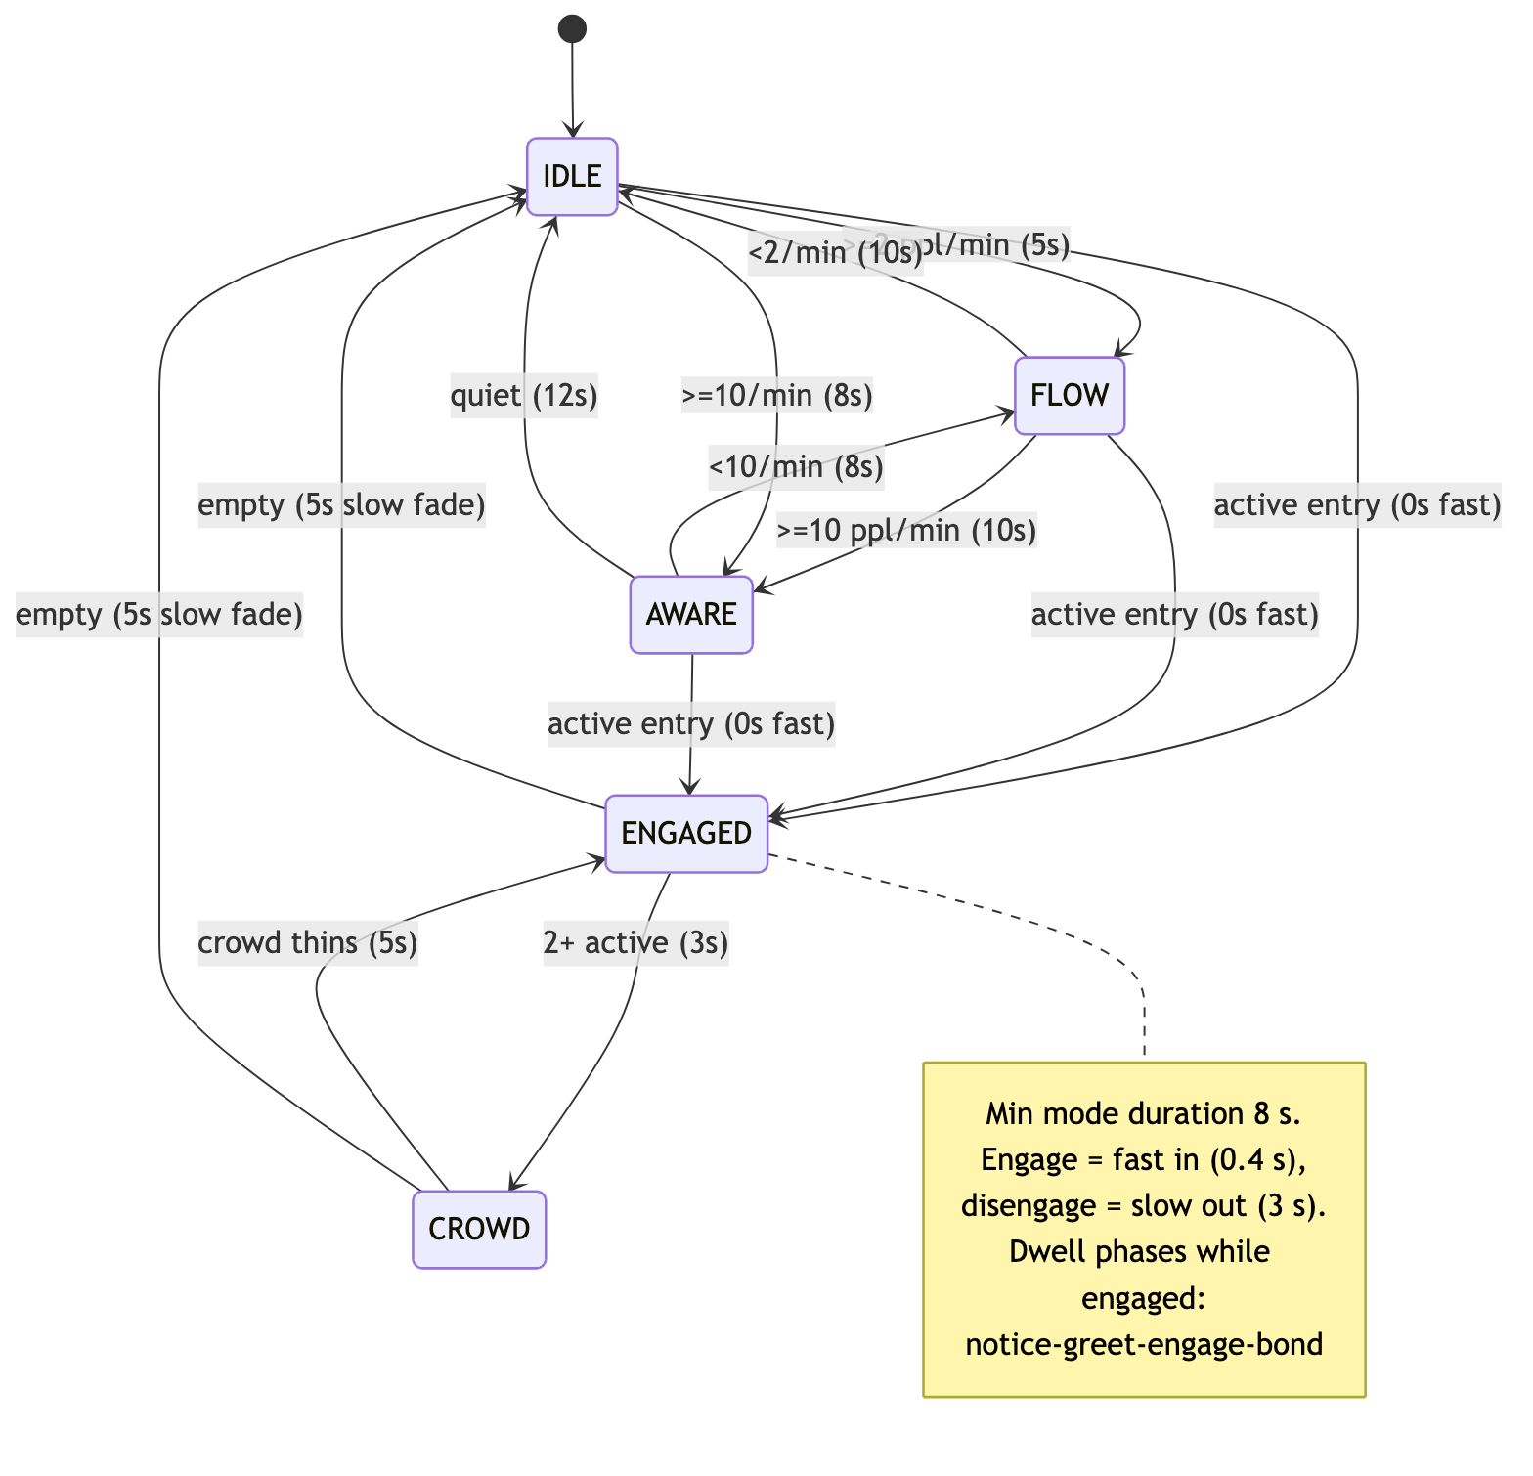
A3 — Behaviour mode state machine: IDLE / FLOW / AWARE / ENGAGED / CROWD with persistence and transition timings
Mode | Trigger | Character (move / bright / pulse / falloff)
IDLE | <2 ppl/min | gentle wander or park; 20 cm/s, dim, slow 4 s pulse, wide 90 cm
FLOW | ≥2 ppl/min sidewalk | drift with traffic; 25 cm/s, medium, 75 cm
AWARE | ≥10 ppl/min sidewalk | energetic, wide reach; 35 cm/s, brighter, fast 2.2 s pulse
ENGAGED | 1 in active zone | follow nearest; breathing + subtle gestures; tight 45 cm
CROWD | 2+ in active zone | follow centroid; brightest/fastest; may bloom all panels
Dwell phases (deepen over time, for an “engagement timeline” figure): notice 0–3 s → greet 3–10 s → engage 10–30 s → bond 30 s+, each unlocking warmer, less frequent gestures. Gesture library = 16 one-shot/ongoing motions (nod, lean, sway, orbit, settle, breathe, bloom, sweep, focus…).

5. Anticipation loop — short-term trends (timescale: seconds → hour)
Prose: when nobody is engaging, the light does not wander randomly. It continually forecasts the next minute-to-hour from the database and pre-positions/energises itself, so it is already “leaning toward” arriving traffic.
◧ Figure A5 — nested time windows feeding three influence signals:
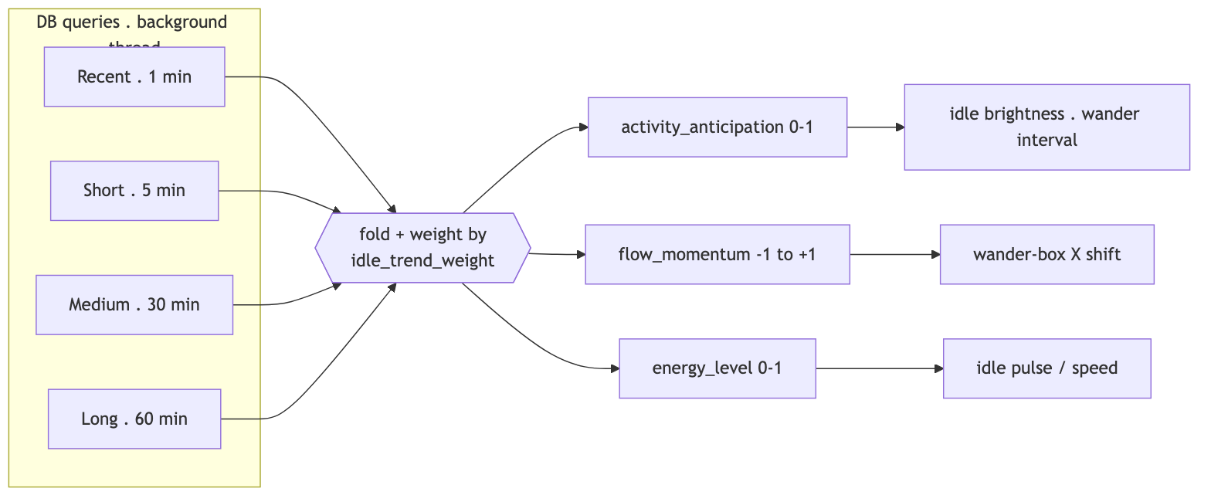
A5 — Trend windows (1/5/30/60 min) folded into activity_anticipation, flow_momentum, energy_level, weighted by idle_trend_weight
Plus two faster sub-systems:
- Flow tracker (FlowState, light_behavior.py:170) — dominant walk direction over a 30 s window, updated every 1.5 s, EMA α=0.25. Drives wander-box bias, triggers FLOW mode, and (V6.5c) biases wander targets toward incoming traffic (triangular distribution peaking ≤60 % toward arrivals).
- Aggression (AggressionState, :112) — a 0–1 “attention seeking” level that rises when ignored, falls when engaged, and is capped by hour of day (AGGRESSION_TIME_CAPS) to suit a financial-district site (near-zero at night, peak at lunch).
◧ Figure A6 — aggression as a tank: inflow = “ignored time + passers-by who don’t stop”, outflow = “engagement”, with a ceiling valve labelled “time-of-day cap (hourly curve).”
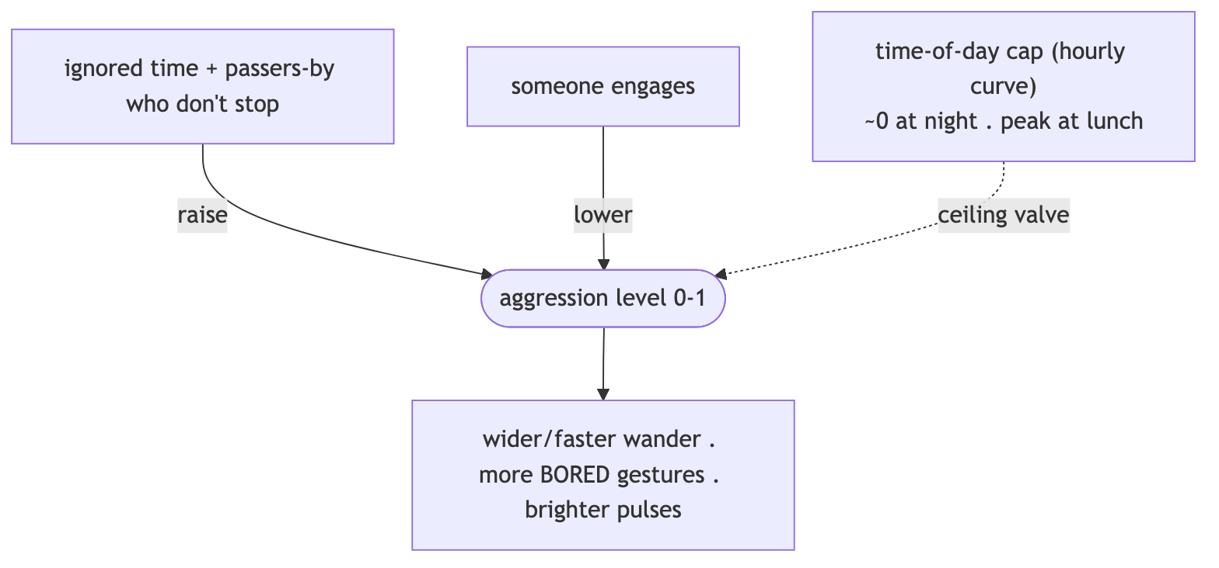
A6 — Aggression modelled as a tank: filled by being ignored, drained by engagement, capped by an hourly time-of-day ceiling

6. Self-tuning loop + the interaction budget (timescale: hours → days)
This is the conceptual heart and the best candidate for a feedback-loop diagram.

6a. Schedule (be precise in captions)
- Meta-review retuning: 3×/day — autotune-meta-review.timer at 06:00 / 14:00 / 22:00, 8-hour analysis window.
- Daily report + daily learning: midnight (00:15) + 06:00 catch-up.
- So four scheduled DB analyses per day total, but the trend-driven personality retuning is 3×. (If your text says “four times a day,” it’s the count of all scheduled passes; the retuning specifically is three.)

6b. The friction: interaction budget
Prose: every adjustment the tuner makes spends budget; budget refills slowly; when it runs low, changes are throttled. This is the friction that prevents the light from chasing noisy, second-to-second signals — it can make a few meaningful moves, then must “earn back” the right to keep changing. (SmartAutoTuner, V6Dev/smart_autotuner.py:607.)
◧ Figure A8 — the budget mechanism:
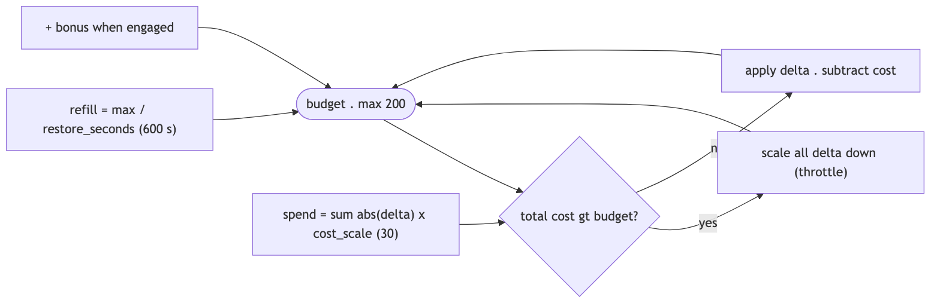
A8 — Interaction budget: spend = Σ|Δ| × cost_scale depletes it, refill = max / restore_seconds replenishes it; over-budget changes are throttled

6c. The full self-tuning feedback diagram
◧ Figure A7 — closed loop. The clever bit: the budget is itself re-tuned by the review. Each node is expanded in §6c-i (A7.1–A7.7).
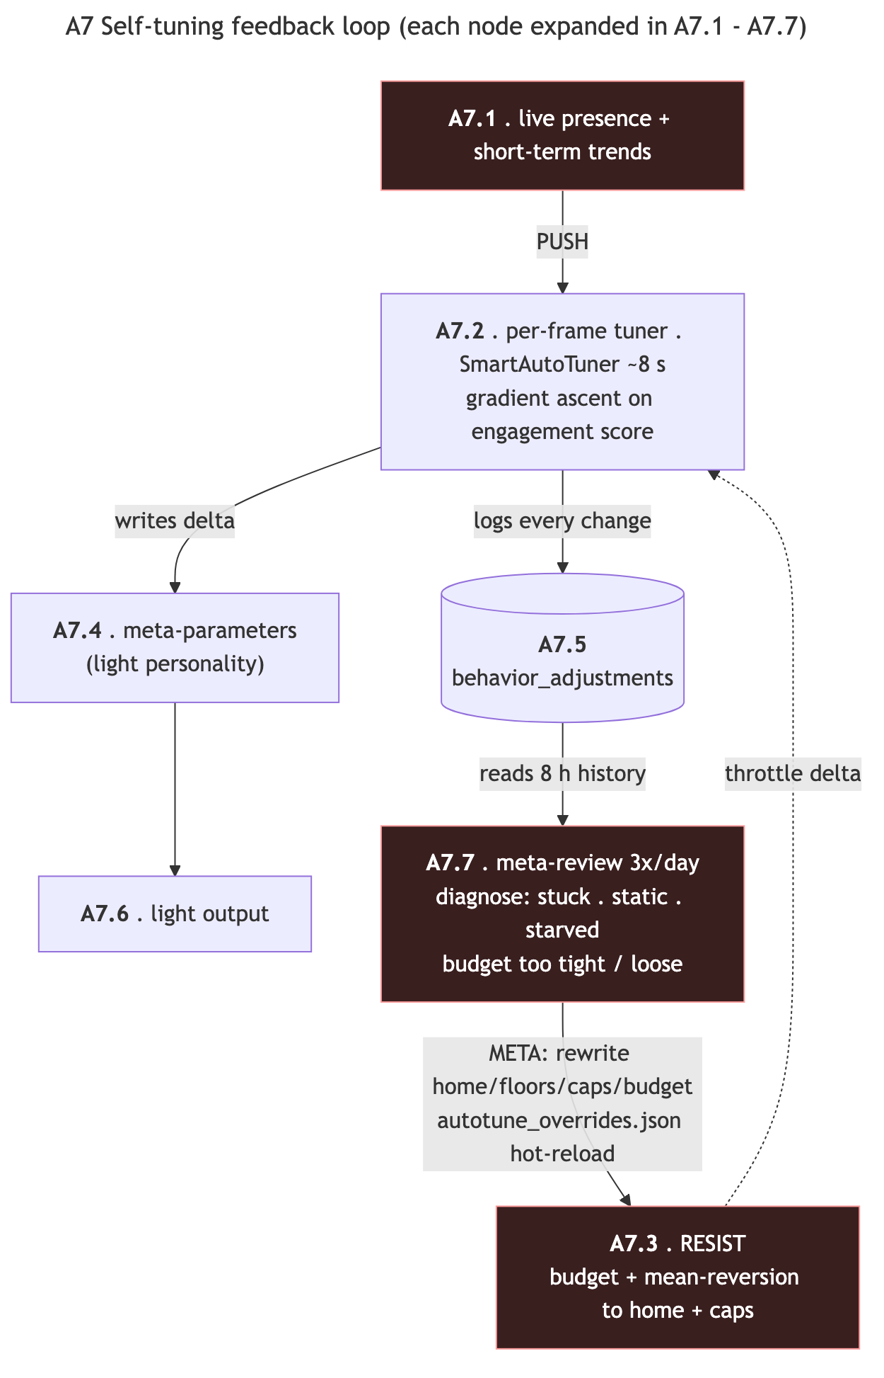
A7 — Self-tuning feedback loop: PUSH (live signal) into the tuner, RESIST (budget + reversion + caps), logged to the DB, re-governed by the 3×/day meta-review
Three forces to label in the figure: PUSH (live signal wants change), RESIST (budget + mean-reversion toward “home” + hard caps), and META (the 3×/day review adjusts how hard each side pushes). Balance of the three = “alive but not frantic, 24/7.”
Self-diagnoses the review can reach (diagnose(), autotune_meta_review.py:334): parameters floor/ceiling-stuck >80 %, activity implausibly low (night/sensor fault), mode starvation (<1 % engaged → raise floors), over-reaction (>30 % engaged → lower home), static parameters → raise curiosity, and budget always-full/depleted/throttling → tighten or loosen.

6c-i. A7 exploded — each node is its own process (A7.1–A7.7)
The feedback diagram above is the overview; each of its seven nodes hides a real process worth one sub-figure. These are rendered in diagrams/ and read as a click-through tour of a single trip around the loop.
Sub-fig | Node | What it shows
A7.1 A7_1_push_signal | PUSH | live presence + trends → a behavior_status dict and a smoothed engagement score (the fitness signal)
A7.2 A7_2_tuner_pipeline | TUNER | full SmartAutoTuner.update() cycle: gate (~8 s) → restore budget → score → gradient sample → estimate gradients → deltas (gradient + regime rules + damping) → curiosity → RESIST → apply
A7.3 A7_3_resist_forces | RESIST | the 4-stage friction stack: mean-reversion → step clamp → budget → value clamp
A7.3b A7_3b_resist_worked_example | RESIST, worked | one +0.050 nudge to energy whittled to ~0.012 (ample budget) or ~0.006 (throttled)
A7.4 A7_4_metaparams_state | meta-params | the 12-value state with ranges/floors, kept in sync with GUI sliders, read by BehaviorSystem
A7.5 A7_5_adjustments_record | behavior_adjustments | the row logged each cycle (old/new, deltas, gradients, budget before/after/cost) + its producer/consumers
A7.6 A7_6_light_output | light output | meta-params → modulation chain → Art-Net (the bridge into the C-series)
A7.7 A7_7_metareview_pipeline | meta-review | read 8 h → diagnose() → compute_adjustments() (≤25 changes) → write overrides → log audit
◧ Figure A7.3b — worked friction example, the figure that shows the friction rather than naming it. Trace one proposed energy change through the stack (constants are the V6.5c defaults; the +0.050 input and budget levels are illustrative):
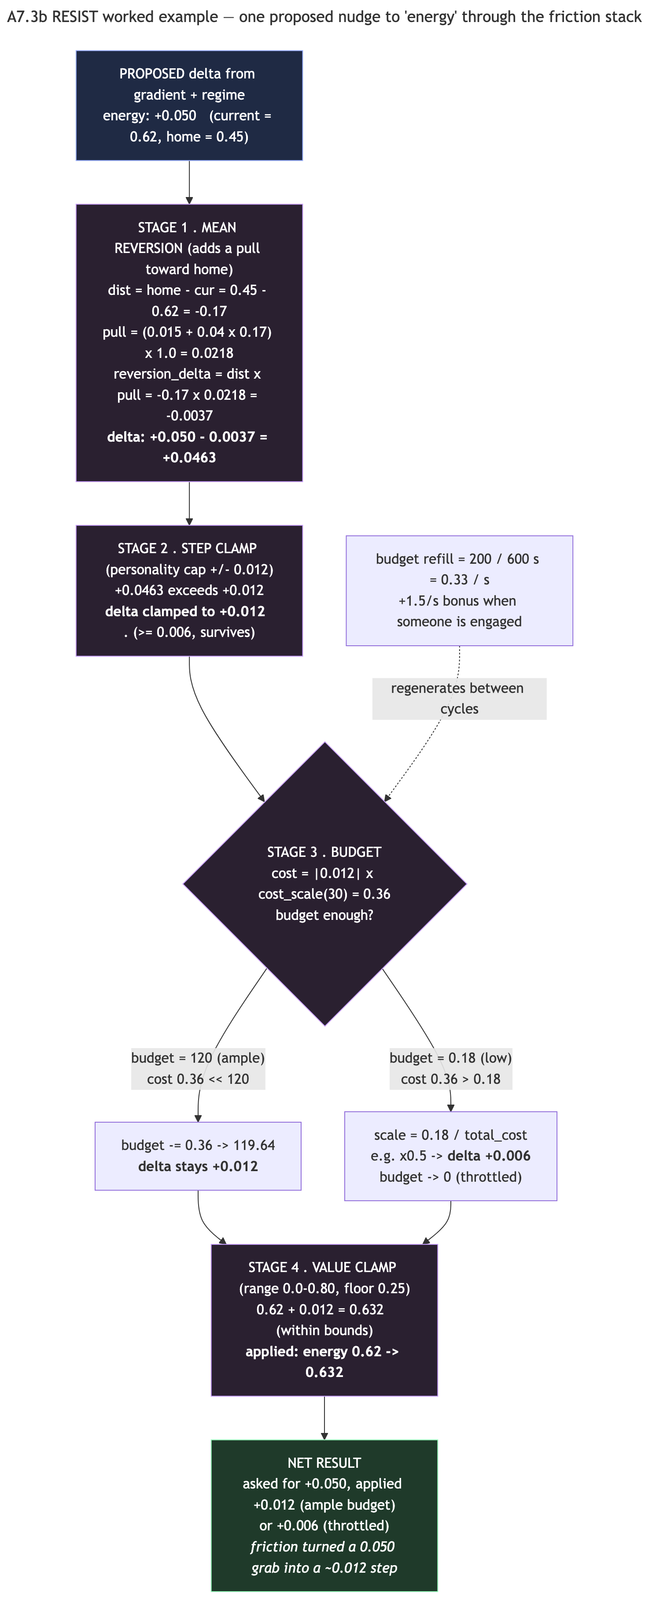
A7.3b — A proposed +0.050 nudge to energy whittled through mean-reversion, step clamp, budget, and value clamp to ~0.012 (or ~0.006 when throttled)
Stage | Operation | Result
proposed (gradient + regime) | — | +0.050
1. mean reversion toward home (0.45) | + (−0.0037) | +0.0463
2. step clamp (personality cap ±0.012) | clamp | +0.012
3. budget (cost = 0.012 × 30 = 0.36) | pay if ample / scale if low | +0.012 or +0.006
4. value clamp (range 0–0.80, floor 0.25) | within bounds | applied 0.620 → 0.632
Friction turned a 0.050 grab into a ~0.012 step — the “deliberate, not twitchy” argument, demonstrated. (Math verified against SmartAutoTuner.update, lightController_osc.py:1886 and smart_autotuner.py.)

6d. Daily learning (separate, gentler)
At midnight the controller computes a 7-day weighted average of engagement by time-of-day and blends ~30 % into the next day’s starting personality (on_daily_report, V6Dev/v6_integration.py:407) — so the light gradually learns “what worked at 9am vs 9pm.”

7. Continuous self-analysis (anti-repetition)
The light also studies its own output to avoid getting stale — the explicit design goal of “evolution, not just reaction.”
◧ DRAW — a small “mirror” loop: light → records own state → reads it back → varies.
Metric | Source | Triggers
position entropy (1 h) | get_position_entropy (tracking_database.py:846) | low ⟶ bias to unexplored space
response similarity (24 h) | get_response_similarity (:936) | high ⟶ force more variety
mode distribution (24 h) | get_mode_distribution | balance check
position cooldown (30 s) | is_position_recently_visited | don’t revisit a spot

8. The database — memory of the installation
One SQLite file (tracking_history.db, WAL mode, batched commits), serving three masters at once: live behaviour, trend analysis, and public reports. Data is tiered — raw events live ~48 h, aggregates live forever — so the file stays fast for years while keeping permanent history.
◧ Figure B1 — a tiered/funnel diagram: raw (48h) → hourly (∞) → daily (∞), with side tables for the light’s own behaviour and its tuning audit.
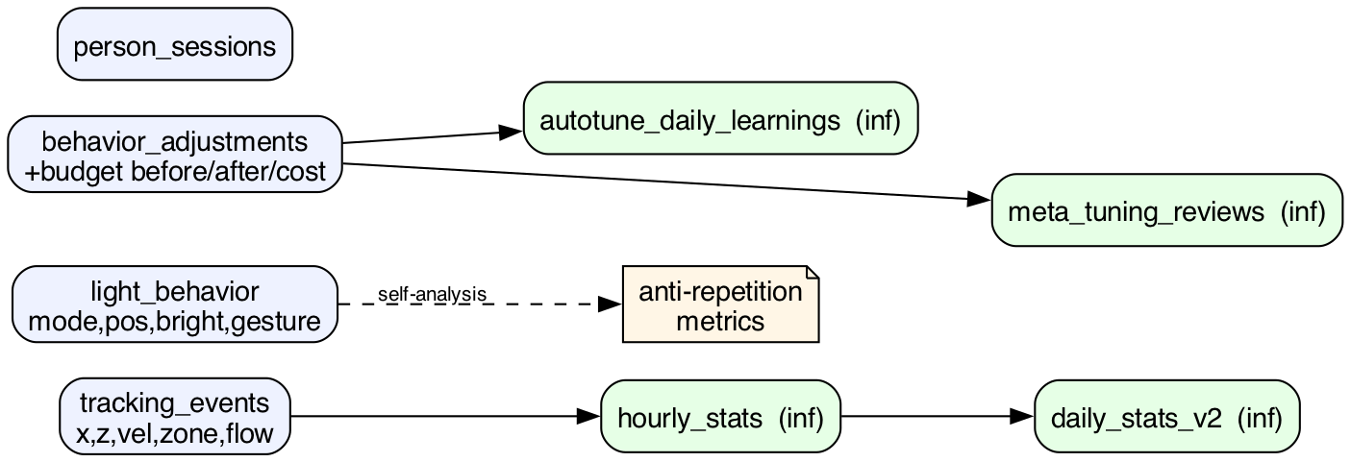
B1 — Tiered database: raw tracking_events / light_behavior / behavior_adjustments (48 h) roll up to hourly_stats and daily_stats_v2 / learnings / reviews kept forever
Table | Stores | Why | Keep
tracking_events | person x/z, velocity, zone, flow_direction | raw interaction record; source of all trend queries | 48 h
light_behavior | light’s own mode/position/brightness/gesture | self-analysis (anti-repetition) | 48 h
behavior_adjustments | every tuning Δ + activity + budget before/after/cost | audit the tuner reads | 48 h
person_sessions | visit start/end/duration, zone, flow | dwell/conversion | 48 h
hourly_stats | per-hour rollup | permanent trend history | ∞
daily_stats_v2 | per-day rollup (peak/quiet, flow balance) | day-over-day trends | ∞
autotune_daily_learnings | optimal values, param journeys, strategy | next-day blending | ∞
meta_tuning_reviews | diagnosis, old→new config, recommendations | transparent/reversible tuning | ∞
Two fields are computed on ingest so trend queries stay cheap: zone (active/passive/unknown) and flow_direction (L→R / R→L / stationary).

9. Real-time ingestion (the sensing front-end)
◧ Figure A10 — camera → YOLO → floor projection → fusion → OSC → controller.
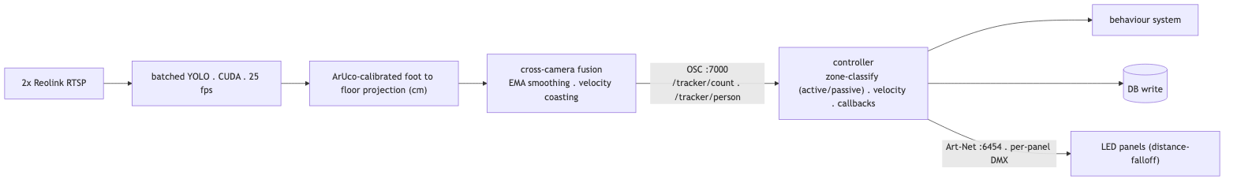
A10 — Real-time ingestion: 2 RTSP cameras → batched YOLO → ArUco floor projection → fusion → OSC :7000 → controller zone-classify + DB write → Art-Net
The camera-to-floor mapping is solved from printed ArUco fiducial markers placed at known positions in the space (P6); detecting them gives the homography/pose that turns pixel coordinates into real-world floor positions.

P6 — An ArUco fiducial marker from the calibration set, used to register camera pixels to real-world floor coordinates
A single pedestrian step becomes, within ~40 ms: a light reaction, a DB row, and a WebSocket frame. Light output leaves over Art-Net/UDP :6454 as per-panel DMX from a distance-falloff model.
◧ Figure B3 — the spatial plan (this is a strong architectural figure): panels along the storefront; active zone (engaging) close in; passive zone (sidewalk traffic) beyond it; two cameras angled inward; ArUco markers. Coordinates in cm, X along the panels, Z out toward the street.
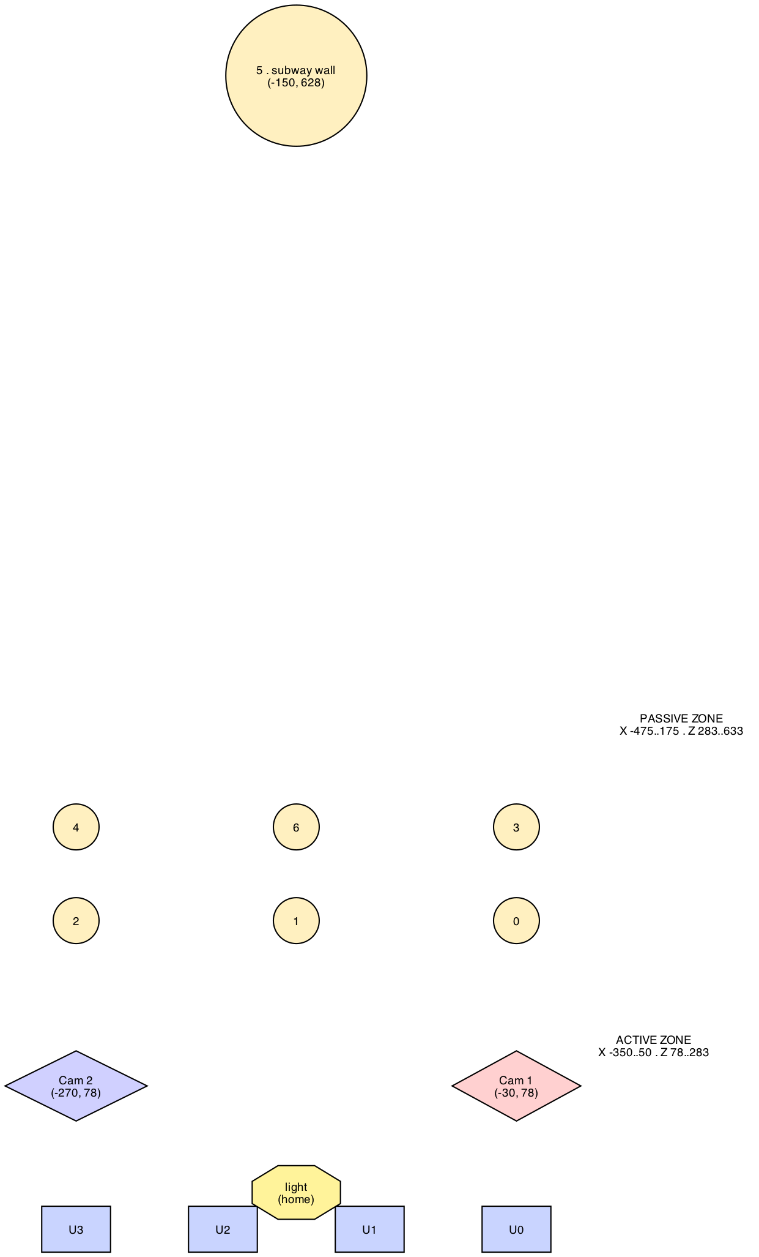
B3 — Installation plan to scale (cm): 4 panel units, two inward-angled cameras, ArUco markers, and the active/passive tracking zones
(B3 is pinned to real centimetre coordinates, so the subway-wall marker sits far up-frame; treat it as a scale reference and redraw with filled zone rectangles for the final poster.)

10. Web interface — two data planes
Prose: the public viewer separates “what the light is doing right now” from “what happened over time.” Live state streams over WebSocket; long-term trends are pre-computed server-side and published as static JSON — the browser never touches the database or does heavy maths.
◧ Figure A11 — two parallel pipes from controller to browser:
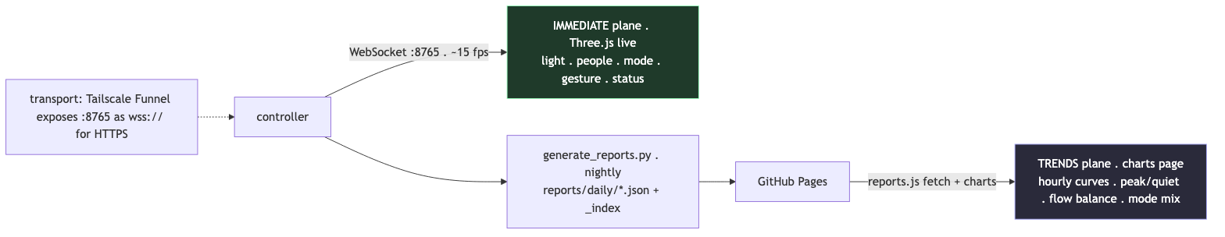
A11 — Two web planes: an immediate WebSocket stream (~15 fps live state) and a nightly static-JSON trends plane published to GitHub Pages
Plane | Transport | Cadence | Content | Computed where
Immediate | WebSocket :8765 | ~15 fps | live light/people/mode/status | controller, sent as-is
Trends | static JSON over HTTPS | nightly | hourly curves, peak/quiet, flow balance, mode mix, tuning summary | SQLite (server-side)

11. Suggested figure set (minimal, high-impact)
For a 10-image Projects submission, this sequence tells the whole story — now ending on the complexity→12-values collapse, which is the strongest single idea to leave a reviewer with. (Diagram IDs in diagrams/.)
- Spatial plan — cameras, zones, panels, light (§9 / B3).
- Top-level pipeline — the three processes + two channels (§1 / A1).
- Three nested loops — the conceptual core (§2 / A2).
- Mode state machine — reaction layer (§4 / A3).
- Personality radar — neutral vs as-deployed meta-parameters (§3a).
- Self-tuning feedback w/ budget — PUSH vs RESIST vs META (§6c / A7).
- Worked friction example — a nudge whittled by the budget (§6c-i / A7.3b).
- Trend windows → influences — anticipation layer (§5 / A5).
- The output funnel — many → ~9-value light state → 12 panel bytes (§3d / C1).
- Per-panel falloff math + 12-channel map — the final collapse to the wire (§3f / C3 + C4, paired).
This ordering opens with place (1) and closes with the irreducible output (9–10), so the narrative arc is “a corner of a city → an adaptive temperament → twelve numbers.” If you can only spare one figure for the output story, use C1; if two, pair C1 with C3. The A7.x and remaining C figures (C2, C5) are excellent for the talk/poster where you have room beyond the 10-image cap.

12. How this relates to the ACADIA 2026 brief — Humanism Recoded (Projects)
Verified call details (ACADIA 2026, call for submissions): theme “Humanism Recoded: Reframing Computation and Making through Embodiment and Culture”; Detroit / Lawrence Technological University, Oct 22–24, 2026. Projects = “600-word text (excluding citations and captions) plus a maximum of 10 images,” blind peer-reviewed, published in the proceedings (CumInCAD, DOI) and “exhibited as posters in the Exhibition.” Projects should present “built work, speculative prototypes, installations, or experimental workflows demonstrating the integration of computational tools with material, cultural, or social contexts.” Projects deadline: June 1, 2026 (final extension). Of the 12 subthemes, the two most relevant here are “Embodied Codes” (“computation situated in bodies, practices, and local contexts”) and “Machines that Care” (“robotics and autonomous systems reimagined as partners in repair, care, and cultural making”).
ACADIA 2026, “Humanism Recoded: Reframing Computation and Making through Embodiment and Culture,” reframes computation around human values, bodies and cultural practice rather than abstracting it away from them — and its Projects category invites “built work, speculative prototypes, installations, or experimental workflows demonstrating the integration of computational tools with material, cultural, or social contexts.” Drop Ceiling answers that directly: it is a built, public, 24/7 architectural light installation whose computation is literally embodied in a storefront and encultured by its site. The system does not run a fixed program; it senses the embodied rhythms of a specific Toronto financial-district sidewalk — commute surges, lunch crowds, the dead of night — and recodes its own behaviour around them, learning over days which character “works” at which hour. The interaction budget is the conceptual hinge for the brief: rather than maximising responsiveness, the project deliberately introduces friction, treating restraint and slowness as humane design values and resisting the extractive logic of an always-optimising machine. In this sense the light behaves less like a sensor-actuator and more like an inhabitant that adapts to its neighbours.
Within the Projects category specifically, the contribution is an experimental authoring workflow for adaptive environments: a transparent, three-loop architecture (instant reaction, hourly anticipation, multi-day self-tuning) in which a small set of human-legible “personality” meta-parameters — responsiveness, energy, sociability, exploration, memory — are continuously, accountably retuned from the installation’s own interaction history, with every decision logged and even re-published to the public as a daily report. This speaks to the “Machines that Care” and “Embodied Codes” subthemes: an autonomous system reframed not as a controller to be optimised but as a cultural participant that watches, remembers, hesitates, and grows a character in dialogue with the people who pass beneath it. The project’s value to the ACADIA audience is methodological as much as aesthetic — it demonstrates how trend analysis, budgeted self-modification, and self-analysis can be composed into an adaptive architecture that remains interpretable and authorable by a designer rather than opaque.

Sources for the conference framing: ACADIA 2026 Call for Submissions and the EasyChair CFP. All system facts trace to the V6.5c source under dc-dev/IO/.

13. Draft 600-word Projects submission text
Ready-to-submit draft body — 599 words (the call allows 600, excluding citations and captions). Now closes on the complexity→12-values collapse (§3d–§3f). Everything above is reference/diagram material; this is the actual proposed text. Slot project title, authors and image captions around it. ~1 word of headroom, so any addition needs a matching cut.
Drop Ceiling is a permanent, public light installation in a downtown Toronto storefront: a single luminous point drifts through a field of LED panels behind the glass while, on the sidewalk outside, two cameras quietly watch the people passing by. It is not a motion sensor that flashes on contact, but a system designed to behave like an inhabitant of its corner — one that reacts in the moment, anticipates the rhythms of the street, and slowly grows a character of its own over weeks of operation.
Computationally, the work is organised as three nested control loops running at three timescales. The innermost loop, at thirty frames per second, drives reaction: a behaviour state machine (idle, flow, aware, engaged, crowd) follows whoever is present, layering sixteen small gestures — a nod, a lean, a slow shared “breathing” — that deepen the longer a person stays. The middle loop, at seconds-to-minutes, drives anticipation: the system reads pedestrian trends across nested one-, five-, thirty- and sixty-minute windows, plus a thirty-second flow tracker, and biases where and how energetically the light idles so that it leans toward arriving foot traffic rather than waiting to be triggered. The outermost loop, spanning days, drives self-tuning.
That self-tuning is the conceptual core. The light’s expression is governed by a small set of human-legible meta-parameters — responsiveness, energy, sociability, exploration, memory, and a handful of output multipliers — that colour how each behaviour mode becomes movement, brightness, and pulse. Three times a day the system analyses its own interaction database, diagnoses pathologies in its recent behaviour (parameters stuck at limits, modes starved, responses gone static), and rewrites its own tuning configuration, which the running light hot-reloads within seconds. Every decision is logged, and a nightly report republishes the day’s patterns to a public web view.
Crucially, the system does not simply maximise responsiveness. An interaction budget meters how much the tuner may change per unit of time: every adjustment spends budget, budget refills slowly, and when it runs low further change is throttled. This deliberate friction — reinforced by mean-reversion toward “home” values and the daily review’s ability to retune the budget itself — keeps adaptation slow and intentional rather than twitchy. The result reads less like an optimising machine and more like a temperament: the light can be eager or reserved, brisk or contemplative, and it earns the right to change.
For all this apparatus, the output is radically simple. Thirty times a second the entire system collapses to the state of one virtual point light, read by the ceiling as just twelve numbers — one brightness value per panel, set purely by distance from the light through a shaped, steerable falloff. That gap, between a city-corner’s worth of context and twelve bytes on a wire, is where the work locates its meaning.
Drop Ceiling addresses Humanism Recoded by situating computation in a body and a place. Its intelligence is not abstracted onto a screen but embodied in a storefront and encultured by a specific site, whose commute surges, lunch crowds, and dead-of-night quiet it learns and answers. The project speaks directly to the Embodied Codes and Machines that Care subthemes: an autonomous system reframed not as a controller to be optimised but as a cultural participant that watches, remembers, hesitates, and grows a character in dialogue with the people beneath it. Its contribution to the Projects track is as much methodological as aesthetic — an authoring approach for adaptive environments in which a designer shapes a few interpretable personality parameters and lets the installation retune them, accountably, from its lived experience of the street.

14. Glossary
The document uses two overlapping vocabularies: concrete software parameters (actual variables in the V6.5c code) and the interaction concepts they implement. They appear scattered through the sections and diagrams; this is the single reference. A recurring source of confusion — flagged here once — is the word “personality”: it is not a variable, but the informal name for the set of 12 tunable meta-parameters (§14.1) taken together. When A2 says Loop 3 “reshapes the personality,” it means the self-tuner is slowly moving those 12 numbers.

14.1 Software parameters — the 12 tunable meta-parameters
The variables the self-tuning loop is allowed to move (the “personality”). Defined in MetaParameters (light_behavior.py:429); live values persist in slider_settings.json; ranges/floors/caps live in autotune_overrides.json and smart_autotuner.py. Split into two groups by how the tuner treats them.
Personality axes (0.0–1.0; rise with activity):
Parameter | Plain meaning | Bends these light outputs
responsiveness | how quickly it reacts | follow-smoothing, move speed, transition durations
energy | overall liveliness | pulse rate, max brightness, gesture frequency
attention_span | how long it stays focused on one person | follow-smoothing, dwell rewards, mode stickiness
sociability | eagerness to engage | gesture chance, entrance flash, engaged brightness
exploration | appetite to wander/visit new space | wander-box size, wander interval, position variety
memory | how strongly the past suppresses repeats | anti-repetition strength, trend-influence weight
Output multipliers (scale the physical outputs; inverse-adjusted by the tuner):
Parameter | Plain meaning
brightness_global | master brightness gain
speed_global | master movement-speed gain
pulse_global | master pulse/breathing-rate gain
follow_speed_global | how fast it chases a tracked person
dwell_influence | how strongly dwell-time bonuses apply (0 = off, 2 = double)
idle_trend_weight | how strongly passive-zone trends bend idle behaviour
(Three further multipliers exist in the dataclass — trend_weight, time_of_day_weight, anti_repetition_weight — but are not actively retuned by the V6 autotuner.)

14.2 Software parameters — the light state (the “pinch point”)
The ≈9 scalars on the PointLight object that the panels actually read each frame (PointLight, lightController_osc.py:2217). Everything in §14.1 exists to set these.
Field | Meaning
position [x, y, z] | the light emitter’s location in the panel field (cm)
current_brightness | instantaneous intensity = brightness_min + (brightness_max − brightness_min) × (sin(pulse_phase)+1)/2
brightness_min / brightness_max | the floor/ceiling the pulse swings between
pulse_speed | ms per breathing cycle (drives pulse_phase)
falloff_radius | distance at which a panel’s contribution reaches zero
falloff_scale [sx, sy, sz] | per-axis stretch of the falloff (anisotropic / ellipsoidal beam)
falloff_rotation | Y-axis rotation of the falloff (lets a gesture steer the beam)
move_speed | how fast position interpolates toward its target

14.3 Software parameters — tuning & friction constants
Govern how the self-tuner changes §14.1 (smart_autotuner.py, autotune_overrides.json).
Term | Meaning
home_values | the per-parameter rest value mean-reversion pulls toward (time-of-day interpolated)
safe_floors | minimums the tuner won’t go below (prevents a “zombie” unresponsive light)
caps | soft maximums per parameter (prevents an obnoxious light)
PARAM_RANGES | the absolute min/max bounds for each of the 12 parameters
budget (max, restore_seconds, cost_scale) | the interaction budget: pool size, refill time, and price per unit of change
reversion (base, progressive) | mean-reversion strength — constant pull + extra pull when far from home
curiosity (interval, strength) | periodic small random nudge to keep the parameter space explored
gradient / engagement score | the fitness signal the tuner climbs (EngagementScorer); higher = more/better engagement

14.4 Software parameters — sensing & spatial
Term | Meaning
active zone | the near region where presence counts as engaging the installation
passive zone | the sidewalk region beyond it; presence counts as passing traffic
passive_rate | people per minute in the passive zone — drives the IDLE/FLOW/AWARE tiers
flow_direction / flow_balance | net walking direction, −1 (R→L) … +1 (L→R)
zone / flow_direction (DB) | fields computed on ingest and stored per tracking_events row
OSC /tracker/... | the messages carrying live counts and per-person positions into the controller
Art-Net / DMX | the protocol/values sent out: 12 channels, one 0–255 brightness per panel

14.5 Interaction concepts — behaviour vocabulary
The conceptual layer: what the light is doing, named for legibility (in the code, the public viewer’s status text, and this document).
Concept | What it means
personality | informal name for the 12 meta-parameters (§14.1) as a set — the light’s evolving disposition
mode | which of five behaviour states the light is in: IDLE, FLOW, AWARE, ENGAGED, CROWD
stickiness | a mode change only commits after its conditions persist for a minimum time (anti-flicker)
gesture | a brief, named motion overlaid on the mode (nod, lean, sway, orbit, settle, breathe, bloom, sweep, focus…)
dwell phase | how engagement deepens with time-in-zone: notice → greet → engage → bond
breathing | the continuous sinusoidal brightness/scale modulation — the light’s visible “rhythm”
bloom | a momentary full-panel illumination (a high point during engagement/crowd)
aggression | a 0–1 “attention-seeking” level: rises when ignored, falls when engaged, capped by hour of day
flow | the real-time dominant walking direction of passive traffic (also the name of a mode)
almost-engaged | a passer-by slowing near the active zone — a candidate the light tries to draw in
proximity | how close the nearest person is to the panels — makes the light slower/brighter/tighter up close

14.6 Interaction concepts — adaptation & system vocabulary
Concept | What it means
the three loops | reaction (~30 Hz), anticipation (sec–hours), self-tuning (hours–days) — see §2 / A2
PUSH / RESIST / META | the three forces on the parameters: live signal pushes change, friction resists it, the meta-review re-governs how hard each acts (A7)
interaction budget | the friction: a metered allowance that makes self-adaptation deliberate rather than twitchy
mean-reversion | the steady pull of every parameter back toward its home_value
curiosity | the deliberate small random exploration of the parameter space
meta-review | the deep 8-hour analysis run 3×/day that diagnoses and rewrites the tuning constants (§14.3)
daily learning | the midnight blend of a 7-day, time-of-day engagement average into the next day’s starting personality
self-analysis | the light reading its own recorded behaviour to avoid repetition (position entropy, response similarity)
regime | predicted traffic context — dead / trickle / steady / rush / event — used to vary tuning aggressiveness
trend window | one of the nested look-back periods (1 / 5 / 30 / 60 min) the anticipation loop reads
engagement | a person entering the active zone; the event the whole system is implicitly optimising toward
the pinch point | the moment all complexity collapses to the ≈9-value light state before fanning out to 12 panel values (§3d, C1)

15. Conceptual goals × the software system — synthesis for the submission
This section bridges two documents: the project’s conceptual writing (the DropCeiling-overview text — open-source intent, light-as-character, AI-agent development, measurable evolution) and the technical system anatomised in §1–§14. The software sections above answer “how does it work”; this section answers “why does the way it works matter,” and proposes how to assemble both into the 600-word ACADIA Projects submission and its 10 figures. Everything here is a proposal to react to, not settled text.
Two reconciliations to make before submitting (places where the overview and the code currently diverge — pick one and make the doc consistent): 1. Control protocol. The overview says panels are driven over the open 0–10V protocol; the V6.5c code sends Art-Net/DMX (StupidArtnet, universe 0). Likely both are true (Art-Net → a DMX/0–10V converter at the fixtures), but the submission should state the actual signal path in one sentence. The “12 values” story (C-series) is unaffected — it’s 12 per-panel intensities either way. 2. Site framing. The overview is site-specific (Haworth showroom, 55 University Ave, the column “alcove,” DesignTO). Earlier draft text here said “financial district” generically. Use the real site; the alcove-between-columns detail is a gift — it is the physical reason the active/passive zone split exists (§14.4). 3. Run length. Both source documents predate the final run. The installation ultimately ran 24 hours a day for 54 days, taking in ~1 million inputs from unique active and passive visitors. Update any “until March 10 / seven weeks / day-25” phrasing to the final figures.

15-0. Scale — the number that makes the rest credible
Lead with this; it changes how every other claim in the submission is read. The installation ran continuously, 24/7, for 54 days, and over that time ingested ~1,000,000 inputs from unique active and passive visitors on the sidewalk. (The raw position-event stream behind those visitors is larger still — each visitor produces many position samples as they cross the field.)
Run at a glance (estimated). The full database is not accessible at writing; the figures below are extrapolated from 34 days of surviving daily reports, which show very stable, repeatable day/week patterns (weekday commute peaks, quiet nights, lighter weekends). Per-day averages from those reports are scaled to the full 54-day run.
Metric | Per day (observed avg) | Over 54 days (est.) | Basis
Tracking events (raw position samples) | ~275,000 | ~15 million | mean of 34 daily reports (median ~265k/day)
Unique visitors (active + passive) | ~18,500 | ~1 million | back-calculated from the stated ~1M total
Short-term evaluations (autotuner cycle, ~8 s) | ~10,800 | ~580,000 | SmartAutoTuner update interval
Flow-tracker updates (~1.5 s) | ~57,600 | ~3.1 million | FlowState, anticipation loop
Long-term evaluations (meta-review, 3×/day) | 3 | 162 | autotune-meta-review.timer
Daily-learning cycles (midnight) | 1 | 54 | DailyReportScheduler + V6 on_daily_report
Rounded, illustrative. “Short-term evaluations” = per-cycle parameter retunes; “long-term evaluations” = the deep 8-hour database reviews. Numbers are deliberately conservative — state them as approximate (“~”, “roughly”) in the submission.
◧ Figure D1 — run totals over 54 days (the same table as a log-scale ladder; good as a single “scale” slide):
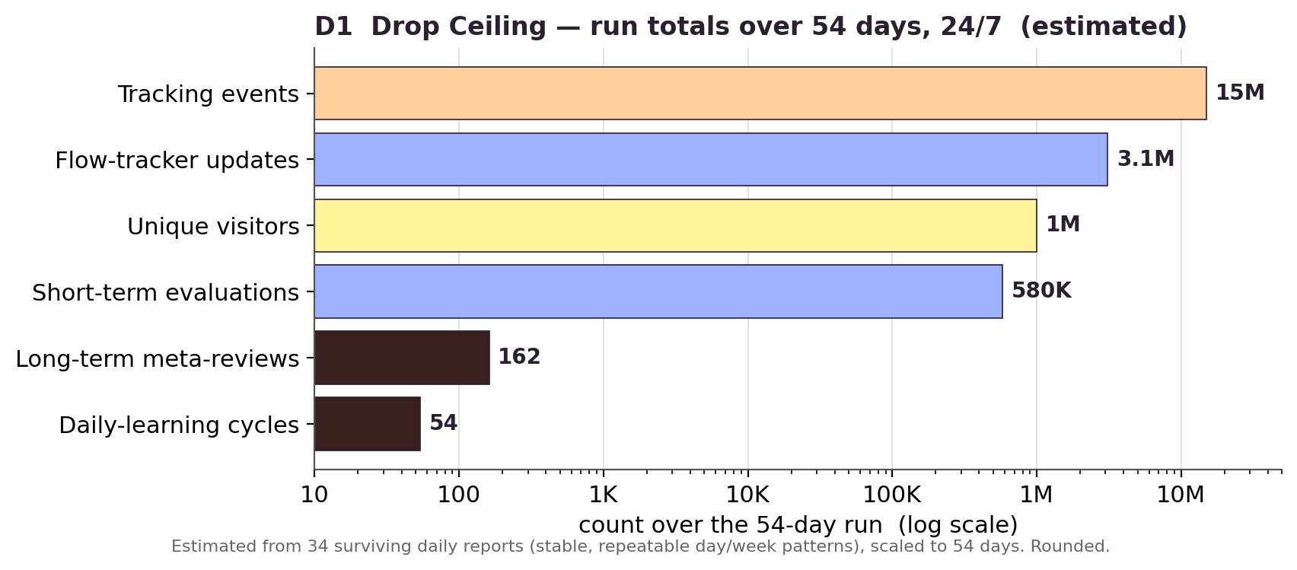
D1 — Estimated Drop Ceiling run totals over 54 days: ~15M tracking events, ~3.1M flow updates, ~1M visitors, ~580K short-term evaluations, 162 meta-reviews, 54 daily-learning cycles
◧ Figure D2 — fast vs slow (the friction argument as a picture: tens of thousands of fast adjustments a day, governed by a handful of slow reviews):
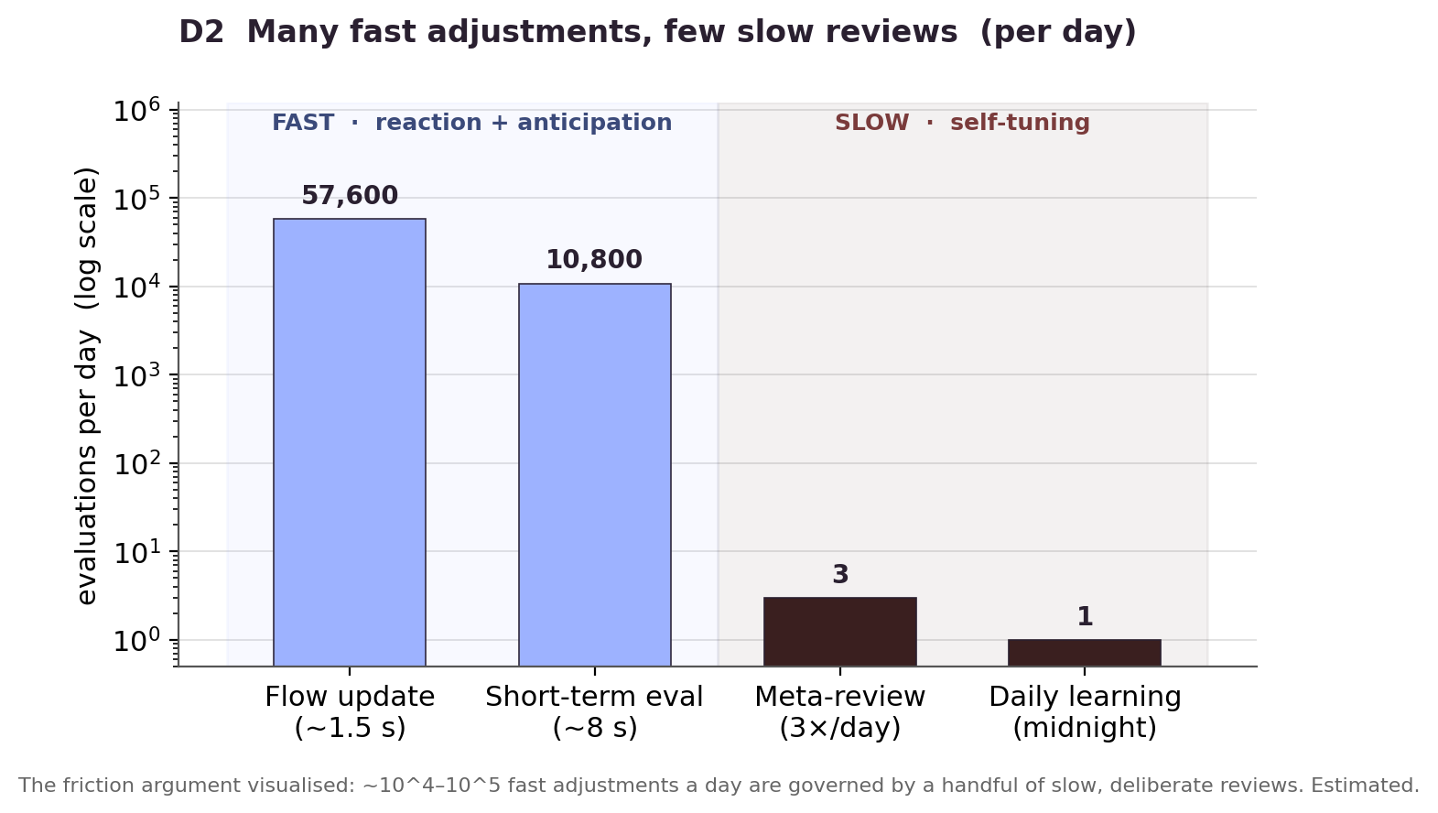
D2 — Evaluations per day on a log scale: flow updates ~57,600 and short-term evals ~10,800 (fast) versus 3 meta-reviews and 1 daily-learning cycle (slow)
(Both rendered by diagrams/src/D_scale_charts.py via matplotlib; re-run to update if the final database yields hard totals.)
Why the scale matters, concretely:
- It converts “it learns” from a claim into a result. A self-tuning system that has only seen a handful of interactions is a hypothesis; one that has metabolised ~1M real-world inputs across 54 uninterrupted days is evidence. The day-1-vs-day-54 drift of the personality (§6, A7) is backed by a population, not an anecdote.
- It is what justifies the whole adaptive apparatus. Trend windows, the 3×/day meta-review, daily learning, the interaction budget — that machinery only earns its keep at volume and over time. At 54 days × 24 h it had ~162 meta-reviews and ~54 daily-learning cycles to work with; the friction/restraint argument is precisely what keeps adaptation stable across that many cycles.
- It reframes the C-series collapse. “Many → twelve values” is striking on its own; “~1M situated human inputs, distilled live into twelve numbers, thirty times a second, for 54 days” is the version that lands. Put the number next to C1.
- It is a falsifiable, peer-review-grade fact. A reviewer can weigh ~1M inputs / 54 days / 24-7; it signals a deployed, sustained work rather than a demo — which is exactly the bar the Projects category rewards.
Phrasing seeds: “24 hours a day for 54 days.” · “roughly one million encounters.” · “a population, not a prototype.” · “fifty-four days of uninterrupted attention.” · “every one of a million inputs distilled, live, to twelve numbers.”
One verification to do before you print a number: confirm whether ~1M counts unique visitors or unique tracked inputs/sessions. The 34 surviving daily reports log ~9.3M raw position events (the basis for the ~15M/54-day estimate above) and a cross-day people tally in the hundreds of thousands — so “~1 million inputs/encounters” is the safest phrasing unless you have a firm unique-visitor query. State the unit explicitly (visitors vs inputs vs events) so it can’t be challenged.

15a. Each conceptual goal, and where it lives in the software
Conceptual goal (from the overview) | How the software embodies it (this guide) | Best evidence / figure
Re-use of ubiquitous infrastructure — turn forgettable office ceiling panels into an expressive medium | The entire output layer is deliberately minimal: 12 dimmable panels addressed as one brightness each. The sophistication is upstream, not in exotic hardware. | C1 / C4 (12 values); §3d
Open hardware + software — published toolkit, standard protocols, 3D-printed connectors | Standard parts throughout: YOLO, OSC, Art-Net/DMX (or 0–10V), SQLite, Three.js — no proprietary stack. The architecture is the contribution, and it’s legible/reproducible. | A1 (all standard components)
Light as a character with goals + evolving methods | The 12 meta-parameters are the character; modes + gestures + dwell phases are its repertoire; aggression/curiosity give it moods and whims. | §3 / §14.5; A3, A6
A personality that learns over hours and days | The three-loop architecture, self-tuning (A7), and daily learning — “day 25 ≠ day 1” is literally the drift of those 12 numbers, logged and auditable. | §2 / §6; A2, A7
Measurable evolution (“more confident, less repetitive”) | Self-analysis metrics (position entropy, response similarity) + the meta_tuning_reviews audit table make evolution a measurable, reversible claim — and at ~1M inputs over 54 days it is backed by a population, not an anecdote. | §15-0; §7 / §8; A7.5, A7.7
Implicit, intuitive interaction — “no app, no screen, no instructions” | Input is presence and flow, not deliberate command; the active/passive zones and proximity response read the body, not an interface. | §4 / §5; A5
Friction / restraint as a value — calm at rush hour, deliberate change | The interaction budget, mean-reversion, and time-of-day aggression caps encode restraint as engineering: the system can act but chooses the rate. | §5 / §6; A6, A7.3b
The 3D model as shared reference / “the installation’s brain” | The calibrated spatial model (zones, panel/camera coordinates, falloff geometry) is the substrate every behaviour reads and the AI agents authored against — BIM-thinking at installation scale. | §9 spatial frame; B3, C2
Built with AI coding agents (a method, not just a tool) | The whole structured-documentation practice — these diagram guides, the parameter ranges, the test/verify loops — is the agent-authoring method made visible. Made tractable by giving the model a spatial substrate to reason over (§15d). | this document set; §15d
The control software is a 3D game | The controller is a pygame + OpenGL real-time 3D scene (“3D Light Controller V6.5”): physical space, digital model, and control code share one runtime and one coordinate frame. | §15d; B3, C2
Public transparency — live web view of the light’s mind | The two web planes expose both the live state and the long-term trends/reports — the system explains itself in plain language to passers-by. | §10; A11

15b. Three candidate framings for the submission (pick one as the spine)
Each reframes the same system around a different load-bearing idea. The strongest for Humanism Recoded is Framing A, but B and C are viable and reusable for talks/abstracts.
- Framing A — “An adaptive temperament from twelve bytes.” Spine: the gap between enormous situated context and a near-trivial output (C1) is where the meaning sits. Restraint, legibility, and character over spectacle.
  - Hook: ~1M situated human inputs over 54 days, collapsed 30×/second to 12 numbers.
  - Payoff: complexity is spent on how to behave, not on resolution or novelty.
  - ACADIA fit: directly Embodied Codes + Machines that Care; the friction argument reads as a humane stance against the always-optimising machine — and the 54-day / ~1M-input scale is what proves the temperament actually formed rather than being asserted.
- Framing B — “Re-coding ubiquitous infrastructure.” Spine: open-source re-use — the most invisible object in the built environment (the office ceiling panel) made expressive with only standard, published parts.
  - Hook: the forgettable made characterful; anyone with panels + a 3D printer can build one.
  - Payoff: a reproducible toolkit and method, not a one-off artwork.
  - ACADIA fit: Built Grounds + Digital Commons; emphasises accessibility/participation.
- Framing C — “The model became the brain” (AI-agent authoring). Spine: a 3D spatial model as the shared reference that both human and AI agents author against — BIM-thinking scaled down, computation situated in a spatial substrate.
  - Hook: the first of the author’s installations built with AI coding agents, guided by a spatial model rather than prose specs.
  - Payoff: a transferable method for authoring spatial-interactive systems with agents.
  - ACADIA fit: Embodied Codes + Collective Intelligence (shared human–machine authorship); the most novel methodologically, but risks overshadowing the artwork.
Recommendation: lead with A, fold in B and C as one sentence each. A gives the piece its meaning, B gives it reproducibility/relevance, C gives it methodological novelty — reviewers reward all three, but only one can be the title idea.

15c. How it comes together — proposed submission package
The 600-word arc (refines §13 with the conceptual layer): - open on the site and the body — a Toronto showroom alcove, presence not input; - name the character — six personality traits, modes, gestures; - reveal the three-loop adaptation and the friction that makes it deliberate; - land the collapse to twelve values as the conceptual climax (C1); - ground it in scale — 24/7 for 54 days, ~1M inputs — so the adaptation reads as demonstrated, not promised; - close on what it means — re-use, transparency, an inhabitant rather than a controller.
The 10 figures (maps the §11 set to the conceptual beats): - Place & body: B3 spatial plan (the alcove, zones, cameras). - System at a glance: A1 pipeline; A2 three loops. - Character: A3 modes; a personality radar (neutral vs as-deployed). - Adaptation & friction: A7 self-tuning loop; A7.3b worked friction example. - The collapse (climax): C1 funnel; C3 per-panel math (or C4 wiring). - Transparency: A11 web planes or a photo of the live installation.
Threads to make explicit that the technical guide currently under-states: - The alcove/columns as the designed reason for the active/passive split — tie the architecture of the site to the architecture of the software. - “Measurable evolution” as a falsifiable claim backed by the audit tables and the 54-day / ~1M-input scale — strong for a peer-reviewed venue; consider one before/after metric (e.g. week-1 vs week-7 engagement rate or gesture variety) if the data supports it. - Scale as a headline fact (§15-0): give it a sentence of its own near the top — it is the single most efficient way to signal a deployed, sustained work to reviewers. - The AI-agent + spatial-model method as a sidebar/short section — it’s a genuine contribution and very on-theme, but keep it from eating the artwork (Framing C risk). - Restraint as the humanist hook — the budget/aggression-cap story is the single clearest bridge to Humanism Recoded; state it as a design value, not a feature.
Open questions for you (these change the emphasis): - Is the ACADIA submission about Drop Ceiling v1 (this specific Haworth install), or the toolkit/method in general? (Decides Framing A/B vs C.) - Do you have quantified day-1-vs-week-7 evidence you’re willing to publish? (Decides whether “measurable evolution” is a headline or a soft claim.) - How much of the AI-agent development story do you want foregrounded vs. kept as a method note? (It’s novel but can dominate.)

15d. The development method — a spatial substrate for human–AI authoring
This is the substance behind Framing C, and the project’s clearest methodological contribution. The argument: a spatial-interactive system is hard for a code-generating model to author because the problem is fundamentally geometric, not textual. Drop Ceiling’s answer was to make the geometry a first-class, shared artifact that both the human and the model read and write. Two pieces did this — a 3D control runtime, and a lightweight 3D modeller that emits “model context.”
Piece 1 — the control software is itself a 3D game (pygame + OpenGL). The final controller (lightController_osc.py, “3D Light Controller V6.5”) is not a headless script; it is a real-time 3D scene built in pygame + PyOpenGL (pygame.display.set_mode(..., DOUBLEBUF | OPENGL), gluPerspective, hand-rolled draw_panel / draw_sphere / draw_ellipsoid_wireframe / draw_tracked_person). This collapses three things that are usually separate into one runtime and one coordinate frame:
- the physical space (panel units, cameras, the alcove, tracking zones — drawn to scale in cm),
- the digital model (the virtual point light, its falloff ellipsoid, the wander box), and
- the control code (the behaviour system writing that light, live).
Why it matters for the submission: the “digital twin” is not a visualisation bolted on afterward — it is the program. You can watch the light think in the same 3D space the panels live in. It is also why the C-series collapse is legible: the OpenGL scene and the Art-Net output read the same PointLight state (§3d–§3f, C2).
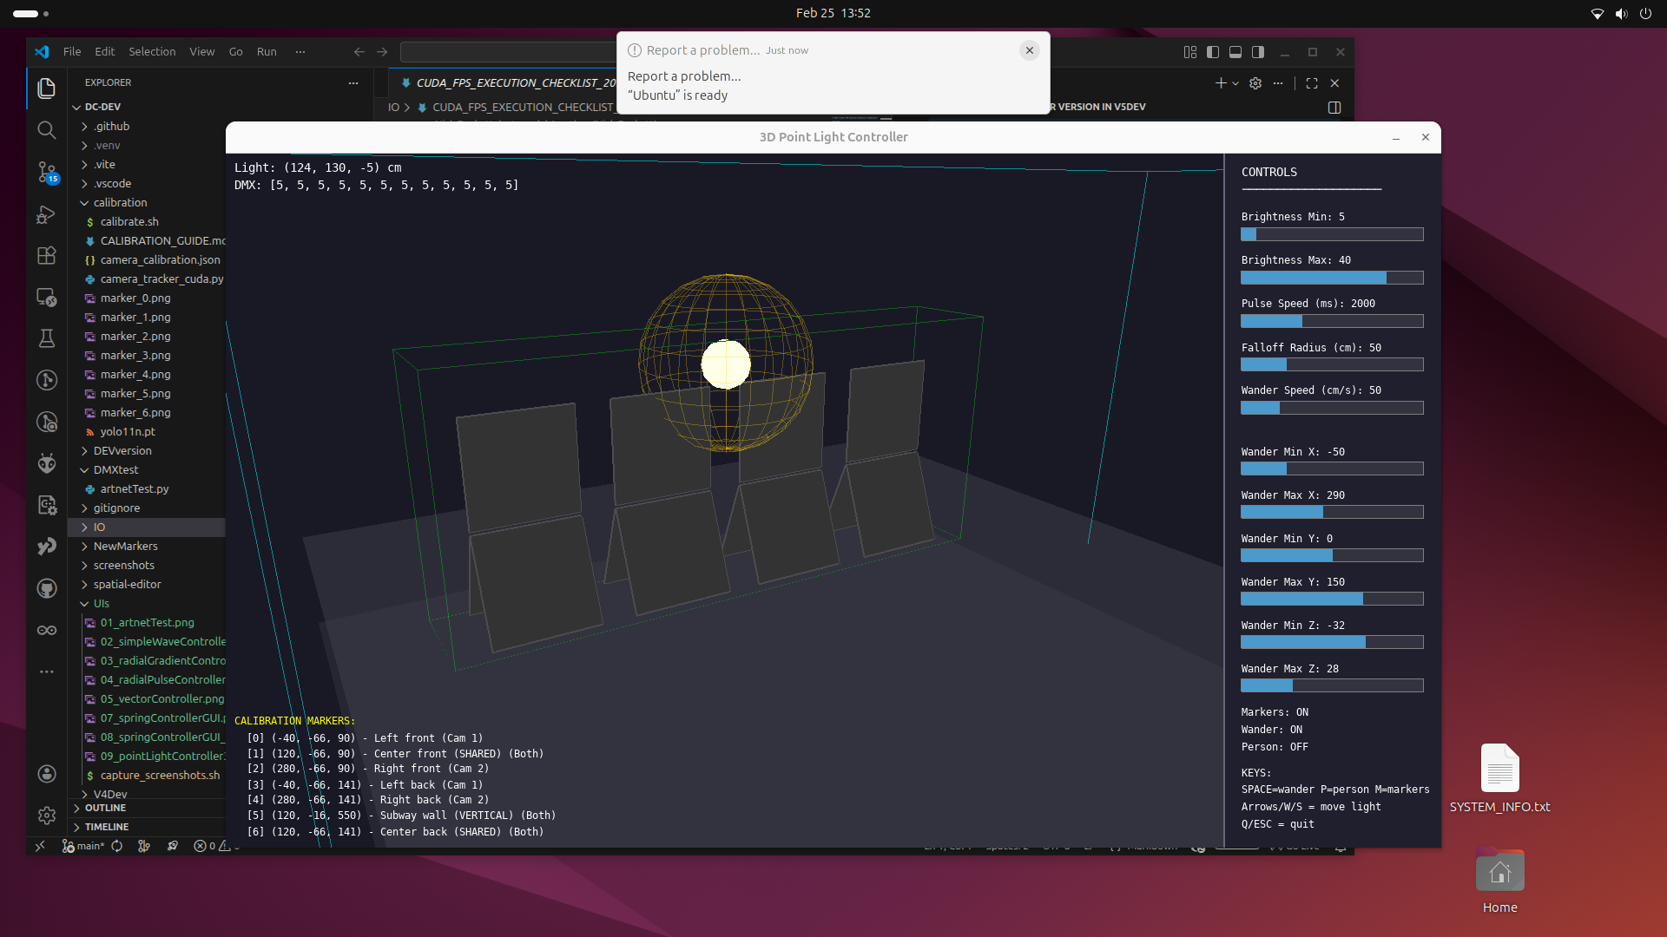 Photo P4 — the control software as a 3D game: physical layout, the virtual light, and the live control parameters share one runtime and one coordinate frame.
Piece 2 — a lightweight 3D modeller that generates model context (spatial-editor/). To get a coding model (Opus 4.5 / 4.6) to reason correctly about that space, the project needed a way to hand it the geometry in a form it could use. The result is a purpose-built browser 3D editor (React + Three.js / react-three-fiber, in spatial-editor/) whose explicit job is to export spatial context for an agent prompt:
- A small, deliberate scene schema (src/schema.js): every object has geometry, a role (actuator / sensor / zone / reference / structural), tags, and relationships. Object types include camera (with an FOV frustum), zone (bounded trigger volume), mesh (imported OBJ), point, box, plane. The schema is designed to be “human-readable as JSON and agent-parseable for spatial context.”
- A context exporter (src/utils/contextExport.js): turns the scene into a structured natural-language Markdown summary — grouped by role, listing positions, bounds, and relationships — that pastes “directly into an agent prompt.” This is the literal bridge from a 3D model to a language model’s working context.
- A converter (src/utils/dropCeilingConverter.js) that round-trips the production IO/world_coordinates.json into the editor and back, validating the schema against the real installation.
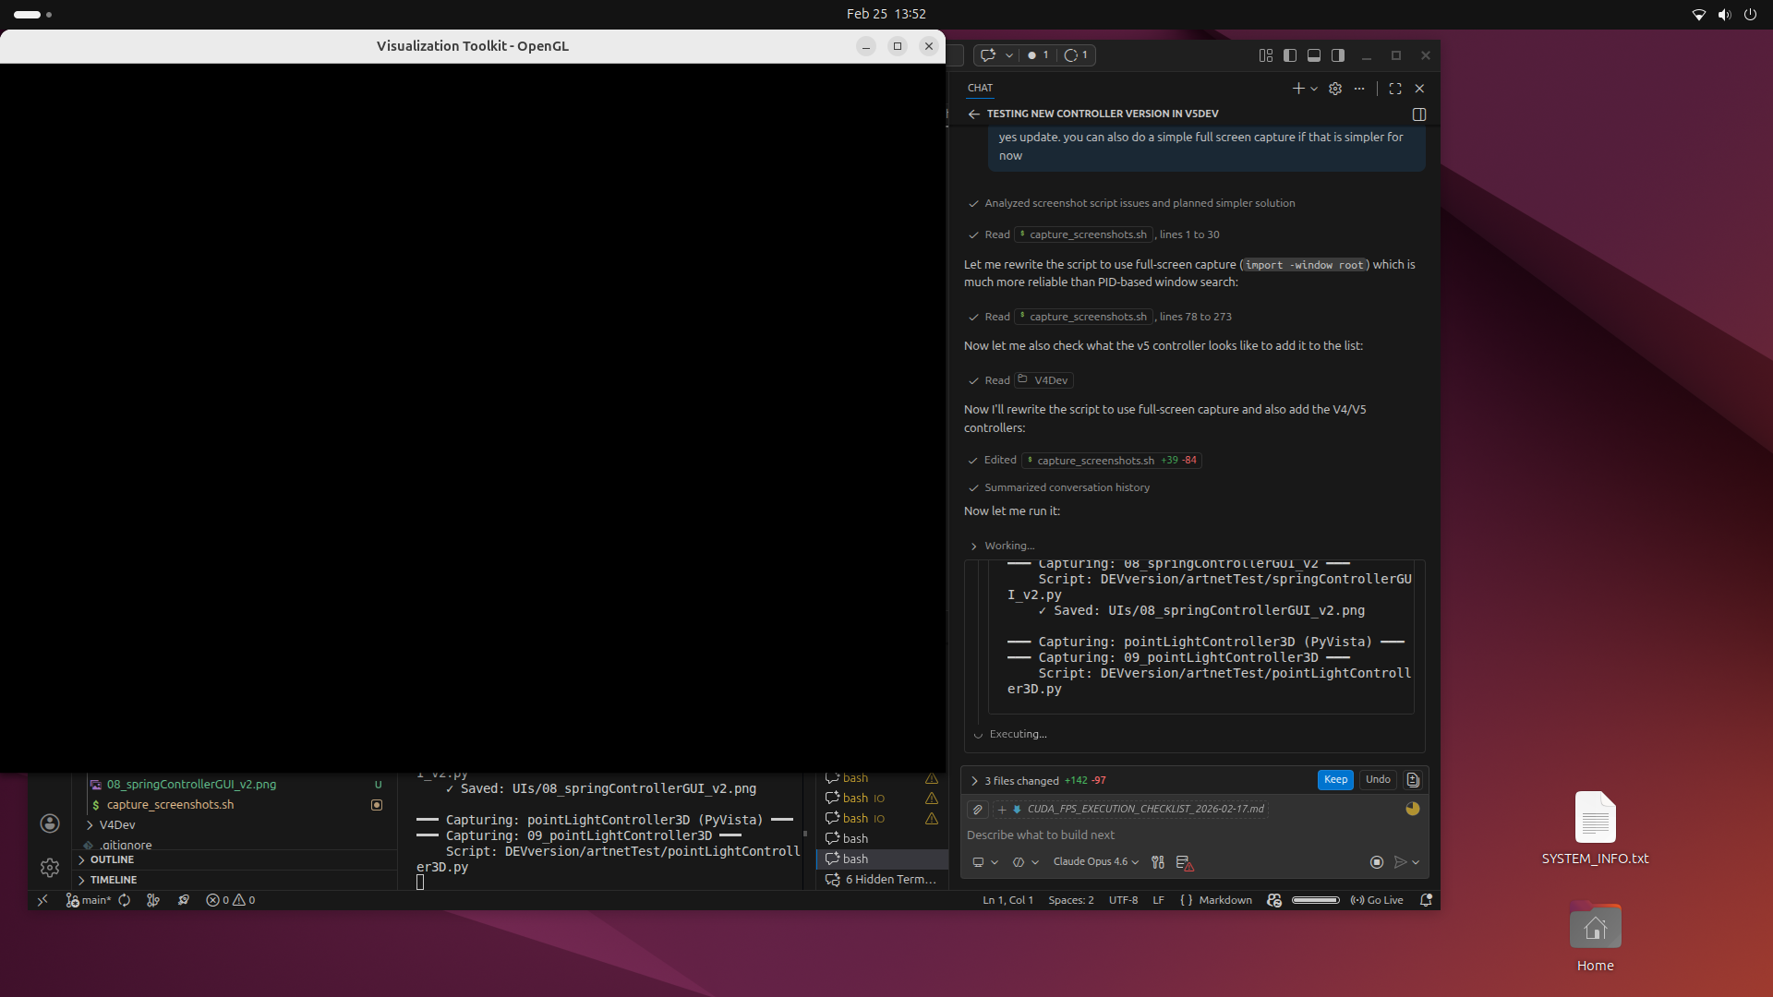 Photo P5 — the human–AI authoring method in practice: the spatial runtime and the coding agent side by side, the model reasoning over the shared geometry. (Crop/clean before publishing — this is a working desktop capture, not a finished figure.)
Piece 3 — the JSON context files (the durable shared reference). Between the editor and the running system sits a set of plain-JSON context files that are the agreed geometry — the same files the human edits, the model reads, and both camera_tracker_osc.py and lightController_osc.py consume at runtime:
File | Holds | Read by
world_coordinates.json | coordinate system, panel unit + subpanel positions/angles, camera positions, zone bounds | controller, tracker, editor converter
camera_calibration.json | per-camera intrinsics + solved pose (the ArUco/homography result) | tracker (floor projection), controller (camera viz)
tracker_settings.json | live tracker tuning (confidence, fusion/match distances, smoothing) | tracker
slider_settings.json | the 12 meta-parameters’ live values | controller
autotune_overrides.json | the tuner’s home values / floors / caps / budget | controller (hot-reload), meta-review (writes)
The method in one sentence (for the text): the 3D model was not a picture of the installation — it was the installation’s shared brain, a spatial substrate that the designer and the AI coding agents both authored against, exported as natural-language context for the model and as JSON for the runtime. This generalises beyond Drop Ceiling: it is a repeatable pattern for authoring spatial-interactive systems with coding agents — give the model geometry as structured context, not prose.
◧ DRAW — Figure E1 (proposed, not yet rendered): the authoring loop. A triangle: (1) 3D modeller (spatial-editor) → exports → (2) model context (Markdown scene summary + JSON files) → feeds → (3) AI coding agent (Opus 4.5/4.6) → writes → (4) control code + the pygame 3D twin → which is observed back in the same coordinate frame → informing the next edit to the modeller. Contrast with the runtime loops (A2): this is the build-time loop, the one that produced the system. (Say the word and I’ll render E1 in the diagram set.)
Honest scoping notes (so the claim survives review): - The editor is a bespoke tool built for this project, not a released product — frame it as “a lightweight modeller we built to generate spatial context,” not a general toolkit, unless you intend to publish it. - Name the models precisely (Claude Opus 4.5 / 4.6) and the role (coding agents that use tools and test, vs. chat) — that distinction is the novel part and your overview already makes it. - This is build-time method, distinct from the runtime AI-ish behaviour (the self-tuner). Keep the two from blurring: agents authored the system; the deployed system then self-tuned on its own. Both are “AI,” but at different layers.

16. Three structural outlines for the ACADIA submission
This document is now a broad reference for several publications. This section narrows back to the one deliverable: the ACADIA 2026 Projects submission — 600 words (excluding citations/captions) + max 10 images, blind peer-reviewed, exhibited as a poster. Three complete outlines follow, each built on a different spine from §15b. All three fit the word/image budget. Pick one; they are mutually exclusive as structures but share most of the same material.
Shared constraints (apply to all three): - ~600 words is ~5 short paragraphs — roughly 90–130 words each. Every paragraph must earn its place; there is no room for a literature review (that goes to citations). - 10 images is generous — use it. Lead with the installation photo (P1); reserve 1–2 slots for the C-series collapse (the strongest single idea). - The scale fact (§15-0: 24/7 × 54 days, ~1M inputs) belongs in every version — it is what turns “it learns” into “it learned.” - State the site (Haworth showroom, 55 University Ave, the column alcove) early; it motivates the active/passive split for free.

Outline 1 — “An adaptive temperament from twelve bytes” (Framing A: meaning-led)
Best fit for Humanism Recoded (Embodied Codes + Machines that Care). Leads with the artwork and its meaning; the method is a closing note. Lowest risk, highest thematic fit.
§ | Paragraph (≈ words) | Carries | Figure(s)
1 | The corner. Site, body, alcove; presence-not-input; the light as an inhabitant. (110) | hook + site | P1 installation photo
2 | A character with traits. Six personality parameters; modes/gestures/dwell; reads flow and bodies, not commands. (120) | what it is | A3 modes; P4 3D twin
3 | Three timescales + friction. Reacts now, anticipates the hour, retunes over days; the interaction budget makes adaptation deliberate. (130) | the engine | A2 loops; A7 / A7.3b
4 | A million encounters. 24/7 × 54 days, ~1M inputs; the temperament formed, measurably (audit + self-analysis). (110) | scale = evidence | D1 or D2
5 | Twelve numbers. The collapse: all of it distilled, 30×/s, to 12 panel values; restraint as the point. Close on re-use + transparency. (110) | the meaning | C1 (+ C3)
- Image budget (10): P1, A2, A3, A7, A7.3b, D2, C1, C3, P4, + one (B3 plan or A11 web).
- Why it wins: the title idea (huge context → tiny output) is unique and on-theme; the friction argument reads as a humane stance, which is exactly the conference’s lens.
- Risk: under-sells the open-source toolkit and the AI-agent method. Fine if the submission is about this artwork, not the method.

Outline 2 — “Re-coding ubiquitous infrastructure” (Framing B: toolkit/maker-led)
Best fit for Built Grounds + Digital Commons. Leads with the open-source re-use of the most invisible object in the built environment. Most accessible/reproducible framing.
§ | Paragraph (≈ words) | Carries | Figure(s)
1 | The forgettable made expressive. Standard office ceiling panels + 0–10V; 3D-printed connectors; open toolkit on GitHub. (120) | hook + openness | P2 unit geometry; P1
2 | A pixel made of a panel. 12 panels as one spatial display; the virtual point light; brightness by distance. (110) | the mechanism | C1 or C4 wiring
3 | Behaviour from standard parts. YOLO + OSC + Art-Net + SQLite; a character (traits/modes) with no proprietary stack. (120) | the system | A1 pipeline; A3
4 | It learns in public. Three loops + friction; 24/7 × 54 days, ~1M inputs; transparent live/▶trend web views. (130) | adaptation + scale | A2; D1; A11
5 | Anyone can build one. Reproducibility, the toolkit as contribution; what you’d change to re-deploy. (110) | the payoff | P3 system diagram
- Image budget (10): P1, P2, A1, A3, A2, C1, C4, D1, A11, P3.
- Why it wins: “accessible interactive lighting from office junk” is a strong, memorable, participatory pitch; aligns with the commons subthemes.
- Risk: the deep self-tuning (your most novel technical work) becomes a supporting detail rather than the star.

Outline 3 — “The model became the brain” (Framing C: method-led)
Best fit for Embodied Codes + Collective Intelligence. Leads with the human–AI authoring method — the spatial substrate that let coding agents reason about a geometric problem. Most methodologically novel; highest reviewer-interest ceiling, highest risk.
§ | Paragraph (≈ words) | Carries | Figure(s)
1 | A geometric problem for a text model. The artwork in one breath, then the authoring challenge: agents can’t see space. (110) | hook + problem | P1; P5 authoring session
2 | A spatial substrate. The pygame 3D twin + the spatial-editor that exports scene → natural-language context + JSON. (130) | the method | P4 twin; E1 authoring loop
3 | What the agents built. Character, gesture library, self-tuner — authored against the shared model. (110) | the result | A3; A7
4 | Then it ran itself. Build-time vs runtime AI; 24/7 × 54 days, ~1M inputs; self-tuning + audit. (120) | the distinction + scale | A2; D2
5 | Collapse + claim. 12 values; and the transferable pattern: give models geometry as context. (120) | meaning + generalisation | C1; (E1 reprise)
- Image budget (10): P1, P5, P4, E1, A3, A7, A2, D2, C1, P3.
- Why it wins: genuinely new contribution (authoring spatial-interactive systems with coding agents); the “3D model as shared brain” line is memorable and very on-theme.
- Risk: the method can eat the artwork; reviewers may want the art foregrounded. Also depends on rendering Figure E1 (proposed in §15d, not yet built) and on cleaning P5 (currently a raw desktop capture).

Choosing — a quick decision aid
If your priority is… | Use | Lead image | Must-build
Thematic fit + the artwork’s meaning | Outline 1 | P1 | — (all figures exist)
Accessibility, openness, reproducibility | Outline 2 | P1 + P2 | — (all figures exist)
Methodological novelty (AI authoring) | Outline 3 | P1 + P5 | E1 render; P5 cleanup
Recommendation: lead with Outline 1 and fold one sentence of B (open toolkit) and one of C (built with coding agents) into §5 — it keeps the strongest thematic spine while signalling the other two contributions. Promote to Outline 2 or 3 only if the call for your specific session/subtheme rewards the toolkit or the method over the artwork.
Cross-cutting to-dos before drafting prose (all outlines): - Confirm the 0–10V vs Art-Net signal path (one sentence) — §15 reconciliation #1. - Decide the unit for the headline number (visitors vs inputs vs events) — §15-0 note. - Pick the one before/after evolution metric you can stand behind (week-1 vs week-7). - If Outline 3: commission E1 and crop P5.

