Predictive Bioinformatics: AI-Based Disease Prediction with Mutation Enhancement

Introduction
With the rapid growth of data-driven technologies, large-scale biological datasets can be efficiently analysed using computational and artificial intelligence techniques. Traditional methods of disease analysis are limited in scalability and speed when dealing with high-dimensional data such as gene expressions.
This project proposes a predictive bioinformatics system that leverages machine learning, feature engineering, and anomaly detection techniques to analyze biological datasets and predict disease outcomes. The system incorporates mutation-based feature extraction as an enhancement layer, improving the predictive performance of the model.
The solution is designed as a web-based AI application, where an intelligent backend processes data and generates predictions, while a user-friendly frontend visualizes results.

Problem Statement
Conventional approaches to analysing biological data lack automation and are inefficient for handling large and complex datasets. There is a need for a scalable, AI-driven system that can:
- process structured biological data
- extract meaningful features
- detect anomalies
- and accurately predict disease outcomes

Objectives
- To design a data-driven predictive system using machine learning
- To implement feature engineering techniques, including mutation-based features
- To integrate anomaly detection for identifying unusual patterns
- To develop a hybrid machine learning model for improved accuracy
- To support multi-disease prediction using a single system
- To visualize results using an interactive dashboard

System Modules
1. Data Collection Module
2. Data Preprocessing Module
3. Feature Engineering Module (Core Module)
4. Mutation Feature Module (Enhancement Layer)
5. Anomaly Detection Module
6. Hybrid Model Training Module
7. Prediction Module
8. Multi-Disease Prediction Module
9. Evaluation Module
10. Visualization Dashboard Module

Expected Outcome
The system will:
- accurately predict disease outcomes using machine learning
- improve performance through mutation-based feature enhancement
- detect anomalies in data for better reliability
- support multi-disease classification
- provide interactive visualization through a dashboard

Advantages
- Automated and scalable system
- Data-driven and accurate predictions
- Supports large datasets
- Integrates multiple AI techniques
- Modular and extensible design

Disadvantages
- Performance depends on data quality
- simplified representation of complex biological data
- possible overfitting of models
- requires computational resources for training
Tools & Technologies
Module | Technology / Tool | Purpose / Role in Project
Data Collection Module | Pandas | Load and handle datasets (CSV, Excel, etc.)
Data Preprocessing Module | Pandas, NumPy | Clean data, handle missing values, normalize and transform data
Feature Engineering Module | Pandas, NumPy, Featuretools | Extract important features and convert raw data into structured format
Mutation Feature Module | Biopython, Python logic | Detect variations/mutations and convert them into numerical features
Anomaly Detection Module | PyOD, Scikit-learn (Isolation Forest) | Identify outliers and unusual patterns in the dataset
Model Training Module | Scikit-learn, XGBoost | Train machine learning models for prediction
Hybrid Model Module | XGBoost, Random Forest (Ensemble Methods) | Combine multiple models to improve prediction accuracy
Prediction Module | Trained ML Models (Scikit-learn/XGBoost) | Generate disease predictions for new input data
Multi-Disease Prediction Module | Scikit-learn (Multi-class classification) | Predict multiple diseases simultaneously
Evaluation Module | Scikit-learn Metrics | Calculate accuracy, precision, recall, and confusion matrix
Visualization Module | Plotly, Matplotlib | Create graphs and visual insights from data and predictions
Dashboard / UI Module | Streamlit / Gradio | Build interactive web interface for user input and output display
Backend API Module | FastAPI | Connect frontend with ML model and handle requests

Conclusion
The proposed system demonstrates a modern AI-driven approach to predictive analytics, combining machine learning, anomaly detection, and feature engineering within a modular architecture. By integrating mutation-based features as an enhancement layer, the system improves predictive performance while maintaining a strong focus on computational efficiency and scalability.

DATASETS
  - breat cancer – python
  - heart datset
- type - kaggle datasets download -d johnsmith88/heart-disease-dataset
- output - heart-disease-dataset.zip
- extract - tar -xf heart-disease-dataset.zip
- move to data/raw
3. diabetes dataset
- type - kaggle datasets download -d mathchi/diabetes-data-set
- extract - tar -xf diabetes-data-set.zip
- output - diabetes-data-set.zip
- move to data/raw
4. gene expression
- type - kaggle datasets download -d crawford/gene-expression
- extract - tar -xf gene-expression.zip
- two csv datasets created, move to data/raw
- data_set_ALL_AML_independent.csv
- data_set_ALL_AML_train.csv
- include actual.csv
5. move all zip files to a folder

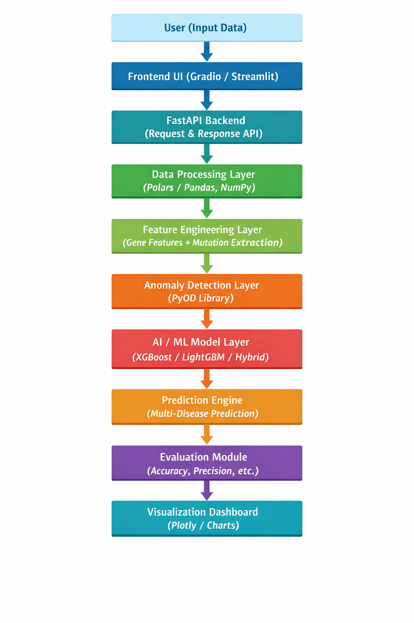
Project Architecture

