**PASSWORD STRENGTH**

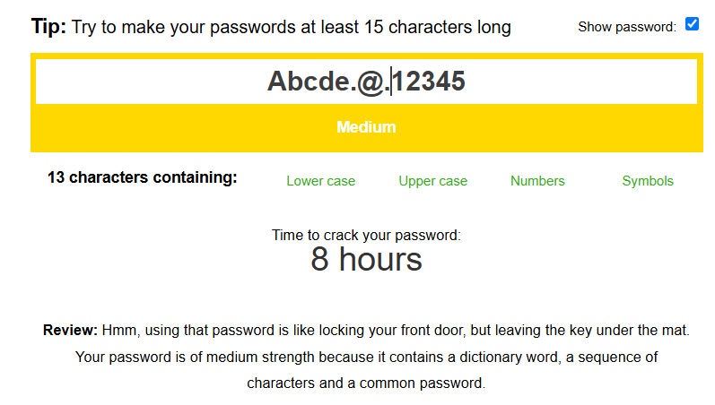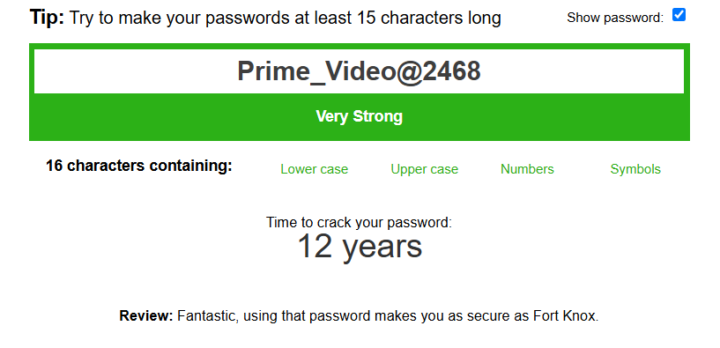

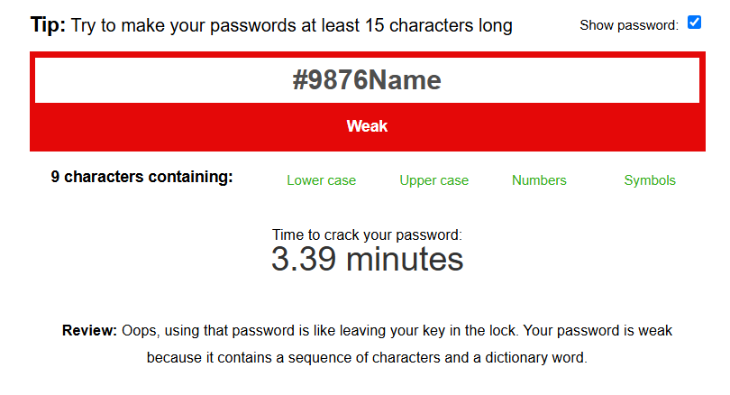 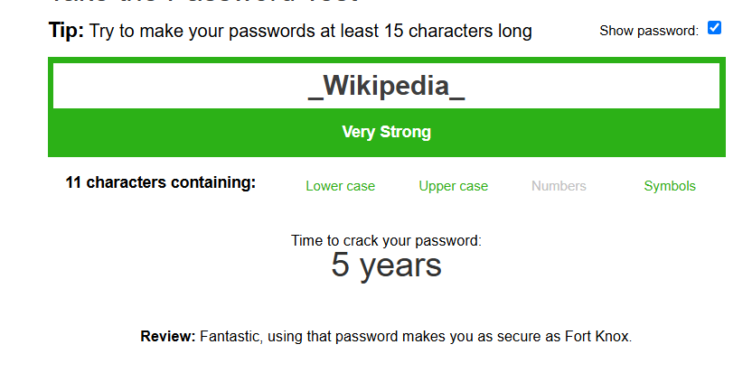

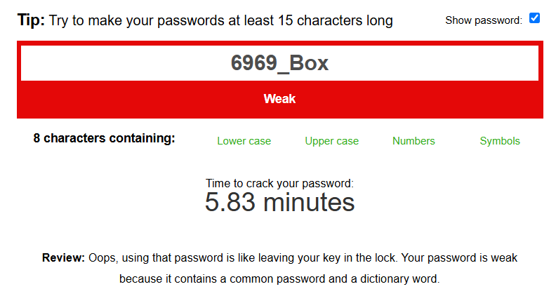 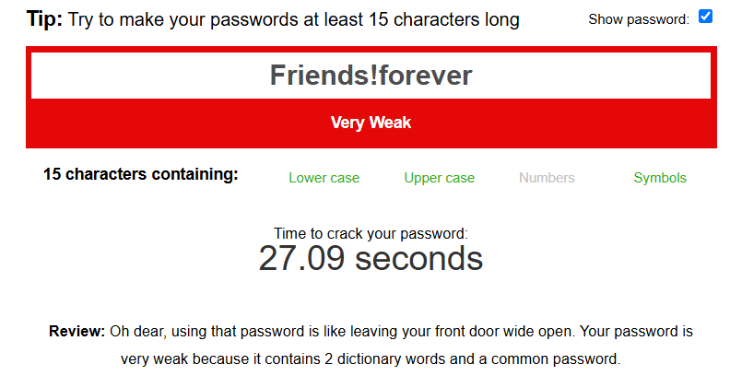

Tips for creating strong password:

1. Make sure to include all symbols, numbers, letters etc
2. Should not be consecutive or sequential of characters
3. Should be unique and innovative
4. Less use of commonly used words together