**Gas Usage Visualization & Basic Analysis**

Gas usage data from the Utilities dataset was gathered to investigate how gas usage varies over time and with temperature. Considering temporal change first, the plot below depicts the cubic feet usage of gas over a ten-year period for the twelve months.

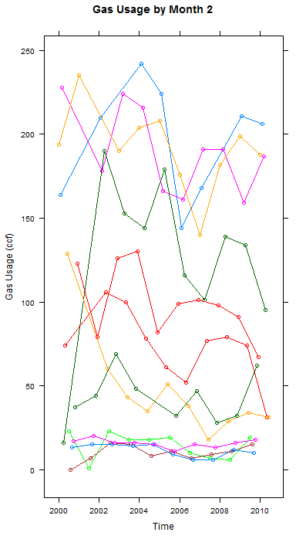

Based on this data, we can see that gas usage in April (shown in black) is much higher than it was ten years ago, while gas usage in June (shown in dark orange) has decreased substantially. The rest of the months have seen their gas usage fluctuate, but not show any long term trends.

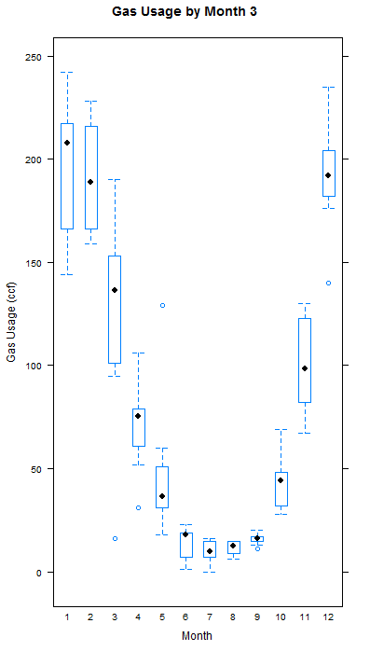

January, February, and March have the most variable gas usages, while June through September have very consistent gas usages as seen from the spread of the bars in Plot 3. In other words, Winters have more variable absolute gas usages than Summers, which agrees with our intuition that similar fluctuations in usage have larger absolute differences when the baseline (as given by the mean) usage is higher.

One potential complication of this analysis is the variable lengths of the months. As it turns out, after adjusting for billing days, our graph looks the same and we draw the same conclusions of how monthly gas usage has changed over the past decade.

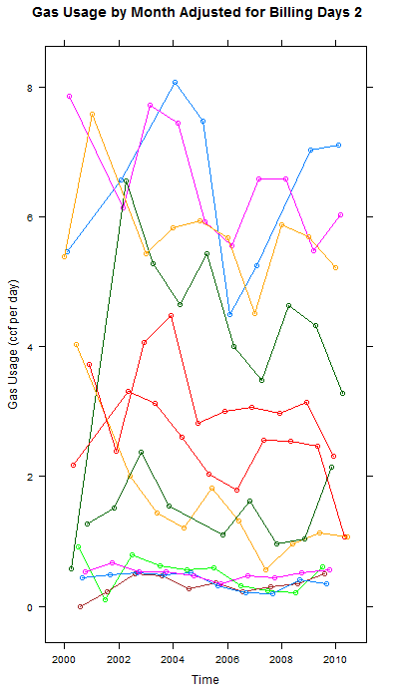

However, this adjustment for month length makes it seem as if the amount of fluctuation has increased even more, from adjusted graph 3. The most variable and most stable months do still occur in Winter and Summer, respectively, although intra-seasonal variation may have slightly shifted. The biggest insight this adjustment provides is that December is more stable than initially thought, due to the identification of the high usage outlier in the following plot that was only detected upon controlling for month length.

.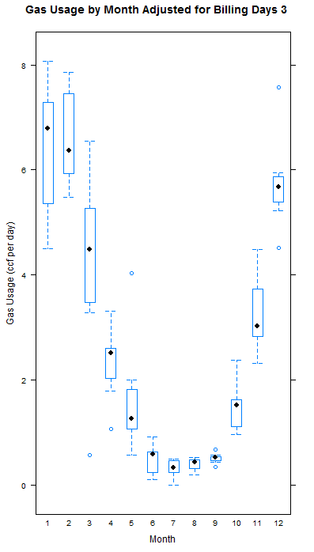

We now investigate the relationship between temperature and gas usage.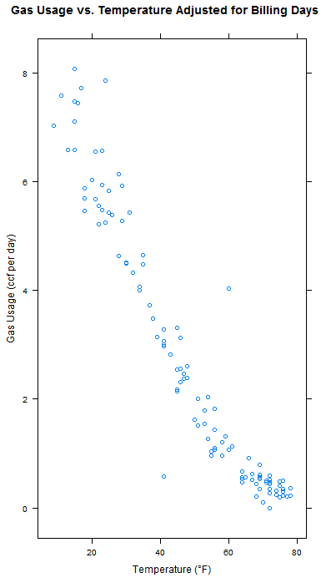

Temperature and gas usage display a generally linear relationship, with a slight logarithmic characteristic, in which an increase in temperature results in a decrease in gas usage. There are 2 noticeable outliers around (40, .4) and (65, 4).

**Chick Growth Visualization & Basic Analysis**

Chicks were given 4 different diets and their resulting weight gains were measured. It was noticed that the chick which had gained the most weight was on diet 3 and the chick which had gained the least weight was on diet 2; does this match the general trend?

Looking at the mean number of grams of body mass that the chicks from each diet gained, we see that chicks gained the most weight (235 grams) on diet 3, then 4, then 2, and the least (118 grams) on diet 1.

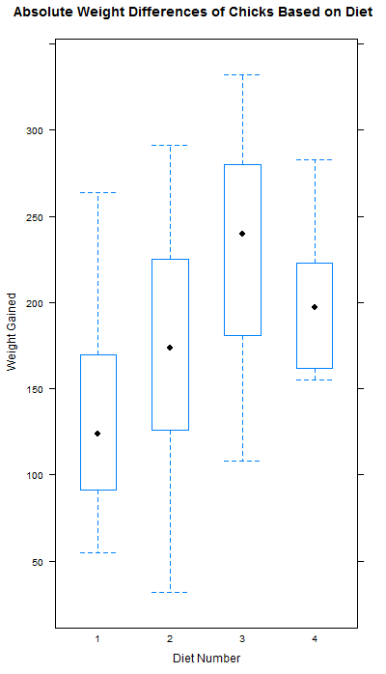

The experimental design of this study was unavailable to us, so we could not assume that the chicks were randomly assigned their diets nor, importantly, that the starting chick weights across each diet were comparable, as confirmed by an ANOVA test.

Thus, we look at the relative weight gained by the chicks on each diet rather than the absolute. Despite the concerns about doing an analysis based on absolute differences, the relative weight difference plot shows us the same information as we gathered from our absolute difference plot.

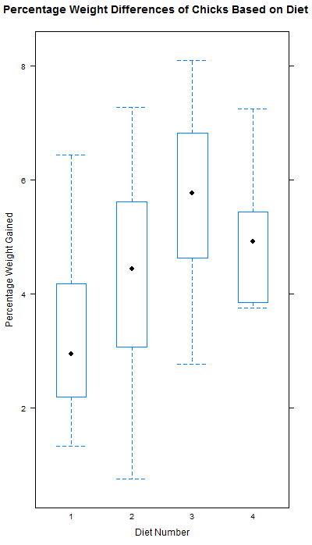

We have thus seen that, despite the concerns over whether the chicks in each diet truly came from the same population, looking at absolute weight differences is a valid starting point for an analysis.