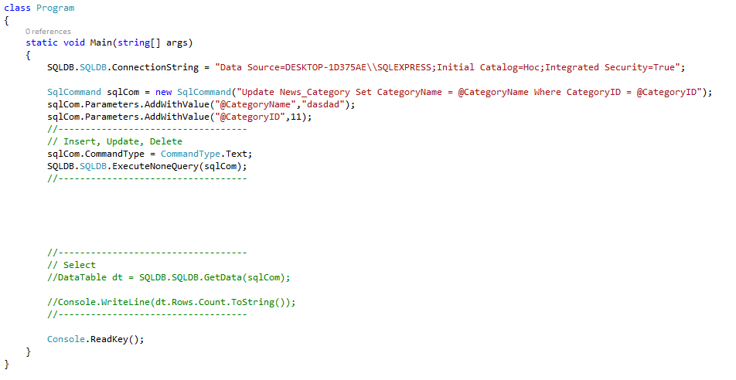

CRUD---Mẫu

static void Main(string[] args)

{

SQLDB.SQLDB.ConnectionString = "Data Source=DESKTOP-1D375AE\\SQLEXPRESS;Initial Catalog=Hoc;Integrated Security=True";

SqlCommand sqlCom = new SqlCommand("Update News_Category Set CategoryName = @CategoryName Where CategoryID = @CategoryID");

sqlCom.Parameters.AddWithValue("@CategoryName","dasdad");

sqlCom.Parameters.AddWithValue("@CategoryID",11);

//-----------------------------------

// Insert, Update, Delete

sqlCom.CommandType = CommandType.Text;

SQLDB.SQLDB.ExecuteNoneQuery(sqlCom);

//-----------------------------------

//-----------------------------------

// Select

//DataTable dt = SQLDB.SQLDB.GetData(sqlCom);

//Console.WriteLine(dt.Rows.Count.ToString());

//-----------------------------------

Console.ReadKey();

}