The University of Azad Jammu and Kashmir


Submitted To: Engr.Fahad Nisar
Session: 2025-2029
Course: SCMT
Name: Noor Fatima
Roll No: 2025-SET-30
Department: Software Engineering Technology
Semester: 02

Lab Task 03

Branching Basic:
Create a branch:
We create a new branch named as “feature/profile”. Branching us allow to work on new features without the main code.
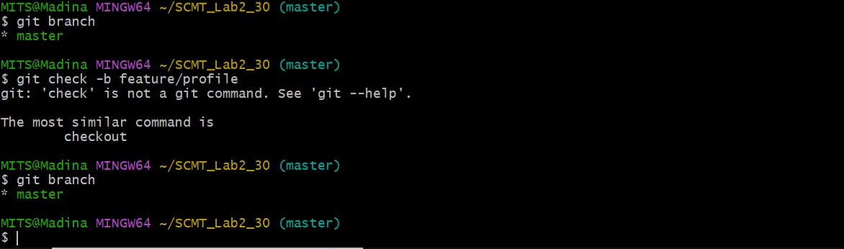

Add content and commit:
Create a profile.txt

Commit the file.
Add the file.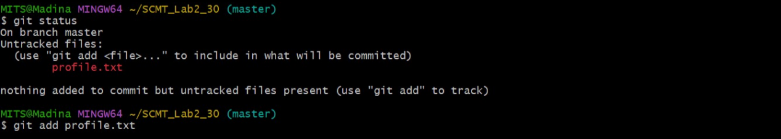
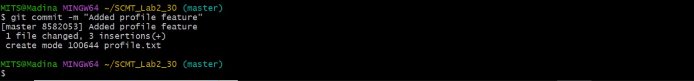

View branching history.
“git log --oneline --graph-all”
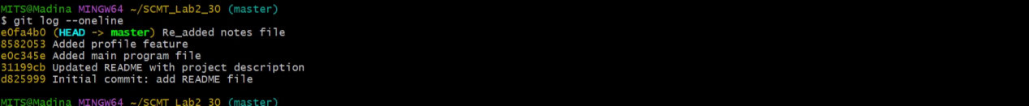

Merging and Conflict:

Switch to main branch:
Working branch is shifted from feature branch to main branch.
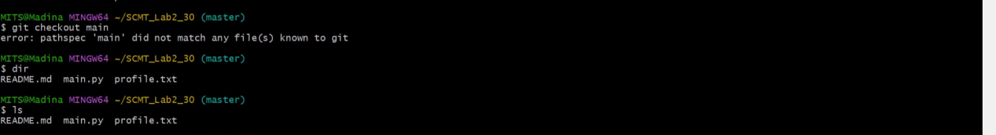

Commit

Merge branch conflict:
Git checkout main
Remote Repository:
Connect local repository
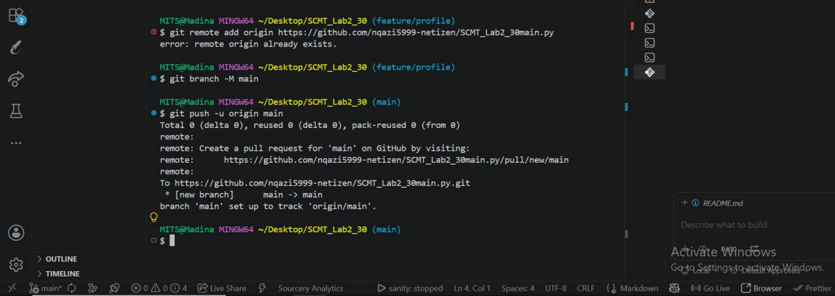

Push branch:
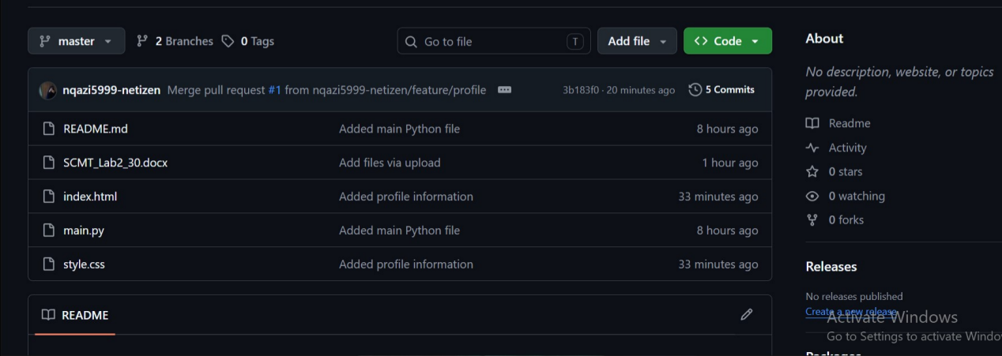

Merged it:

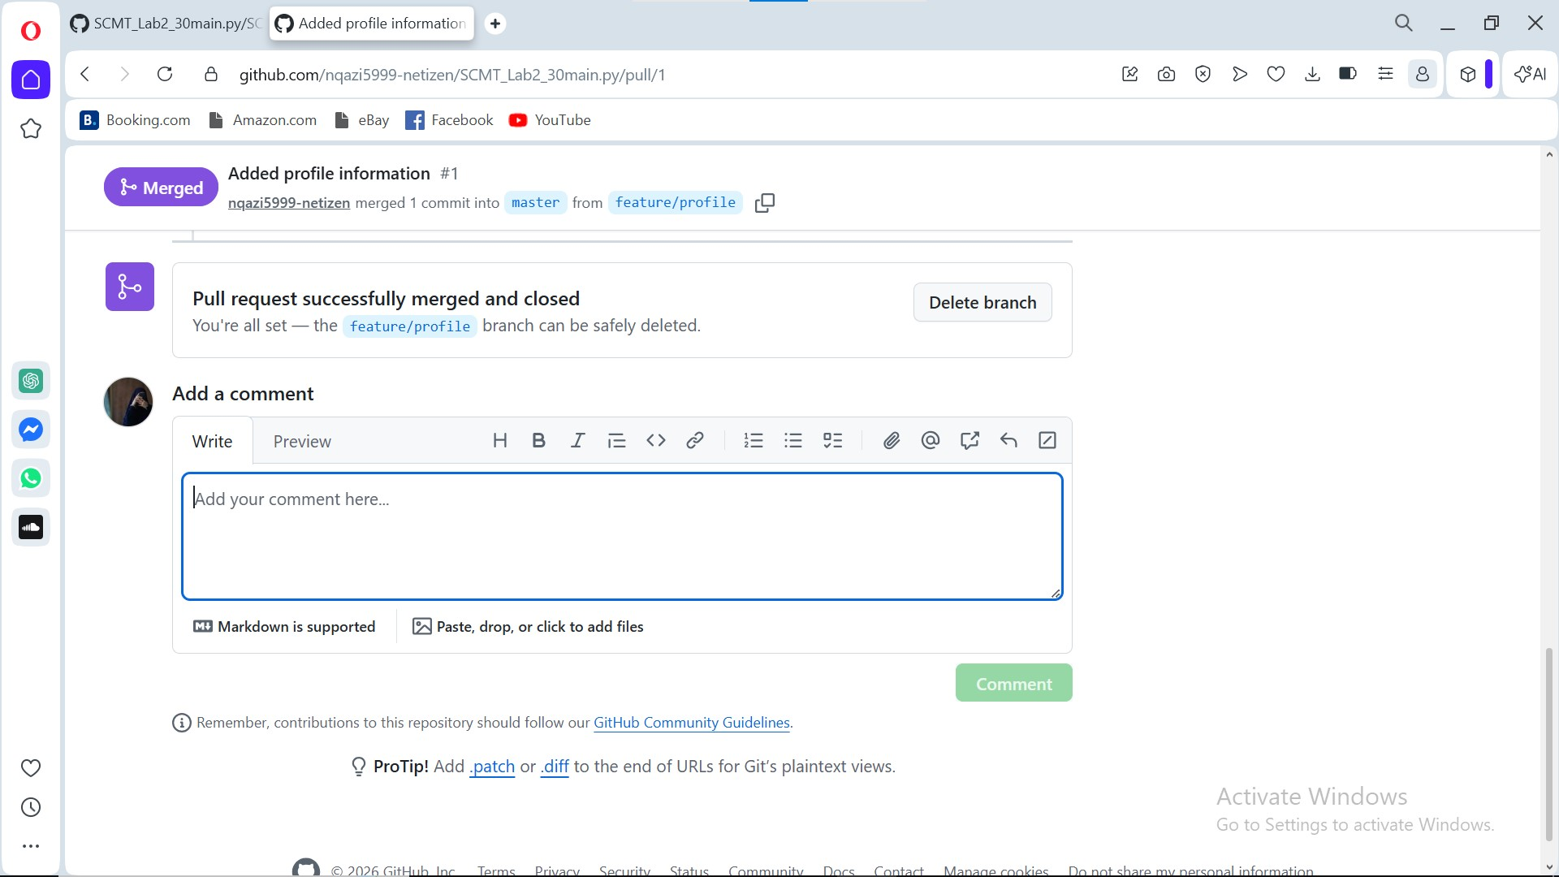

Create feature file.

Git add file.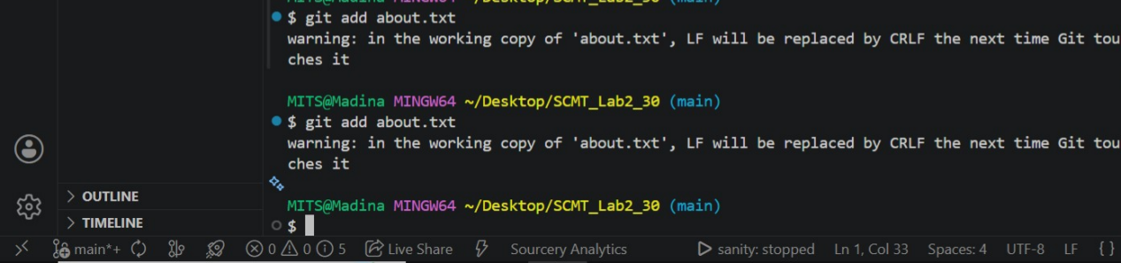

Add commit:
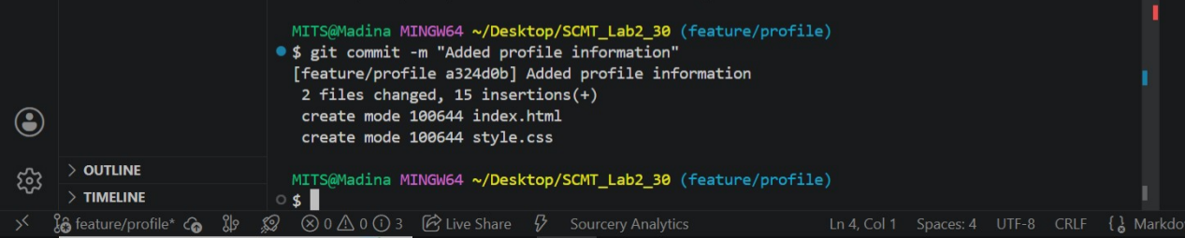

Push branch:
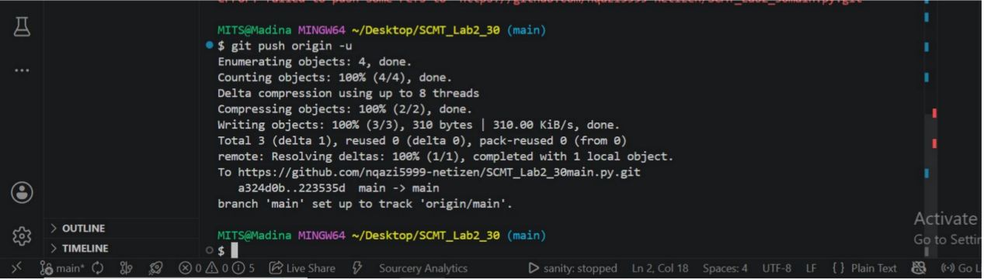

Final Verification:
Git log --oneline --graph --all
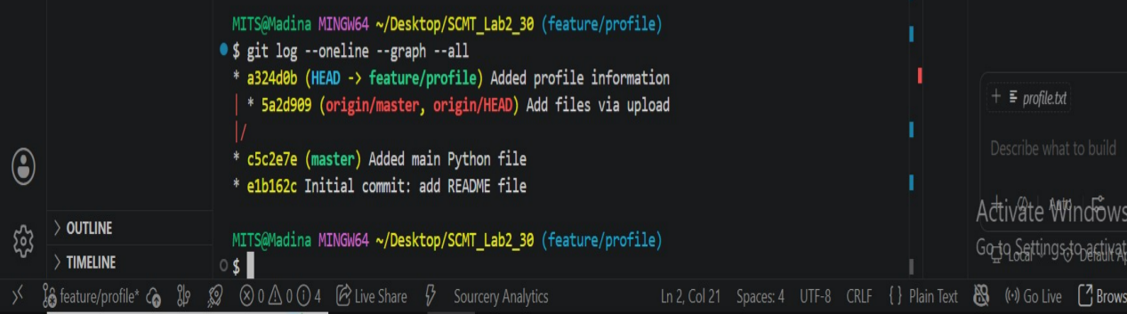

THE END

