Project Report
Housing Affordability & Market Trends
Bella Illingworth & Nikko Higgins
1. Introduction

The United States is experiencing record levels of housing unaffordability, with home prices and rents rising much faster than many households can manage. In this report, we look at how these national trends show up in Iowa by examining county-level data on income, rent, and home values from 2019 to 2022. The goal is to understand how income relates to housing affordability, which counties have seen the biggest cost increases, and whether housing prices and rents are rising faster than incomes in certain areas. By looking at these patterns together, we can get a clearer picture of where affordability pressures may be building across the state.

2. Data

This project primarily uses data from the Iowa Data Portal and additional data pulled from the U.S. Census Bureau’s API. We also created a separate CSV file listing all Iowa counties and their FIPS codes, sourced from the National Weather Service. This allowed us to use the FIPS codes when calling the Census API and then match the results back to the correct county names in my dataset.

2.1 Iowa Median Housing Value
We first retrieved the data by using the U.S. Census Bureau’s American Community Survey (ACS) API. We loaded a CSV file containing Iowa counties and their FIPS codes, which required identifying each county in the Census system. After sending an API request for every Iowa county, the API returned the requested data, which contained values for median rent, median home value, and population across all 99 Iowa counties from 2019 to 2022, resulting in 396 rows and 6 columns.

We standardized county names by removing the word County extracted the year from the Date Collection End Date, and converted MedianRent, MedianHomeValue, and Population into integers so they could be used for calculations later in the analysis. After cleaning, we saved the dataset as cleaned_ia_county_housing(2019-2022).csv, which served as the finalized housing file for the project.

2.2 Iowa Median Household Income
The income data required more preparation because the raw file was much larger than the housing dataset. The original download contained 21,538 rows, covering fields such as Geographic ID and Variable Description, and many years of information. Since our focus was only on median household income for Iowa counties between 2019 and 2022, we filtered the dataset to the following observations: County, Year, and MedianHouseholdIncome. After narrowing it down, the dataset aligned with the housing data at 396 rows, giving us one row per county per year.

We also cleaned the dataset by shortening county names, converting the date field into a numeric year, and transforming MedianHouseholdIncome from text into integers. Once the dataset was cleaned and standardized, we saved it into a new file named cleaned_ia_county_income(2019-2022).csv. This ensured that our cleaned version remained separate from the raw file and was ready for merging.

2.3 Combine Housing Value and Household Income
Once we finished cleaning both datasets, we created new dataframes from the cleaned files and then combined them into a single dataframe called merged_df. To do this, we performed an inner merge using County and Year as the matching keys. This produced a complete and ready-to-analyze dataframe that includes both housing and income data for all Iowa counties from 2019 to 2022.

Table 1: Data Dictionary

Column | Type | Source | Description
County | Text | Both | The name of the Iowa county.
Year | Text | Both | The year the data was recorded (2019-2022).
MedianRentValue | Numeric | U.S. Census Bureau’s API | The median monthly rent value in the county for that year.
MedianHomeValue | Numeric | U.S. Census Bureau’s API | The median home value in the county for that year.
MedianHouseholdIncome | Numeric | Iowa Data Portal | The median household income in the county for that year.
Popululation | Numeric | U.S. Census Bureau’s API | The total population of the county for that year.
Rent_to_Income | Numeric | Computed | Ratio of annual rent to median household income (used to measure rental affordability).
Value_to_Income | Numeric | Computed | Ratio of home value to household income (used to measure home-buying affordability).
Rent_pct_change | Numeric | Computed | Percent change in median rent between 2019 and 2022 for each county.
Value_pct_change | Numeric | Computed | Percent change in median home value between 2019 and 2022 for each county.
Income_pct_change | Numeric | Computed | Percent change in median household income between 2019 and 2022 for each county.

3. Analysis

3.1 How does median household income relate to housing affordability across Iowa counties?

One of the first questions we were curious about was whether higher incomes translate into better housing affordability for Iowa counties. To explore this, we filtered merged_df to be data from 2022 only and created two simple affordability measures: Rent-to-Income and Value-to-Income. These ratios helped us see whether housing costs were taking up a small share of income or a much larger one.

From there, we plotted income against both rent and home values to get a better sense of the overall pattern. As we looked at the scatterplots, we noticed that counties with higher incomes generally tended to have higher rents and higher home values. The correlation analysis shows that income and rent share a moderate positive correlation (r = 0.462), as shown in Figure 1. Meanwhile, the connection between income and home value appears even stronger, with a correlation of (r = 0.745) in Figure 2.

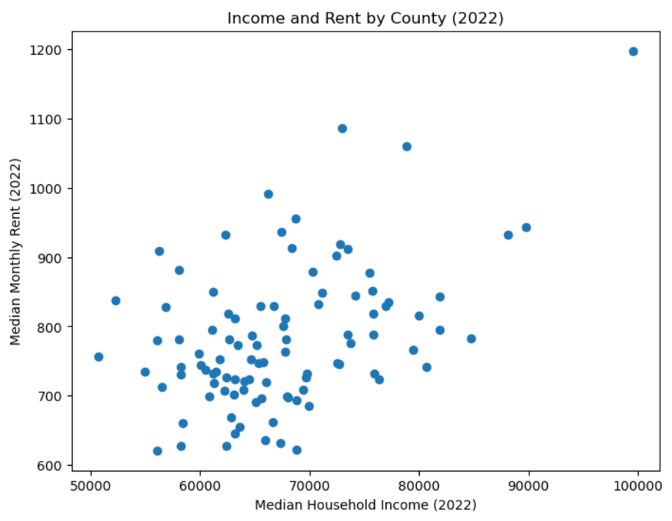
Figure 1. Scatterplot of median household income vs. median home value (2022)

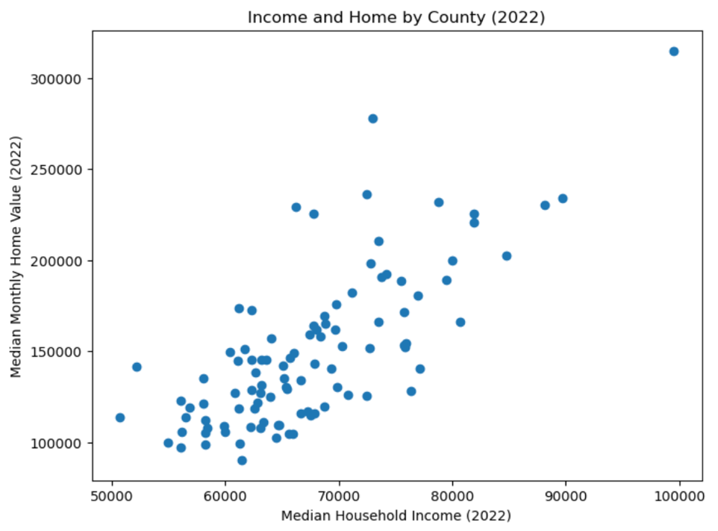
Figure 2. Scatterplot of median household income vs. median home value (2022)

Now that we know that income and home have a stronger relationship. We wanted to explore further which counties have the least affordable housing for home buying. Table 2 highlights the counties where home prices take up the biggest share of household income. Johnson County stands out with a Value_to_Income ratio of 3.81, which means the median home price is almost four times the median household income. This makes sense, especially considering the influence of universities and student-driven markets, since counties like Iowa City and Ames are included. The rest of the list features counties that are either growing rapidly or known for recreation, indicating that high demand might be driving prices up faster than incomes.

Table 2: Least Affordable Counties for Home Buying

County | MedianHouseholdIncome | MedianHomeValue | Value_to_Income
Johnson | 72977 | 277800 | 3.806679
Story | 66197 | 229100 | 3.460882
Winneshiek | 67770 | 225400 | 3.325955
Dickinson | 72446 | 236100 | 3.258979

3.2 Which Iowa counties experienced the greatest changes in rent, home value, and income from 2019 to 2022?
We were also curious about how much things had changed over time, especially between 2019 and 2022, a period that saw major shifts in housing markets nationwide. Before the analysis, we reshaped the data into a wide format and calculated both absolute and percent changes in 2029 and 2022 for MedianRent, MedianHomeValue, and MedianHouseholdIncome. This allowed us to compare counties directly and see which ones were changing the fastest.

When we looked at the percent change results, we noticed that the differences across Iowa counties were noticeable. Some counties saw housing costs rise very quickly, while others only changed a little over the same period. From Figure 3, counties like Adams, Shelby, Davis, and Greene had some of the largest increases in rent, with growth often above 25 percent. Home values increased even more in certain areas, especially in counties such as Ringgold, Appanoose, Cherokee, and Mills, where prices rose by more than 30 percent.

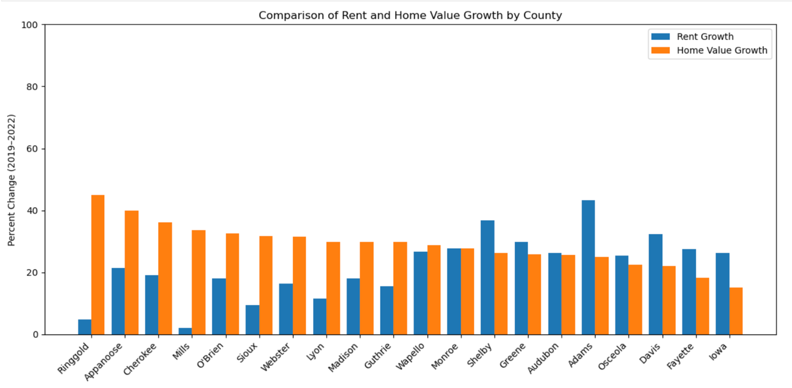
Figure 3. Rent and Home Value Growth by County (2019–2022)

MedianHouseholdIncome did increase during this time, but it did not grow as quickly as MedianRent or MedianHomeValue in many counties. The counties with the highest income growth, such as Webster, Madison, Adams, and Monroe, generally saw increases between about 20 and 30 percent, as shown in Figure 4. After exploring these trends, we realized that this growth can be affected by many factors, such as job growth, population changes, or the economy after the pandemic.

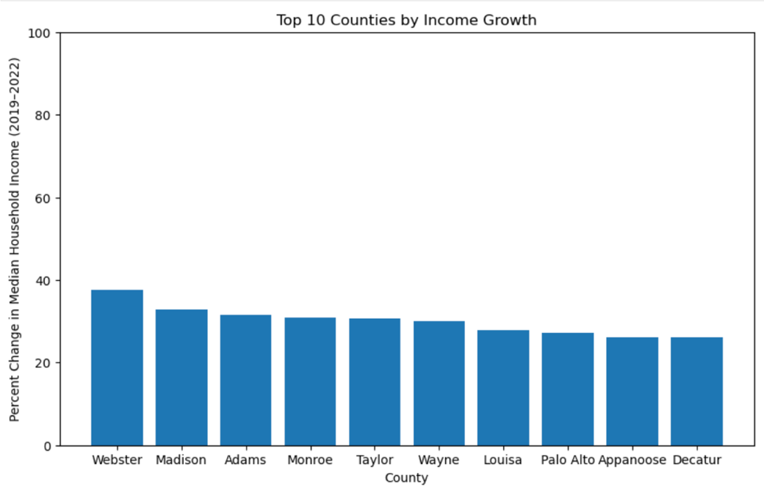
Figure 4. Top 10 Counties by Income Growth (2019–2022)
3.3 Are housing costs rising faster than incomes in certain counties?
Seeing how MedianHouseholdIncome and MedianHomeValue were rising made us want to see if incomes were keeping up or falling behind. Thus, we create an overall statewide trend from 2019 to 2022 using merged_df.

Both MedianHouseholdIncome and MedianHomeValue increased steadily, but MedianHomeValue rose noticeably faster, especially from 2021 to 2022 (Figure 5). This shows us that the housing market over the past year has not been favorable for people looking to buy a new home. Except for the period from 2020 to 202,1, when the entire world was facing the pandemic, which is why we see home values are lower than the median income.

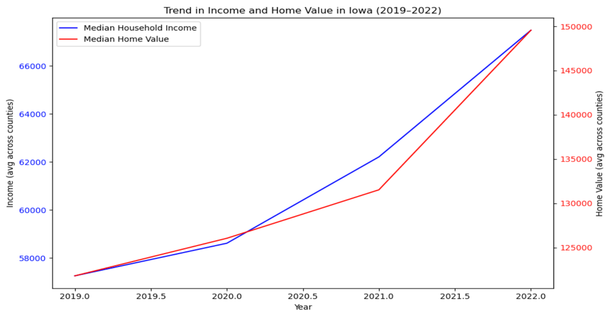
Figure 5. Iowa Income and Home Value Trend (2019–2022)

After looking at the overall trend at the state level, we wanted to dig deeper and see which counties had rent or home values increasing faster than income. To do this, we calculated the difference between rent growth and income growth, as well as the difference between home value growth and income growth. This helped us identify counties where housing costs were rising much faster than earnings.

For Rent_vs_Income_gap, counties such as Greene, Audubon, Fayette, Shelby, and Ida stood out, with rent increases far outpacing income growth (Figure 6). A similar pattern appeared for Value_vs_Income_gap, as many of these same counties also experienced home price growth that exceeded income growth by a large margin, shown in Figure 7.

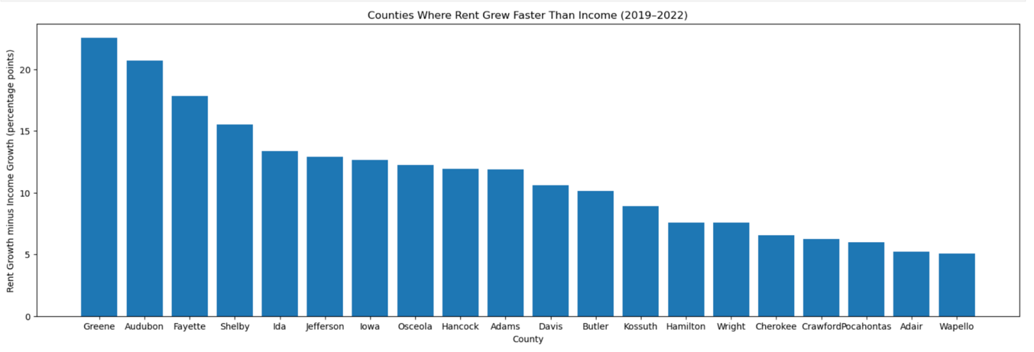
Figure 6. Counties Where Rent Grew Faster Than Income (2019–2022)

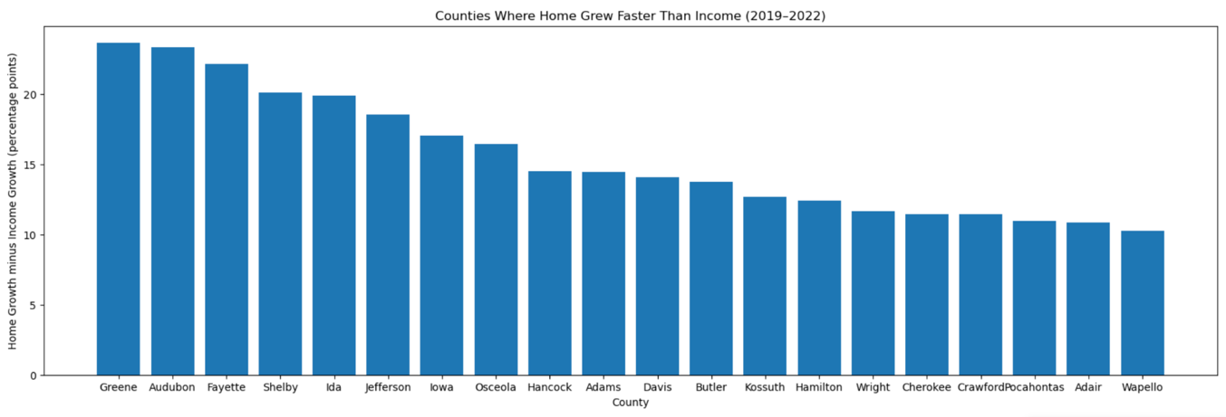
Figure 7. Counties Where Home Value Grew Faster Than Income (2019–2022)

4. Conclusion

In this project, we analyzed housing affordability trends in Iowa by looking at the relationship between income and housing costs, the changes in rent and home values over time, and whether housing costs are rising faster than incomes. Based on the analysis questions in our proposal, here are our outcomes:

- How does median household income relate to housing affordability across Iowa counties?

The counties with higher income tend to have higher rents and home values. The correlation (r = 0.745) between income and home value is stronger than the correlation between income and rent (r = 0.462). This shows that housing prices are affected by income levels.

- Which Iowa counties experienced the greatest changes in rent, home value, and income from 2019 to 2022?

There were many counties where the housing costs had significant increases, where home values were changing faster than rent. The counties included Ringgold, Appanoose, Cherokee, and Mills, all up by 30%. Even though incomes did increase, they were not able to compete with the rising housing costs.

- Are housing costs rising faster than incomes in certain counties?

There were many counties that had housing costs rising faster than incomes. The counties like Greene, Audubon, Fayette, Shelby, and Ida had rent increases that
surpassed income growth. This could later lead to possible financial challenges.

Overall, the results show that the housing costs are rising at a faster rate than household incomes. This issue could increase housing affordability challenges for many households, specifically in counties that have rapid housing market growth. The limitations of this project are that it is only from the years 2019 to 2022, and it lacks employment and demographic information. Future work could be looking into the socioeconomic features and having a larger range of data to find more patterns in affordability.

https://www.jchs.harvard.edu/sites/default/files/interactive-item/files/Harvard_JCHS_State_of_the_Nations_Housing_2025_Press_Release.pdf
https://data.iowa.gov/Community-Demographics/Iowa-Median-Household-Income-in-the-Past-12-Months/9tir-hza4/data_preview
https://www.census.gov/data/developers/data-sets.html
https://www.weather.gov/media/pimar/FIPS/ia_cnty.pdf

