LAB 5 – Stored procedures and Triggers

Create database and insert data to store information of employees as following:

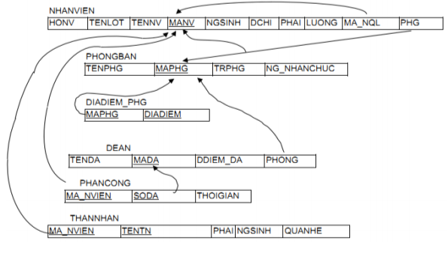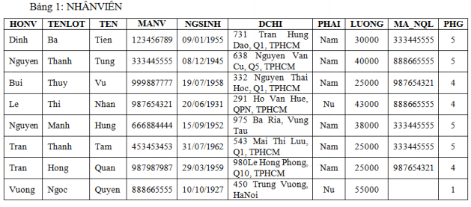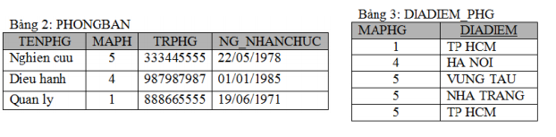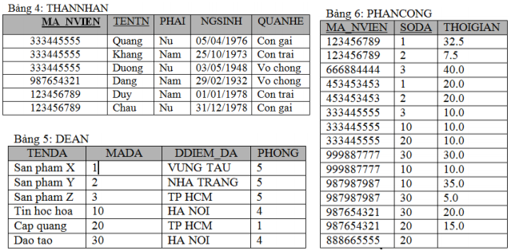

1. Write store procedures to do bellow tasks: (SPs were named SP_[number])
2. List all employees whose salary is greater than the input parameter.
3. List all information of employees (code, name, entered date, supervisor’s id, supervisor’s name) that were employed from s to f. S and f are date value that were been input parameters.
4. List all employees in the department that whose code is input parameter.
5. List all employees that do not have supervisor.
6. List all information about employees, include: name, code, working times in months to now.
7. List all information about departments, include: code, name of department, number of employees of department.
8. List all employees (code, name, salary) whose salary more than the average salary of the department that they work in.
9. List N employees that have the highest salary. N is the input parameter.
10. Increase 10% for salary of all employees in the city A. A is the input parameter.
11. Delete all no personnel departments.
12. Write triggers to ensure:
13. The average salary of each department must be fewer than 50000.
14. The salary of the head of each department must be greater than or equal to salary of all employees in this department.
15. The different between average salary of employees in HCM and HN must fewer than 10000.
16. There is not group that have more than five employees that are in the same family.
17. The different between number of male and female employees must fewer than 10%.

Answer:

create database QuanLy_WS

use QuanLy_WS

-- CREATE TABLE

create table NHANVIEN (

HONV nvarchar(20) not null,

TENLOT nvarchar(20),

TEN nvarchar(20) not null,

MANV int not null primary key,

NGSINH date not null,

DCHI nvarchar(50) not null,

PHAI nvarchar(10) not null,

LUONG int not null,

MA_NQL int foreign key references NHANVIEN(MANV),

PHG tinyint

)

create table PHONGBAN (

TENPHG nvarchar(50) not null,

MAPHG tinyint not null primary key,

TRPHG int not null foreign key references NHANVIEN(MANV),

NG_NHANCHUC date not null

)

create table DIADIEM_PHG (

MAPHG tinyint not null foreign key references PHONGBAN(MAPHG),

DIADIEM nvarchar(30),

primary key (MAPHG, DIADIEM)

)

create table THANNHAN (

MA_NVIEN int not null foreign key references NHANVIEN(MANV),

TENTN nvarchar(20) not null,

PHAI nvarchar(10) not null,

NGSINH date not null,

QUANHE nvarchar(20) not null,

primary key (MA_NVIEN, TENTN)

)

create table DEAN (

TENDA nvarchar(50) not null,

MADA tinyint not null primary key,

DDIEM_DA nvarchar(30) not null,

PHONG tinyint not null foreign key references PHONGBAN(MAPHG)

)

create table PHANCONG (

MA_NVIEN int not null foreign key references NHANVIEN(MANV),

SODA tinyint not null foreign key references DEAN(MADA),

THOIGIAN decimal(18, 1),

primary key(MA_NVIEN, SODA)

)

alter table NHANVIEN add constraint FK__NHANVIEN__PHG foreign key (PHG) references PHONGBAN(MAPHG)

-- INSERT DATA

insert into NHANVIEN (HONV, TENLOT, TEN, MANV, NGSINH, DCHI, PHAI, LUONG)

values ('Dinh', 'Ba', 'Tien', 123456789, '01/09/1955', '731 Tran Hung Dao, Q1, TPHCM', 'Nam', 30000)

insert into NHANVIEN (HONV, TENLOT, TEN, MANV, NGSINH, DCHI, PHAI, LUONG)

values ('Nguyen', 'Thanh', 'Tung', 333445555, '12/08/1945', '638 Nguyen Van Cu, Q5, TPHCM', 'Nam', 40000)

insert into NHANVIEN (HONV, TENLOT, TEN, MANV, NGSINH, DCHI, PHAI, LUONG)

values ('Bui', 'Thuy', 'Vu', 999887777, '07/19/1968', '332 Nguyen Thai Hoc, Q1, TPHCM', 'Nam', 25000)

insert into NHANVIEN (HONV, TENLOT, TEN, MANV, NGSINH, DCHI, PHAI, LUONG)

values ('Le', 'Thi', 'Nhan', 987654321, '06/20/1931', '291 Ho Van Hue, QPN, TPHCM', 'Nu', 43000)

insert into NHANVIEN (HONV, TENLOT, TEN, MANV, NGSINH, DCHI, PHAI, LUONG)

values ('Nguyen', 'Manh', 'Hung', 666884444, '09/15/1952', '975 Ba Ria, Vung Tau', 'Nam', 38000)

insert into NHANVIEN (HONV, TENLOT, TEN, MANV, NGSINH, DCHI, PHAI, LUONG)

values ('Tran', 'Thanh', 'Tam', 453453453, '07/31/1962', '543 Mai Thi Luu, Q1, TPHCM', 'Nam', 25000)

insert into NHANVIEN (HONV, TENLOT, TEN, MANV, NGSINH, DCHI, PHAI, LUONG)

values ('Tran', 'Hong', 'Quan', 987987987, '03/29/1959', '980 Le Hong Phong, Q10, TPHCM', 'Nam', 25000)

insert into NHANVIEN (HONV, TENLOT, TEN, MANV, NGSINH, DCHI, PHAI, LUONG)

values ('Vuong', 'Ngoc', 'Quyen', 888665555, '10/10/1927', '450 Trung Vuong, Ha Noi', 'Nu', 55000)

insert into PHONGBAN (TENPHG, MAPHG, TRPHG, NG_NHANCHUC) values ('Nghien cuu', 5, 333445555, '05/22/1978')

insert into PHONGBAN (TENPHG, MAPHG, TRPHG, NG_NHANCHUC) values ('Dieu hanh', 4, 999887777, '01/01/1985')

insert into PHONGBAN (TENPHG, MAPHG, TRPHG, NG_NHANCHUC) values ('Quan ly', 1, 888665555, '06/19/1971')

update NHANVIEN set MA_NQL = 333445555, PHG = 5 where MANV = 123456789

update NHANVIEN set MA_NQL = 888665555, PHG = 5 where MANV = 333445555

update NHANVIEN set MA_NQL = 987654321, PHG = 4 where MANV = 999887777

update NHANVIEN set MA_NQL = 888665555, PHG = 4 where MANV = 987654321

update NHANVIEN set MA_NQL = 333445555, PHG = 5 where MANV = 666884444

update NHANVIEN set MA_NQL = 333445555, PHG = 5 where MANV = 453453453

update NHANVIEN set MA_NQL = 987654321, PHG = 4 where MANV = 987987987

update NHANVIEN set PHG = 1 where MANV = 888665555

insert into DIADIEM_PHG (MAPHG, DIADIEM) values (1, 'TP HCM')

insert into DIADIEM_PHG (MAPHG, DIADIEM) values (4, 'HA NOI')

insert into DIADIEM_PHG (MAPHG, DIADIEM) values (5, 'VUNG TAU')

insert into DIADIEM_PHG (MAPHG, DIADIEM) values (5, 'NHA TRANG')

insert into DIADIEM_PHG (MAPHG, DIADIEM) values (5, 'TPHCM')

insert into THANNHAN (MA_NVIEN, TENTN, PHAI, NGSINH, QUANHE)

values (333445555, 'Quang', 'Nu', '04/05/1976', 'Con gai')

insert into THANNHAN (MA_NVIEN, TENTN, PHAI, NGSINH, QUANHE)

values (333445555, 'Khang', 'Nam', '10/25/1973', 'Con trai')

insert into THANNHAN (MA_NVIEN, TENTN, PHAI, NGSINH, QUANHE)

values (333445555, 'Duong', 'Nu', '05/03/1948', 'Vo chong')

insert into THANNHAN (MA_NVIEN, TENTN, PHAI, NGSINH, QUANHE)

values (987654321, 'Dang', 'Nam', '02/29/1932', 'Vo chong')

insert into THANNHAN (MA_NVIEN, TENTN, PHAI, NGSINH, QUANHE)

values (123456789, 'Duy', 'Nam', '01/01/1978', 'Con trai')

insert into THANNHAN (MA_NVIEN, TENTN, PHAI, NGSINH, QUANHE)

values (123456789, 'Chau', 'Nu', '12/31/1978', 'Con gai')

insert into DEAN (TENDA, MADA, DDIEM_DA, PHONG) values ('San pham X', 1, 'VUNG TAU', 5)

insert into DEAN (TENDA, MADA, DDIEM_DA, PHONG) values ('San pham Y', 2, 'NHA TRANG', 5)

insert into DEAN (TENDA, MADA, DDIEM_DA, PHONG) values ('San pham Z', 3, 'TP HCM', 5)

insert into DEAN (TENDA, MADA, DDIEM_DA, PHONG) values ('Tin hoc hoa', 10, 'HA NOI', 4)

insert into DEAN (TENDA, MADA, DDIEM_DA, PHONG) values ('Cap quang', 20, 'TP HCM', 1)

insert into DEAN (TENDA, MADA, DDIEM_DA, PHONG) values ('Dao tao', 30, 'HA NOI', 4)

insert into PHANCONG (MA_NVIEN, SODA, THOIGIAN) values (123456789, 1, 32.5)

insert into PHANCONG (MA_NVIEN, SODA, THOIGIAN) values (123456789, 2, 7.5)

insert into PHANCONG (MA_NVIEN, SODA, THOIGIAN) values (666884444, 3, 40.0)

insert into PHANCONG (MA_NVIEN, SODA, THOIGIAN) values (453453453, 1, 20.0)

insert into PHANCONG (MA_NVIEN, SODA, THOIGIAN) values (453453453, 2, 20.0)

insert into PHANCONG (MA_NVIEN, SODA, THOIGIAN) values (333445555, 3, 10.0)

insert into PHANCONG (MA_NVIEN, SODA, THOIGIAN) values (333445555, 10, 10.0)

insert into PHANCONG (MA_NVIEN, SODA, THOIGIAN) values (333445555, 20, 10.0)

insert into PHANCONG (MA_NVIEN, SODA, THOIGIAN) values (999887777, 30, 30.0)

insert into PHANCONG (MA_NVIEN, SODA, THOIGIAN) values (999887777, 10, 10.0)

insert into PHANCONG (MA_NVIEN, SODA, THOIGIAN) values (987987987, 10, 35.0)

insert into PHANCONG (MA_NVIEN, SODA, THOIGIAN) values (987987987, 30, 5.0)

insert into PHANCONG (MA_NVIEN, SODA, THOIGIAN) values (987654321, 30, 20.0)

insert into PHANCONG (MA_NVIEN, SODA, THOIGIAN) values (987654321, 20, 15.0)

insert into PHANCONG (MA_NVIEN, SODA, THOIGIAN) values (888665555, 20, null)

go

-- 1

create proc SP_1

@salary int

as Select * from NHANVIEN where LUONG > @salary

exec SP_1 1000

-- 2

CREATE Proc SP_2

@StartDate date,

@EndDate date

AS SELECT NV.MANV, NV.TEN, NV.LUONG, NV.MA_NQL, SV.TENTN AS [SUPERVISOR_NAME]

FROM NHANVIEN NV

JOIN THANNHAN SV ON NV.MANV = SV.MA_NVIEN

WHERE NV.NGSINH BETWEEN @StartDate AND @EndDate;

EXEC SP_2 '01/09/1955','01/10/1965'

--3

create proc SP_3

@Code int

as select * from NHANVIEN where PHG = @Code

exec SP_3 4

--4

create proc SP_4

as select * from NHANVIEN where MA_NQL is null

exec SP_4

--5

create proc SP_5

as

select TEN, MANV, DATEDIFF(MONTH, NGSINH, getDate()) as [working month] from NHANVIEN

exec SP_5

--6

create proc SP_6

as

select MAPHG,TENPHG, count(*) as soluongnv from PHONGBAN join NHANVIEN on NHANVIEN.PHG = PHONGBAN.MAPHG

group by MAPHG, TENPHG

exec SP_6

--7

CREATE PROC SP_7

AS

SELECT NV.MANV, NV.TEN, NV.LUONG

FROM NHANVIEN NV

WHERE NV.LUONG > (

SELECT AVG(NV2.LUONG)

FROM NHANVIEN NV2

WHERE NV2.PHG = NV.PHG

)

EXEC SP_7

--8

CREATE PROC SP_8

@hsalary int

AS

SELECT TOP (@hsalary) *

FROM NHANVIEN

ORDER BY LUONG DESC;

EXEC SP_8 32000

go

--9

CREATE PROC SP_9

@city nvarchar(50)

AS

UPDATE NHANVIEN SET LUONG = LUONG * 1.1

WHERE DCHI = @city

EXEC SP_9 @city = '450 Trung Vuong, Ha Noi'

SELECT * FROM NHANVIEN

go

--10

CREATE PROC SP_10

AS

DELETE FROM PHONGBAN

WHERE MAPHG NOT IN (SELECT DISTINCT PHG FROM NHANVIEN);

EXEC SP_10

go

WS1:

-- câu 3:

CREATE PROC procStudentList

@pClassCode varchar(10) = '',

@pMark float = 0

AS

SELECT s.classCode, s.rollNo, s.fullName, m.subjectCode, m.mark

FROM Student s

INNER JOIN Mark m ON s.rollNo = m.rollNo

WHERE (s.classCode = @pClassCode OR @pClassCode = '') AND m.mark >= @pMark

EXEC procStudentList

WS2:

-- C12

CREATE PROCEDURE procProductList

@pYear INT,

@pMonth INT,

@pMaLoaiHang VARCHAR(10) OUTPUT

AS

SELECT TOP 1 @pMaLoaiHang = sp.maLoaiSP

FROM SanPham sp

INNER JOIN HoaDonChiTiet hct ON

sp.maSP = hct.maSP

INNER JOIN HoaDon hd ON hct.maHD = hd.maHD

WHERE YEAR(hd.ngayLapHD) = @pYear AND MONTH(hd.ngayLapHD) = @pMonth

GROUP BY sp.maLoaiSP

ORDER BY SUM(sp.donGia * hct.soLuong) DESC

DECLARE @maLoaiHang VARCHAR(10)

EXEC procProductList 2007, 10, @maLoaiHang OUTPUT

SELECT maLoaiSP, tenLoaiSP FROM LoaiSanPham WHERE maLoaiSP = @maLoaiHang