LAB 4 – ABC DATABASE

Question 1: (1.sql)
Write SQL statements to create ABC database.
Then, write SQL statements to create all tables and constraints of ABC. Note: need to add appropriate primary and foreign keys.

- Table: KHACHHANG
Name Type Size
MAKH Nvarchar 5
TENKH Nvarchar 30
DIACHI Nvarchar 50
DT Nvarchar 10
EMAIL Nvarchar 30
Constraint: TENKH - not null, DT must have from 7 to 10 digit chars.

- Table: SANPHAM
Name Type Size
MAVT Nvarchar 5
TENVT Nvarchar 30
DVT Nvarchar 20
GIAMUA int
SLTON int
Constraint: TENVT - not null, GIAMUA >0, SLTON >=0.

- Table: HOADON
Name Type Size
MAHD Nvarchar 10
NGAY Date/Time
MAKH Nvarchar 5
TONGTG int
Constraint: NGAY must be prior to current date.

- Table: CHITIETHOADON
Name Type Size
MAHD Nvarchar 10
MAVT Nvarchar 5
SL int
KHUYENMAI int
GIABAN int
Constraint: SL>0.

Write SQL statements to insert data to database as follow:

Table VATTU:
MaVT | TenVT | DVT | GIAMUA | SLTON
VT01 | XI MANG | BAO | 50000 | 5000
VT02 | CAT | KHOI | 45000 | 50000
VT03 | GACH ONG | VIEN | 120 | 800000
VT04 | GACH THE | VIEN | 110 | 800000
VT05 | DA LON | KHOI | 25000 | 100000
VT06 | DA NHO | KHOI | 33000 | 100000

Table KHACHHANG:
MAKH | TENKH | DIACHI | DT | EMAIL
KH01 | NGUYEN THI BE | TAN BINH | 8457895 | bnt@yahoo.com
KH02 | LE HOANG NAM | BINH CHANH | 9878987 | namlehoang @abc.com.vn
KH03 | TRAN THI CHIEU | TAN BINH | 8457895
KH04 | MAI THI QUE ANH | BINH CHANH
KH05 | LE VAN SANG | QUAN 10 |  | sanglv@hcm.vnn.vn
KH06 | TRAN HOANG KHAI | TAN BINH | 8457897

Table HOADON:
MAHD | NGAY | MAKH
HD001 | 12/05/2000 | KH01
HD002 | 25/05/2000 | KH02
HD003 | 25/05/2000 | KH01
HD004 | 25/05/2000 | KH04
HD005 | 26/05/2000 | KH04
HD006 | 02/06/2000 | KH03
HD007 | 22/06/2000 | KH04
HD008 | 25/06/2000 | KH03
HD009 | 15/08/2000 | KH04
HD010 | 30/09/2000 | KH01

Table CHITIETHOADON:
MAHD | MAVT | SL | GIABAN
HD001 | VT01 | 5 | 52000
HD001 | VT05 | 10 | 30000
HD002 | VT03 | 10000 | 150
HD003 | VT02 | 20 | 55000
HD004 | VT03 | 50000 | 150
HD004 | VT04 | 20000 | 120
HD005 | VT05 | 10 | 30000
HD006 | VT04 | 10000 | 120
HD007 | VT04 | 20000 | 125
HD008 | VT01 | 100 | 55000
HD009 | VT02 | 25 | 48000
HD010 | VT01 | 25 | 57000

Write SQL statements to do bellow task. Write each statement in one .sql file. Question number n was named n.sql:

- (2.sql) List all customers live in “TAN BINH” as following:
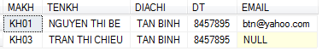
- (3.sql) List all products whose name include “GACH” and price more than 110 as following:
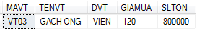
- (4.sql) List all orders with these customer, by ascending order of order date as following:
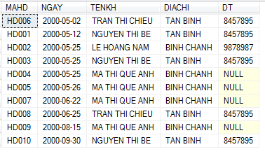
- (5.sql) List all customers that did not place order in June 2000 as following:
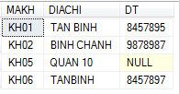
- (6.sql) List all detail orders that have GIABAN >= GIAMUA. Note that: TriGiaMua = GIAMUA * SL, TriGiaBan = GIABAN * SL.
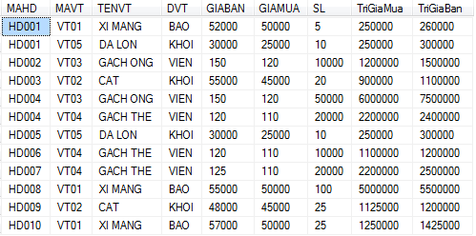
- (7.sql) List all orders which has maximum total value as following:
- (8.sql) List all products which were bought in minimum number of orders as following:
