Question 1: In this circumstance, I recommend using Agile methodology for the following reasons:

1. In term of requirements characteristics:

* Reliability:

+ The project requirements are well-defined and possible.

+ It can run while the project finished.

=> The project is expected to be highly reliable.

- Types and number of requirement:

+ In this project, there are both functional and non-functional requirements.

+ The project has a lot of functional and non-functional. The project need to device functions to each people such as:

For lecturer: Providing the ability to manage constructive questions and student group. Also, lecturers can import student lists from the FAP system or Excel files, assign presentation and review groups. In addition, they can create reports on student activities

For student: They are provided the ability to view constructive questions, give their own critical opinions on the questions. Also they can vote the presentations of others.

For academic staff: providing functions that allow statistics on class hours conducted according to the constructivist method, monitor students’ feedback.

+ Moreover, there are a lot of functions that need to create such as: allow users to log in with FU’s email account. Needing some non-functional as security, high performance, reliability,…

* Types and number of requirements defined this project is very complex and many functions.
* How often the requirements can change (Frequency of requests may change):

+ Because this is a new development system. Also, it has not had a similar system before. So that, it may be change during the development process.

+Furthermore, this is a new system for an university with the number of students enrolling has increased very rapidly, therefore, the system will change a lot to provide user’s requirements.

=> The requirements may be changed regularly in the future.

* Determination of requirements at an early stage

The requirements determinate early and have well-defined. However, this is the new system, so that, the project may encounter changes or adjustments throughout the development process to accommodate customer requirements

=> It is well-defined but not enough.

1. In term of development team:
   * Team size: Our team will include 4-6 extensive experience and skills developers.
   * Level of understanding of user requirements by the developers:

+ Our team is supported by IT department in FU. Therefore, members in IT department can help our team understand about requirements.

+ Also, other departments commit to sending employees to join the project to support out team. So, all of the requirements defined clearly above and our members can understand.

+ Moreover, all members in our team has a lot of experience and skills.

* Our team can easily understand and build an application that meets the requirements.

1. In term of user involvement

- Our team is supported by IT department in FU. Also other departments commit to sending employees to join the project to support out team.

=> The organization can provide additional resources and information when needed. The user involvement is high.

In conclusion, the software development methodology that I suggest for this situation is Agile. This is a complex project, so that our team need to device project into smaller parts to be more easily. Also, this project can be change easily due to the new system and change to provide use requirements. Our team is a professional team with the supportive of FU’s members, they can support our team to provide more resources when needed. It can assist customers in deploying the product early and collecting reviews and feedback from users to improve the product better.

The development model that I bests fits the factors I identified is Scum. Because scum model suitable for complex projects with multiple requirements and the project needs to be completely completed within 9 months, it is very suitable. When apply Scrum model, our team can early detection of errors, and customers quickly see the product and provide early feedback.

Question 2:

Our team is a professional team, and team is supported by FU’s members. The type of testing that I recommend the team to do for this project is a combination of unit testing, performance testing, system testing and security testing.

+ Unit Testing: Since requirements are clearly classified in terms of functionality -> Test individual code modules or functions to ensure that they work as expected by the requirement.

+ Performance testing: An university has a lot of students so that performance testing very important. To satisfy non-functional requirements -> Test to ensure the system performs well under the expected load of a large number of concurrent users without degrading performance and behavioral response of the user without significant latency

+ System testing: is the process of testing the entire application. This is important to ensure that the application meets all its requirements and that it is stable and reliable.

+ Security testing: The information regarding an university is very important. If the information is leaked, it is very risk. Therefore, security testing is the most important. Security testing involves evaluating a system's defenses to identify vulnerabilities and ensure that confidential data, integrity, and functionality are protected from unauthorized access, attacks, or any form of security risks.

* I believe this combination of testing will provide the team with comprehensive and thorough testing coverage for this project, helping to ensure that the application is tested properly and any bugs are found and fixed early during development. It will help ensure that the application is high quality, reliable, secure

Question 3:

* Four functional requirements:

+ Lecturer needs to provide the ability to manage constructive questions and student group.

+ Lecturer can create reports on student activities such as answering questions, evaluating presentations of other students or groups.

+ Student has ability to view constructive question, give their own critical opinions on the questions, critically evaluate the presentations of other members of groups.

+ Academic staff needs to provide functions that allow statistics on class hours conducted according to the constructivist method, and monitor students’ feedback during the learning process.

* Two non-functional requirements:

+ The system needs to ensure high performance and reliability.

+ The system need to ensue information security.

Question 6: Two user stories based on my answers in question 3:

+ As a lecturer, I want to create reports on student activities such as answering questions, evaluating presentations of other students or groups, so that I can be more easily to follow my student during leaning.

+ As a student, I want to view constructive question, give my own critical opinions on the questions, critically evaluate the presentations of other members of groups, so that I can give my opinions to others and learn from others’ answers.

Questions 7:

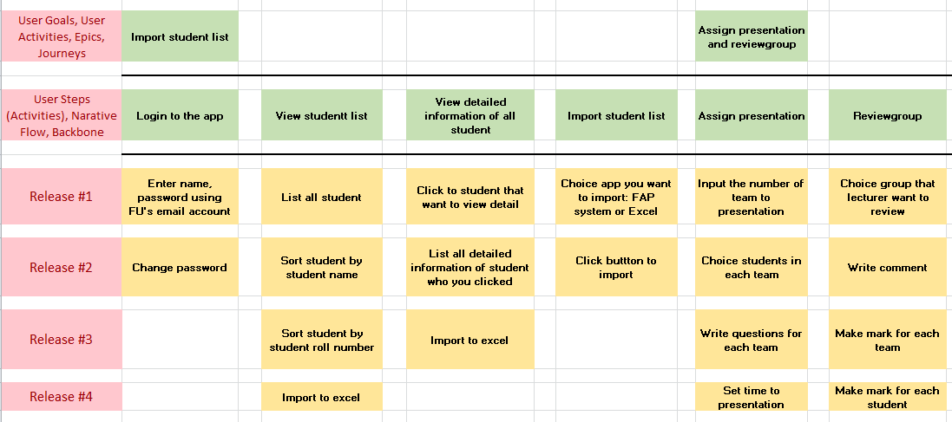

Question 4:



Question 5: 4 functional test cases is:

a. Test case 1: Load testing

- Description:  Test the system when a lot of student assign to app

- Objective: Ensure the system can handle high traffic without crashing or significant slowdown.

- Test Steps:

+ Simulate a gradual increase in the number of concurrent users.

+ Measure system response times at different load levels.

+ Monitor server resource utilization (CPU, memory, etc.).

+ Identify the maximum concurrent users the system can handle.

* Expected Result:

+ Response times should remain within acceptable thresholds.

+ Server resources should be monitored to ensure they do not reach critical levels.

+ Identify and document the maximum load the system can handle without degradation.

b. Test case 2: Navigation and User Interface Consistency

- Description: Perform user interface testing on different devices such as tablets, -desktop computers, and mobile phones.

- Objective: Confirm that the user interface is displayed correctly and is fully functional across all device types.

* Test Steps:

+ Navigate through different sections of the application.

+ Check for consistent menu structures and navigation paths.

+ Verify that UI elements (buttons, menus, headers) are uniformly styled.

+ Test the application on different devices and screen sizes.

* Expected Result:

+ Users should experience consistent navigation throughout the application.

+ UI elements should maintain a uniform style and appearance.

+ The application should be responsive and display correctly on various devices.

c. Test case 3: View constructive question

- Objective: To identify that the question input can be upload on the web

- Test Steps:

+ Enter a the comment you want to test

+ Check the comment can upload on the web correctly

+ Check the time a comment can upload on the web

+ Test a lot of other comments

* Expected Result:

+ The comment can be upload on the web correctly

+ The comment can be upload in 2s.

1. Test case 4: View list students and information of students

- Objective: To ensure information of student is correctly

- Test steps:

+ Enter the information of student

+ Check information of students who created

* Expected Result:

+ The information of student correctly

+ The information of student can be upload after input and save.