**Nguyễn Quang Minh**

**2231200136**

**Lab 1**

**Q2:**

**Problem 1:**

* **Entities, key attributes, related attributes**
* Hospital:
* Doctors: doctor code, doctor’s name, date of employment, specialty.
* Patients: patient id, patient’s name.
* Treatment details (Weak entity): doctor id, patient id, date, duration, result.
* **Relationships**
* Hospital - Doctors: Employs
* Hospital – Patients: Admits -> Doctor id (derived attribute).
* Doctors – Patients: Treats -> Treatment details (Weak entity)
* **Cardinality**
* Hospital – Doctors: One to Many
* Hospital – Patients: One to Many
* Doctors – Patients: Many to Many
* **ER model**

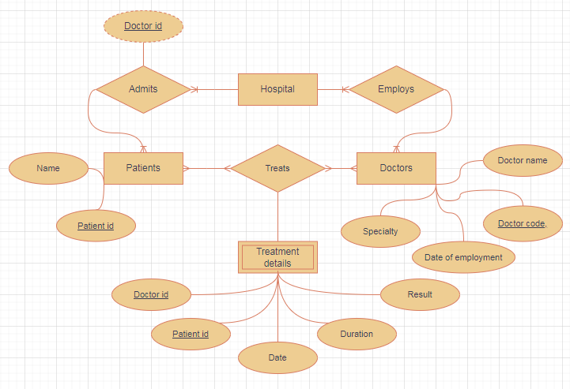

**Problem 2:**

* **Entities, key attributes, related attributes**
* University:
* Faculties: Faculty code, faculty name.
* Classes: Class code, class name, wholesale number.
* Student: Student id, full name, date of birth, gender, address, graduation point.
* Subjects: Subject code, subject name, number of credit.
* Library card: Card number, issue date, expiration date.
* Exam score (Weak entity): student id, subject id.
* **Relationships**
* University – Faculty: has
* Faculty – Classes: has
* Student – Classes: be placed
* Student – Subjects: study -> Exam score (Weak entity)
* Student – Library cards: has
* **Cardinality**
* University – Faculty: One to Many
* Faculty – Classes: One to Many
* Student – Classes: One to Many
* Student – Subjects: Many to Many
* Student – Library cards: One to One
* **ER model**

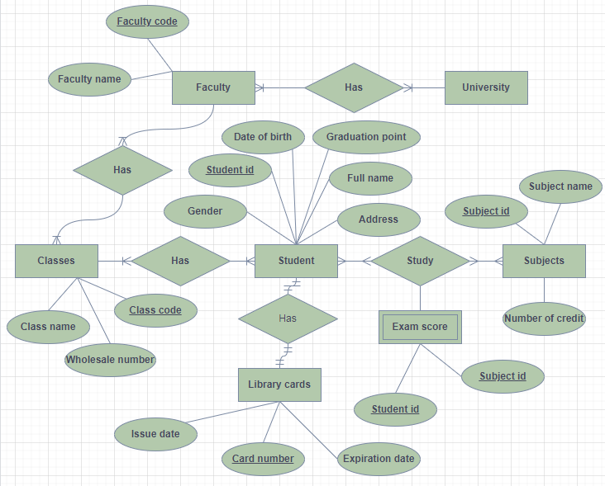

**Problem 3:**

* **Entities, key attributes, related attributes**
* Hotel
* Rooms: Room code, room name.
* Floors: Floor code, floor name.
* Guests: Id card number, full name, phone number,
* Service: Service code, service name, amount
* Invoice: Invoice code, identity card code, full name of the customer, number of staying day (Derived attribute) = departure – arrival, room id, total amount for room, service name, total amount for service, total amount (Derived attribute).
* **Relationships**
* Hotel – Rooms: has
* Floor – Rooms: has
* Guest – Rooms: stays -> Invoice (Weak entity)
* Service – Rooms: attaches
* **Cardinality**
* Hotel – Rooms: One to Many
* Floor – Rooms: One to Many
* Guest – Rooms: Many to Many
* Service – Rooms: Many to One
* **ER model**

