**FPT ACADEMY INTERNATIONAL**

**FPT – APTECH COMPUTER EDUCATION**



**College-Website**



|  |  |  |
| --- | --- | --- |
| **Center Name:** | FPT – Aptech – HCM | |
|  | Address:590 Cach Mang Thang Tam,  District 3, Ho Chi Minh City | |
| **Instructor:** | Mr. Ngo Phuoc Nguyen | |
| **Class:** | T1.2009.A0 | |
| **Group:** | 01 | |
| **Group members** | Name  Luu Thanh Sang | Student ID  Student1278914 | |
|  | Nguyen Quang Nguyen | Student1279066 | |
| **January-2022** | Luu Huy Hoang  Nguyen Duc Nam | Student1279605  Student1279119 | |

1.The user needs to go to the file ITMCollegeContext.cs and fix the connection string in line 37

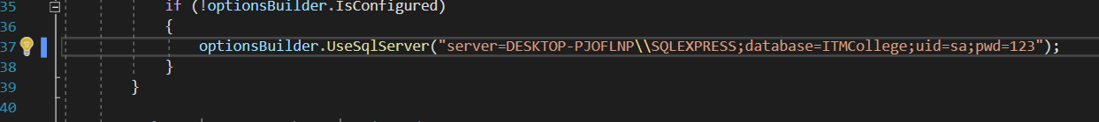

2.User can login <https://localhost:44332/Admin/Home/Login> to login Admin System

|  |  |
| --- | --- |
| Username | Password |
| admin | 123 |

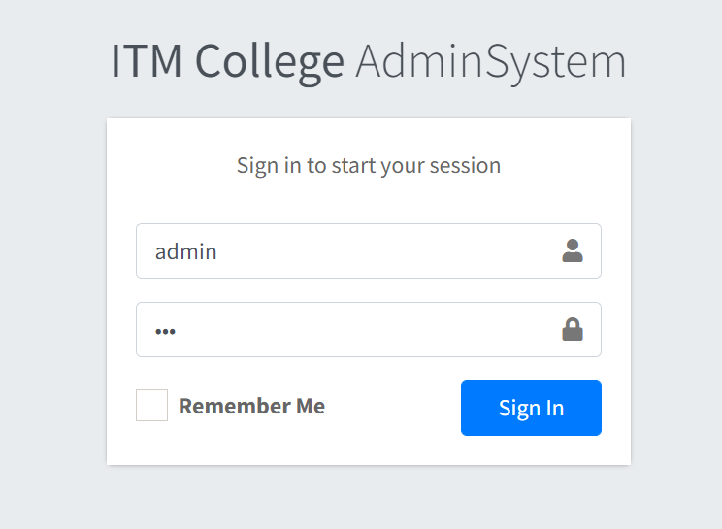

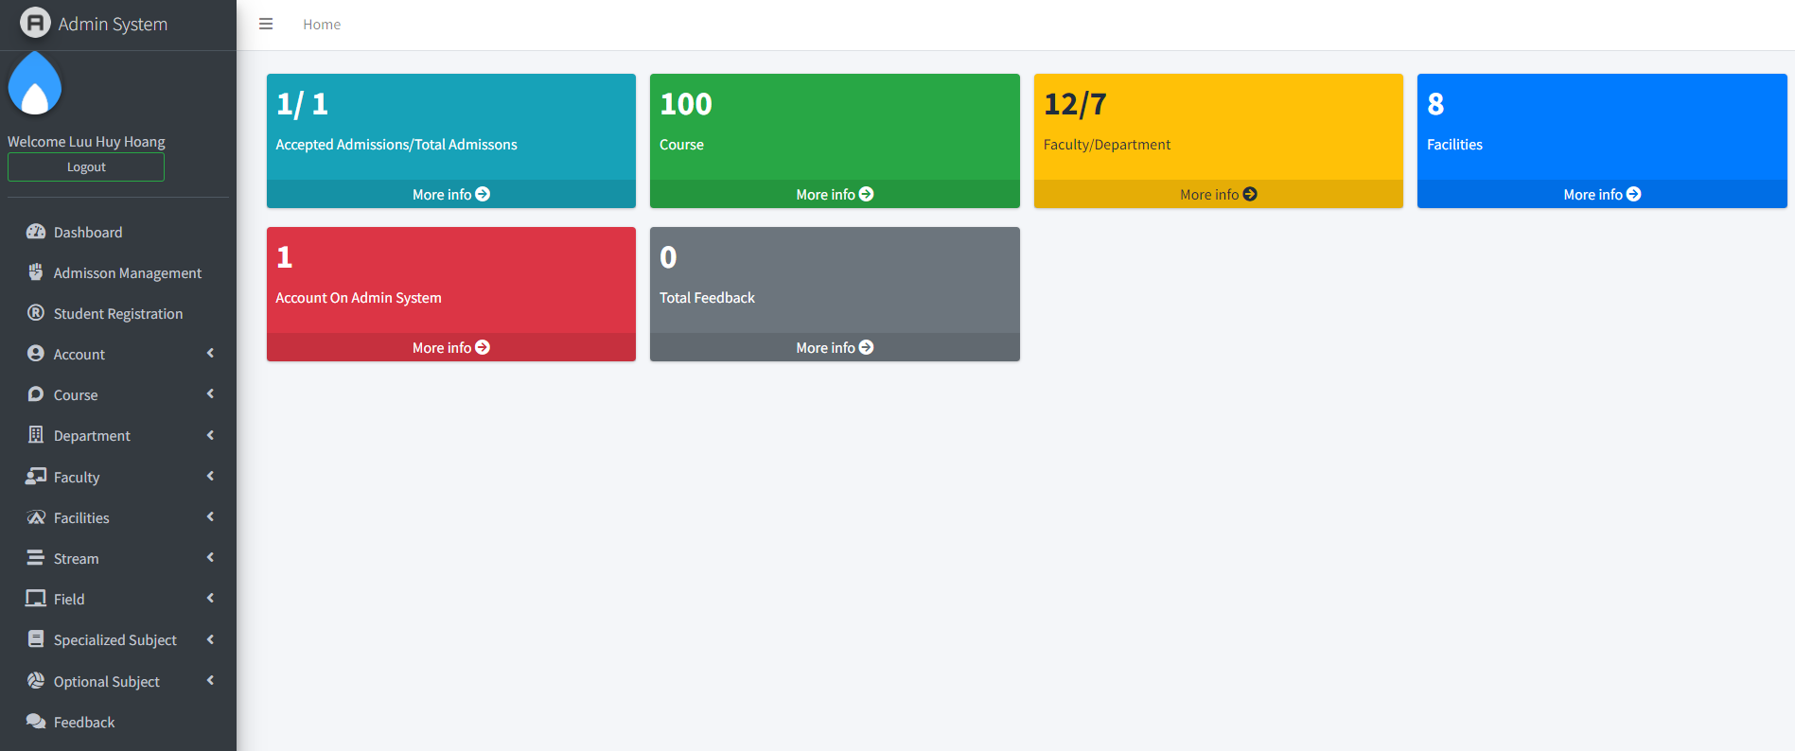

In terms of Account management, admin can view information create and edit, or delete that user. There are 2 kinds of user: admin and user

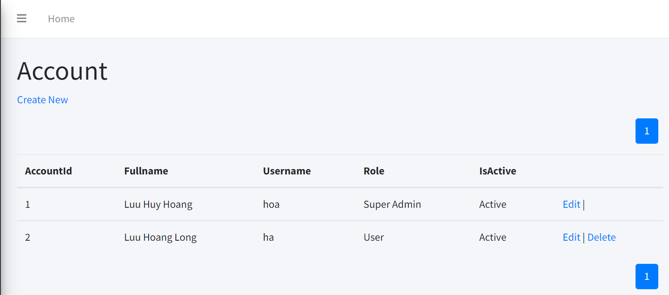

Admin can create Account

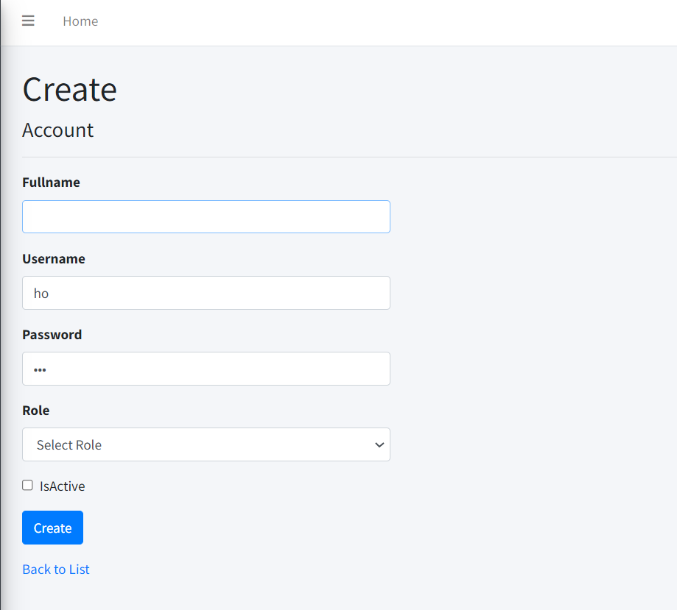

Interms of Student Registration , admin can view information and details .

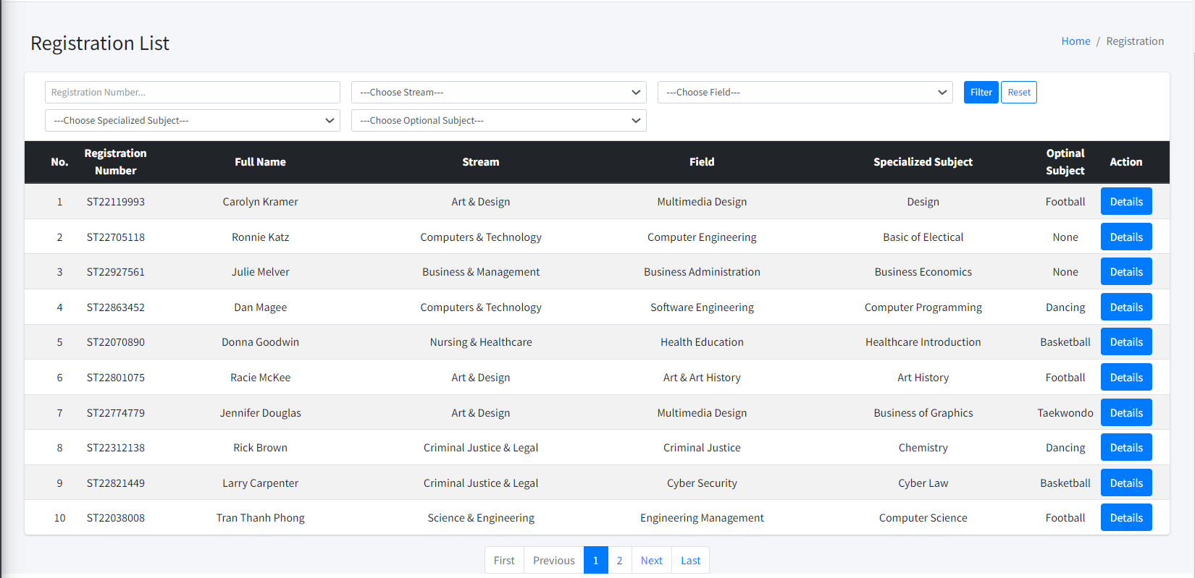

Interms Admissions Management, admin can view information and Edit .

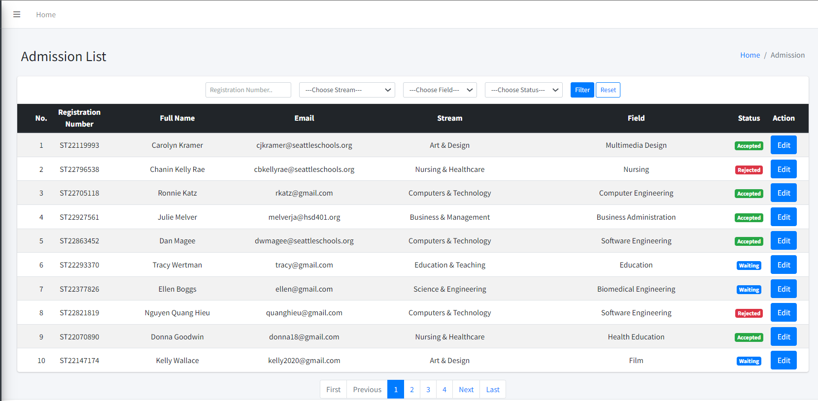

Edit Admission Post

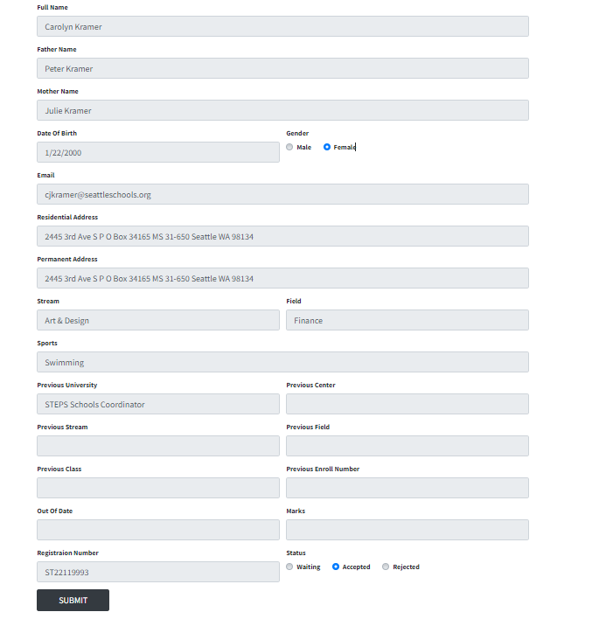

In terms of Course, admin can create, view, edit,details, delete, course.



Another that, User can View Homepage, About Us,Student,Course,Contact and without login in.



3. User can see all courses available and click on each course to see course details.



3.User can View Admissions in Student



If users want to admit, they can fill in Admissions form online or Download the form

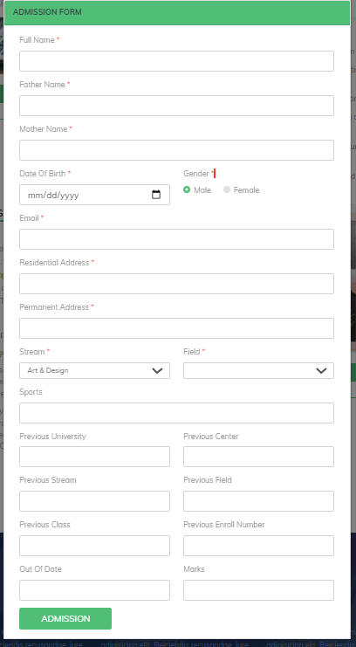

Then submit Admission User can receive a Registration Number

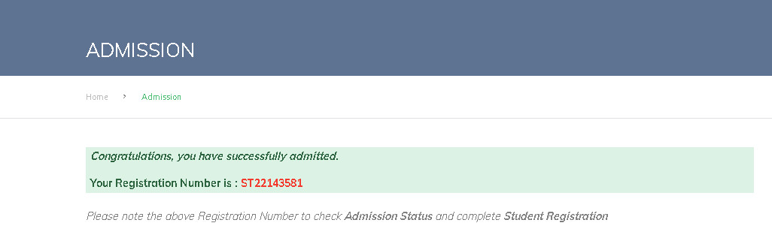

User can check Addmissions if approved or not

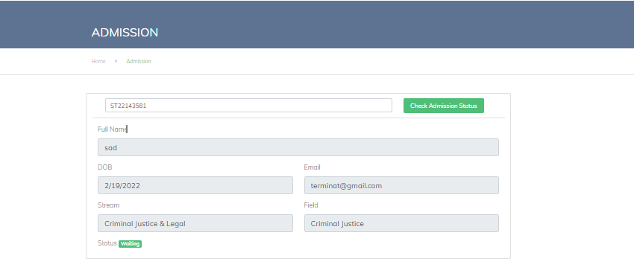

After it has been approved , User can go Student Registration in Student to Submit Registration number and Registration.

If Registration Number field is empty : 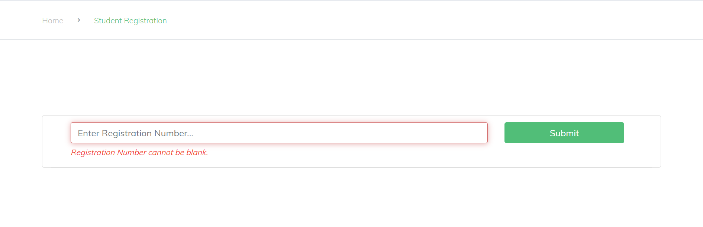

If users input an invalid Registration Number :

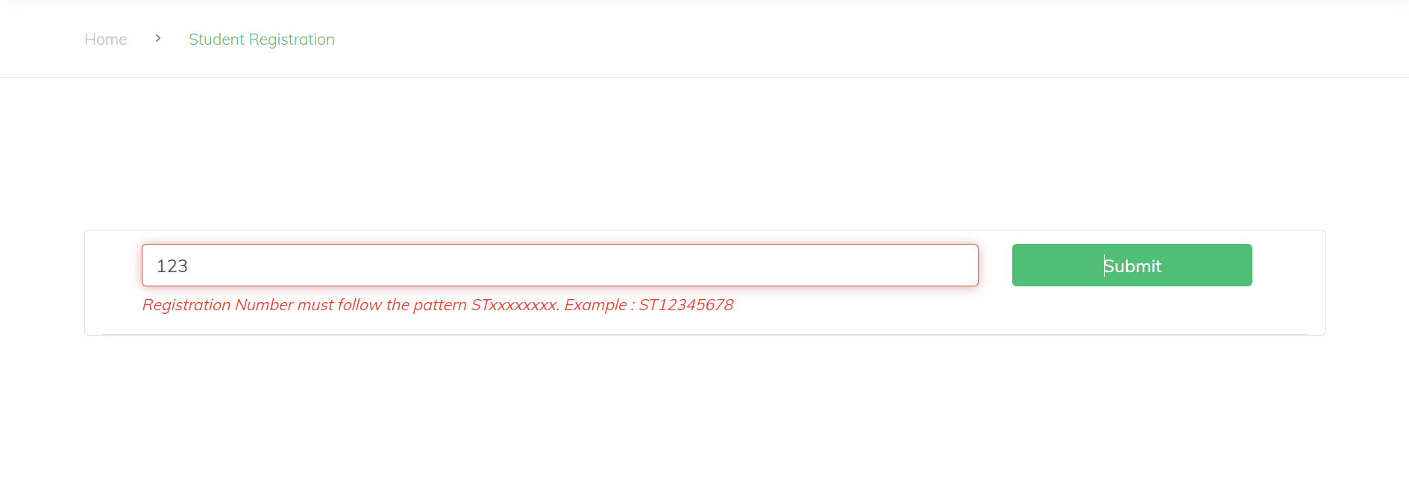

If users Admission Status is not Accepted yet  
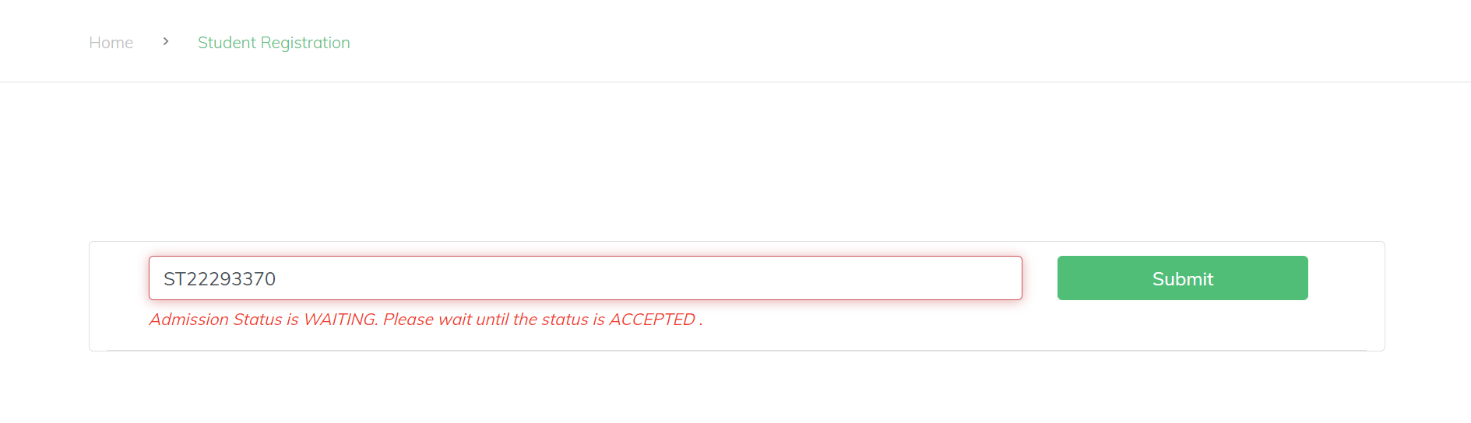

If users input a Registration Number which is registered.

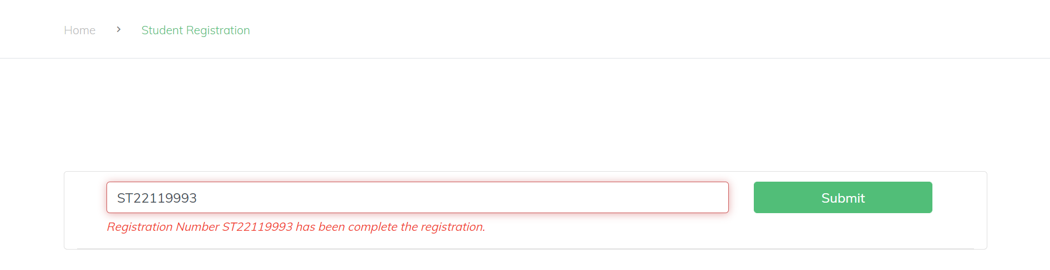

If users input a valid Registration Number, Registration Form will be display

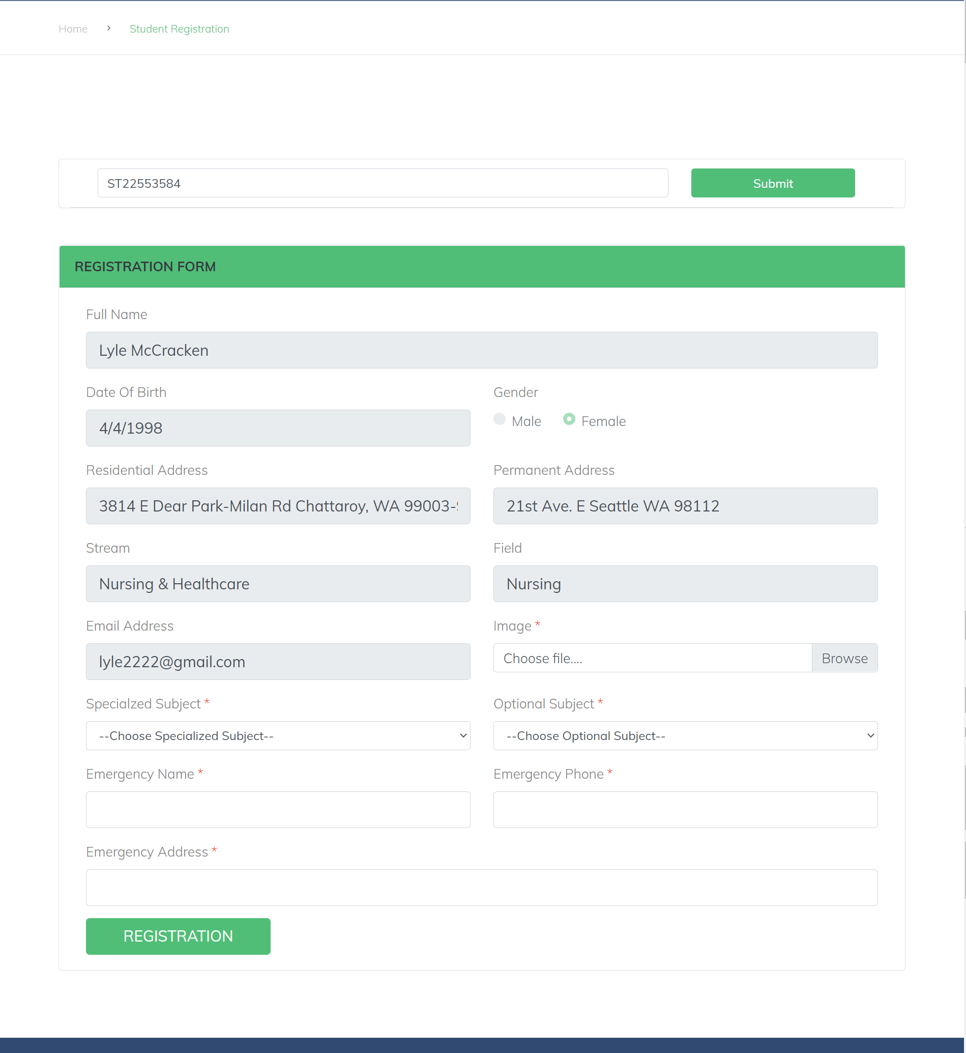

User input the require information to form and click on Registration Button to submit Registration Form.

If registration success

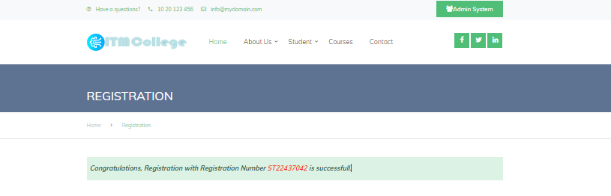

If registration failed

