**To: Professor Kearns**

**From: Anh Nguyen**

**Assignment1: Destructive Testing Analysis**

1. **Worst case number of drops:**

Algorithm:

step 1: Divide the ladder (n-rungs) into √n intervals.

step 2: From interval i = 1 to i = √n, test the highest rung in the interval until device 1 broke.

step 3: Record the rung where device 1 broke

step 4: If device 1 is broken, continue with device 2, test the last interval from the bottom going up until device 2 broke.

step 5: Subtract 1 from the last fail test rung to get the highest safe rung.

Complexity:

step 1: O(1)

step 2: There are √n intervals. In the worst case, we have to compare at most √n intervals. O(√n)

step 3: O(1)

step 4: The size of the interval is √n. In the worst case, we have to test all rung in the intervals, so there will be √n test. O(√n)

step 5: O(1)

f(n) = O(1) + O(√n) + O(1) + O(√n) + O(1)

**f(n) = O(2√n)**

**II. Graphs**

1. Graph 1 - Highest Safe Rung = 100

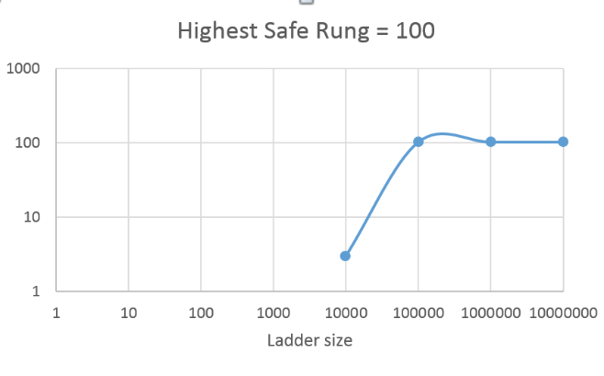

|  |  |  |  |  |
| --- | --- | --- | --- | --- |
| *Ladder size* | 10,000 | 100,000 | 1,000,000 | 10,000,000 |
| *# of drop* | 3 | 102 | 102 | 102 |

1. graph 2 - Highest Safe Rung = ladder size - 1

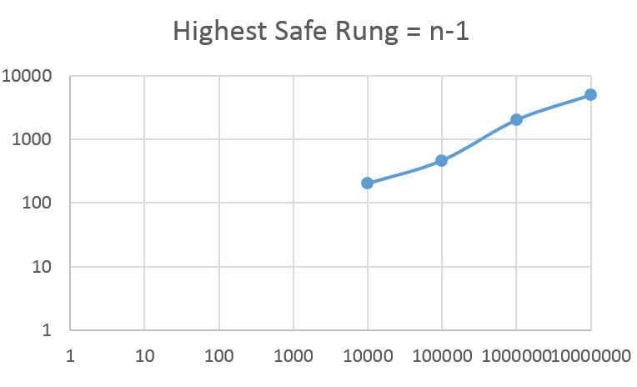

|  |  |  |  |  |
| --- | --- | --- | --- | --- |
| *Ladder size* | 10,000 | 100,000 | 1,000,000 | 10,000,000 |
| *# of drop* | 200 | 461 | 2000 | 4919 |

1. graph 3 - worst case where highest safe rung is n-1



|  |  |  |  |  |
| --- | --- | --- | --- | --- |
| *Ladder size* | 10,000 | 100,000 | 1,000,000 | 10,000,000 |
| *# of drop* | 200 | 461 | 2000 | 4919 |

**Interpreting Graph 3:**

By my analysis, the worst case is when highest safe rung is n-1. In that case, the number of drop would be 2√n. However, the actual number of drop by my simulation sometime is lower than the analysis number

|  |  |  |
| --- | --- | --- |
| Ladder size | Analysis #drop | Simulation #drop |
| 10,000 | 200 | 200 |
| 100,000 | 632 | 461 |
| 1,000,000 | 2000 | 2000 |
| 10,000,000 | 6324 | 4919 |

That is because when calculate the √n interval, I round the number √n down. That make the intervals shrink down. By shrinking down the interval, the number of drop with device2 decrease. That is why the total drop by my simulation is different with the analysis's number.