**BÀI TẬP THIẾT KẾ LUẬN LÝ SỐ 1**

**Thiết kế bộ đếm Modulo-3 Up-Down sử dụng J-K FFs, Encoding-B, Mealy**

**\*Problem:**

-Counter has two inputs: enable (C), count direction (D).

-When C = 1, the counter will count in the direction specified by D, and it will stop counting when C = 0.

-The counter will count up when D = 0 and count down when D = 1.

-The counter has one output Y which will be asserted (Y = 1) when the counter:

+Reaches 2 while counting down.

or

+Reaches 0 while counting up.

**\*\*State diagram:**

**\*\*\*State table:**

|  |  |  |  |
| --- | --- | --- | --- |
| Present state | Next state / Output | | |
| CD = 0X | CD = 10 | CD = 11 |
| **u0** | **u0/0** | **u1/0** | **d2/1** |
| **u1** | **u1/0** | **u2/0** | **d0/0** |
| **u2** | **u2/0** | **u0/1** | **d1/0** |
| **d0** | **d0/0** | **u1/0** | **d2/1** |
| **d1** | **d1/0** | **u2/0** | **d0/0** |
| **d2** | **d2/0** | **u0/1** | **d1/0** |

**\*\*\*\*State reduction:**

|  |  |  |  |  |  |  |
| --- | --- | --- | --- | --- | --- | --- |
| Output table | | | | | | |
| CD | u0 | d0 | u1 | d1 | u2 | d2 |
| 0X | 0 | 0 | 0 | 0 | 0 | 0 |
| 10 | 0 | 0 | 0 | 0 | 1 | 1 |
| 11 | 1 | 1 | 0 | 0 | 0 | 0 |

* {u0, d0}, {u1, d1}, {u2, d2} cùng output

|  |  |  |  |  |  |  |
| --- | --- | --- | --- | --- | --- | --- |
| Next state table | | | | | | |
| CD | u0 | d0 | u1 | d1 | u2 | d2 |
| 0X | u0 | d0 | u1 | d1 | u2 | d2 |
| 10 | u1 | u1 | u2 | u2 | u0 | u0 |
| 11 | d2 | d2 | d0 | d0 | d1 | d1 |

* {u0, d0}, {u1, d1}, {u2, d2} cùng next state
* {u0, d0}, {u1, d1}, {u2, d2} là các trạng thái tương đương
* Rút gọn trạng thái còn u0, u1, u2. **Đặt các trạng thái là s0, s1, s2.**

**\*\*\*\*\*State encoding ( Using encoding B (prioritized adjacency) ):**

|  |  |  |  |
| --- | --- | --- | --- |
| Present state | Next state / Output | | |
| CD = 0X | CD = 10 | CD = 11 |
| s0 | s0/0 | s1/0 | s2/1 |
| s1 | s1/0 | s2/0 | s0/0 |
| s2 | s2/0 | s0/1 | s1/0 |

**10/0**

**0X/…**

**0X/…**



**11/0**



**10/1**

**11/1**

**11/0**

**10/0**

**0X/…**



**-**Highest priority: {}

-Second priority: **{s0, s1}**; {s0, s2}; **{s1, s2}**

-Third priority: **{s0, s1}**; **{s1, s2}**

* **s0 = 00, s1 = 01, s2 = 11**

|  |  |  |  |
| --- | --- | --- | --- |
| **Q1** | **Q0** | **S1** | **S0** |
| **0** | **0** | **0** | **0** |
| **0** | **1** | **0** | **1** |
| **1** | **0** | **X** | **X** |
| **1** | **1** | **1** | **0** |

* **S1 = Q1**
* **S0 = Q1’Q0**

**\*\* Mạch Decode:**

**-shematic:**

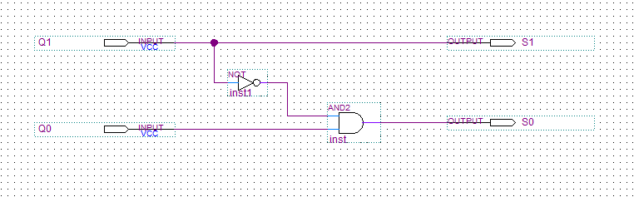

**-đóng gói:**

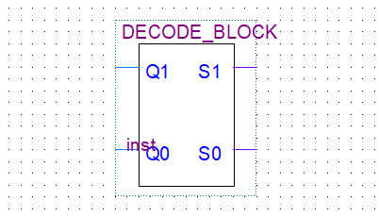

**10/0**

**0X/…**

**0X/…**



**11/0**



**10/1**

**11/1**

**11/0**

**10/0**

**0X/…**



**\*\*\*\*\*\*Choice of memory elements: J-k FFs:**

|  |  |  |  |  |
| --- | --- | --- | --- | --- |
| **Y** | | | | |
| **Q1Q0\CD** | **00** | **01** | **11** | **10** |
| **00** | **0** | **0** | **1** | **0** |
| **01** | **0** | **0** | **0** | **0** |
| **11** | **0** | **0** | **0** | **1** |
| **10** | **X** | **X** | **X** | **X** |

* Diagram, schematic

  Description automatically generated**Y = CDQ0’ + CD’Q1**

**-đóng gói:**

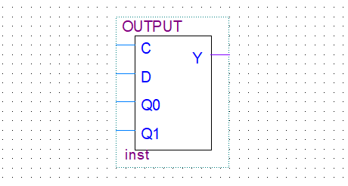

|  |  |  |  |  |
| --- | --- | --- | --- | --- |
| **Q0(next)** | | | | |
| **Q1Q0\CD** | **00** | **01** | **11** | **10** |
| **00** | **0** | **0** | **1** | **1** |
| **01** | **1** | **1** | **0** | **1** |
| **11** | **1** | **1** | **1** | **0** |
| **10** | **X** | **X** | **X** | **X** |

* **Q0(next) = Q0C’ + Q1D + Q0’C + Q1’CD’**

|  |  |  |  |  |
| --- | --- | --- | --- | --- |
| **Q1(next)** | | | | |
| **Q1Q0\CD** | **00** | **01** | **11** | **10** |
| **00** | **0** | **0** | **1** | **0** |
| **01** | **0** | **0** | **0** | **1** |
| **11** | **1** | **1** | **0** | **0** |
| **10** | **X** | **X** | **X** | **X** |

* **Q1(next) = Q1C’ + Q0’CD + Q1’Q0CD’**

|  |  |  |  |  |
| --- | --- | --- | --- | --- |
| **Q1Q0(next)** | | | | |
| **Q1Q0\CD** | **00** | **01** | **11** | **10** |
| **00** | **00** | **00** | **11** | **01** |
| **01** | **01** | **01** | **00** | **11** |
| **11** | **11** | **11** | **01** | **00** |
| **10** | **XX** | **XX** | **XX** | **XX** |

|  |  |  |  |  |
| --- | --- | --- | --- | --- |
| **J1-K1 J0-K0** | | | | |
| **Q1Q0\CD** | **00** | **01** | **11** | **10** |
| **00** | **0-X 0-X** | **0-X 0-X** | **1-X 1-X** | **0-X 1-X** |
| **01** | **0-X X-0** | **0-X X-0** | **0-X X-1** | **1-X X-0** |
| **11** | **X-0 X-0** | **X-0 X-0** | **X-1 X-0** | **X-1 X-1** |
| **10** | **X-X X-X** | **X-X X-X** | **X-X X-X** | **X-X X-X** |

* **K0 = Q1’CD + Q1CD’**
* **J0 = C**
* **K1 = C**
* **J1 = Q0’CD + Q0CD’**

**\*\* Mạch tạo ngõ vào FFs:**

**-Đóng gói:**

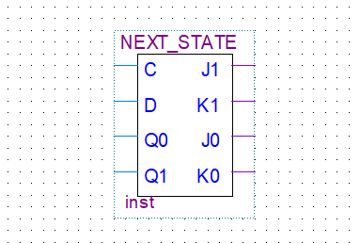

**\*\* Tổng hợp toàn hệ thống:**

**-Đóng gói:**

**\*\* Waveform:**

