

Requirements Specification Document

FUNiX Passport

Revision History

Date | Version | Description | Author
18/10/2023 | v1.0 | Funix Passport | Hoang Minh Nguyen

Table of Contents
Project overview 4
Project summary 4
Project scope 4
Project Requirements and Specifications 4
Functional Requirements 4
Non-functional requirements 4
System Security 5
Availability and responsiveness 5
Efficiency 5
Software Specifications 5
Software architecture and design 5
Software architecture 5
Usecase 6
Usecase of User 7
Usecase of Translator 8
Usecase of Reviewer 8
Usecase of Administrator 8
Usecase of the System 8
Class Diagram 9
Sequence Diagram 10
Activity Diagram 10

Specification document

Project overview

Project summary
- System: Funix Passport
- The objective of the FUNiX Passport project is to develop a system that facilitates students' access to Vietnamese documents, including video subtitles and document pages. The system aims to enhance students' comprehension of educational materials without relying solely on existing English auto-subtitles.

Project scope
- The project will provide user-friendly subtitles for course learning materials, translated by academic professionals from Funix.
- The system serves a heterogeneous user base consisting of learners engaged in Funix's online courses, translators contributing to the translation process, administrators overseeing system management, and subtitle reviewers responsible for ensuring quality and accuracy of subtitles.
- The system will be deployed as a Google Chrome browser extension.

Project Requirements and Specifications

Functional Requirements
- Backend:
- Facilitate the seamless submission of corresponding subtitle files by translators for each video hosted on MOOC sites, as well as the upload of translated documents. This functionality empowers both translators and administrators to efficiently oversee and maintain translation and subtitle-related data.
- A comprehensive database encompasses a curated collection of subjects, video links, and accompanying visit metrics for each video.

- Translator:
- Upload the translated Vietnamese subtitle file:
- Access the upload screen and provide necessary information such as Video Name, Video URL, Course ID, and Video ID.
- Attach the translated subtitle file.
- Upon clicking submit, the application will facilitate the upload and storage of data in the database.

- Upload translated Document file in Vietnamese:
- Input the Translation Name and URL of the Document.
- Attach the translated Document file.

- View the list of uploaded translation files:
- Two Dashboards will be available, one displaying subtitle translations and the other displaying Document translations.

- Download the translated file:
- By clicking on the link provided on the Dashboard, users can download the translation data, including the Subtitle file or Document file.

- Download the translated file:
- By clicking on the link provided on the Dashboard, users can download the translation data, including the Subtitle file or Document file.

- Search for translations using filters:
- Have the ability to search for translations using different filters such as Translation name, URL, Translator, Course ID, and Video ID.

- Delete subtitle files or documents:
- Can choose to delete that particular translation.

- Edit information:
- Can opt to make edits to the information associated with that translation.
- Two types of editing are available: Edit the metadata of the translation file or Re-upload a different translation file in place of the original.

- Administrator:
- Primarily responsible for user account management.
- Deletion of user accounts.
- Granting permissions to a user (transferring the role from User to Translator).
- Revoking permissions from a user (reverting the role from Translator to User).

- Reviewer
- View the list of uploaded translation files:
- Two Dashboards will be available, one displaying subtitle translations and the other displaying Document translations.
- Search for translations using filters:
- Have the ability to search for translations using different filters such as Translation name, URL, Translator, Course ID, and Video ID.
- Entrusted with the responsibility of meticulously assessing the precision of the Translator's video translations and providing constructive feedback.
- Download the translated file:
- By clicking on the link provided on the Dashboard, users can download the translation data, including the Subtitle file or Document file.

- Extension
- Establishing communication with the Backend system, enabling the retrieval of translation data and facilitating the display of said translated content for students' utilization.
- Extract the URL, enabling the retrieval of pertinent information such as video_ID or course_ID.
- Initiate a request to the Backend, enclosing the extracted data:
- If the website originates from MOOC sources, the Extension will submit the course_ID and video_ID to procure the corresponding subtitles.
- In all other cases, the Extension will seek to locate and translate the Document by transmitting the entire URL to the Backend. .
- Once the Extension receives the returned data from the Backend, it will display a popup to prompt the user to decide whether they wish to utilize the translation or not. If the user consents to the translation, the translated content will be presented to the user.

Non-functional requirements
- Backend
- Execute database operations to facilitate the management of translation files.
- Incorporate a dedicated Database designed to store comprehensive Metadata for each translation, encompassing both the data contributed by the Translator and the data generated internally by itself.

- Regarding the translation of Videos, the Database will store the subsequent data:
- ID (auto-generated): The unique identifier for the translation.
- Translator (auto-generated): The name of the translator who uploaded the translation.
- UploadedDate (auto-generated): The timestamp indicating when the translation was uploaded.
- Name: The designated name for the translation.
- URL: The web address associated with the translation, which can refer to a document website or a video link.
- Video ID: The specific identification number assigned to the corresponding video.
- Course ID: The identifier for the video source in the Vietnamese language.
- Vietnamese Subtitle URL: The file path leading to the translated Vietnamese subtitle file.
- English Subtitle URL (Optional): The file path leading to the translated English subtitle file, if avail

- For Document translations, the database will include the following fields:
- ID (auto-generated): The unique identifier for the translation.
- Translator (auto-generated): The name of the translator who uploaded the translation.
- UploadedDate (auto-generated): The timestamp indicating when the translation was uploaded.
- Name: The designated name for the translation.
- URL: The web address associated with the translation, which can refer to a document website or a video link.
- Document URL: The file path leading to the translated Document file.

System Security
- Stringent security measures are imperative to ensure the robust protection of data, which is securely stored within a fortified Database.
- The implementation requires the utilization of API Keys or Tokens to accurately authenticate and authorize access to, as well as modification of, data residing within the Database.

Availability and responsiveness
- The system's user interface is intentionally designed with a user-friendly approach, ensuring accessibility and ease of comprehension for individuals with varying levels of technological proficiency.
- The development focus of the Extension primarily revolves around its integration within the Google Chrome browser environment, strategically devised to meet users' demand seamlessly and promptly whenever necessitated.

Efficiency
- The system is expected to exhibit consistent and reliable performance, ensuring promptness in displaying translations upon student access to the website, with an upper limit of 1 second.
- The processing speed for submitting and executing Translator operations should be swift, with an average response time for each operation not exceeding 0.5 seconds.

Software Specifications
- Document Access:
- The system should support different file formats such as PDF, DOC, PPT, and video subtitles in SRT format.
- The system's user interface is intentionally designed with a user-friendly approach, ensuring accessibility and ease of comprehension for individuals with varying levels of technological proficiency.

- Document Translation:
- The translation should be performed accurately and efficiently to minimize delays or errors.

- Subtitle Synchronization:
- The system is expected to exhibit consistent and reliable performance, ensuring promptness in displaying translations upon student access to the website, with an upper limit of 1 second.
- The processing speed for submitting and executing Translator operations should be swift, with an average response time for each operation not exceeding 0.5 seconds.

- Subtitle Customization:
- Students should be able to toggle the display of subtitles on/off

- User Management:
- The system should provide user authentication and account creation for students.
- Each student should have a personal profile to track their document history, preferred settings, and translation preferences.

- Performance and Reliability:
- The system should be responsive and provide fast document loading times, ensuring smooth access to educational materials.
- The system should be reliable, minimizing downtime and errors to avoid disrupting students' learning experience.

- Security:
- Stringent security measures are imperative to ensure the robust protection of data, which is securely stored within a fortified Database.
- The implementation requires the utilization of API Keys or Tokens to accurately authenticate and authorize access to, as well as modification of, data reflected within the Database.

- Scalability:
- The system should be designed to handle a large number of students and a growing library of documents.
- It should be capable of scaling up its resources to accommodate increased usage without compromising performance.

- Compatibility:
- It should work on popular web browsers to ensure widespread accessibility.

- Support and Maintenance:
- The system should provide a support mechanism for students to report issues or seek assistance.
- Regular maintenance and updates should be performed to fix bugs, add new features, and improve system performance.

Software architecture and design

Software architecture
- Client-Server architecture

- Divide the system into two main components: the Client, which is the Google Chrome browser extension, and the Server, which hosts the application logic, database, and handles requests and responses.

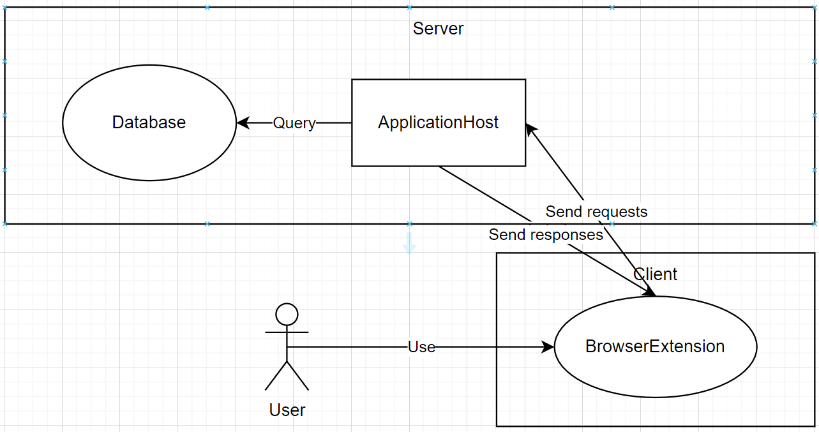

- Advantages of Client-Server Architecture for FUNiX Passport:
- Scalability: The client-server architecture allows for scalability by separating the processing and data storage on the server-side, making it easier to handle a large number of users and documents.
- Security: By centralizing data and logic on the server, it becomes easier to implement robust security measures, ensuring the privacy and protection of user data and documents.
- Performance: The server can perform computationally intensive tasks like document translation, subtitle synchronization, and processing video files, allowing the client-side to focus on display and user interaction.
- Compatibility: The client-server architecture is suitable for a diverse user base as it supports different browsers, making it accessible from various platforms.

Usecase
- Actors:
- User: Solely equipped with the ability to login and logout from the application.

- Translator: Linguistic experts are capable of executing the following operations within the application:
- Upload the translated Vietnamese subtitle file
- Upload translated Document file in Vietnamese
- View the list of uploaded translation files
- Download the translated file
- Search for translations using filters
- Delete subtitle files or documents
- Edit information

- Administrator: Primarily entrusted with the responsibility of overseeing user account management:
- Deletion of user accounts
- Granting permissions to a user (transferring the role from User to Translator)
- Revoking permissions from a user (reverting the role from Translator to User)
- Reviewer:
- Entrusted with the responsibility of meticulously assessing the precision of the Translator's video translations and providing constructive feedback
- View the list of uploaded translation files
- Search for translations using filters
- Download the translated file

Usecase of User
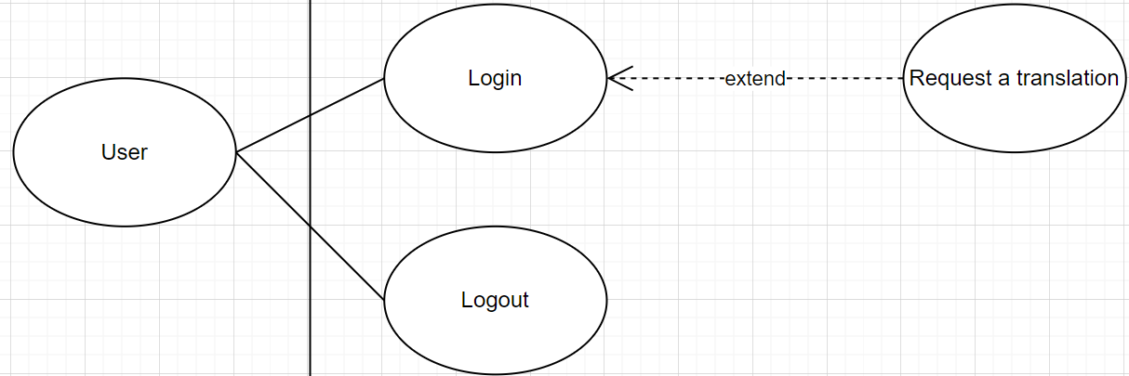

Use Case Name | Login
Description | Users can log in to the system and use the functions therein.
Condition | User has not logged into the system
Mainstream | 1. User accesses the management website. Click on "Login"  2. The system displays the Login Form.  3. User enters login information.  4. If the login information is correct, update the information into the system.  5. User request the transcription
Secondary stream | In step 4, if the login information is incorrect, a notification will be displayed to the user.

Use Case Name | Logout
Description | Users can log out after using the system.
Condition | User has logged into the system
Mainstream | 1. User accesses the control panel. Click on "Log out"  2. The system logs out and displays the Login Form.
Secondary stream

Usecase of Translator
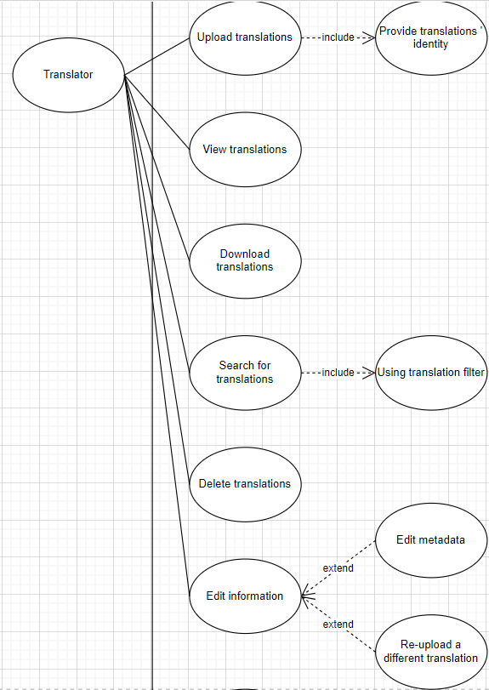

Use Case Name | Upload translations
Description | Translator can attach the translated subtitle file or document to the system
Condition | Translator has logged into the system
Mainstream | 1. Translator accesses the management page. Click on “Translations” in the control panel  2. Translator click on “Upload translation”  3. The system displays two options: “Upload subtitle” and “Upload document”  4. Translator choose “Upload subtitle”  5. System allows translator to upload subtitle and displays status (Successful, Error, Uploading)
Secondary stream | - In step 4, if the translator choose “Upload document”  5. System allows translator to upload document and display status (Successful, Error, Uploading)

Use Case Name | View translations
Description | Translator can view subtitle translations or document translations
Condition | Translator has logged into the system
Mainstream | 1. Translator accesses the management page. Click on “Translations” in the control panel  2. Translator clicks on “View translations”  3. The system displays two options: “View subtitles” and “View documents”  4. Translator chooses “View subtitles”  5. System displays a list of subtitles  6. Translator clicks on one of the subtitles  7. System displays that subtitle
Secondary stream | - In step 4, if the translator chooses “View documents”  5. System displays a list of documents  6. Translator clicks on one of the documents  7. System displays that documents

Use Case Name | Download translations
Description | Translator can download subtitle translation or document translation
Condition | Translator has logged into the system
Mainstream | 1. Translator accesses the management page. Click on “Translations” in the control panel  2. Translator click on “Download translation”  3. The system displays two options: “Download subtitle” and “Download document”  4. Translator choose “Download subtitles”  5. System displays a list of subtitles  6. Translator clicks on one of the subtitles  7. System allows translator to download that subtitle and displays status (Successful, Error, Downloading)
Secondary stream | - In step 4, if the translator choose “Download documents”  5. System displays a list of documents  6. Translator clicks on one of the documents  7. System allows translator to download that document and displays status (Successful, Error, Downloading)

Use Case Name | Search for translations
Description | Search for translation by filtering translation’s identity
Condition | Translator has logged into the system
Mainstream | 1. Translator accesses the management page. Click on “Translations” in the control panel  2. Translator clicks on “View translations”  3. The system displays two options: “View subtitles” and “View documents”  4. Translator chooses “View subtitles”  5. System displays a list of subtitles  6. Translator clicks on “Search” and System displays filters  7. Translator enters Video Name, Video URL, Course ID, Video ID  8. System displays the found video. Display “Not found” if there is no corresponding video
Secondary stream | - In step 4, if the translator chooses “View documents”  5. System displays a list of documents  6. Translator clicks on “Search” and System displays filters  7. Translator enters Document Name, Document URL  8. System displays the found document . Display “Not found” if there is no corresponding document

Use Case Name | Delete translations
Description | Translator can delete subtitle files or documents
Condition | Translator has logged into the system
Mainstream | 1. Translator accesses the management page. Click on “Translations” in the control panel  2. Translator clicks on “View translations”  3. The system displays two options: “View subtitles” and “View documents”  4. Translator chooses “View subtitles”  5. System displays a list of subtitles  6. Translator searches for a existing subtitle using filters  7. System displays that subtitle  8. Translator clicks on “Delete”  9. System deletes the subtitle and displays status (Successful, Error, Deleting)
Secondary stream | - In step 4, if the translator choose “View documents”  5. System displays a list of documents  6. Translator searches for a existing document using filters  7. System displays that document  8. Translator clicks on “Delete”  9. System deletes the document and displays status (Successful, Error, Deleting)

Use Case Name | Edit information
Description | Translator can edit information of the translation
Condition | Translator has logged into the system
Mainstream | 1. Translator accesses the management page. Click on “Translations” in the control panel  2. Translator clicks on “View translations”  3. Translator searches for a translation using filters. It can be a subtitle or a document  4. System displays the translation  5. Translator clicks on “Info” and system displays the metadata of the translation  6. Translator clicks on “Edit” and system displays two options: “Edit metadata” and “Re-upload a different translation”  7. Translator chooses “Edit metadata” and system allows translator to edit it  8. After editing, translator clicks on “Save”  9. System saves the changes and displays status (Changes saved successfully or Changes saved unsuccessfully)
Secondary stream | - In step 7, if the translator chooses “Re-upload a different translation”.  8. System allows translator to upload translation and display status (Successful, Error, Uploading)

Usecase of Reviewer
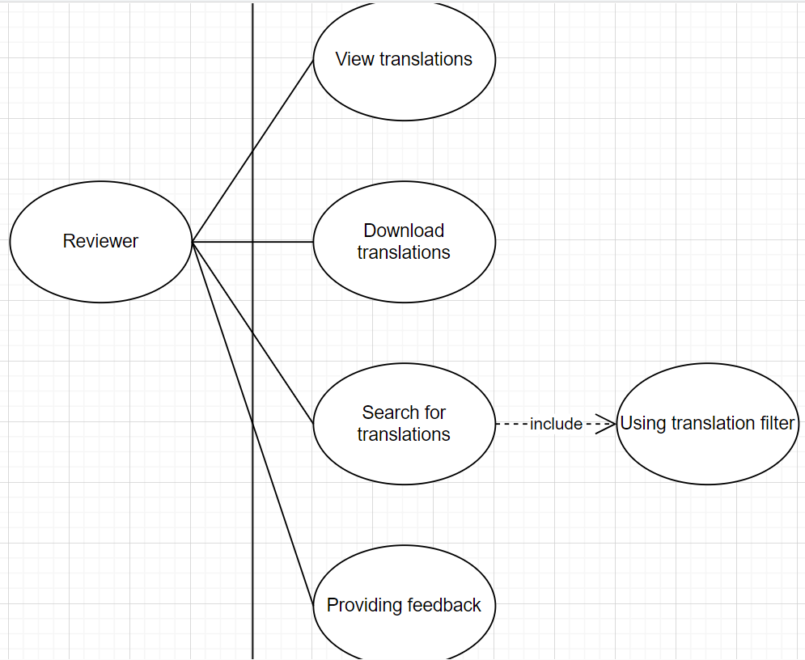

Use Case Name | View translations
Description | Reviewer can view subtitle translations or document translations
Condition | Reviewer has logged into the system
Mainstream | 1. Reviewer accesses the management page. Click on “Translations” in the control panel  2. Reviewer clicks on “View translations”  3. The system displays two options: “View subtitles” and “View documents”  4. Reviewer chooses “View subtitles”  5. System displays a list of subtitles  6. Reviewer clicks on one of the subtitles  7. System displays that subtitle
Secondary stream | - In step 4, if the reviewer chooses “View documents”  5. System displays a list of documents  6. Reviewer clicks on one of the documents  7. System displays that documents

Use Case Name | Download translations
Description | Reviewer can download subtitle translation or document translation
Condition | Reviewer has logged into the system
Mainstream | 1. Reviewer accesses the management page. Click on “Translations” in the control panel  2. Reviewer click on “Download translation”  3. The system displays two options: “Download subtitle” and “Download document”  4. Reviewer choose “Download subtitles”  5. System displays a list of subtitles  6. Reviewer clicks on one of the subtitles  7. System allows reviewer to download that subtitle and displays status (Successful, Error, Downloading)
Secondary stream | - In step 4, if the reviewer choose “Download documents”  5. System displays a list of documents  6. Reviewer clicks on one of the documents  7. System allows reviewer to download that document and displays status (Successful, Error, Downloading)

Use Case Name | Search for translations
Description | Search for translation by filtering translation’s identity
Condition | Reviewer has logged into the system
Mainstream | 1. Reviewer accesses the management page. Click on “Translations” in the control panel  2. Reviewer clicks on “View translations”  3. The system displays two options: “View subtitles” and “View documents”  4. Reviewer chooses “View subtitles”  5. System displays a list of subtitles  6. Reviewer clicks on “Search” and System displays filters  7. Reviewer enters Video Name, Video URL, Course ID, Video ID  8. System displays the found video. Display “Not found” if there is no corresponding video
Secondary stream | - In step 4, if the reviewer chooses “View documents”  5. System displays a list of documents  6. Reviewer clicks on “Search” and System displays filters  7. Reviewer enters Document Name, Document URL  8. System displays the found document . Display “Not found” if there is no corresponding document

Use Case Name | Providing feedback
Description | Reviewer can providing constructive feedback for the translator about the transcription
Condition | Reviewer has logged into the system
Mainstream | 1. Reviewer accesses the management page. Click on “Translations” in the control panel  2. Reviewer clicks on “View translations”  3. Reviewer searches for a translation using filters. It can be a subtitle or a document  4. System displays the translation  5. Reviewer clicks on “Send feedback” and system allows reviewer to enter feedback  6. After the feedback was sent, system displays status (Feedback sent successfully, Feedback sent unsuccessfully)
Secondary stream

Usecase of Administrator
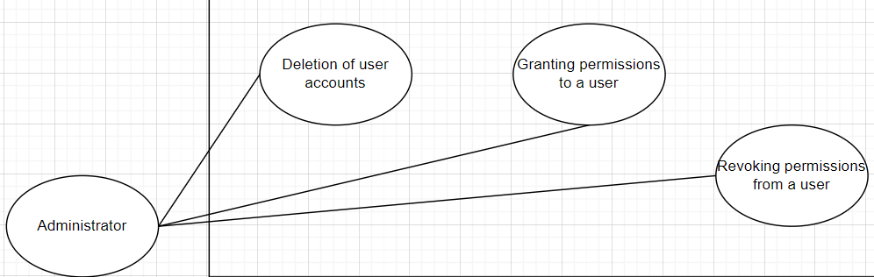

Use Case Name | Deletion of user accounts
Description | Administrator can delete user accounts
Condition | Administrator has logged into the system
Mainstream | 1. Administrator accesses the management page. Click on “Manage accounts” in the control panel  2. System displays account list  3. Administrator clicks on one of the accounts  4. System displays three options: “Delete”, “Make Translator”, “Make User”  5. Administrator clicks on “Delete”  6. System deletes the account and displays status (Changes saved successfully or Changes saved unsuccessfully)
Secondary stream

Use Case Name | Granting permissions to a user
Description | Administrator can change role from User to Translator
Condition | Administrator has logged into the system
Mainstream | 1. Administrator accesses the management page. Click on “Manage accounts” in the control panel  2. System displays account list  3. Administrator clicks on one of the accounts  4. System displays three options: “Delete”, “Make Translator”, “Make User”  5. Administrator clicks on “Make Translator”  6. System grants permissions to the account and displays status (Changes saved successfully or Changes saved unsuccessfully)
Secondary stream

Use Case Name | Revoking permissions from a user
Description | Administrator can change role from Translator to User
Condition | Administrator has logged into the system
Mainstream | 1. Administrator accesses the management page. Click on “Manage accounts” in the control panel  2. System displays account list  3. Administrator clicks on one of the accounts  4. System displays three options: “Delete”, “Make Translator”, “Make User”  5. Administrator clicks on “Make User”  6. System revokes permissions from the account and displays status (Changes saved successfully or Changes saved unsuccessfully)
Secondary stream

Usecase of the System
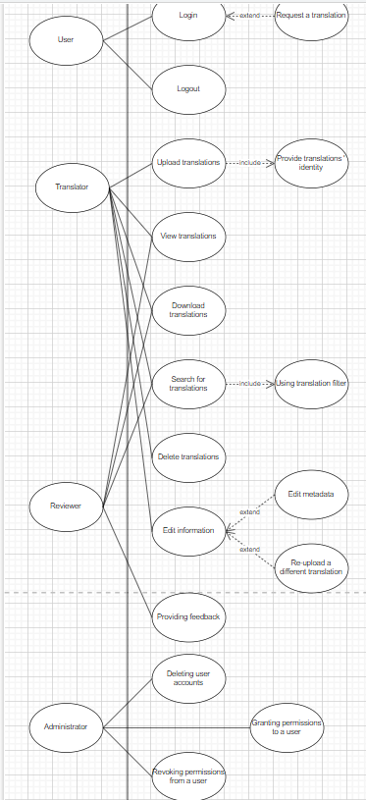

Class Diagram
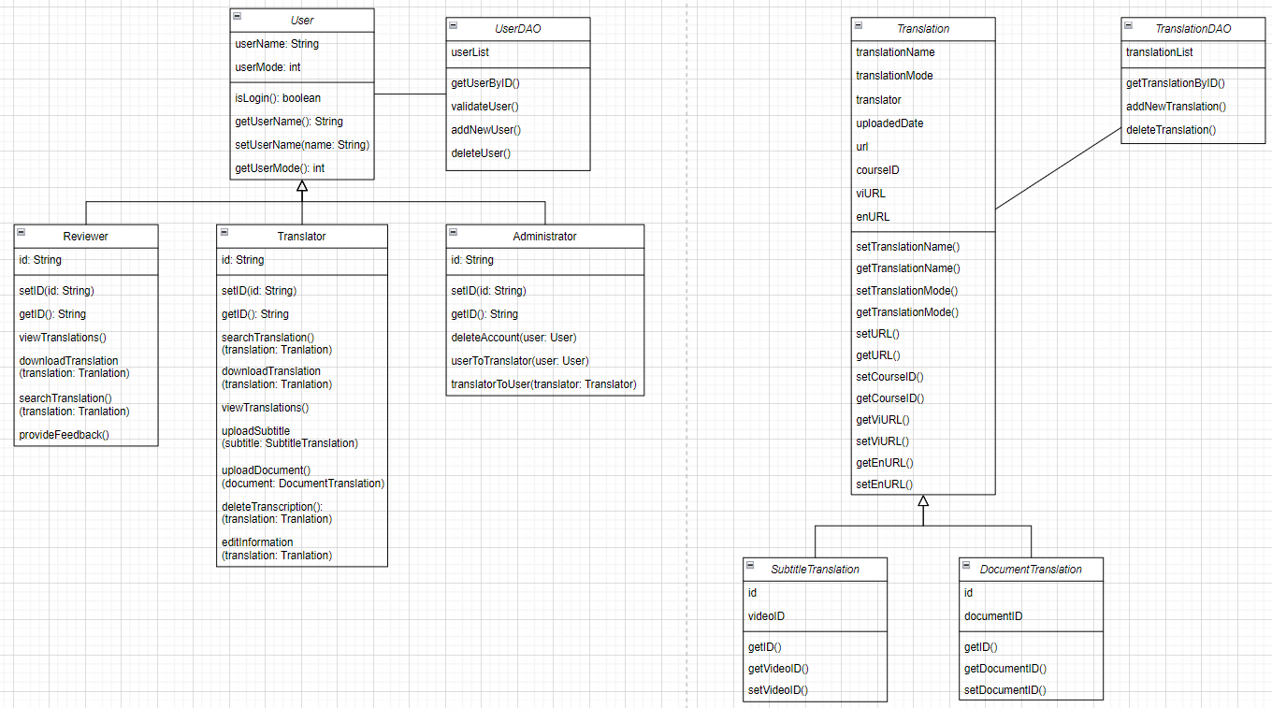

Sequence Diagram
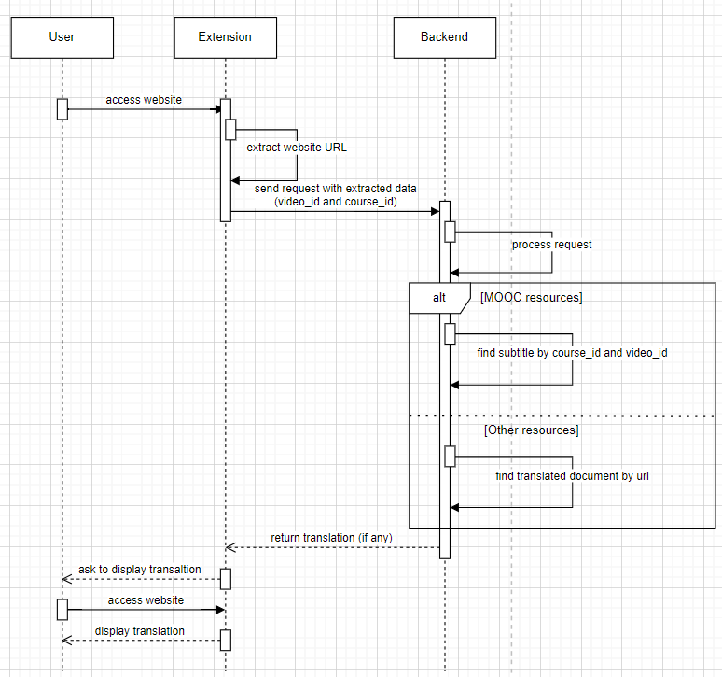

Activity Diagram
