|  |  |  |
| --- | --- | --- |
| A1 | A2 | A3 |
| 2 | **16** | **102** |
| 3 | **16** | **103** |

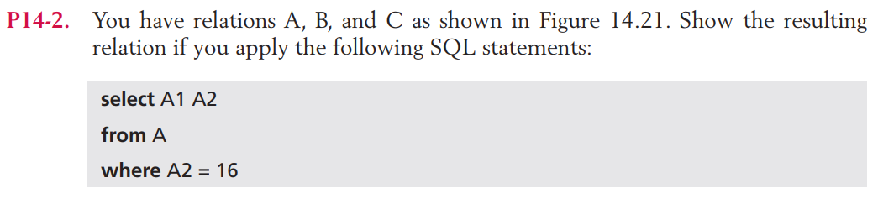

|  |  |
| --- | --- |
| A1 | A2 |
| 2 | **16** |
| 3 | **16** |

|  |
| --- |
| A3 |
| 100 |
| 102 |
| 103 |
| 104 |

|  |
| --- |
| B1 |
| 29 |

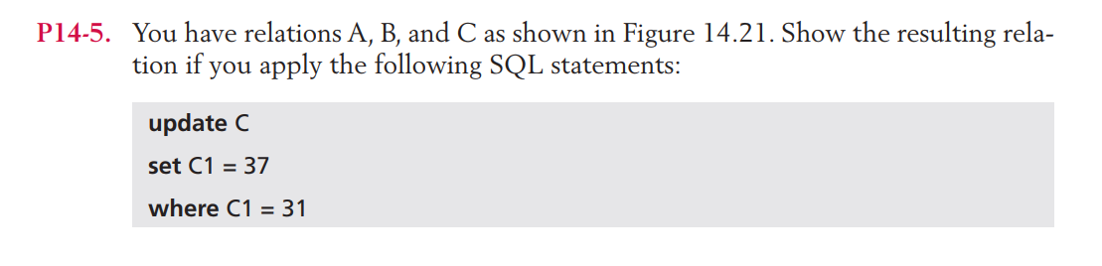

|  |  |  |
| --- | --- | --- |
| C1 | C2 | C3 |
| 37 | **401** | **1006** |
| 32 | **401** | **1025** |
| 33 | **405** | **1065** |