1. Does the source MAC address match your PC interface?

- Yes

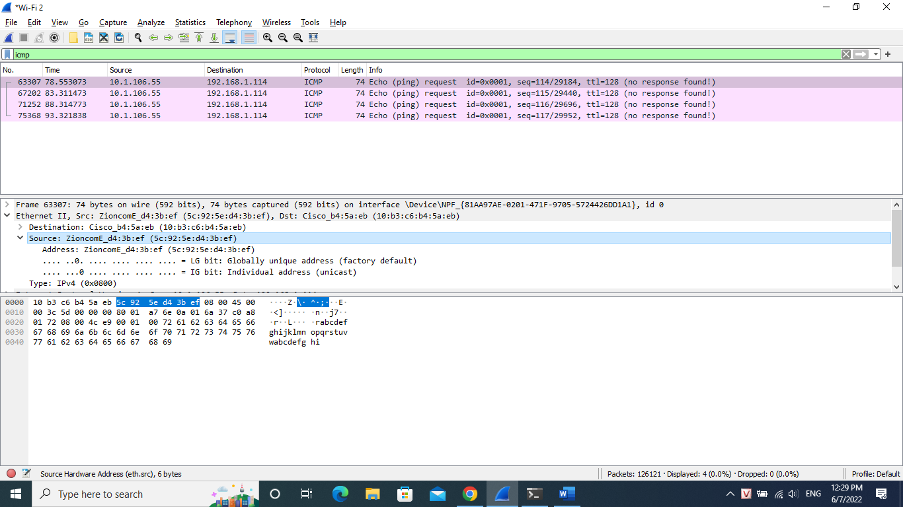

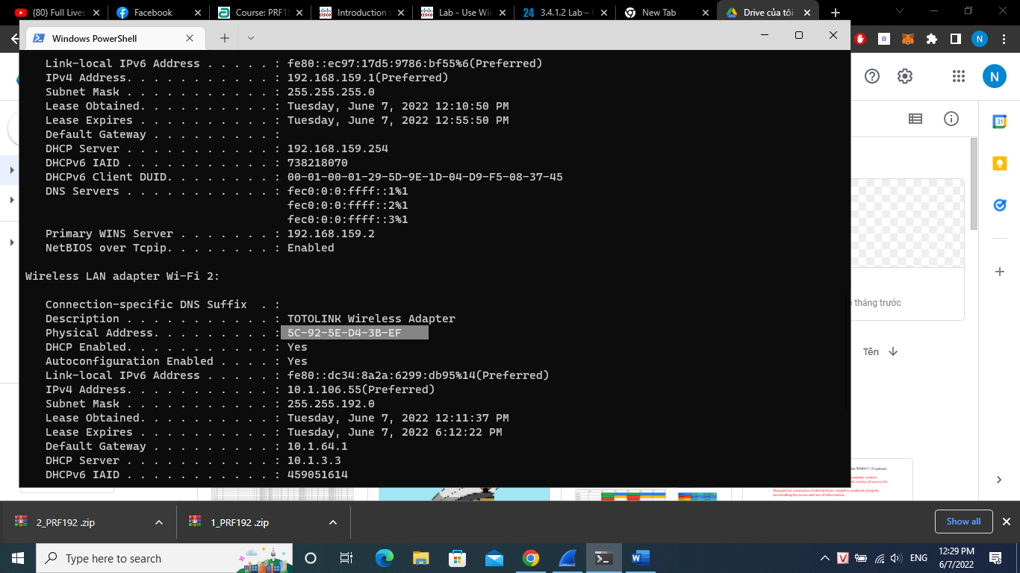

2. Does the destination MAC address in Wireshark match your team member MAC address?

- Yes

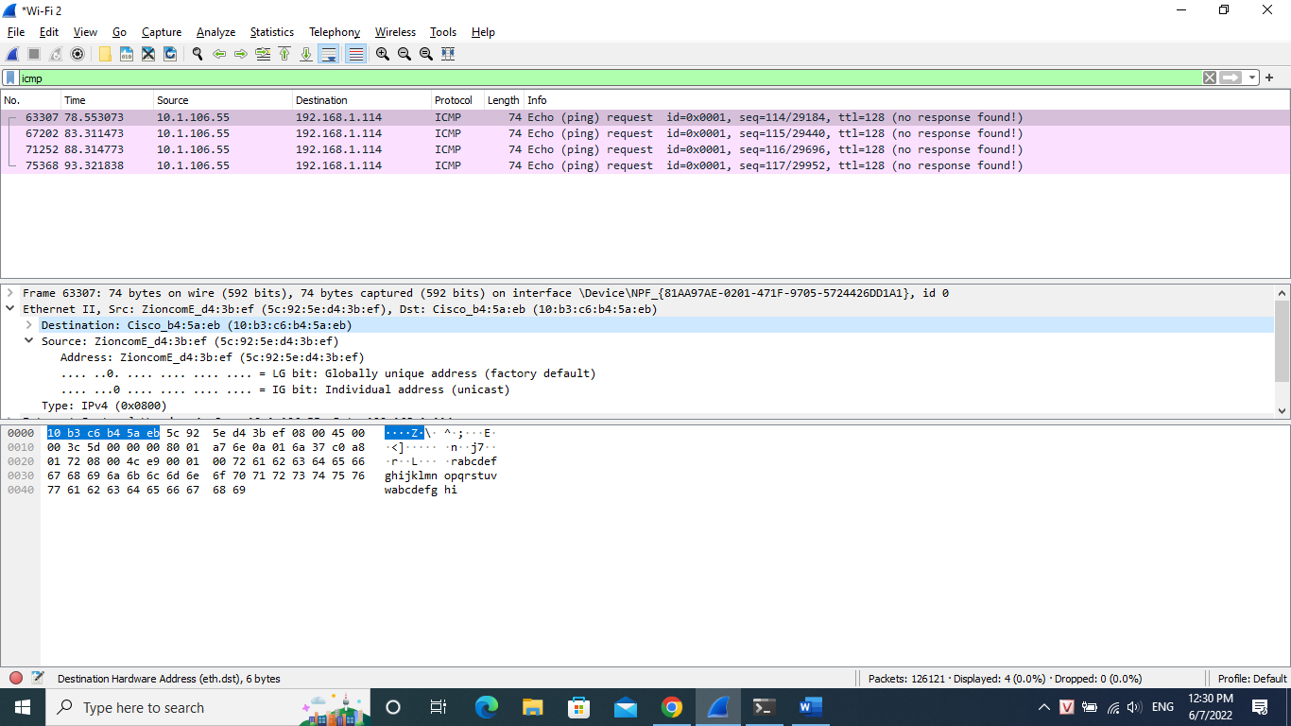

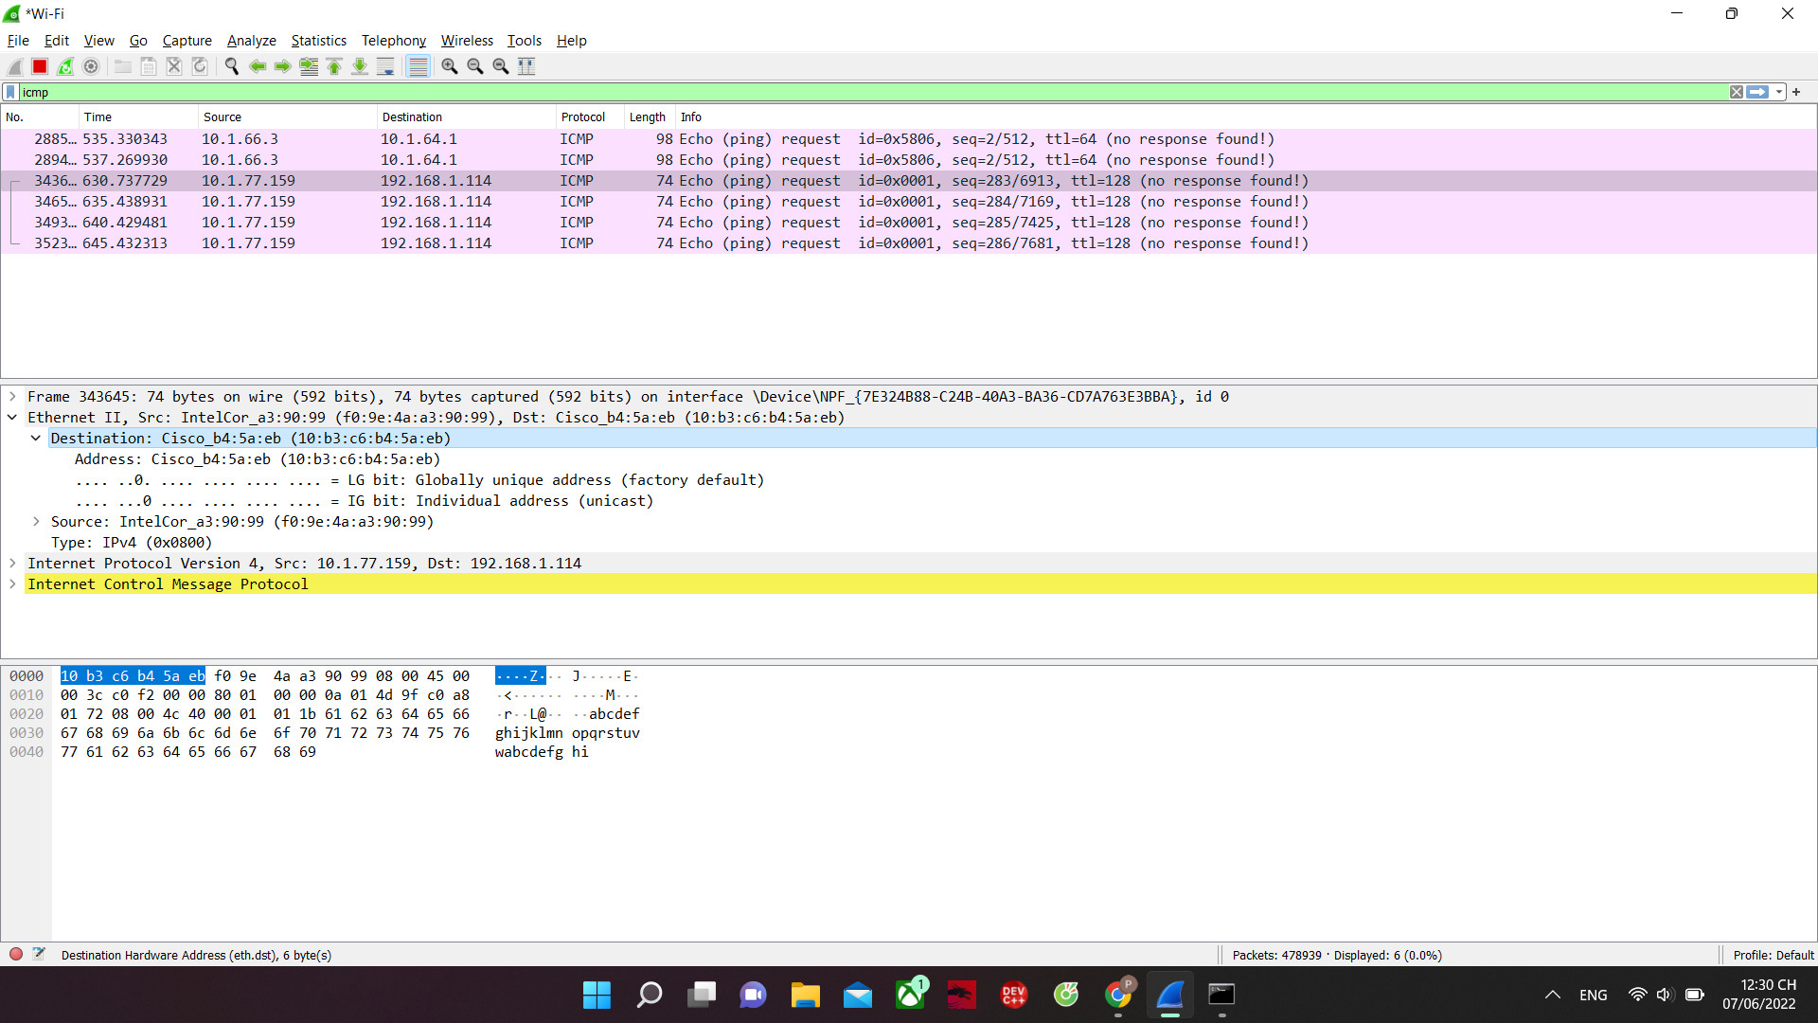

3.How is the MAC address of the pinged PC obtained by your PC?

- It’s obtained through ARP request ( get Mac address from destination section)

Part 2:

IP address for www.yahoo.com: Type your answers here. **74.6.231.20**

MAC address for www.yahoo.com: Type your answers here**. 10:b3:c6:b4:5a:eb**

IP address for www.cisco.com: Type your answers here. **72.163.4.185**

MAC address for www.cisco.com: Type your answers here. **10:b3:c6:b4:5a:eb**

IP address for www.google.com: Type your answers here. **172.217.31.14**

MAC address for www.google.com: **10:b3:c6:b4:5a:eb**