**Đặng Hoàng Nguyên – SE171946**

**Phạm Trung Hậu – SE171764**

**What are the Ethernet adapter physical addresses?**

PC-A MAC Address: 000C.85ED.2867

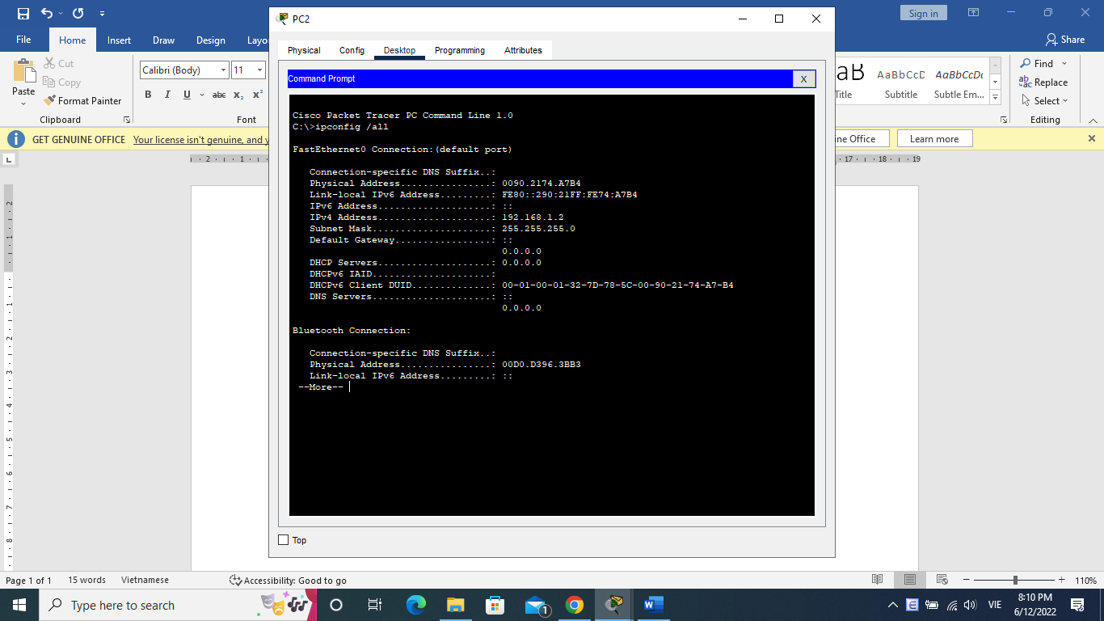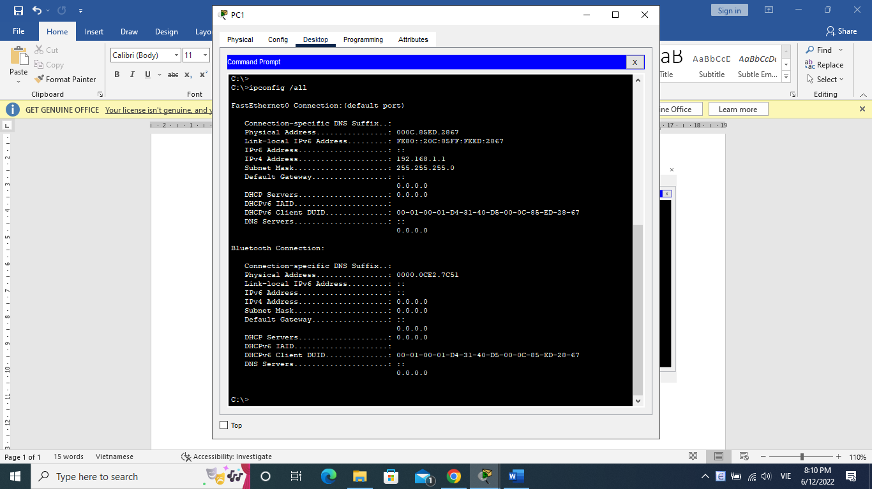PC-B MAC Address: 0090.2174.A7B4

On the second line of command output, what is the hardware addresses (or burned-in address [bia])?

S1 Fast Ethernet 0/1 MAC Address: 0090.0c6c.5b01

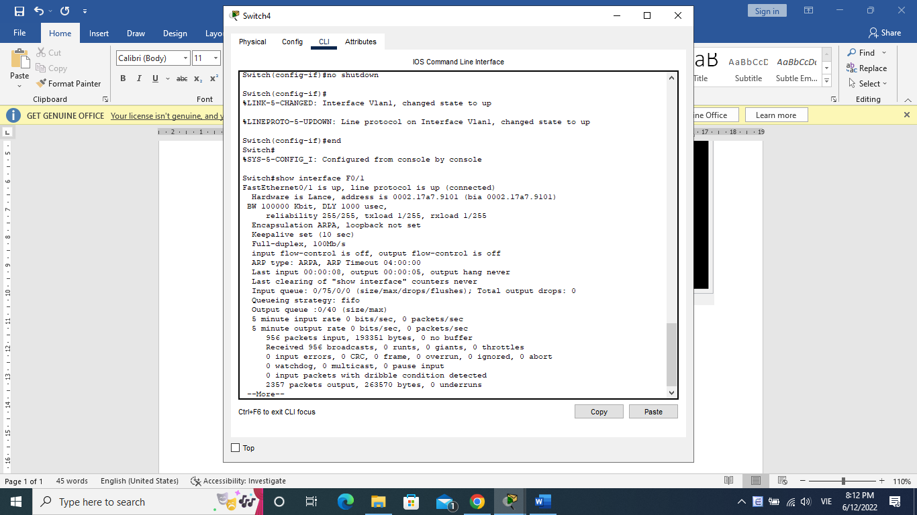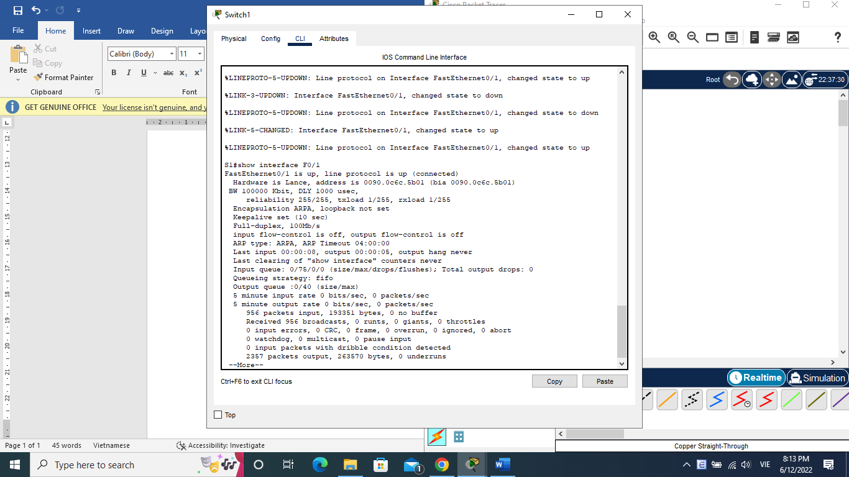S2 Fast Ethernet 0/1 MAC Address: 0002.17a7.9101

Are there any MAC addresses recorded in the MAC address table? Yes

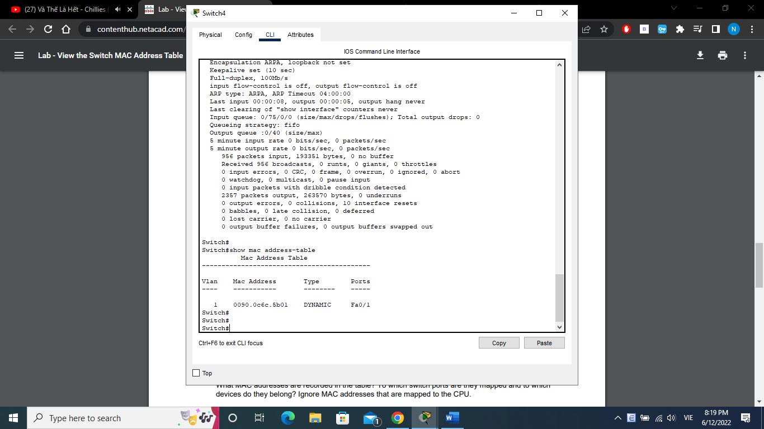

**What MAC addresses are recorded in the table? To which switch ports are they mapped and to which devices do they belong? Ignore MAC addresses that are mapped to the CPU.**

MAC address: 0090.0c6c.5b01

Belong to Switch 1 (S1)

**If you had not previously recorded MAC addresses of network devices in Step 1, how could you tell which devices the MAC addresses belong to, using only the output from the show mac address-table command? Does it work in all scenarios?**

The show mac address-table command will show every MAC address of device which connected. This won’t show the MAC address of devices connected to the same port ex: hub.

**Does the MAC address table have any addresses in it for VLAN 1? Are there other MAC addresses listed?** No

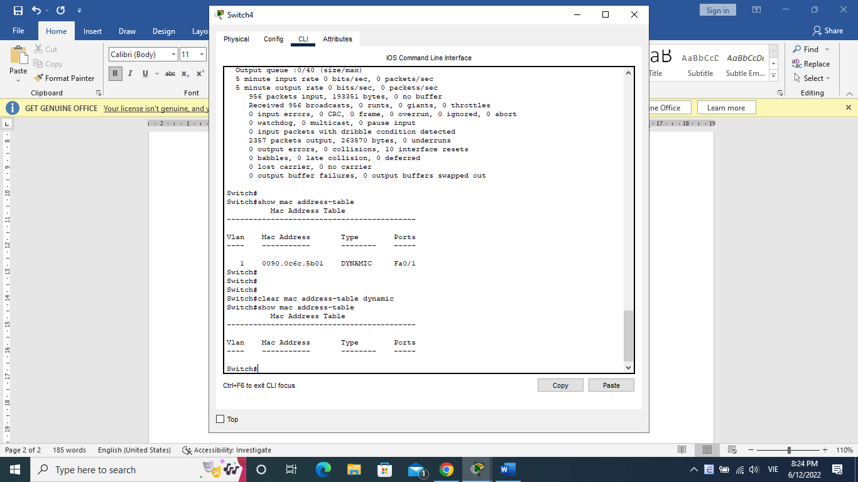

**Wait 10 seconds, type the show mac address-table command, and press Enter. Are there new addresses in the MAC address table?** Yes

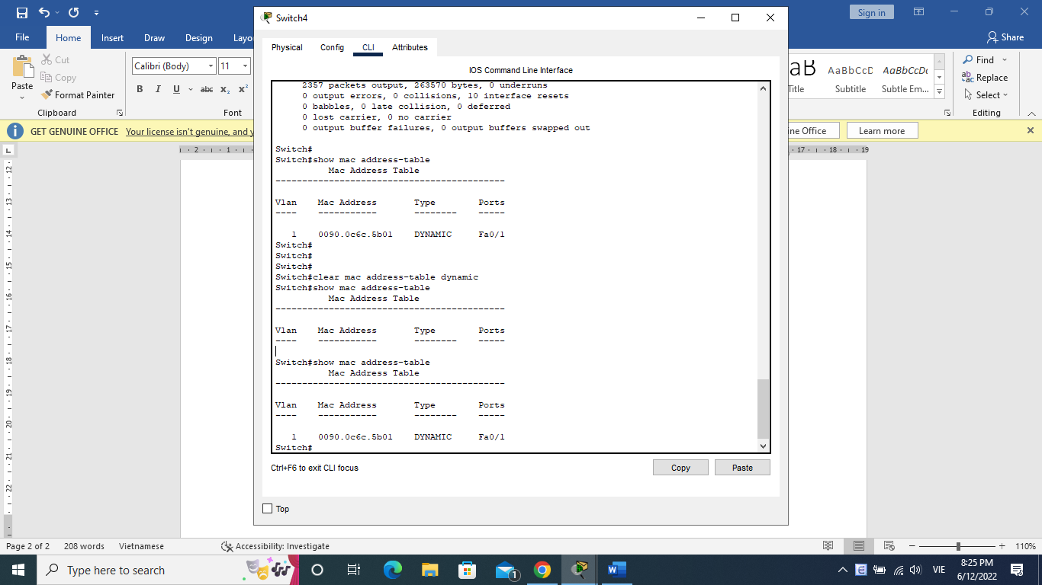

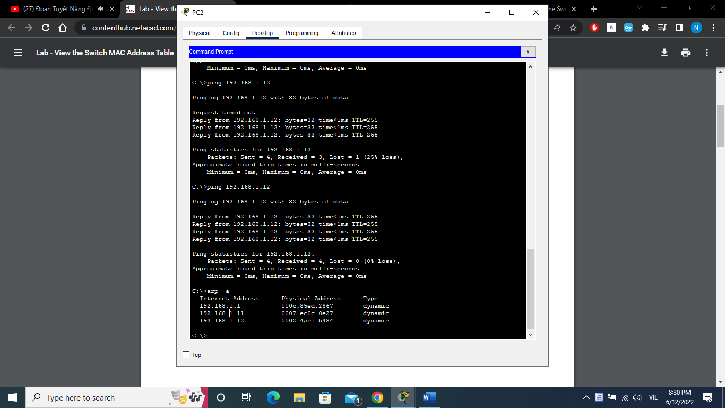Not including multicast or broadcast addresses, how many device IP-to-MAC address pairs have been learned by ARP? 3

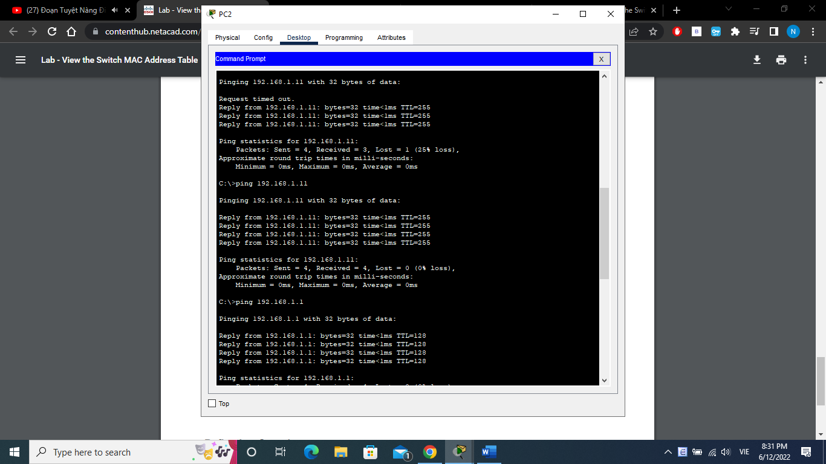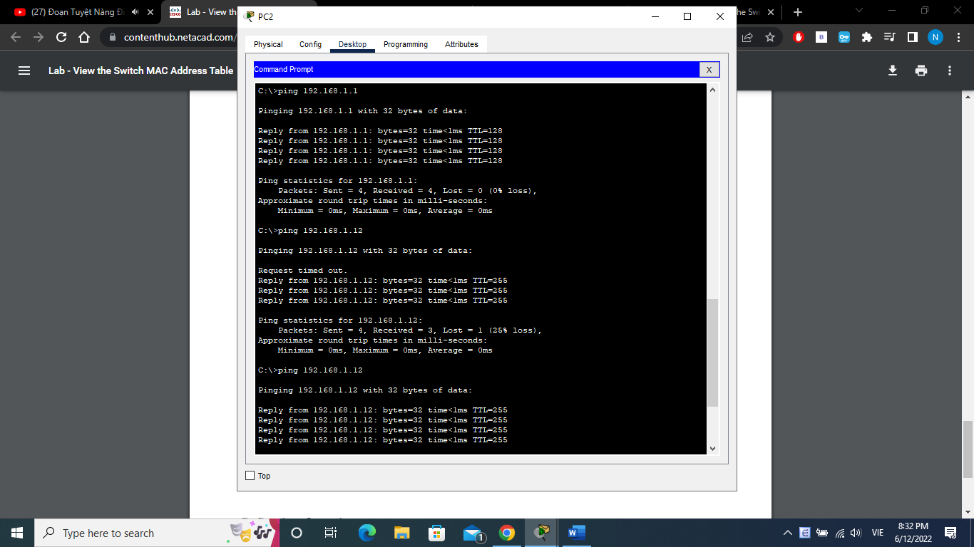Did all devices have successful replies? If not, check your cabling and IP configurations ? Yes

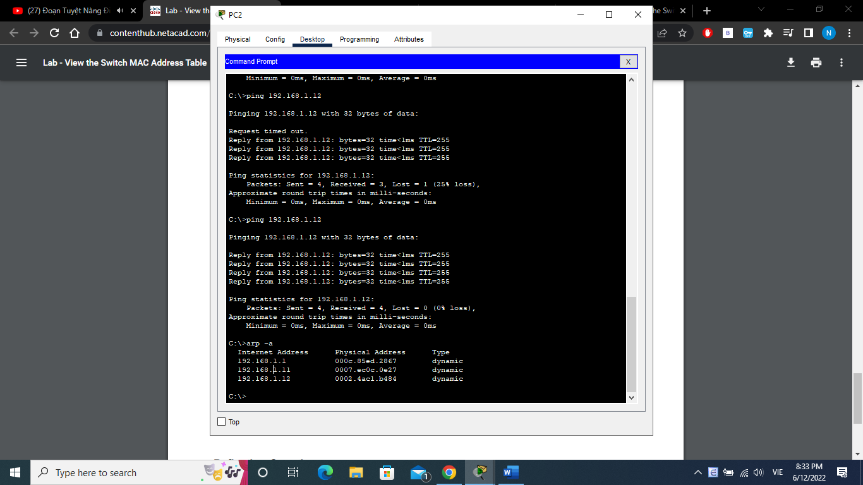

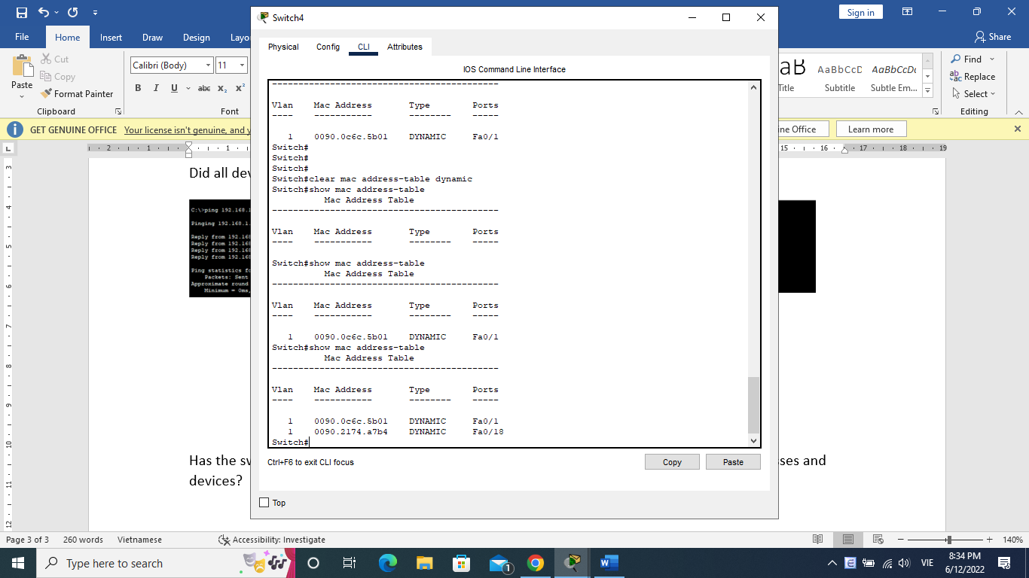Has the switch added additional MAC addresses to the MAC address table? If so, which addresses and devices? Yes, it is PC2

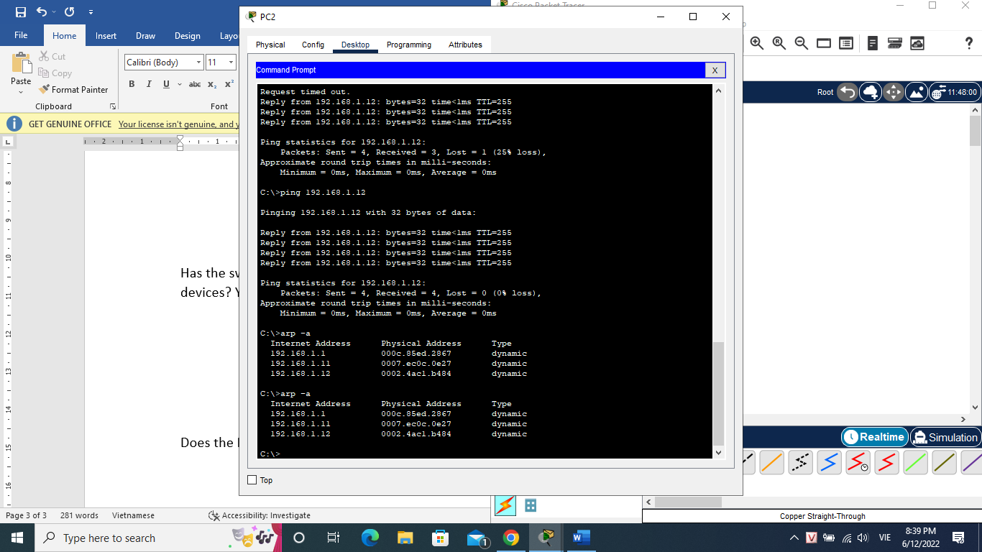Does the PC-B ARP cache have additional entries for all network devices that were sent pings? No

**On Ethernet networks, data is delivered to devices by their MAC addresses. For this to happen, switches and PCs dynamically build ARP caches and MAC address tables. With only a few computers on the network this process seems fairly easy. What might be some of the challenges on larger networks?**

It’s harder to send data because when data delivered to the destination mac, it has to search for them as well as you are able to “spoof” easier.