Huỳnh Ngọc Quang – SE181838

OSG202 - MUATC

Upload the word or pdf file to cms describes some questions as  
• Present the content of manipulating of some command (including syntax, whatdoes it for?, capture two of examples for each command) as  
o man

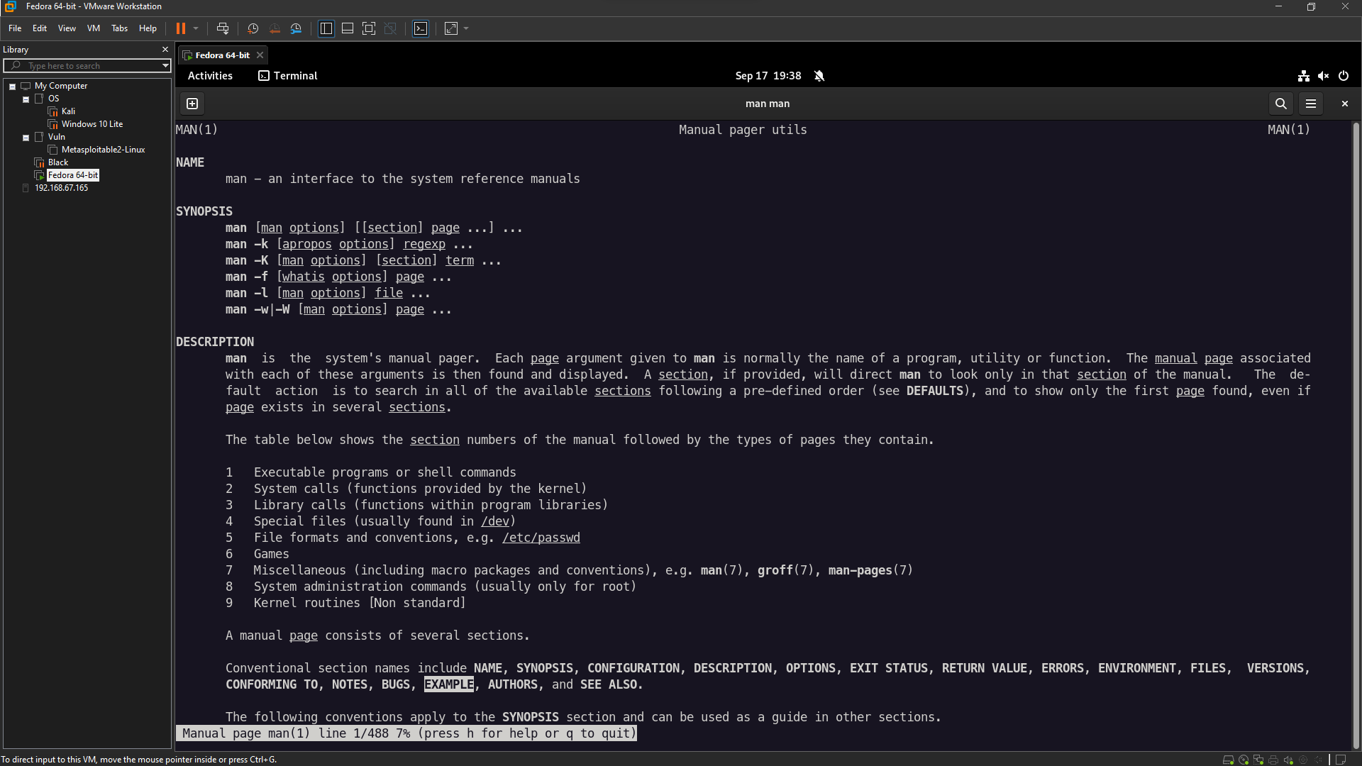

o bg, fg

o who

o chown, chgrp, chmod

o date

o su, top, kill, jobs

• Capture the terminal screen using the “grep “nhu nui” thoca.txt” and give your  
explanation the result. (Notes: thoca.txt is the file in above tutorial)

• Submit the C/C++ files and objects files as the below content then capture the  
result of the program and explanation your result that you get

Chương trình chạy lệnh hệ thống “man ls” mỗi câu lệnh hệ thống sau khi thực thi xong sẽ trả về một mã status (exit status) xác định trạng thái kết thúc của chương trình đó (Ví dụ: 0 có nghĩa là chương trình thực hiện thành công và không có lỗi nào) -> kết quả trả về của lệnh này sẽ được lưu vào biến ret. Cuối cùng chương trình trả về ret.