# Lab 2 (2-3-4)

Huỳnh Ngọc Quang SE181838

**Install and Use ClamAV**

**OS Install:**

**Install ClamAV on Ubuntu**

**Step 1: Update the Repository**

**Step 2: Install ClamAV**

**Step 3: Verify ClamAV**

**Disable the “freshclam” Service**

**Download Updates Using freshclam (First Method)**

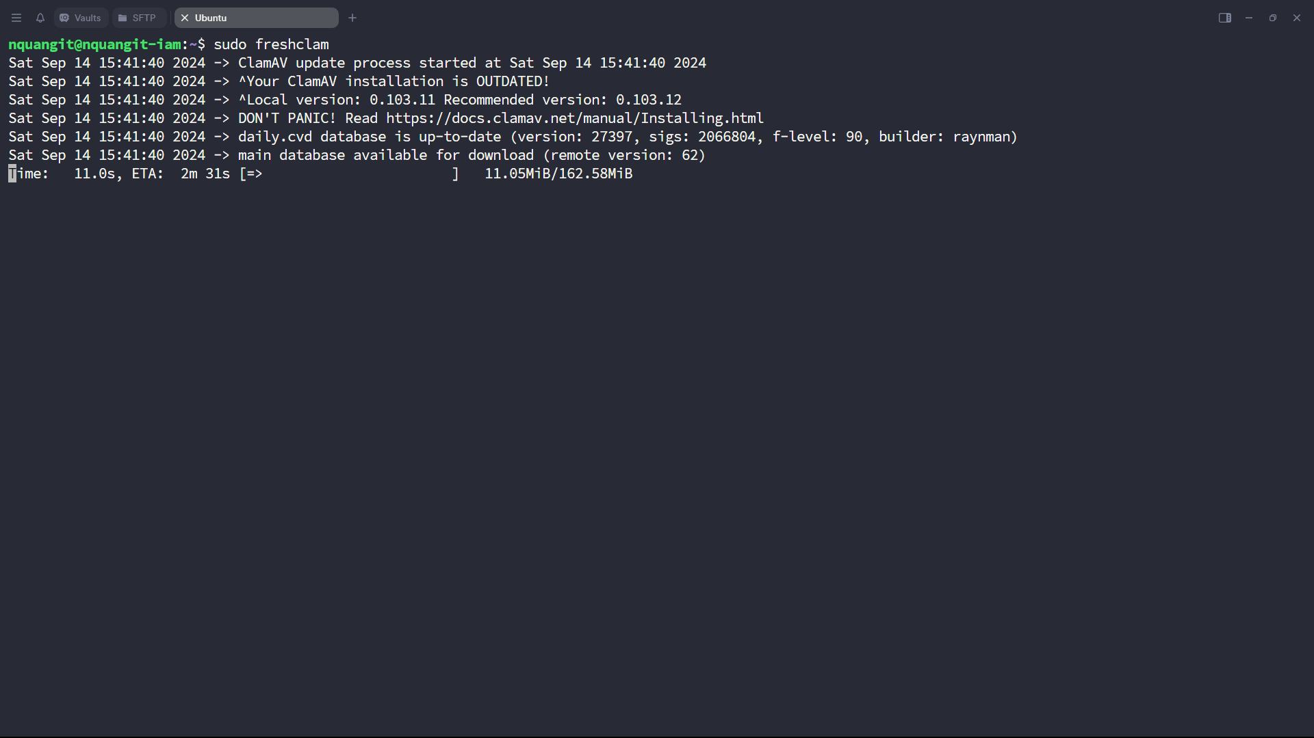

Download Updates Using Official Website (Second Method)

Another way is to download the “ClamAV” database from its official website <https://database.clamav.net/daily.cvd>

Then copy the “daily.cvd” file into the “var/lib/clamav” file through the copy command “cp”:

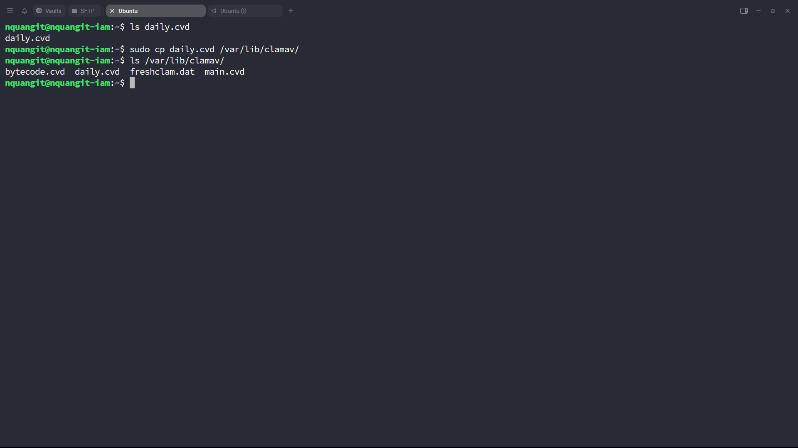

Scan a Directory

**Scan a Directory**

**LAB 4:Detect Malware Capabilities with YARA**

**Install YARA**

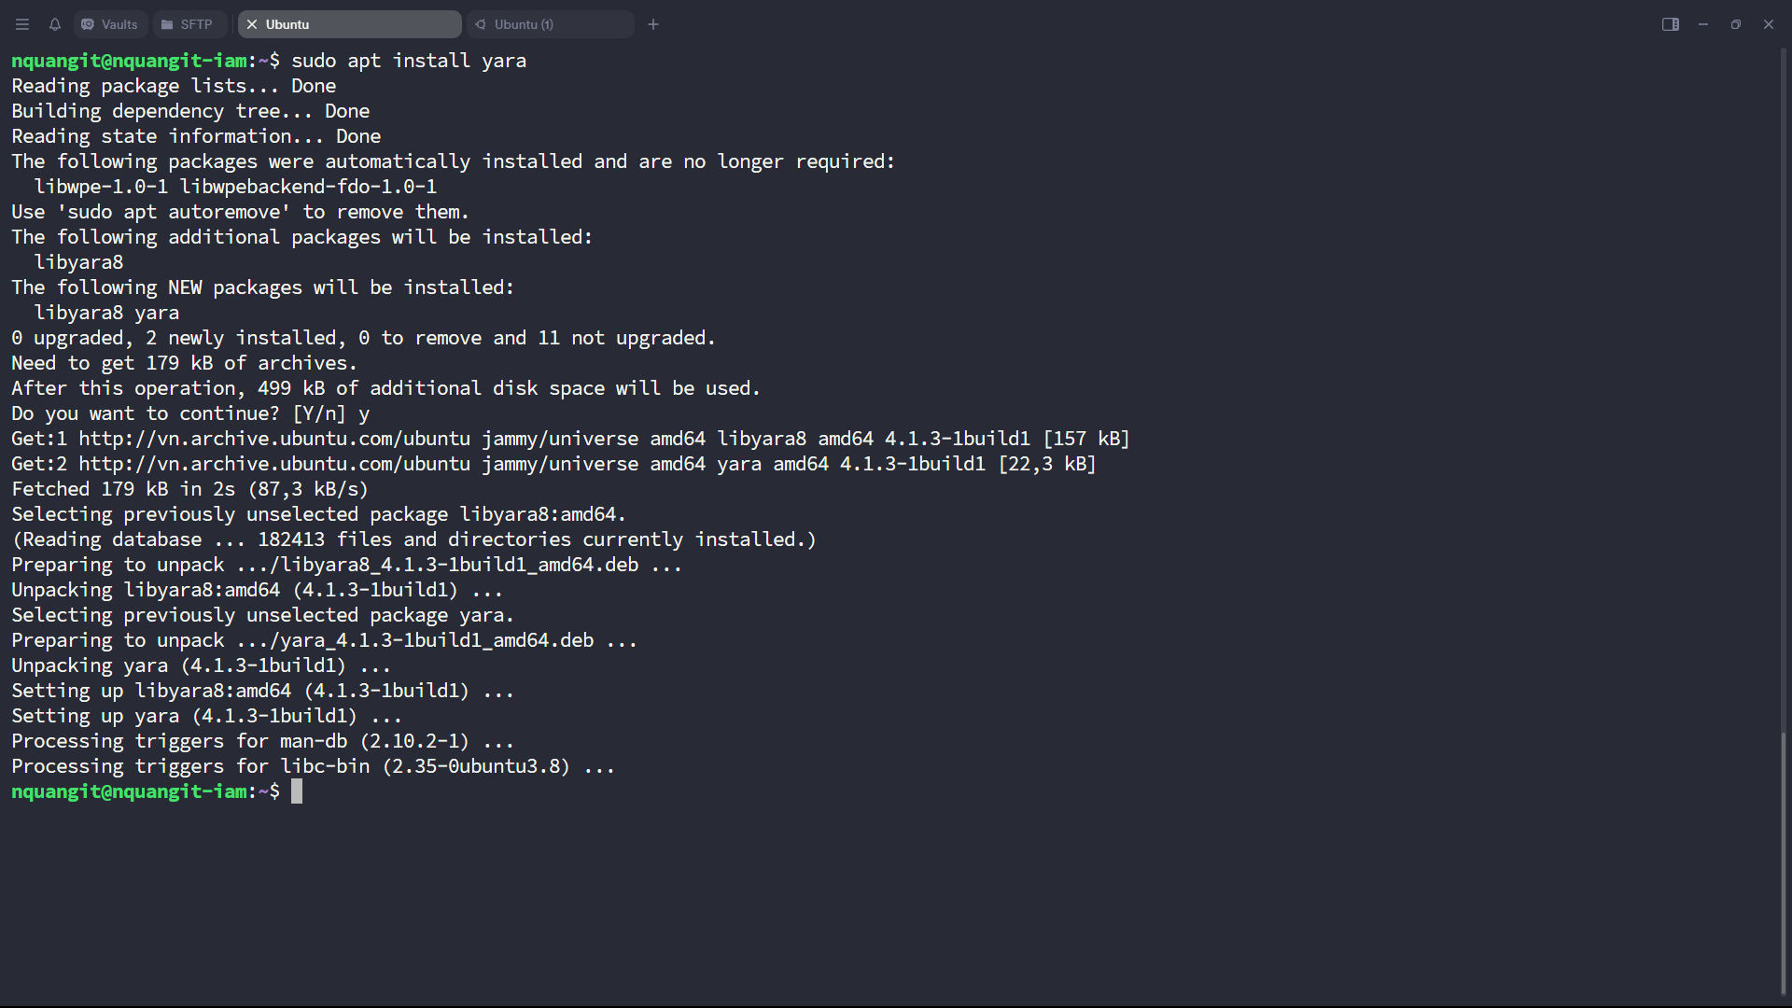

Install p7zip-full:

**Download package.01.ful.7z:**

**Download file clam_to_yara.py:**

**Convert file clamav sang yara:**

Install python2

**Create a new rule file called custome.yara**

**Test yara rules:**

