Bài tập tuần 4
Họ và tên: Nguyễn Quốc Huy
MSSV: 22652941
1 docker --version
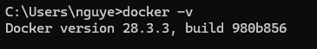
2 docker run hello-world
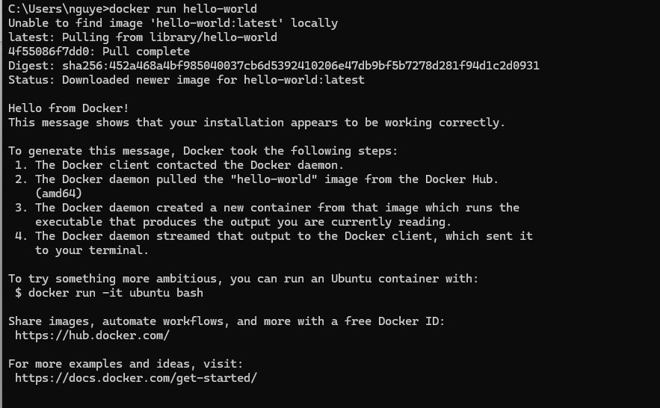
3 docker pull nginx
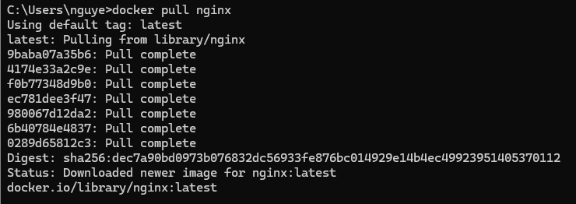
4 docker images
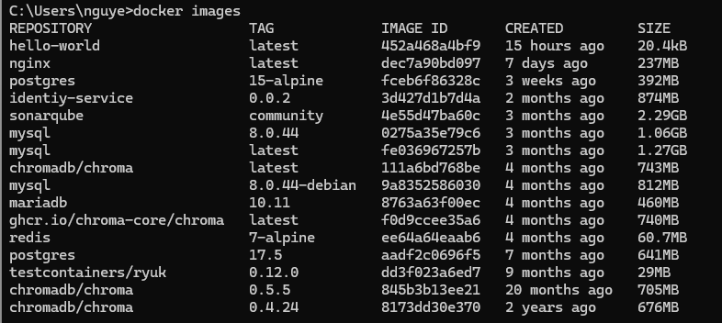
5 docker run -d nginx
6 docker ps
7 docker ps -a
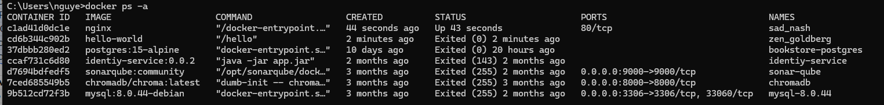
8 docker logs <container_id>
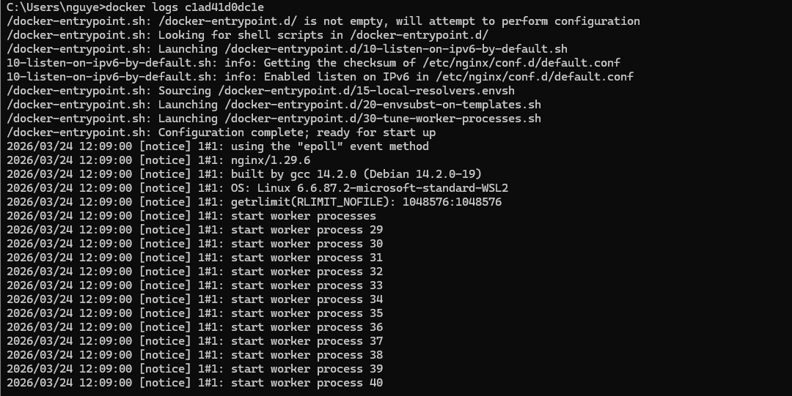
9 docker exec -it <container_id> /bin/sh
10 docker stop <container_id>
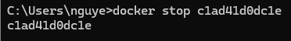
11 docker restart <container_id>
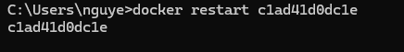
12 docker rm <container_id>
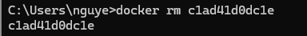
13 docker container prune
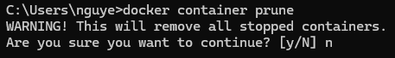
14 docker rmi <image_id>
15 docker image prune -a
16 docker run -d -p 8080:80 nginx
17 docker inspect <container_id>
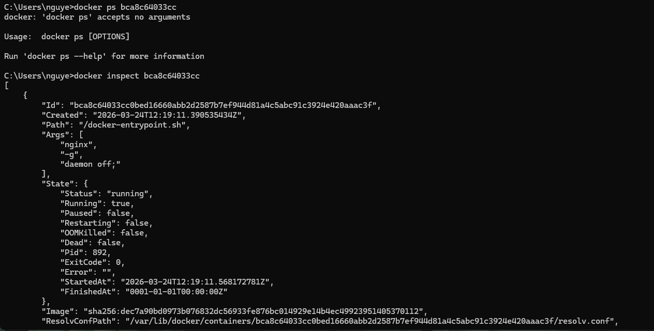
18 docker run -d -v mydata:/data nginx
19 docker volume ls
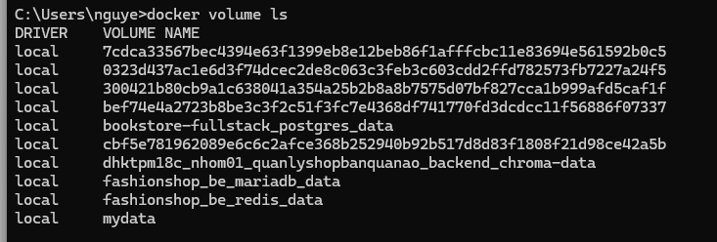
20 docker volume prune
21 docker run -d --name my_nginx nginx
22 docker stats
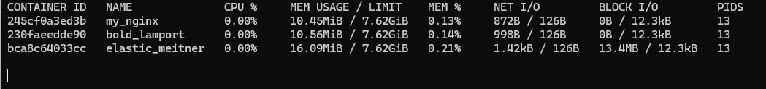
23 docker network ls
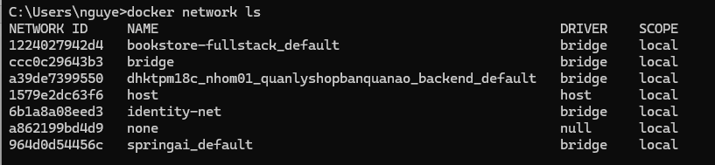
24 docker network create my_network
25 docker run -d --network my_network --name my_container nginx
26 docker network connect my_network my_nginx
27 docker run -d -e MY_ENV=hello_world nginx
28 docker logs -f my_nginx
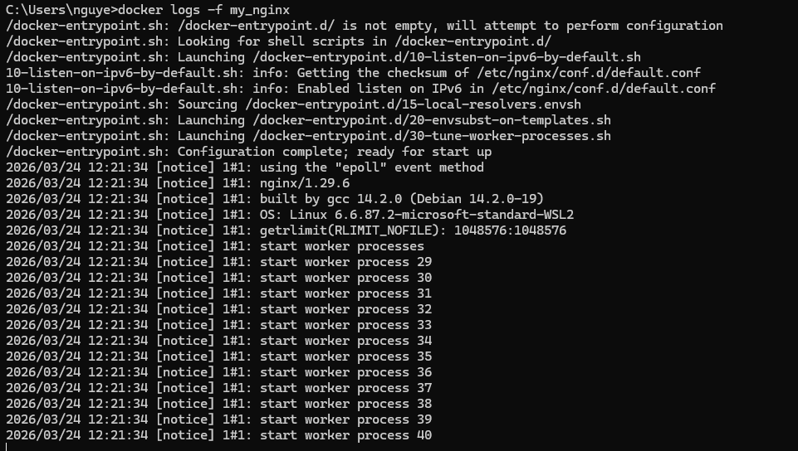
29 FROM nginx
COPY index.html /usr/share/nginx/html/index.html
30 docker build -t my_nginx_image .
31 docker run -d -p 8080:80 my_nginx_image

