Assembly Language and Computer Architecture Lab

Week 2

Assignment 1: Assigning a 16-bit number to a register
Source code: addi $s0, $zero, 0x2110003d is to calculate sum of 2 values 0x2110003d and 0, then store the final value to register $s0.
MIPS implemented 3 instructions:
- Set high-order 16 bits of $at to 0x2110 and low-order 16 bits to 0
- Use bitwise OR immediate to set $at to bitwise OR of itself and 0x003d (value of 0x2110003d is now stored in $at).
- Add $zero to $at, then store final result to $s0.

Assignment 2: Assigning a 32-bit number to a register
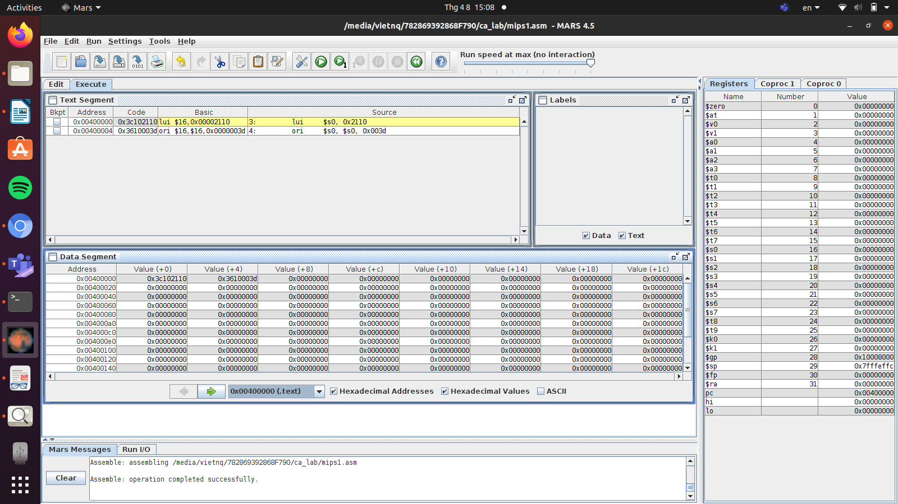
The location (address) of each instruction as we can see in the first row of the Data Segment table, they are at the first 2 cells:
lui $s0, 0x2110 => 0x00400000
ori $s0, $s0, 0x003d => 0x00400004

Assignment 3: li psuedo instruction
The value to be loaded by li is 0x2110003d (in 32-bit range), while the operand is limited in range of 16 bits for the I-type instruction, so MIPS implemented 2 basic instructions for each half of the value instead of 1 instruction compared to the smaller value (0x2).
The ways these 2 basic instructions implemented are similar to the first 2 instruction in the case of Assignment 1.

Assignment 4: Calculating simple math expression 2X+Y
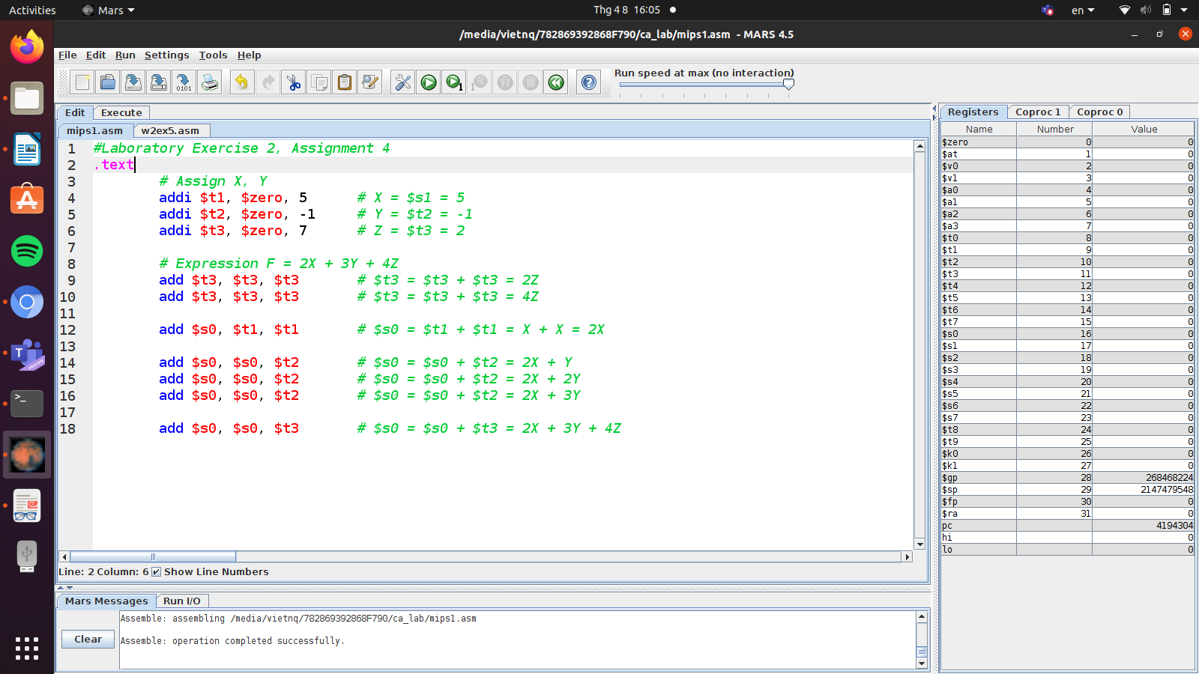

Assignment 5: Multiplication
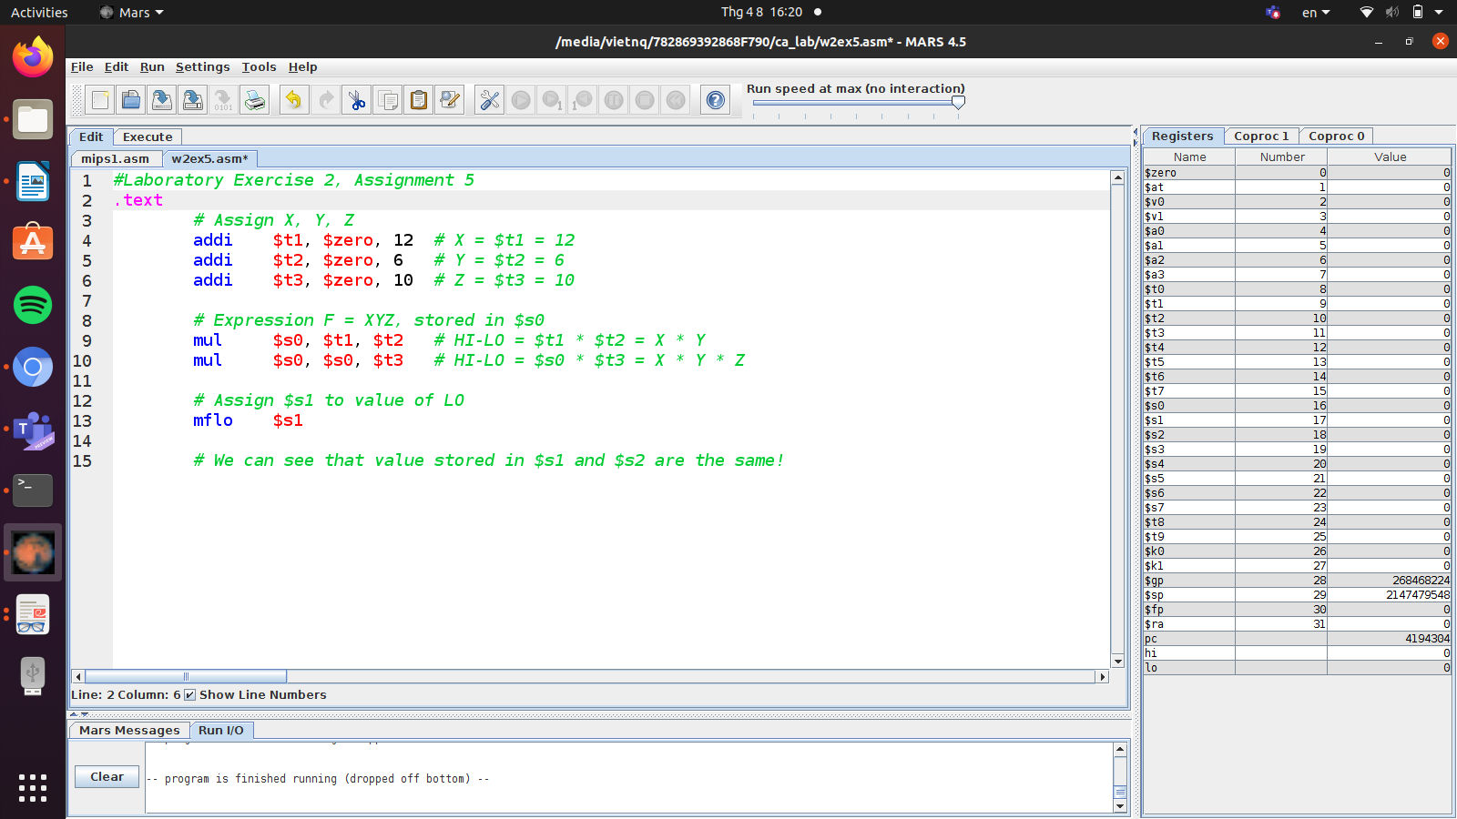

Assignment 6: Declaring and accessing variables
- The la instruction is implemented by 2 basic instructions lui and ori. For example, the machine code of these 2 instructions for variable X are: 0x3c011001 and 0x34380000, where the last 4 numbers are 2 parts of the address of variable X (10010000).
- lw: load value of a variable in memory by its address, then store in the register.
- sw: assign a value for a variable in memory.

