Assembly Language and Computer Architecture Lab

Week 3

Assignment 4
- Program Counter (PC) is the register that is affected by jump/branch instructions.
- Below are explainations of calculating target addresses:

Branch instruction (bne, beq)
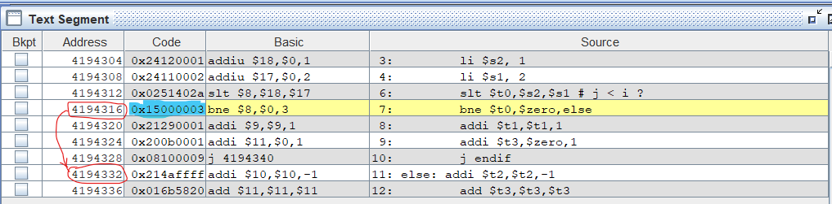
The bne instruction has machine code 0x15000003 and address 4194316.
Let analyse its machine code:
- Convert to binary: 0001 0101 0000 0000 [0000 0000 0000 0011] (the last 16 bits are jump addr).
- Get jump addr and left shift 2 bits: 0000 0000 0000 0011 00
- Sign-extended to 32 bits: 00 0000 0000 0000 0000 0000 0000 0011 00
- Add 4(10) for the next instruction, we then get:
0000 0000 0000 0000 0000 0000 0001 0000(2) = 16(10)
- Add 16 to the address in base 10, we have the next instruction: 4194316 + 16 = 4194332

Jump instruction ( j )
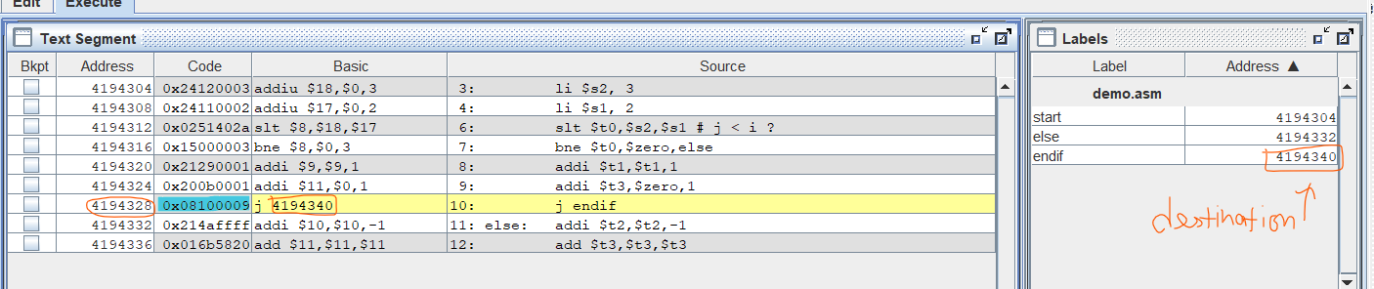
The j instruction has machine code 0x08100009 and address 4194328.
Let analyse its machine code:
- Convert to binary: 0000 10[00 0001 0000 0000 0000 0000 1001] (the last 26 bits are jump addr).
- Get jump addr and left shift 2 bits: 00 0001 0000 0000 0000 0000 1001 00 = 12(10)
- Current address: 4194328(10) = 0000 0000 0100 0000 0000 0000 0001 1000(2)
- Get first 4 bits of current address to get 32 bits address of destination:
0000 00 0001 0000 0000 0000 0000 1001 00 = 4194340(10)

