Open the project

Open "SegmentMode.vcproj" in IRcamera folder, the main codes are in "main.cpp", all the parameters are listed in "main.h". Calibration parameters are set as macros in "calibration.h".

Calibration

- Set the macro TESTMODE to be 1, and run the program.
- Put the calibration board in the view and make sure the number of objects in the view is same as number of reflectable tags on the board.
- Make sure the position of board is like this:
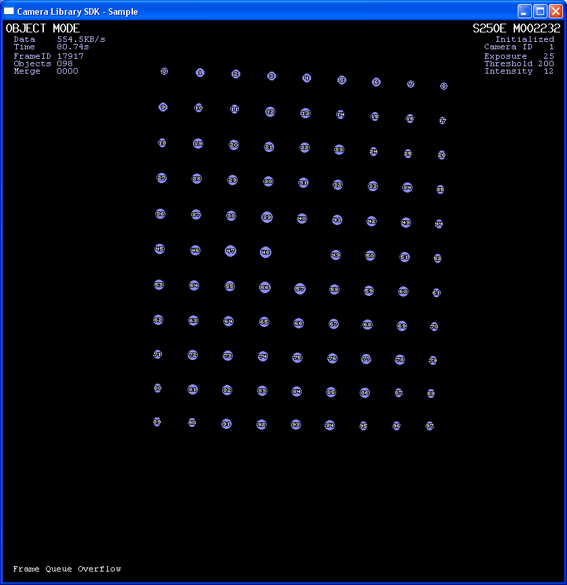
The board should be a little spinned, left conner should be higher than the right. And when the position is proper, the labeled number of most left column should be {0, 9, 18, 27, 36, 45, 53, 62, 71, 80, 89}(from top to bottom).
- When the number of objects is right, the program will automatically report the position data to the file "camera_frame.txt" in default directory.
- Run the "calibration.m" file in the same folder and it will output the new parameters values as the format of C macros, copy these lines and replace the origin ones in "calibration.h".

Collecting Tracking data

After calibration, change the "TESTMODE" to 0, and set all the macros in "main.h". Run the program and it will write the data into the desired file.

The codes are pretty simple and poor, so please give me advises if any, thanks!
Jian Shi jianshi2011@u.northwestern.edu

