Our Services

* Northland Cloud (P) Ltd provides extensive IT expertise to businesses across the globe in software programming and development in PHP, DotNet, C#.NET, VB.NET, as also App Development.
* and Custom Software Development; in web development services including website development, and in HTML, AJAX, ASP.NET, J2EE, ASP etc; in CMS development in Drupal, Joomla, WordPress, Magento, DotNetNuke, Typo3, ExpressionEngine, TYPOlight etc; in database development and administration; IT server administration and management; software upgrades, maintenance, and testing; eCommerce website designing, graphics designing, and more.

s

Landing pAGE / Home

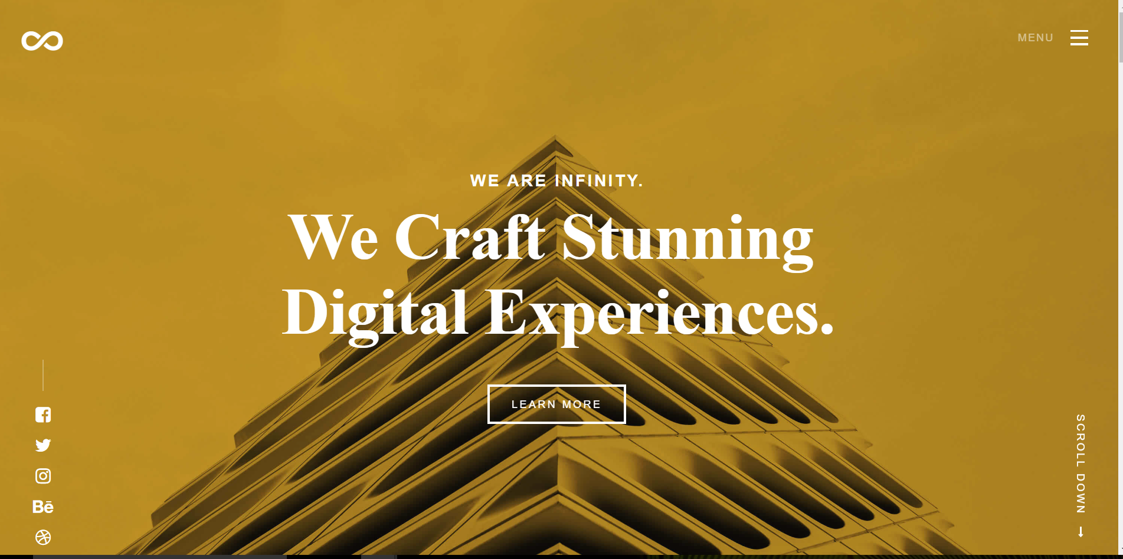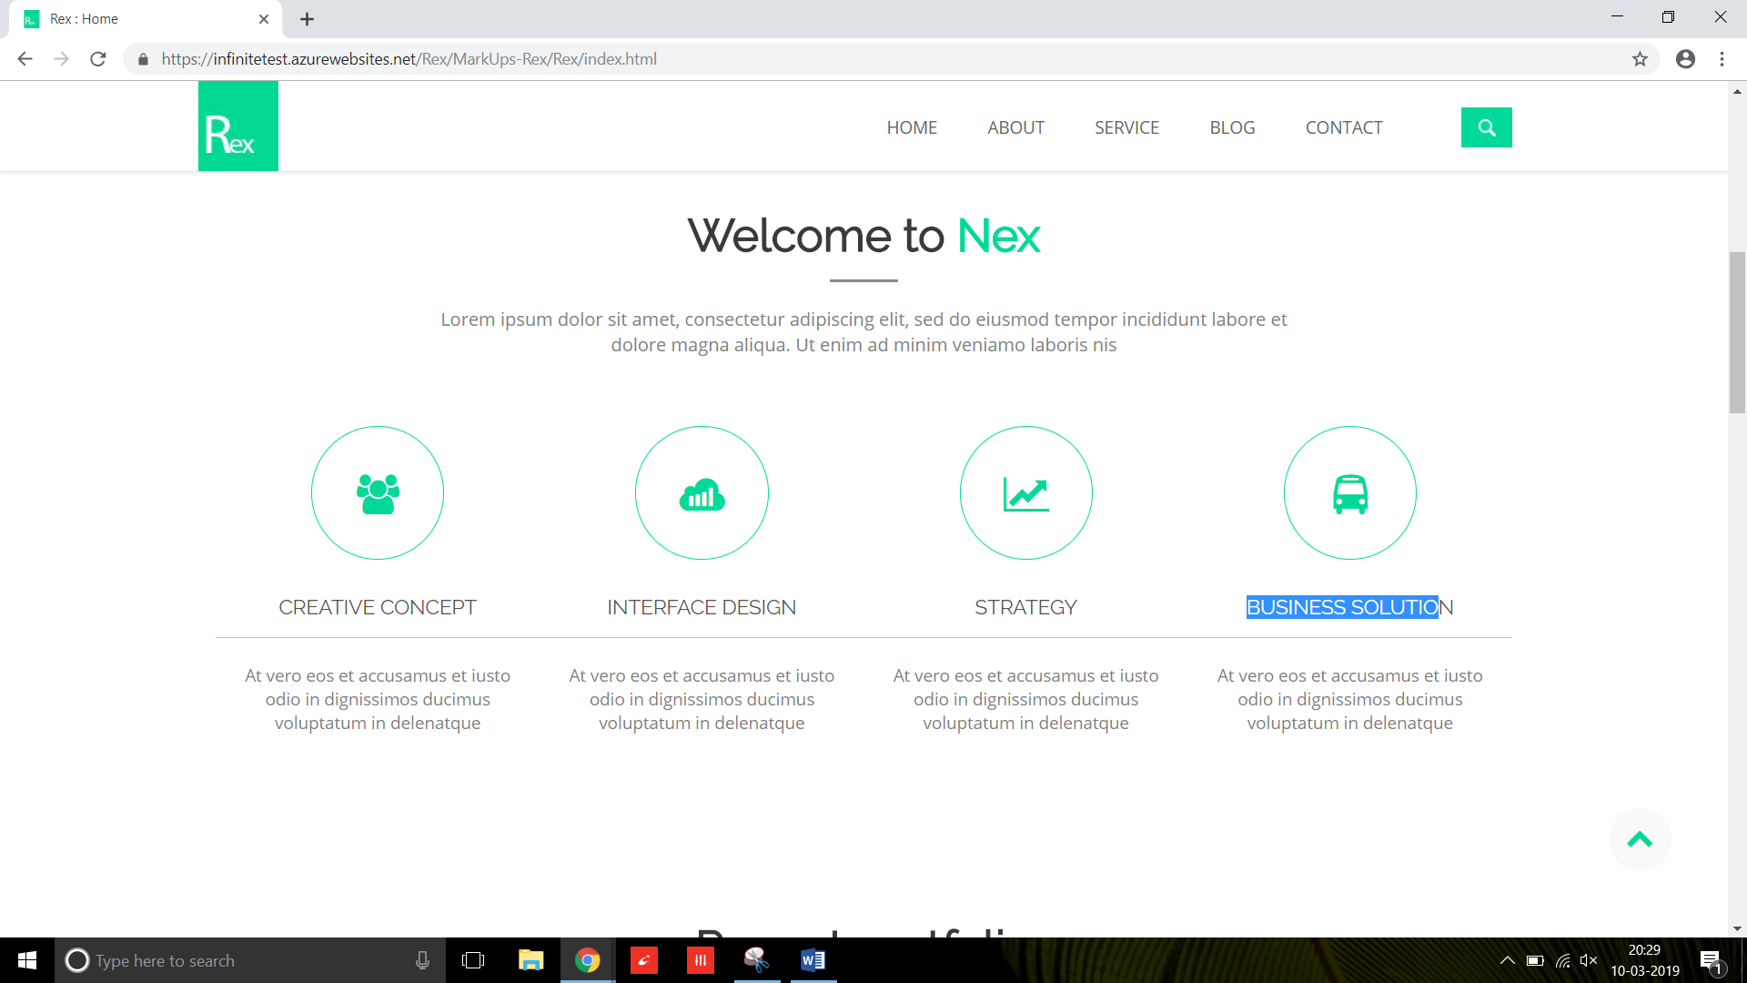

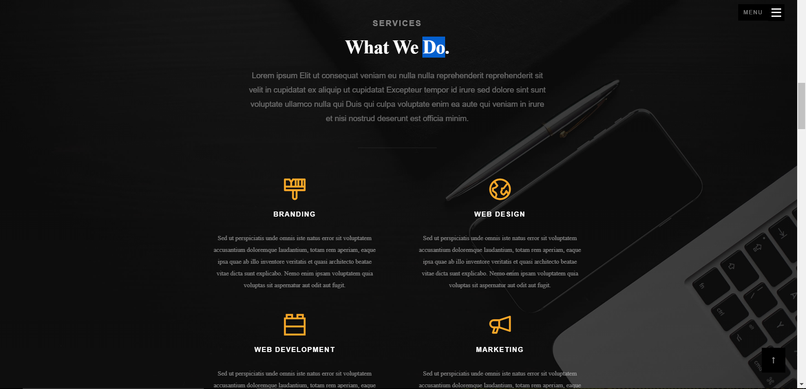

\*\* The content and theme will be of the Rex

